Home

* + 1. User Interface

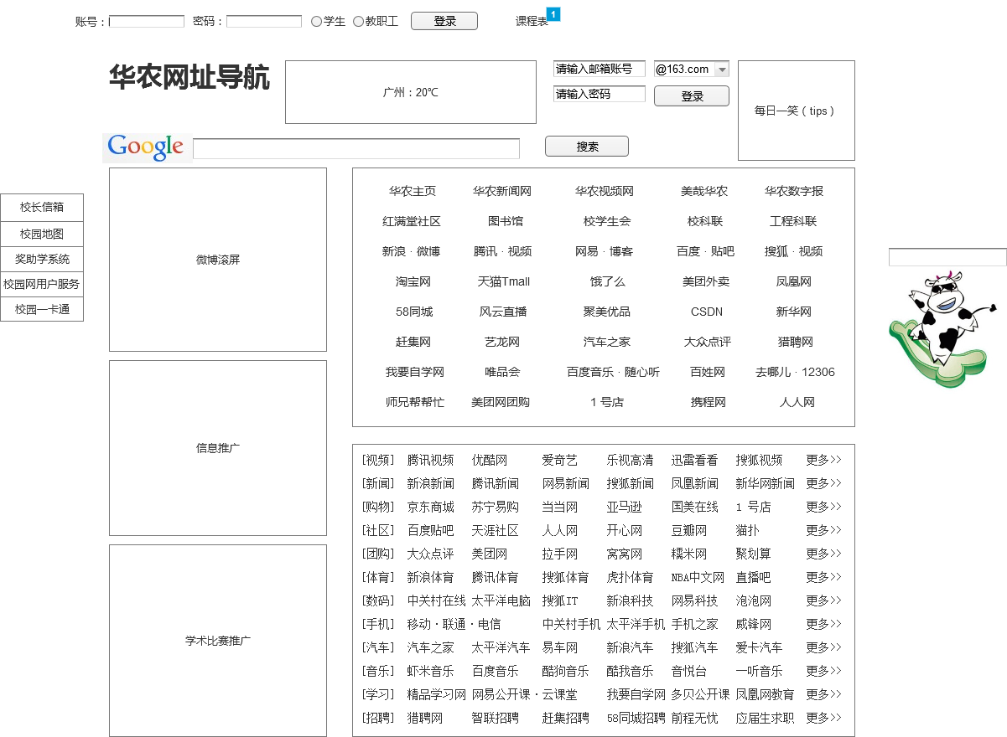

* + 1. Widget Table

|  |  |  |
| --- | --- | --- |
| Footnote | Name | Interactions |
| 1 |  | 鼠标单击时:  用例 1:  在 当前窗口 打开 Page 2 |