Document No. TP&TR
Version Date 22 Aug 2022
BRANSON L20 Database Design Test Plan and Test Result

CONFIDENTIAL

Test Plan and Report
Document No. TP&TR
Version 0.01
22 Aug 2022
Prepared For *****
Project Number BRANSON
Project Name BRANSON L20 Database Design

Wind River Systems, Inc.
500 Wind River Way
San Diego, CA 94501
510-749-2288 phone
510-749-2006 fax
www.windriver.com

Copyright
Unless otherwise agreed in writing, all copyright and intellectual property rights embodied in this document are and shall remain the property of Wind River Systems, Inc. This document is provided solely for the purposes of evaluating the work proposed and no other rights whatsoever to use the information herein are granted. The contents of this document may not be disclosed to any third party without the prior written consent of Wind River Systems, Inc.

Trademarks
Wind River, the Wind River logo, Tornado, and VxWorks are registered trademarks of Wind River Systems, Inc. Any third-party trademarks referenced are the property of their respective owners. For further information regarding Wind River trademarks, please see http://www.windriver.com/corporate/html/trademark.html.
Revision History
Date | Version | By | Description of Change
22 Aug, 2002 | 0.01 | Kunming Yang | Draft

Contents
1 Introduction 5
1.1 Purpose and Scope 5
1.2 Readership 5
1.3 Project Background 5
1.4 References 5
2 Test Enviornment 6
2.1 Pre request 6
3 Test Strategy 7
3.1 Preparation 7
3.2 Test 7
Appendix A：Test Results Record 9
A.1. Test Result 9

Introduction

Purpose and Scope
This document describes how to test the database storage speed of the BRANSON L20 Database Design project.

Readership
The reader is assumed to be familiar with the Wind River product VxWorks7 2107.

Project Background
Customer requested Wind River to provide a database for Branson L20 Platform, supporting the VxWorks7 2107 Operating System.

References

Test Enviornment

Pre request
Software：
Ref | Description | Formate | Author | Version
 | Windows 10 | DVD | Microsoft | 21H1
 | VxWorks7 | DVD | Wind River | 2107
 | BSP | Source code | Wind River
Hardware:
Ref | Description | Supplier | Part No.
 | AM5708 | TI
 | Ethernet CAT5e cable | Any
 | Windows PC with a 100/1000 Mbit/s network card | Any

Test Strategy

Preparation
All codes are running in RTP mode, so the BSP should support timestamp system call for high-precision timing.
The database should include 3 tables at least.
The tested table should include 1,000,000 records at least.
Other table should include 5000 records at least.
The storage operation is called in RTP L20.
Another RTP is used to send the storage commands.

Test
Ref | Procedure | Expected Results
T.1 | Change DataTask to public object in RTP L20’s MainTask.cpp  The code is like:  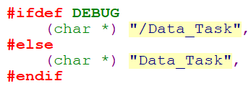 | None
T.1 | Change message queue Control to public object in MainTask.cpp  The code is like:  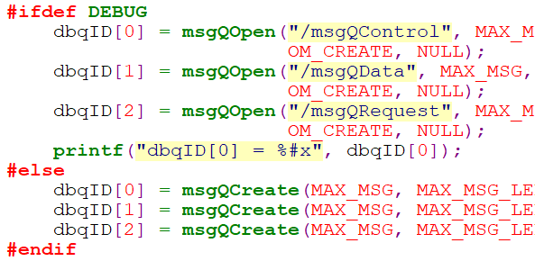 | None
T.1 | call DBAccessL20DB::StoreWeldResult in DataTask::ProcessTaskMessage to insert 5000 records from the other RTP.  The code is like:  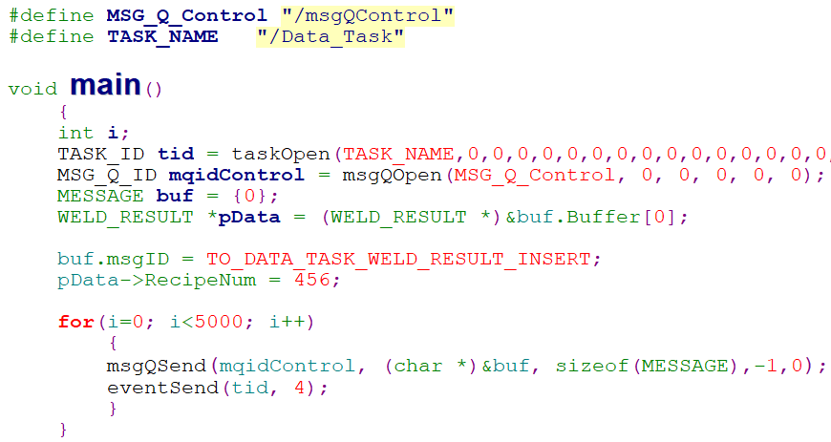 | The step should take 3 minutes
T.1 | call DBAccessL20DB::StoreWeldSignature in DataTask::ProcessTaskMessage to insert 5000 records. | The step should take 3 minutes
T.1 | call DBAccessL20DB::StoreWeldResult in DataTask::ProcessTaskMessage to insert 995,000 records. | The step should take several hours
T.2 | Add calling to sysTimestampLock() before and after DBAccessL20DB::StoreWeldResult | None
T.2 | count the time difference after second sysTimestampLock() | None
T.2 | The code is like  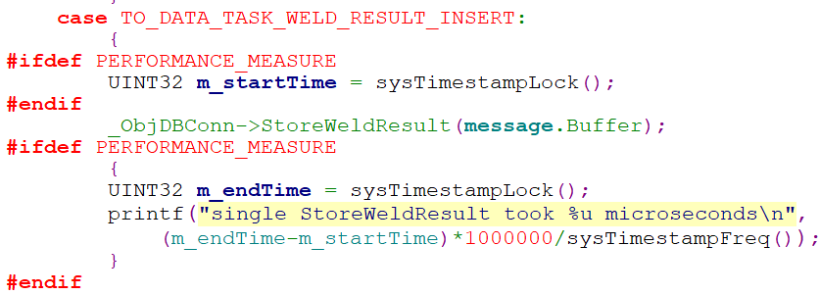 | None
T.3 | call DBAccessL20DB::StoreWeldResult in DataTask::ProcessTaskMessage to insert 10 records. | The console shows the result, like this:  -> single StoreWeldResult took 472 microseconds  …
T.3 | Select the maximum and minimum values | max: xxx microseconds  min: xxx microseconds

Appendix A：Test Results Record

Test Result
Ref. | result
 | single StoreWeldResult took 160 microseconds
 | single StoreWeldResult took 472 microseconds
 | single StoreWeldResult took 168 microseconds
 | single StoreWeldResult took 600 microseconds
 | single StoreWeldResult took 81 microseconds
 | single StoreWeldResult took 695 microseconds
 | single StoreWeldResult took 494 microseconds
 | single StoreWeldResult took 5 microseconds
 | single StoreWeldResult took 94 microseconds
 | single StoreWeldResult took 517 microseconds
max: 695 microseconds
min: 5 microseconds

