**Team: PayTrust**

**Members:**

1. Ope Jeremiah
2. Joseph
3. Ahmed
4. Samila
5. Ridwan

**Problem definition**

Did you know that a substantial percentage of individuals, approximately 10% of world population because this age falls in the 65 years or later and they require essential health support? Addressing this need, our innovative solution bridges the gap by offering a comprehensive health assistance application. Unlike existing services, our application not only facilitates health chat but also encourages in-person visits to healthcare facilities. By strategically allowing users to choose branches closest to their location, the application streamlines access to vital health readings and services. This ensures a holistic and convenient approach to healthcare management, promoting overall well-being.

**Design specification**

Landing page: This is where a user sees a brief introduction about the website being a health assistance website and also to signup.

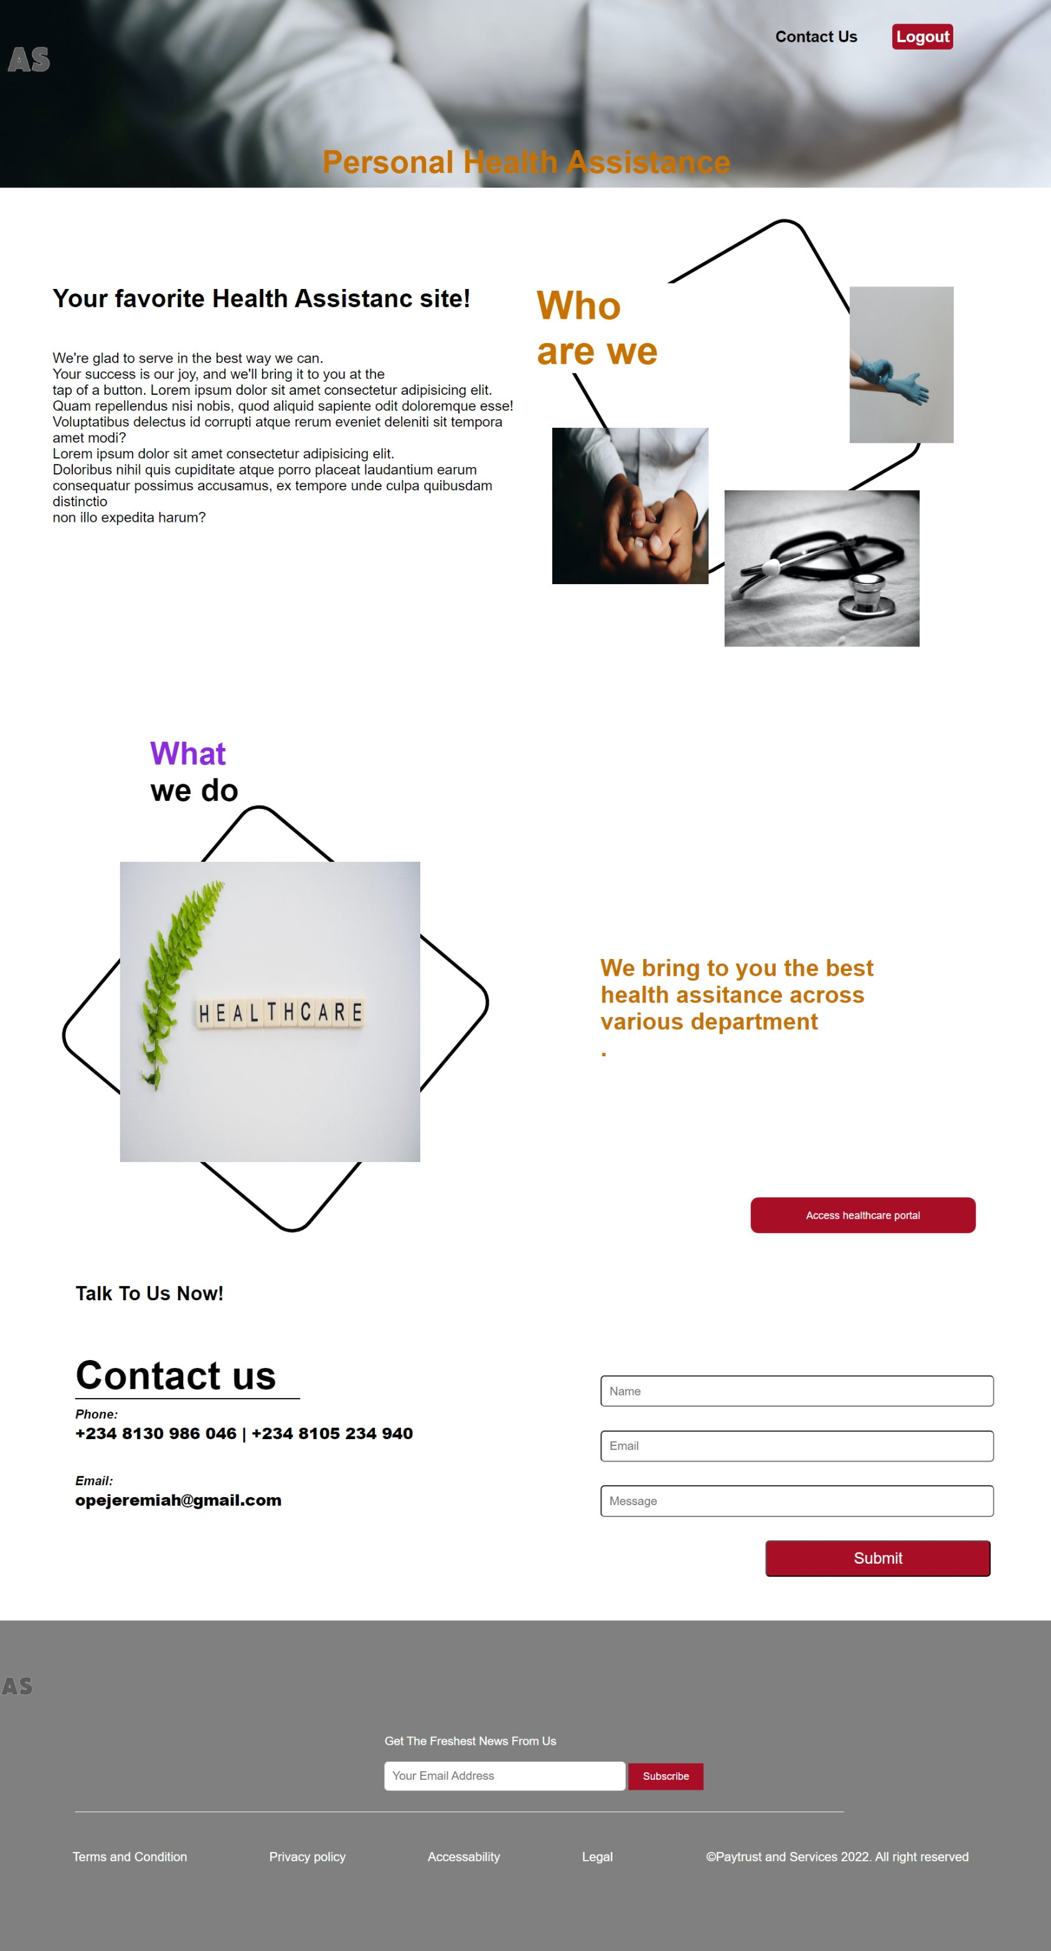

User sign-up: Here users would enter in their credentials (email, user password etc) and login.

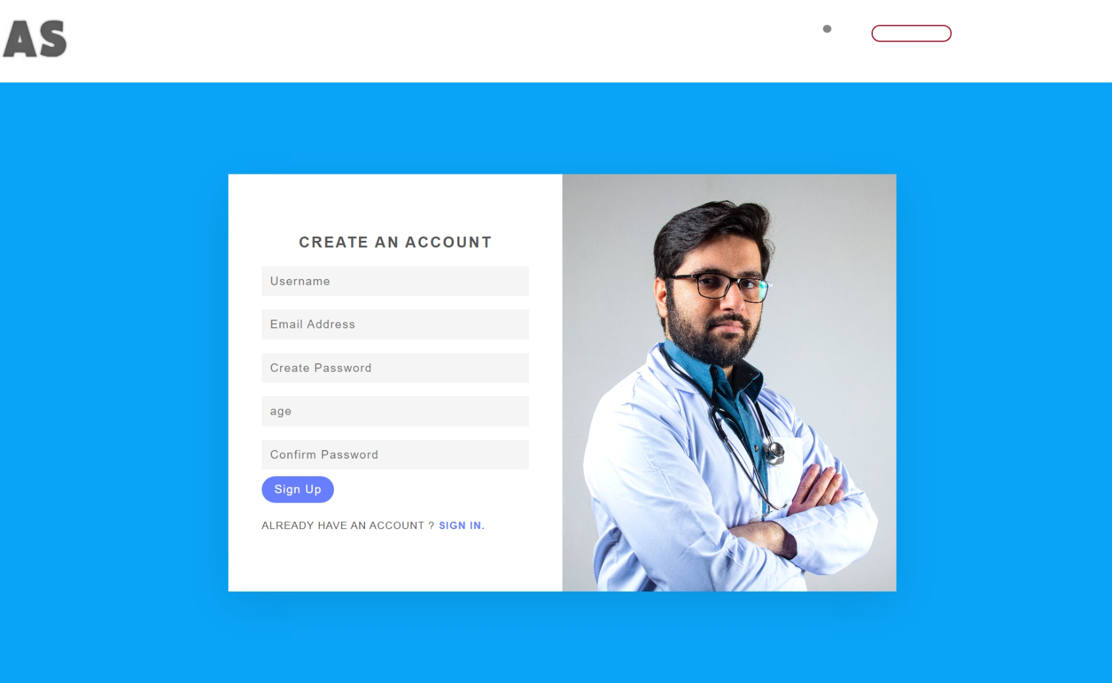

Department and Branch selection: User select department you want to work on just as in a normal hospital. Dental Care, Africa, Nigeria, Abuja, Garki was used as sample location in the project.

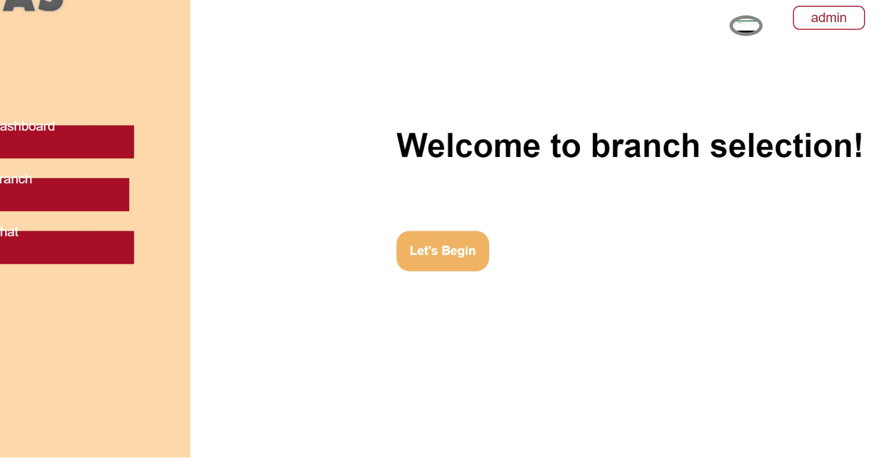Task: Users can either schedule appointment, and get medicine dosage. Users can also view the status of these activities. For appointment, 0 means turning down ones appointment and 1 is approving appointment. This score can only be given by doctors in a department when their clients submit their appointment.

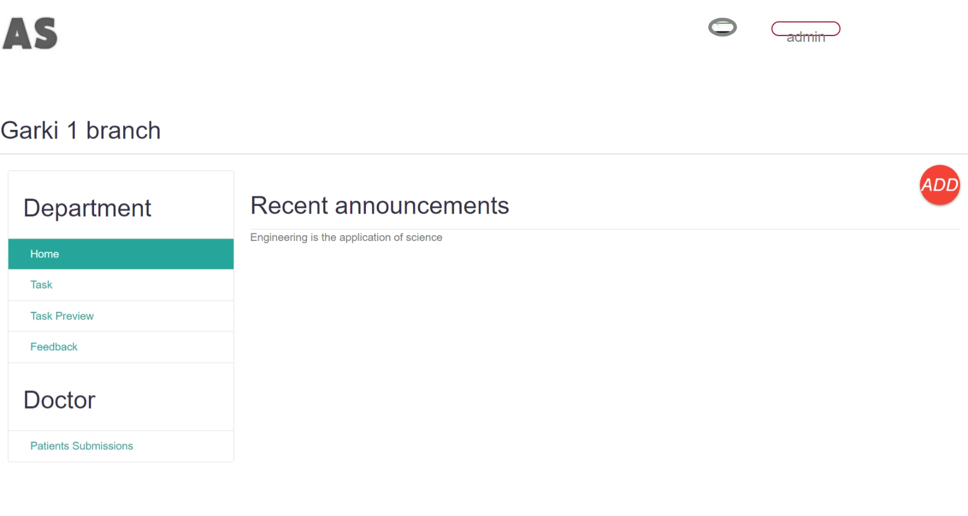

Feedback: Users can give feed back for each department and branch hence help improve such department and branch.

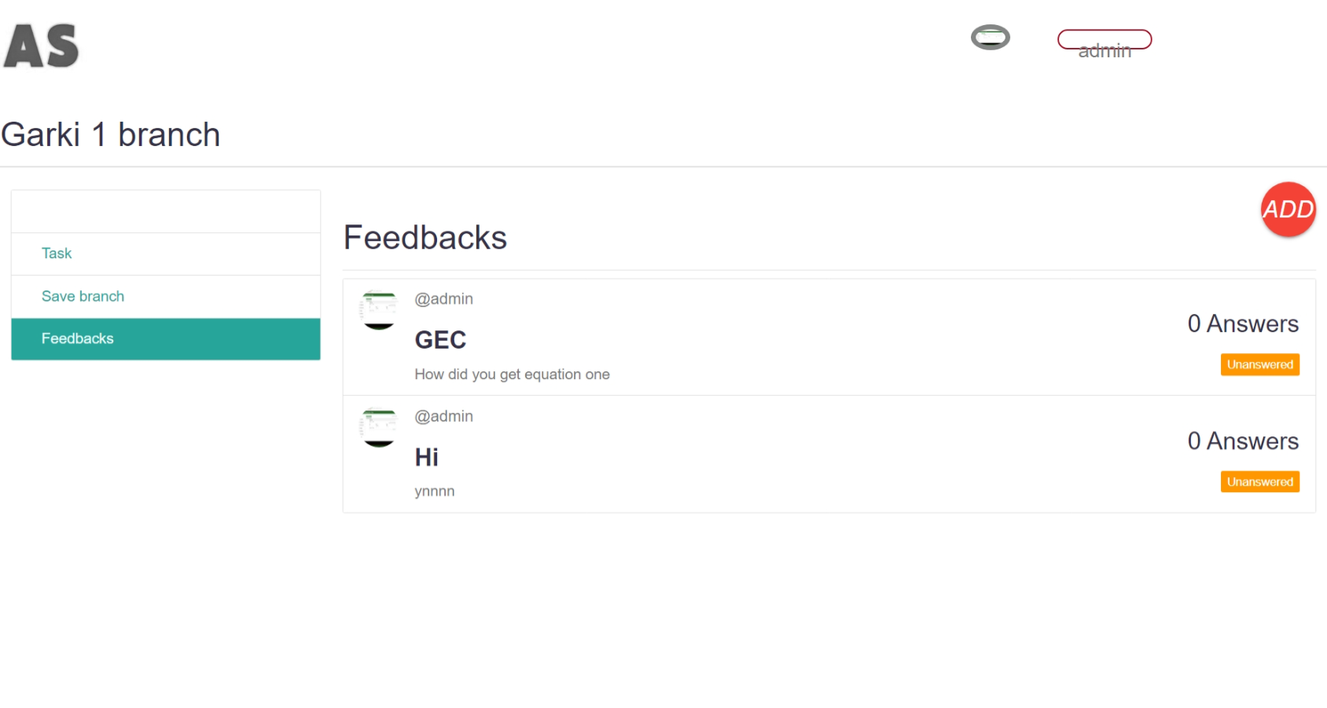

Profile**:** Users can save departments and also edit their profiles

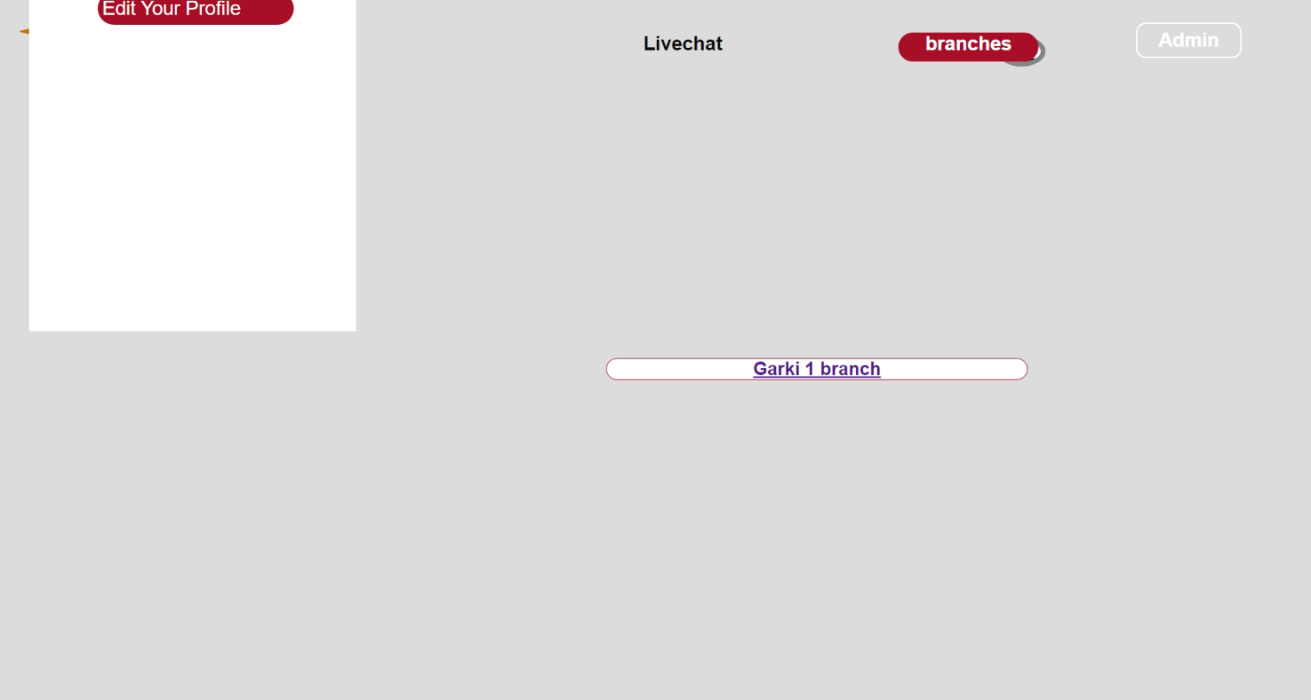

**Flowchat:**

The flow chat can be gotten in the root folder of the file.

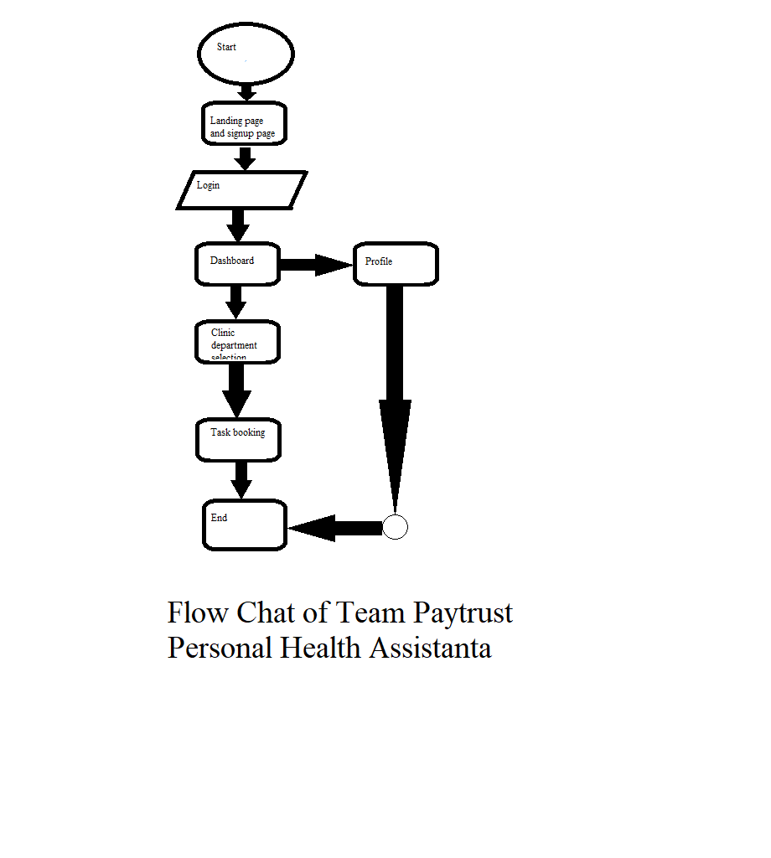

**Database design**

Using Structured query language (SQL), team payTrust was able to create a personal health assistance application which supports features such as medicine dosage record, appointment etc.

The first table was the profile for users, second was Assisgment. Assignments gives people opportunity to create forms such as appointment forms, medical dosage forms and etc. Assigment table also allows patients to fill theses created forms. The Table titled blog has several other tables and they are category, article, courses, subjects, rooms, reps, mems, chairs and table. These are variable which stores the values for clinic department name, continents, country, state, local government area and area. These data are used so an individual gets the doctor closet to his or her location. The course table is used to store branch name because this is the last table in the hireracy of the individual data input. The remaining datable are used as a test table. User can also

**Test Data**

The test data used in the project is located In a folder named media and an SQL file named db.sqlite3.

**Project installation Instructions**

User can use the project ones he or she installs python 3.5 or higher. Then using pip run the command “pip install -r requirements.txt” followed by “python mange.py runserver” .

**Database File**

The database file used in the project is in the root directory named db.sqlite3 and it is an SQL source file.