MANU2518 – Advanced Manufacturing and Mechatronics
ASM3 – Practical Assignment

Student group 6
Cù Đình Bách - s4080405
Trần Quốc Việt Hải - s4134271
Cao Phương Linh – s4136220
Nguyễn Minh Anh – s4103697

Table of Contents
1 Introduction 3
1.1 Project Background 3
1.2 Project purpose 3
1.3 Literature review 3
2 Design Requirements 4
2.1 Fabrication Method 4
2.2 Power Source 5
2.3 Payload Capacity 5
2.4 Test Conditions and Locomotion Requirements 5
3 First Prototype 5
3.1 Process 5
3.2 Improvements / Modifications 7
4 Second Prototype 7
4.1 Process 7
4.2 Improvements / Modifications 8
5 Final Product 9
5.1 CAD Model 11
5.2 Laser Cutting and 3D printing layout: 13
5.3 Assembly Process 13
6 Testing and Evaluation 14
6.1 Fabrication Method 14
6.2 Power source 14
6.3 Payload Capacity 14
6.4 Appearance and weight 15
7 Conclusion 15
8 Team Contribution 16
9 References 16

Table of Figures
Figure 1: Side view of first prototype’s CAD model 6
Figure 2: Front view of first prototype’s CAD model 7
Figure 3: CAD model of first prototype’s full robot assembly 7
Figure 4: CAD model of second prototype’s full robot assembly 8
Figure 5: Side view of second prototype’s CAD model 8
Figure 6: Front view of second prototype’s CAD model 9
Figure 7: Carrying tray for the payload (milk box) 10
Figure 8: Final Robot side view 10
Figure 9: Final Robot fullbody 11
Figure 10: Final 3D-printed holder, top view 11
Figure 11: Final 3D-printed holder, bottom view 12
Figure 12: Final prototype full assembly CAD model 12
Figure 13: Final prototype CAD leg assembly side view (1 side) 13
Figure 14: Final prototype CAD model front view 13
Figure 15: Final prototype laser cutting design 14
Figure 16: 3D printer preview of shaft 14

Introduction

Project Background
This project focuses on the design and fabrication of a multi-legged walking robot using the Theo Jansen linkage mechanism. A key requirement of the design is its ability to carry a payload with a weight of around 200g while maintaining a stable moving motion.
Ultimately, this project needs to serve as a practical study of bio-inspired robotic locomotion and as a demonstration of how simple linkage systems can be used in real tasks, including carrying loads and crossing obstacles.

Project purpose
The purpose of this project is to design and fabricate a four-legged walking robot using the Theo Jansen mechanism.
The robot will be constructed primarily from 3mm acrylic sheets through laser cutting, ensuring ease of fabrication and accuracy in part geometry. It will be powered by compact batteries (9-volt battery).
A central design requirement is the robot’s ability to carry a payload equivalent to a 220 g milk bottle.

This project also reflects our understanding of mechanical linkages, material selection, and design optimization. It shows our ability to apply theoretical knowledge to practical problems and to use simple fabrication methods to create a working prototype. In addition, the project demonstrates our skills in teamwork, problem solving, and testing, which are all important for future engineering practice.

Literature review
The Jansen mechanism, also referred to as the Jansen linkage, is a planar linkage system originally developed by Dutch artist Theo Jansen for his Strandbeest creations [1].
The Jansen mechanism is a one-degree-of-freedom system that uses eight rigid links and seven revolute joints. Together, these parts change continuous rotary motion into a walking pattern. The design is based on triangular linkages that turn the crankshaft input into a smooth foot path that looks like the step cycle of animals [2].
Each leg is made of several segments connected by pivoting joints. When the crank rotates, the rocker arms move back and forth, sending motion to the transmission links, which then drive the lower leg segments. This creates a closed foot path with two main phases. The stance phase is when the foot is on the ground, giving support and pushing the body forward. The swing phase is when the foot is lifted to clear the ground. Unlike wheels, which rely on rolling, this mechanism allows an efficient stepping action on soil, sand, or uneven surfaces.
From an engineering view, the Jansen mechanism is simple and easy to scale [3]. With only one crank input per leg, many legs can be linked together using shafts, gears, or belts. This means that even complex robots can work with only a small number of actuators. The mix of efficiency, simplicity, and bio-inspired movement explains why the Jansen mechanism is often studied in robotics as a good balance between design and performance.

Design Requirements
The design of the multi-legged walking robot is governed by a set of functional and fabrication requirements to ensure manufacturability, reliability, and performance under specified conditions. These requirements are summarized as follows, and some crucial requirements are detailed below:
- Lightweight, optimized material used as well as design
- Be able to walk straight smoothly and steadily with good balance
- Be able to carry 200-220g of payload without reduction in performance
- Laser-cut, 3D printed parts should have good fitting cuts, joints secure and stable
- The speed of the robot should be fast and smooth with efficient operation
- Design of robot should be creative with upgrade in functionality and aesthetics

Fabrication Method
Most structural components must be laser-cut. The stock material is 3 mm acrylic plates, which ensures ease of machining and consistent thickness. Additional parts of different thicknesses may be sourced from external vendors if required.
All parts must be arranged within a single 2D drawing file (saved in *.DXF format) for efficient cutting.
A minimum spacing of 1 mm between adjacent parts in the cutting layout must be maintained to avoid damage or interference during laser cutting.

Power Source
The robot should be powered by batteries that provide sufficient power for the motor (the maximum voltage that the motor can handle is 9 volts). The battery will be housed in an enclosure on the robot, it must be portable, lightweight, and fit somewhere on the robot. There should be a switch for turning the robot on and off.

Payload Capacity
The robot must be able to carry a payload of approximately 200–220 grams, equivalent to the weight of a small milk bottle.

Test Conditions and Locomotion Requirements
The robot, while carrying the payload, must demonstrate stable walking motion across the carpeted classroom floor for about 40 to 60 cm.

First Prototype

Process
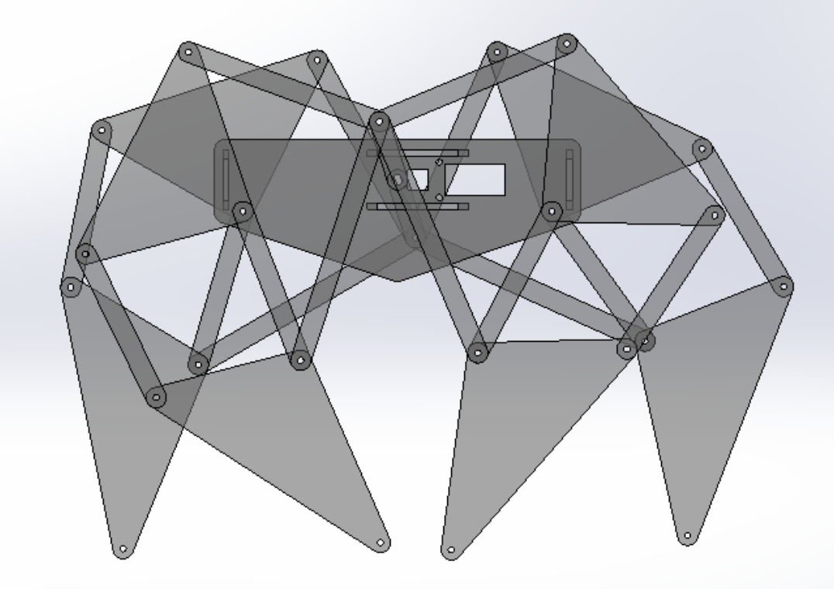
Figure 1: Side view of first prototype’s CAD model
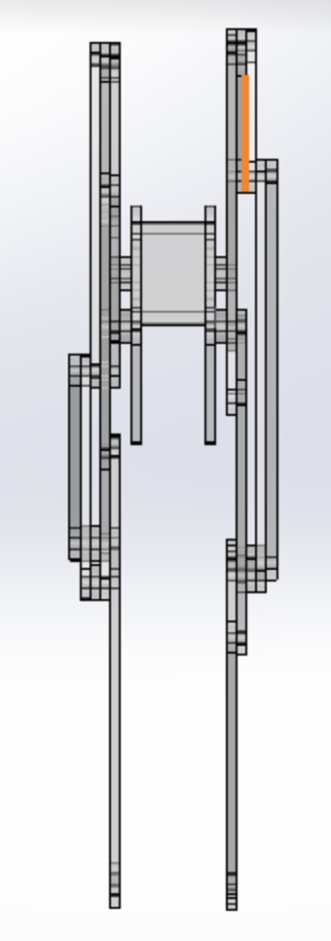
Figure 2: Front view of first prototype’s CAD model
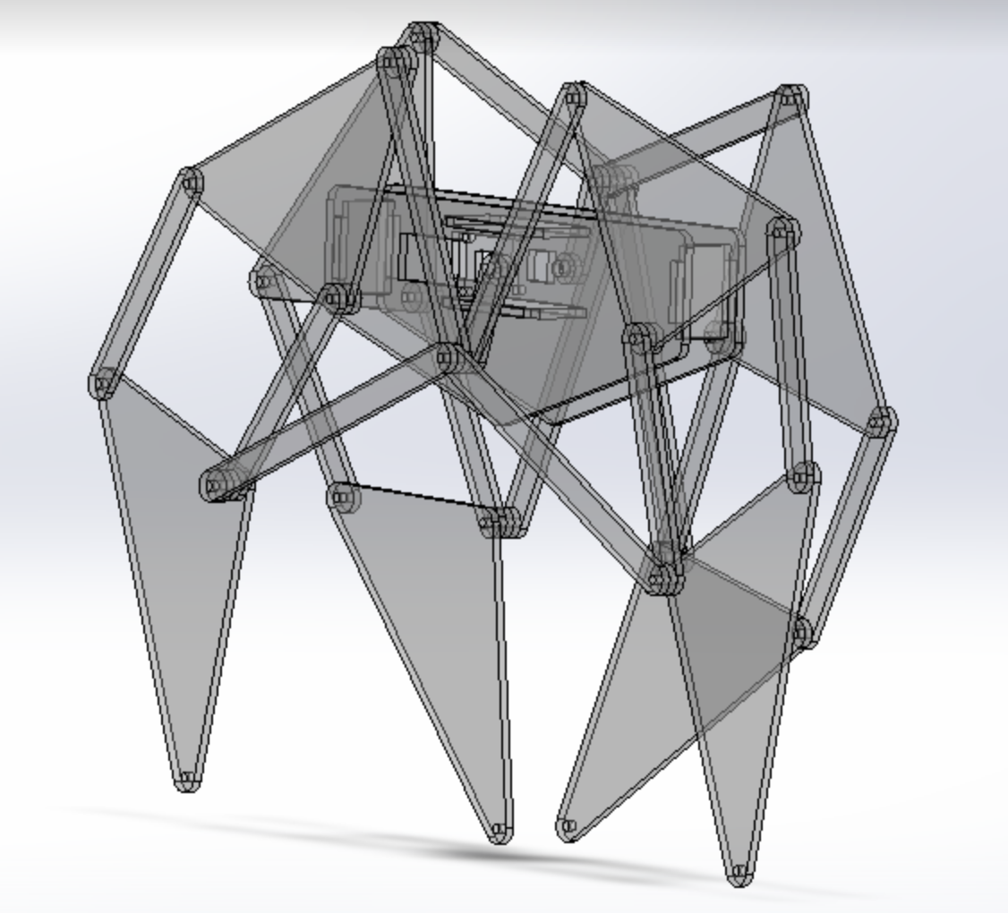
Figure 3: CAD model of first prototype’s full robot assembly
For the first prototype, we used a multiple of the dimensions provided in the assessment requirements file. All dimensions were multiplied by 2 to make the robot bigger, making it too heavy for our single. We expected it to be more stable; however it brought challenges regarding the torque provided by the single motor, which at the time was powered by 2 AA batteries (1.5 Volts).

Improvements / Modifications
For improving this first prototype, we intended to reduce the size of robot to orginal scale. We were also looking for using difference batery for more stability.

Second Prototype

Process
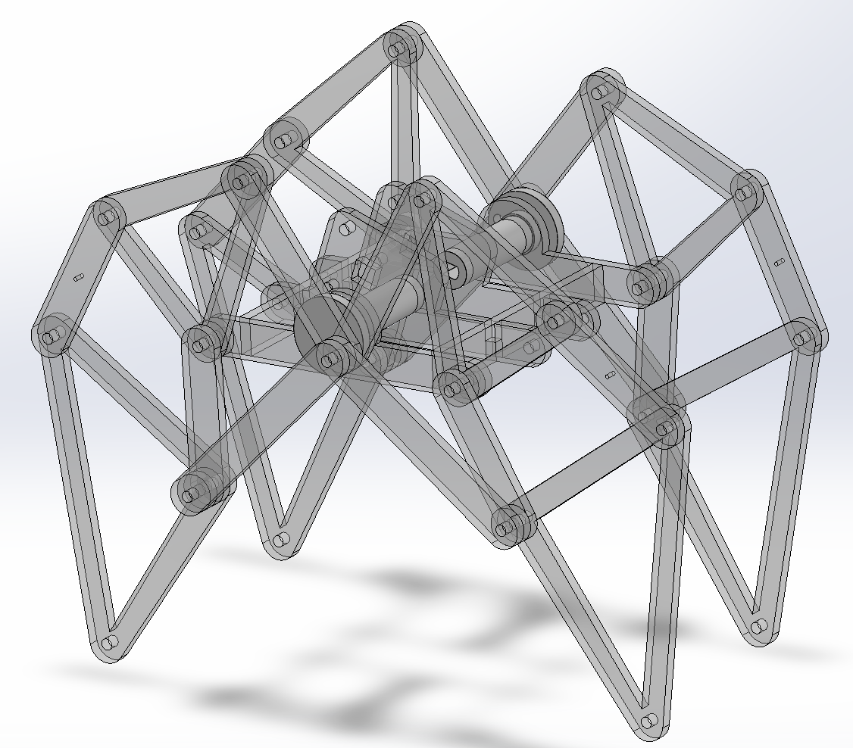
Figure 4: CAD model of second prototype’s full robot assembly
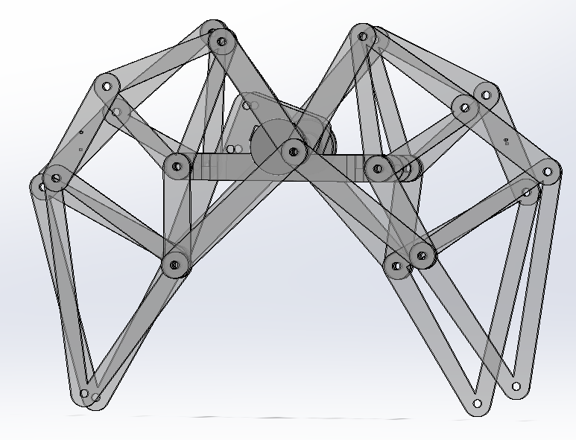
Figure 5: Side view of second prototype’s CAD model
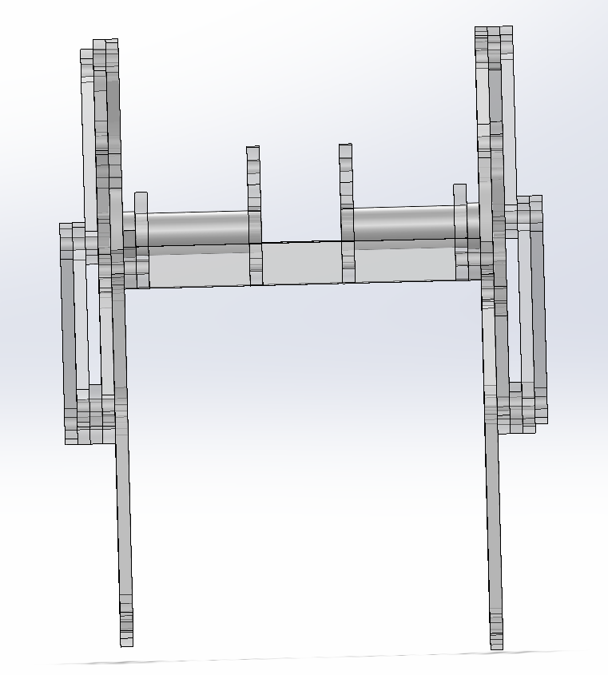
Figure 6: Front view of second prototype’s CAD model
For this prototype, our team already design to the original size, We also redesigned the shaft connections, replacing the previous loose screw joints with a more stable locking system.

Improvements / Modifications
The second prototype still had many weaknesses:
- Used screws to join the joints → some joints jam and others become loose during rotation.
- Powered by two AA (1.5 V) batteries → movement is too slow.
- No place to mount a payload.
- Each leg uses only one thin triangular piece → legs are flimsy and wobble, so the robot cannot walk straight.
- Screws protrude outward → cause interference and snagging.
To improve this prototype, we planned to replace screws with shaft locks so the joints would be more secure and rotate smoothly. We switched to a 9-volt battery, add a 3D-printed part for the payload, and reinforce each leg with two triangular pieces for better stability. In addition, the screws were turned inward for a neater design. With these changes, we hoped the robot would move faster, walk more steadily, and carry small loads effectively.
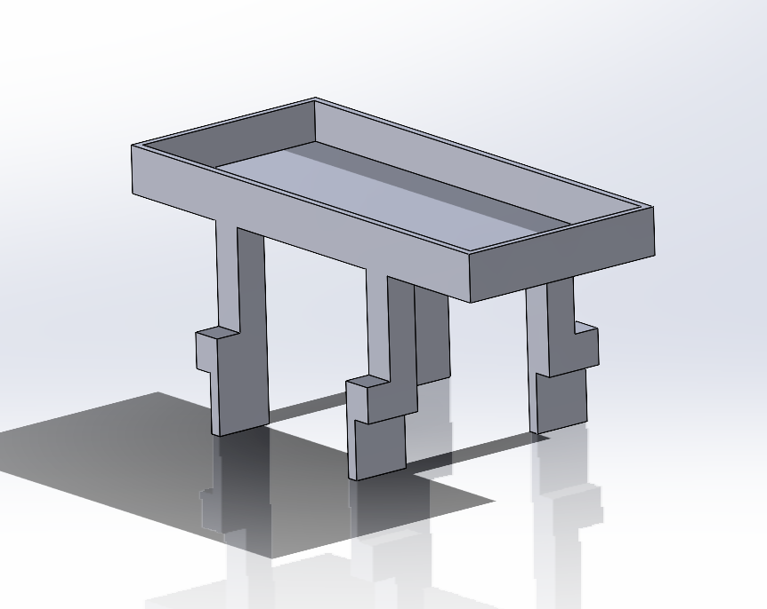
Figure 7: Carrying tray for the payload (milk box)

Final Product
In our final product, our group implemented several technical upgrades to improve both performance and design. We replaced screws with shaft locks to ensure stronger and smoother joint connection and switched to a 9V battery to provide more power to the motor. A custom 3D-printed component was added to support payload placement, while each leg was reinforced with an additional triangular piece to increase stability during locomotion. Finally, we reoriented the screws inward, resulting in a cleaner, more compact, and functional structure.
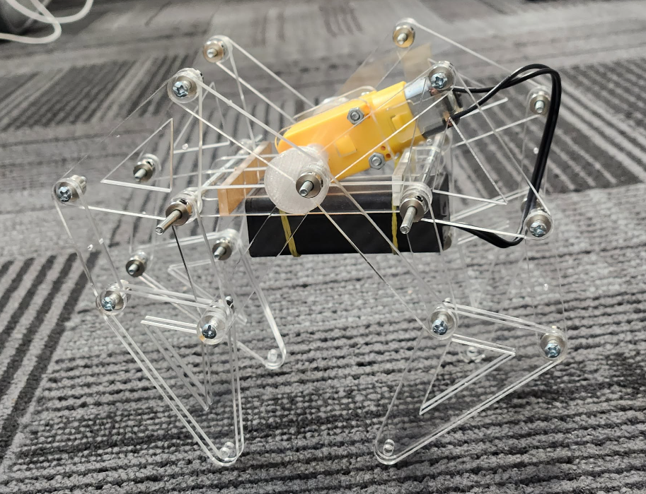
Figure 8: Final Robot side view

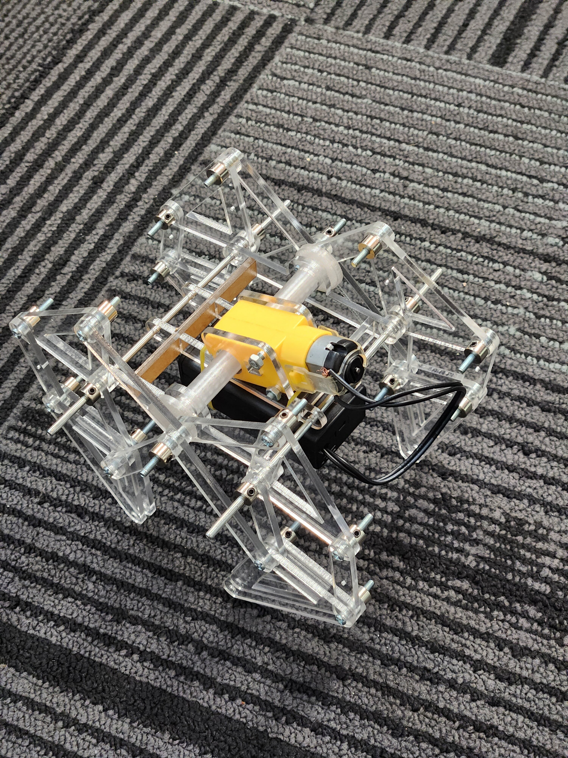
Figure 9: Final Robot fullbody
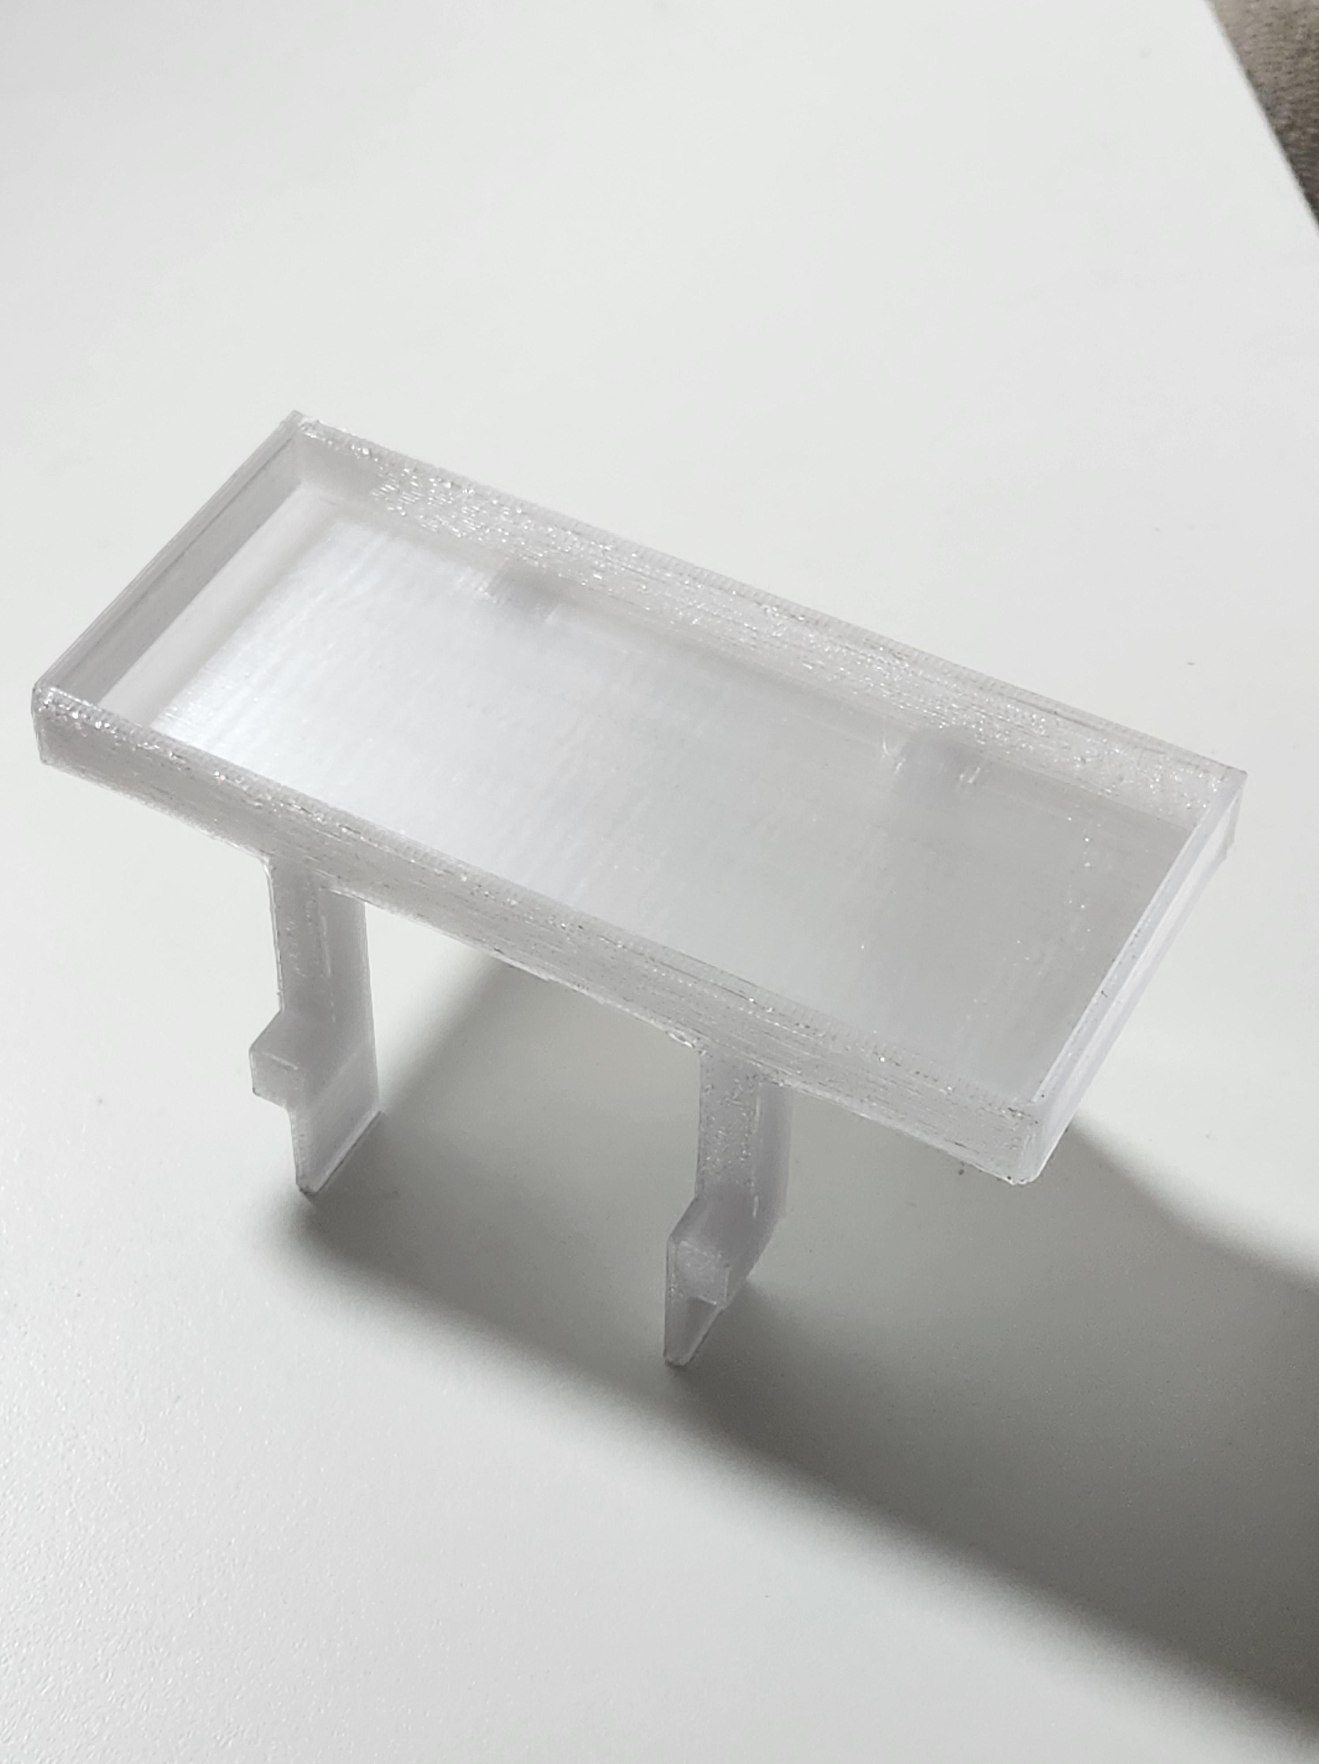
Figure 10: Final 3D-printed holder, top view
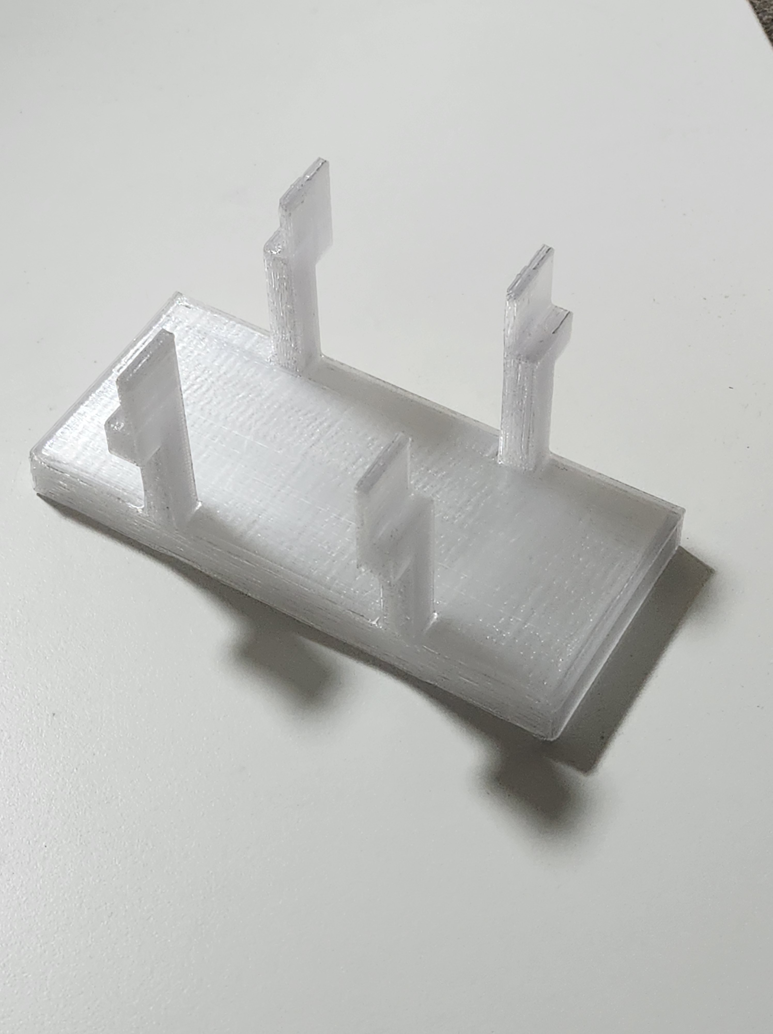
Figure 11: Final 3D-printed holder, bottom view

CAD Model
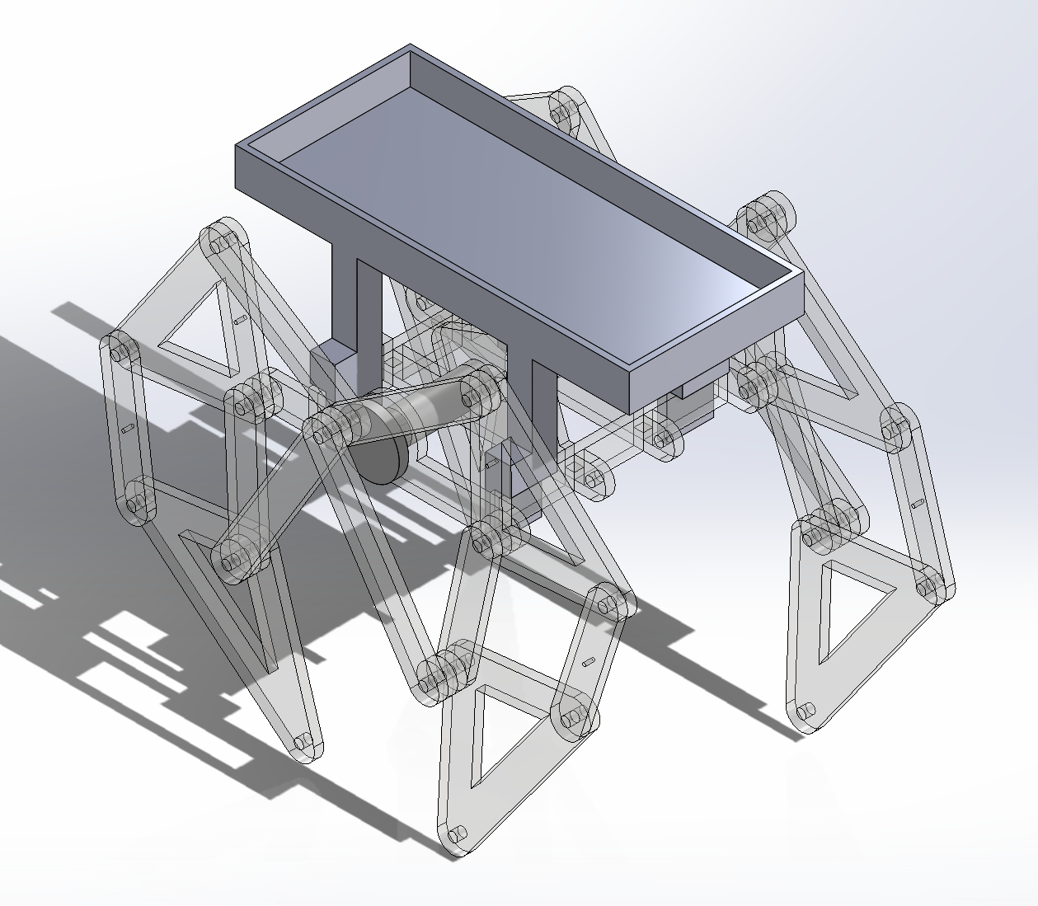
Figure 12: Final prototype full assembly CAD model
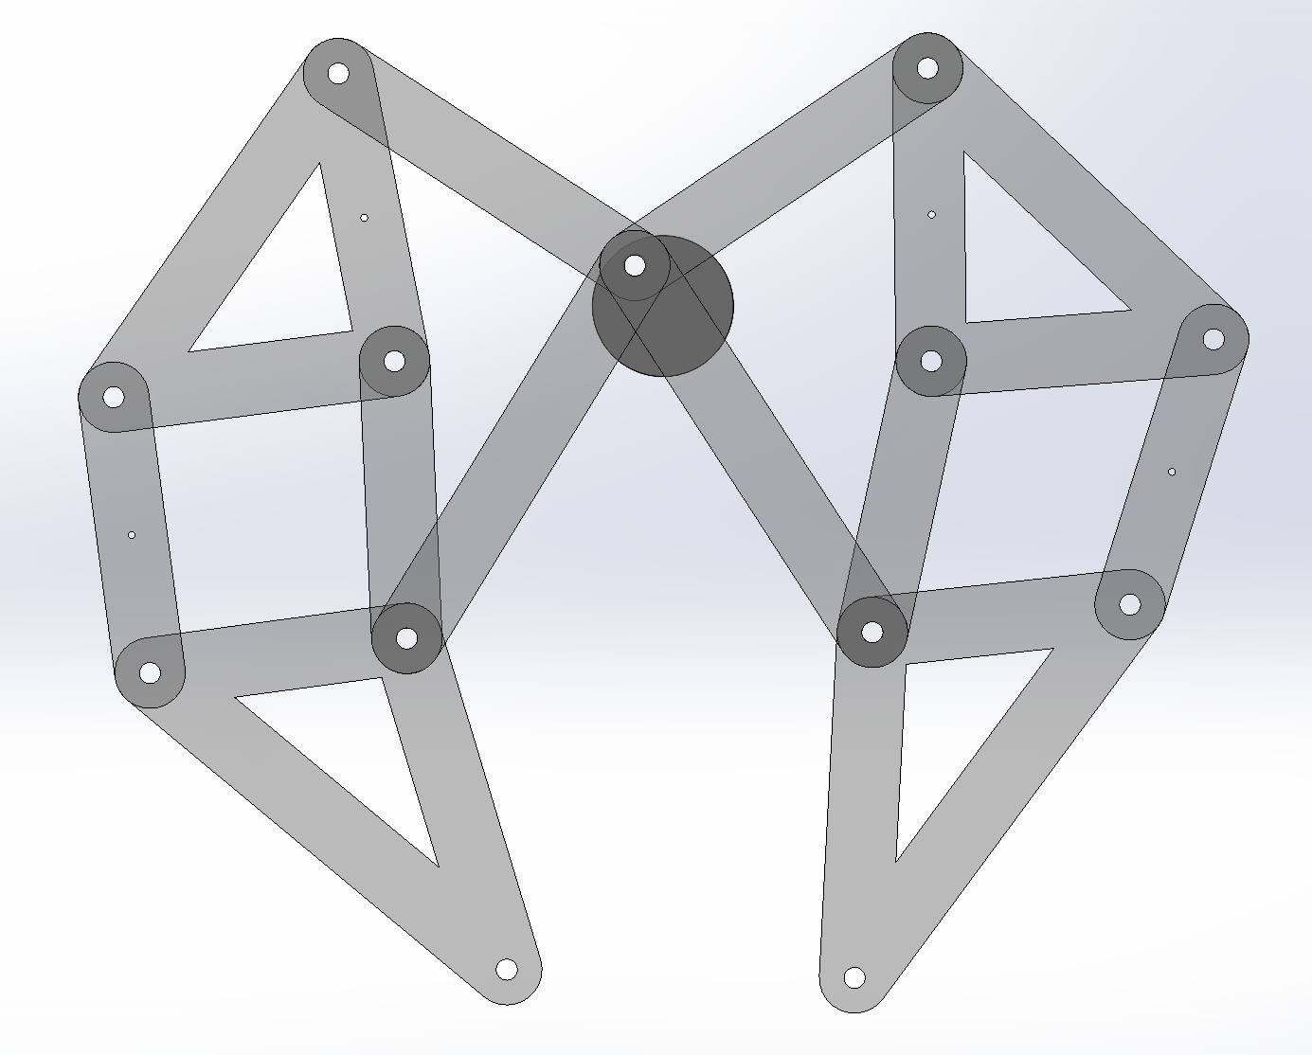
Figure 13: Final prototype CAD leg assembly side view (1 side)
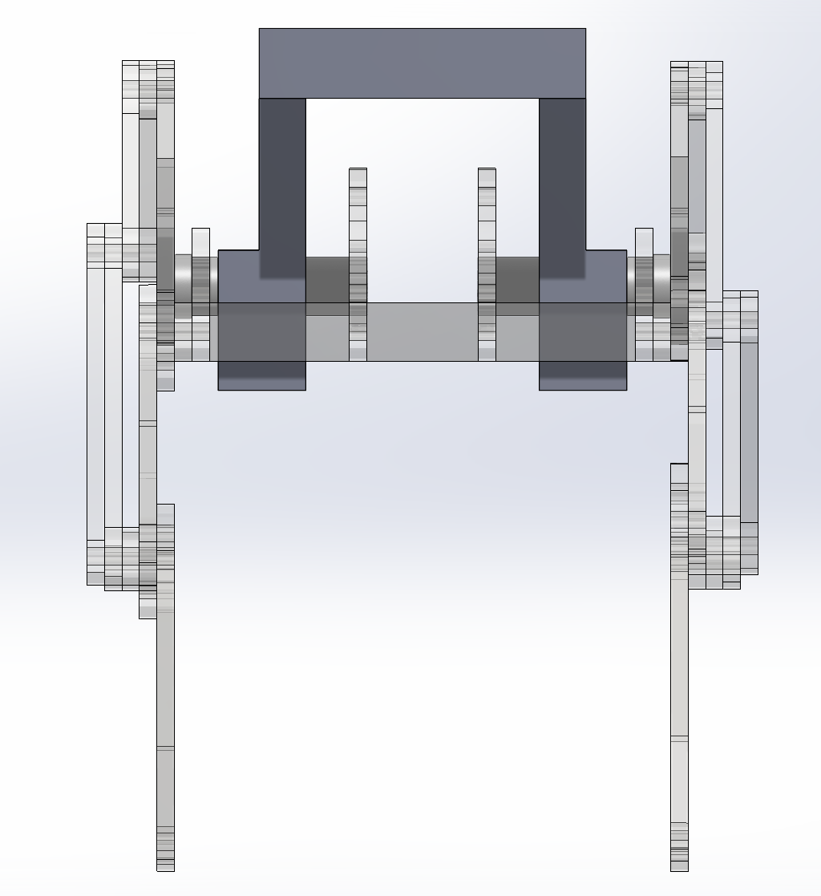
Figure 14: Final prototype CAD model front view

Laser Cutting and 3D printing layout:
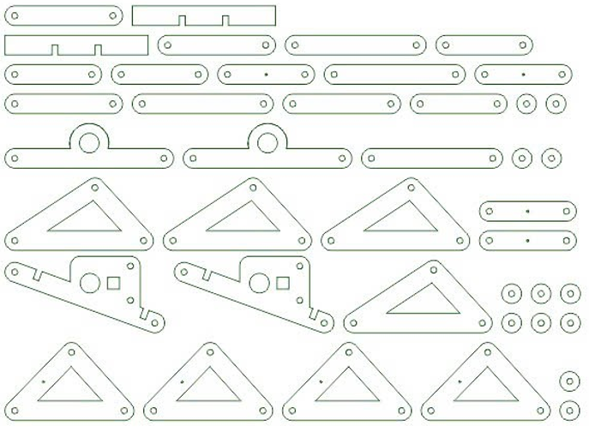
Figure 15: Final prototype laser cutting design
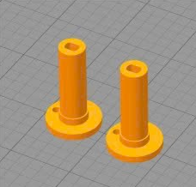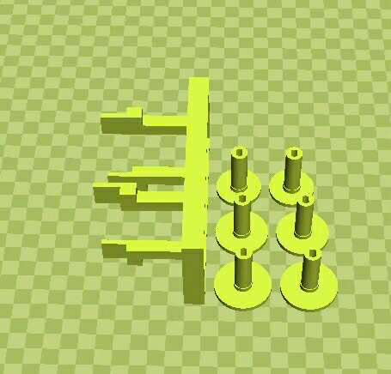
Figure 16: 3D printer preview of shaft

Assembly Process
The assembly was carried out step by step, from the main body down to the legs:
- Body and connectors: The central body frame was first assembled, and the shaft connectors were attached to hold the motor and axle in place.
- Leg modules: Each leg was built separately using 3 triangular plates and two straight linkages, joined together with screws and shaft locks to form a Jansen linkage.
- Leg–body connection: The completed leg modules were then attached to the body through the shaft connectors, making sure each pair of legs was aligned correctly on both sides.
- Motor installation: The DC motor was mounted on top of the frame and connected to the main axle, providing rotational motion to drive the leg mechanism.
- Holder: The milk holder is placed on top of the shaft connectors of the body for easy removal and attachment for testing.
Final adjustments: All screws were tightened and oriented inward to keep the design neat, and the battery pack was secured beneath the body to complete the assembly.

Testing and Evaluation
Testing condition: Our testing was conducted on the classroom floor, which was covered with carpet. The robot was required to walk in a straight line for about 40 – 60 cm (equivalent to four carpet tiles). In addition, it needed to carry a 180 ml milk box placed on top as a payload. Our team was allowed to perform two test runs to evaluate this requirement, and the detailed results are presented below.

Fabrication Method
All structural components were fabricated using laser cutting on 3 mm acrylic plates, ensuring consistent geometry and smooth assembly. The parts were arranged in a single DXF cutting layout with proper spacing, and no interference or damage occurred during fabrication.

Power source
This provided stable performance without unexpected shutdowns and delivered enough power for the robot to walk and complete the required test.

Payload Capacity
The final prototype was able to carry a 180 ml milk box on top while moving. On flat and smooth surfaces (such as a table), the robot walked straight as expected. However, when tested on a carpeted surface, the robot initially turned about 180 degrees before continuing to move forward. Overall, the robot performed well on smooth surfaces but showed instability on rough or uneven surfaces such as carpet.

Appearance and weight
The final prototype weighs approximately 250 g, including the battery and motor. Its transparent body gives it a clean and visually appealing look, making the overall design both functional and aesthetically pleasing.

Conclusion
Through this project, our team successfully designed, built, and tested a walking robot based on the Jansen mechanism. The final prototype, powered by a 9V battery and equipped with a custom holder, was able to carry a 180 ml payload and walk across both flat and carpeted surfaces. While the robot performed reliably on smooth surfaces and met the basic testing requirements, its motion on rough surfaces showed areas for further improvement. Overall, this project gave us valuable hands-on experience in mechanical design, prototyping, and testing, and demonstrated the importance of iteration in engineering development.

Team Contribution
Member | Task | Contribution | Signature
Hai | Leg Design, Report | 25% | Tran Quoc Viet Hai
Bach | Body Design, Report | 25% | Cu Dinh Bach
Linh | Item Holder + Connector, Report | 25% | Cao Phuong Linh
Anh | Assembly + Testing, Report | 25% | Nguyen Minh Anh

References
[1] wolfCat workshop, “Paper Linkages Part 6 - Jansen’s Linkage,” Youtube. Jun. 7AD. [Short]. Available: https://www.youtube.com/shorts/PBuOBGfEzXk
[2] Wikipedia Contributors, “Jansen’s linkage,” Wikipedia, May 28, 2019. https://en.wikipedia.org/wiki/Jansen%27s_linkage
[3] Rohit John Varghese, “Stair-Ascending Strandbeest,” The University of Texas at Austin, https://cloud.wikis.utexas.edu/wiki/spaces/RMD/pages/51054238/10+-+Stair-Ascending+Strandbeest

‌

