- Windows defender Status
- F

- Local group policy
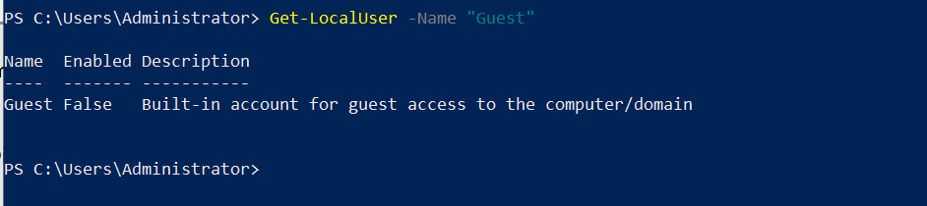
- Check for unused or disable accounts
Commands :
Search-ADAccount -UsersOnly -AccountInactive -TimeSpan 90.00:00:00 | Select Name, SamAccountName, LastLogonDate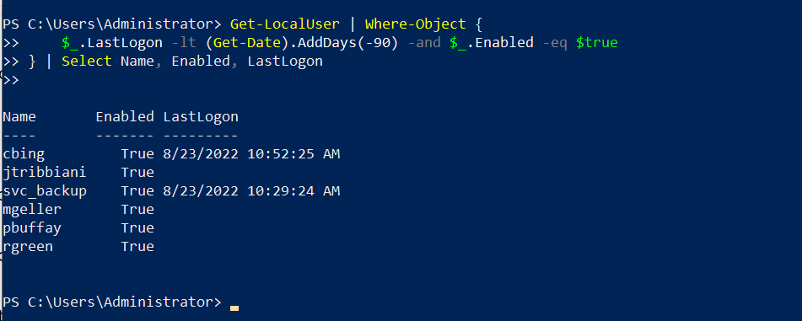

- Rename admin accounts
Commands: Get-LocalUser | Where-Object {$_.SID -like "*-500"} | Select Name, Enabled, PasswordRequired, PasswordExpires

- Netstat /ano
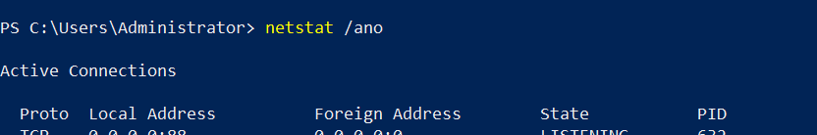

- Windows is up to date
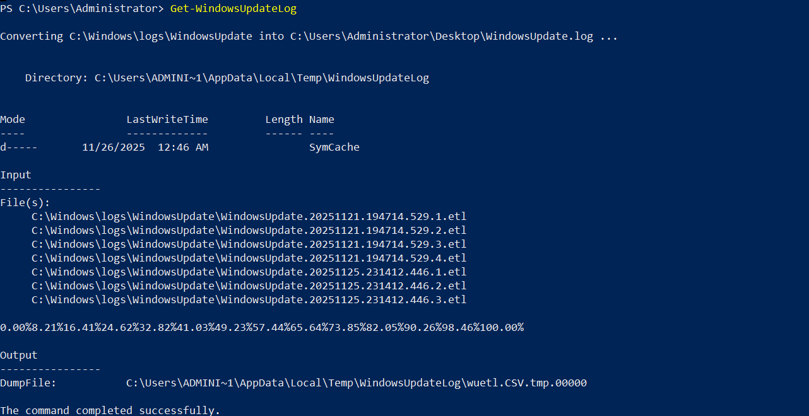

- Who to check password policy press Win+r = gpedit.msc
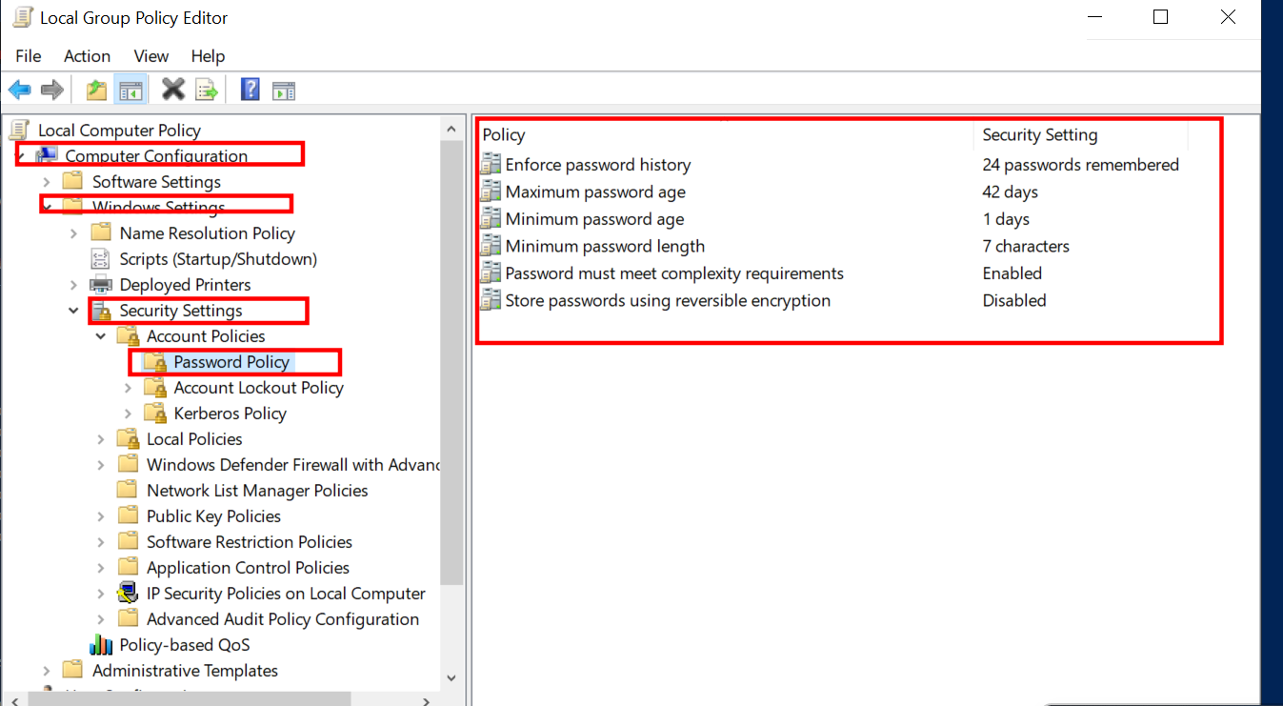

Commands: Get-ADDefaultDomainPasswordPolicy
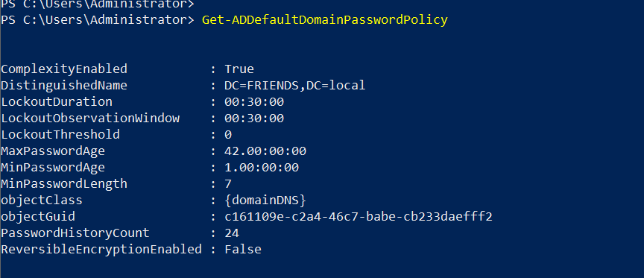

- Account lockout policy
Commands: Get-ADDefaultDomainPasswordPolicy
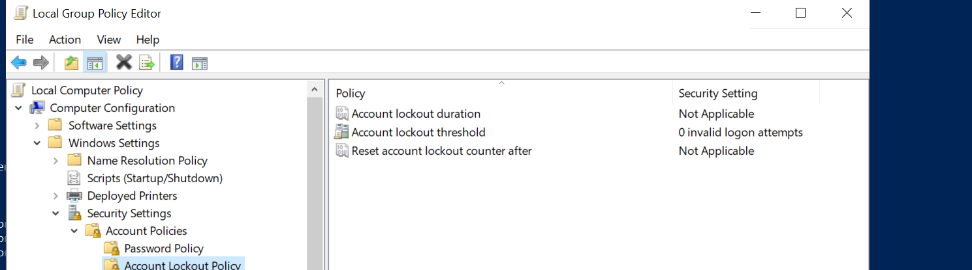

- User lockout policy
Win+ r = secpol.msc
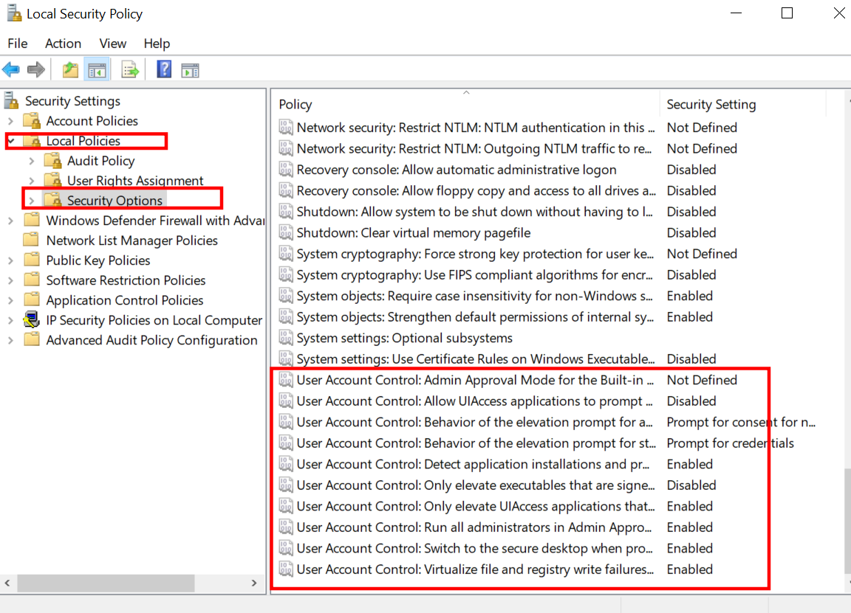

Commands: (Get-ItemProperty "HKLM:\SOFTWARE\Microsoft\Windows\CurrentVersion\Policies\System").EnableLUA
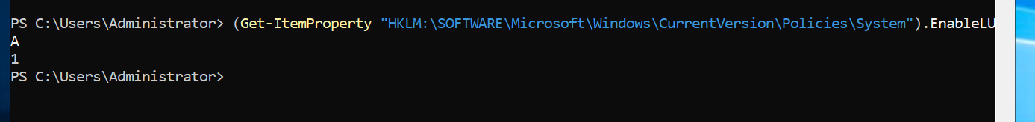

- Interactive logon (locol group policy)
Win+R = secpol.msc
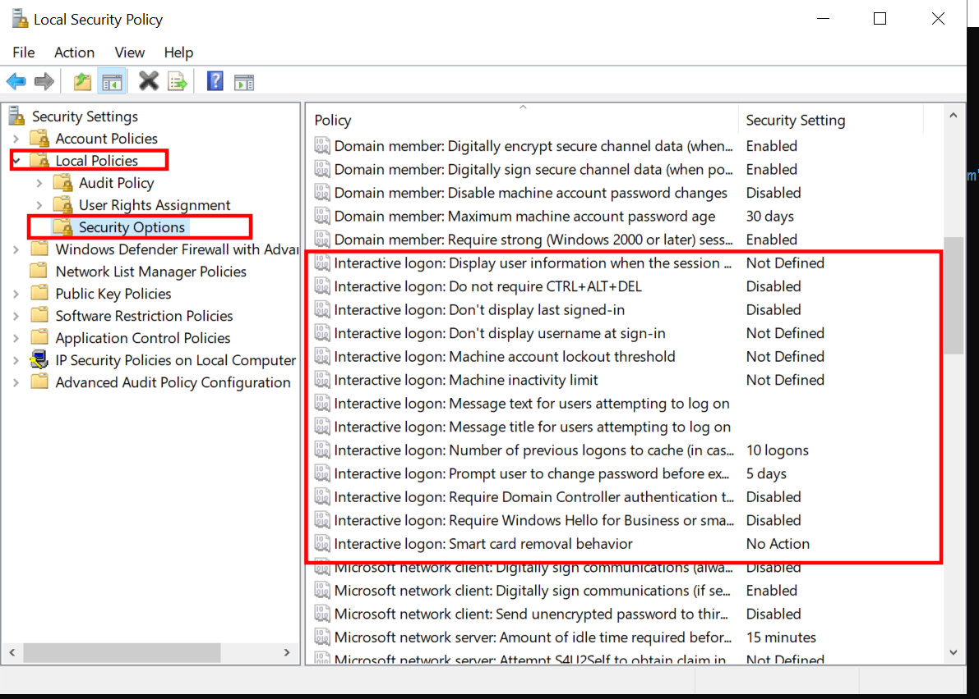

- Network logon (locol group policy)
Win+R = secpol.msc
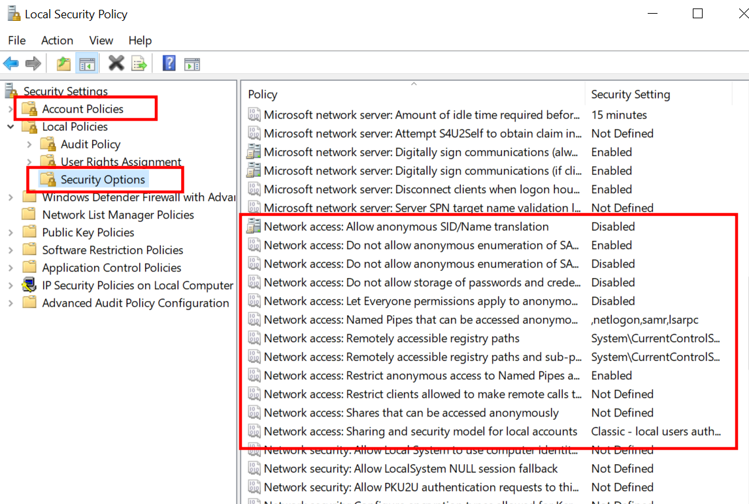

- Network security (local group policy)
Win+R = secpol.msc
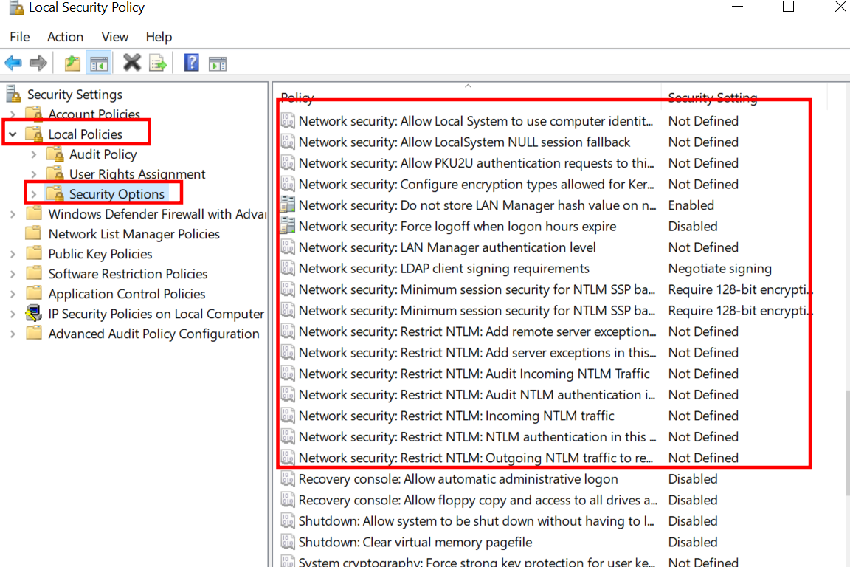

- Windows update (locol group policy)
Win+R = gpedit.msc

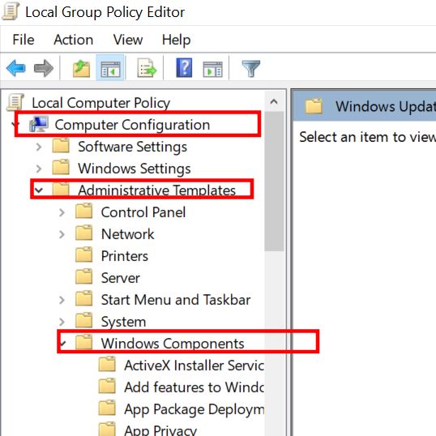

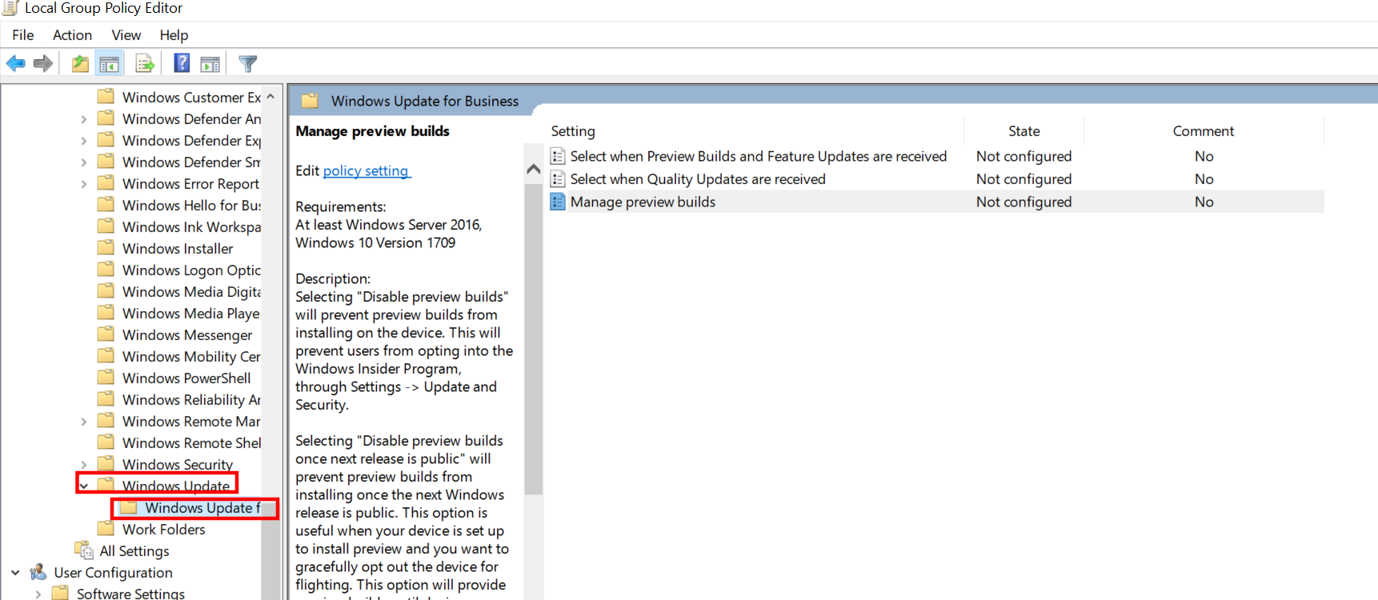

- Bitlocker enables in all drives


- Disable Plain text password
✔ 0 = Disabled (Secure) ❌ 1 = Enabled (Insecure, dangerous!)
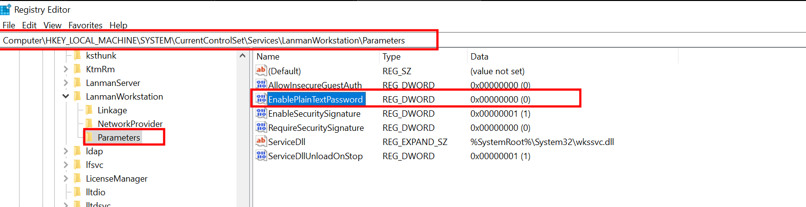
- Disable IPv6
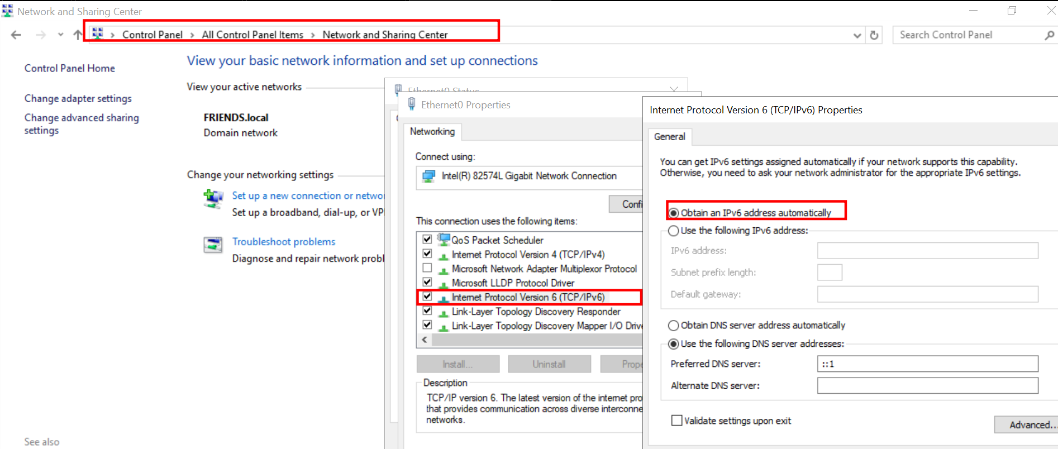

- RDP

- Netbios is disable over TCp
Commands: Get-WmiObject -Class Win32_NetworkAdapterConfiguration | Select-Object Description, TcpipNetbiosOptions
Step 2: GUI
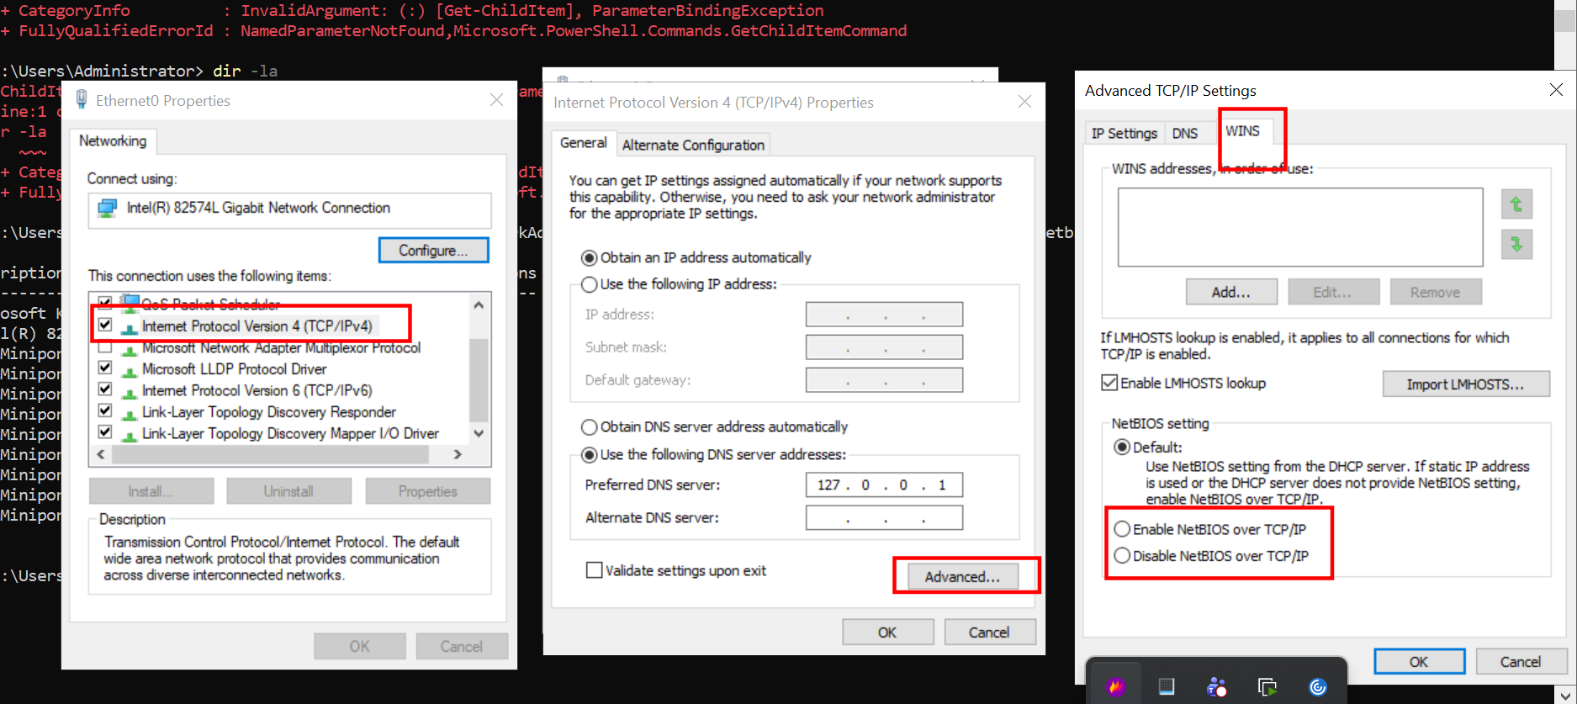

- Network time config
Commands : w32tm /query /status
Step 2: GUI
Win+R = services.msc
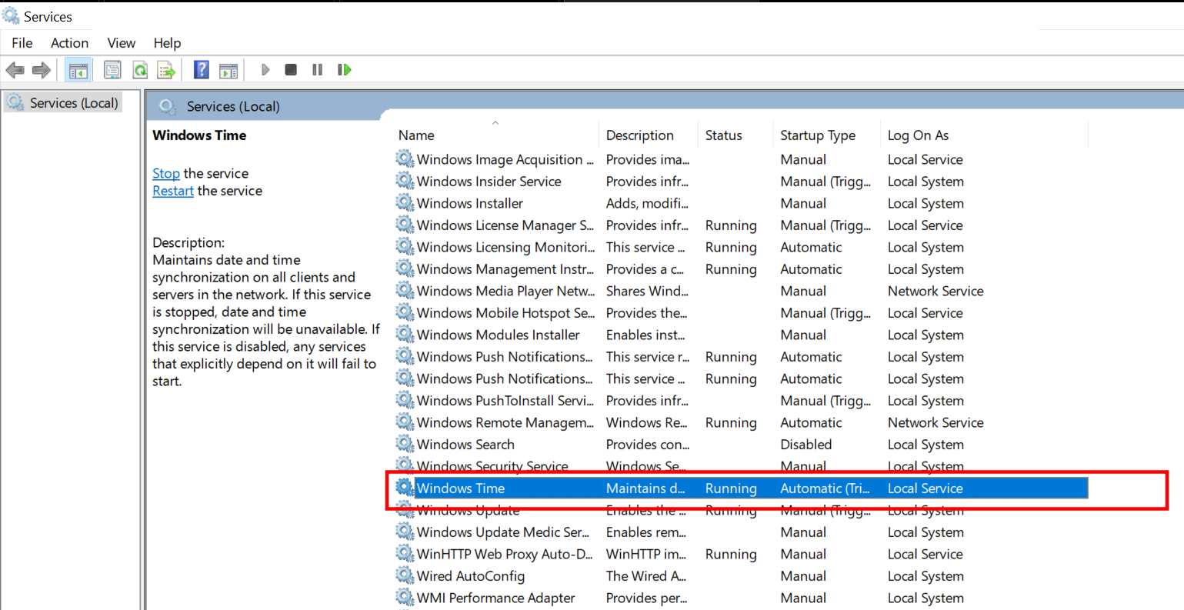

- SMBv1 enables ?
Open Control Panel
Click Programs and Features
Click Turn Windows features on or off

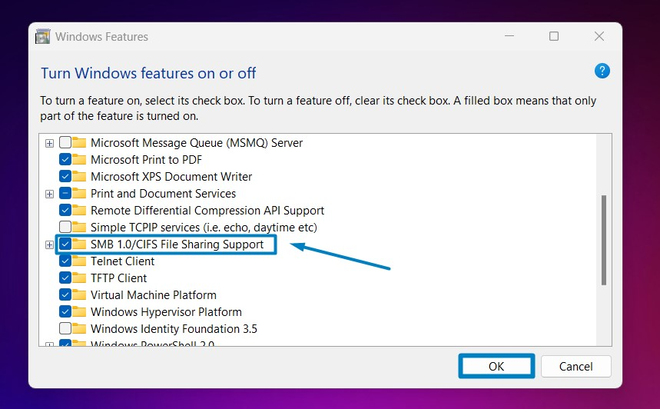

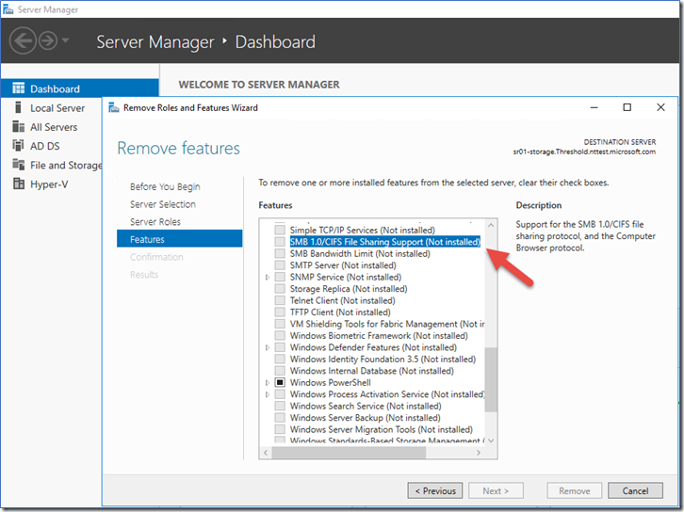

- Vulnerable& outdate component

- Startup app review and remove unnessary applications

- Team viewer & anydesk

- Usb pendrive

- Netstat /ano to check ports

- Ideal sleep time
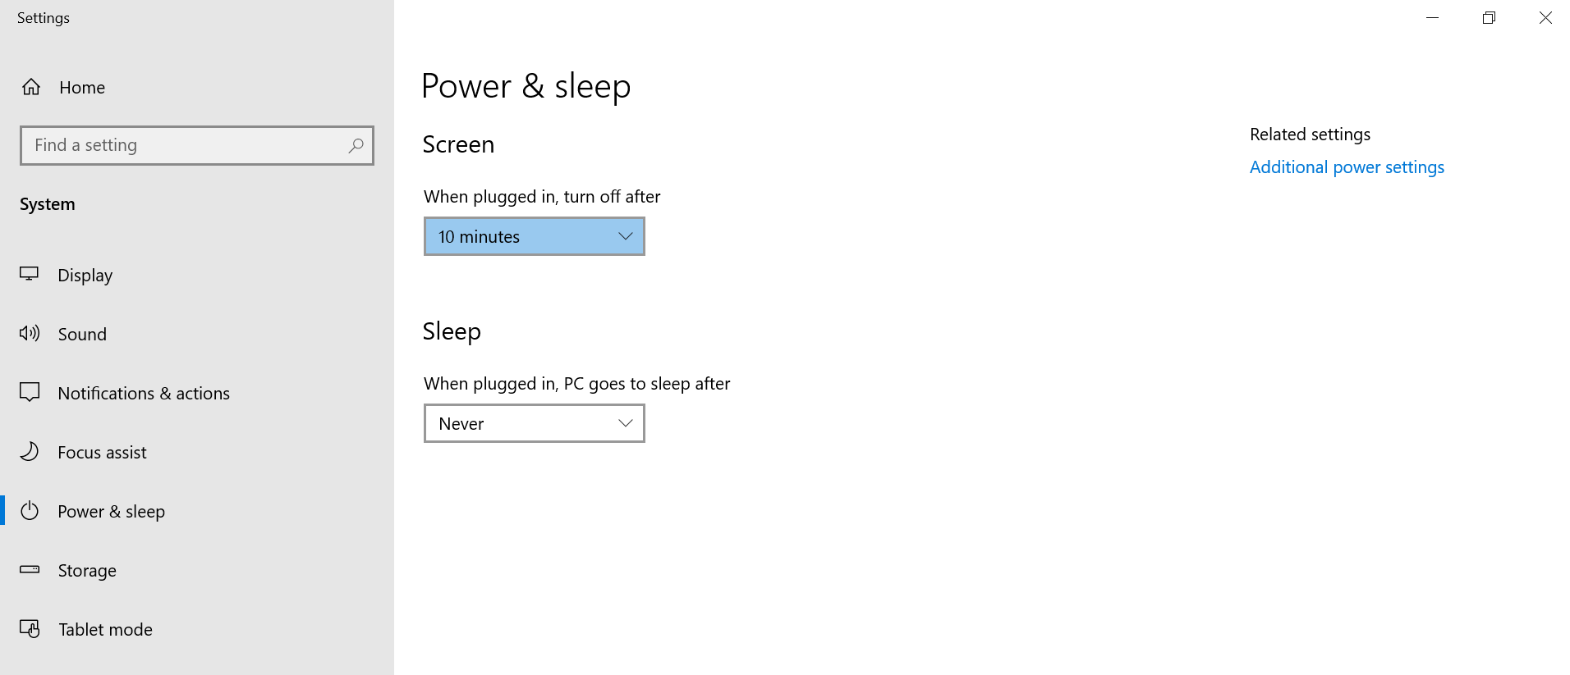

- Check winrm configuration
Commands: Get-Service WinRM
Commands: winrm enumerate winrm/config/listener
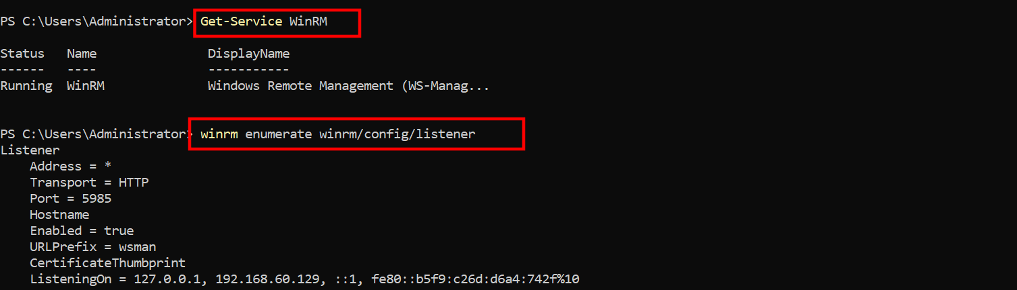
commands: winrm get winrm/config
PS C:\Users\Administrator> winrm get winrm/config
Config
MaxEnvelopeSizekb = 500
MaxTimeoutms = 60000
MaxBatchItems = 32000
MaxProviderRequests = 4294967295
Client
NetworkDelayms = 5000
URLPrefix = wsman
AllowUnencrypted = false
Auth
Basic = true
Digest = true
Kerberos = true
Negotiate = true
Certificate = true
CredSSP = false
DefaultPorts
HTTP = 5985
HTTPS = 5986
TrustedHosts
Service
RootSDDL = O:NSG:BAD:P(A;;GA;;;BA)(A;;GR;;;IU)S:P(AU;FA;GA;;;WD)(AU;SA;GXGW;;;WD)
MaxConcurrentOperations = 4294967295
MaxConcurrentOperationsPerUser = 1500
EnumerationTimeoutms = 240000
MaxConnections = 300
MaxPacketRetrievalTimeSeconds = 120
AllowUnencrypted = false
Auth
Basic = false
Kerberos = true
Negotiate = true
Certificate = false
CredSSP = false
CbtHardeningLevel = Relaxed
DefaultPorts
HTTP = 5985
HTTPS = 5986
IPv4Filter = *
IPv6Filter = *
EnableCompatibilityHttpListener = false
EnableCompatibilityHttpsListener = false
CertificateThumbprint
AllowRemoteAccess = true
Winrs
AllowRemoteShellAccess = true
IdleTimeout = 7200000
MaxConcurrentUsers = 2147483647
MaxShellRunTime = 2147483647
MaxProcessesPerShell = 2147483647
MaxMemoryPerShellMB = 2147483647
MaxShellsPerUser = 2147483647

- Validate schudle task for suspicious task
Win+R = taskschd.msc
Tasks running from unusual locations:
- %APPDATA%\
- %TEMP%\
- %ProgramData%\
- C:\Users\<user>\Downloads
- C:\Windows\System32\Tasks\<weird name>
Step 2: Commands: Get-ScheduledTask | Select TaskName, TaskPath, State
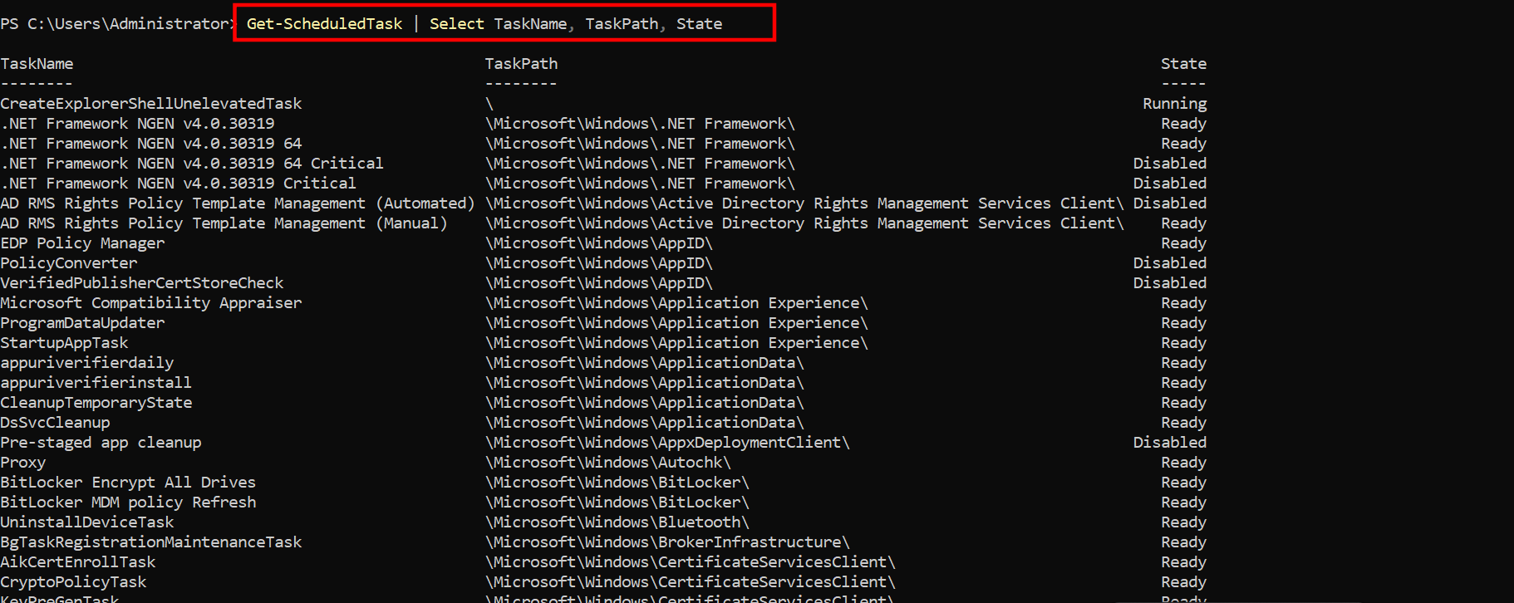

Step 3
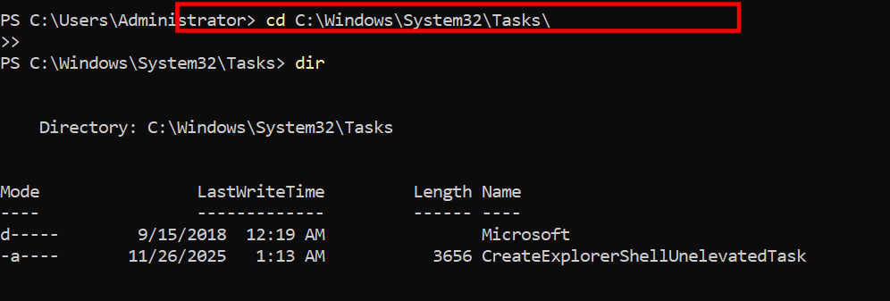

- Autoplay/auto run

Steps:
- Open Control Panel
- Click AutoPlay
Look for settings under:
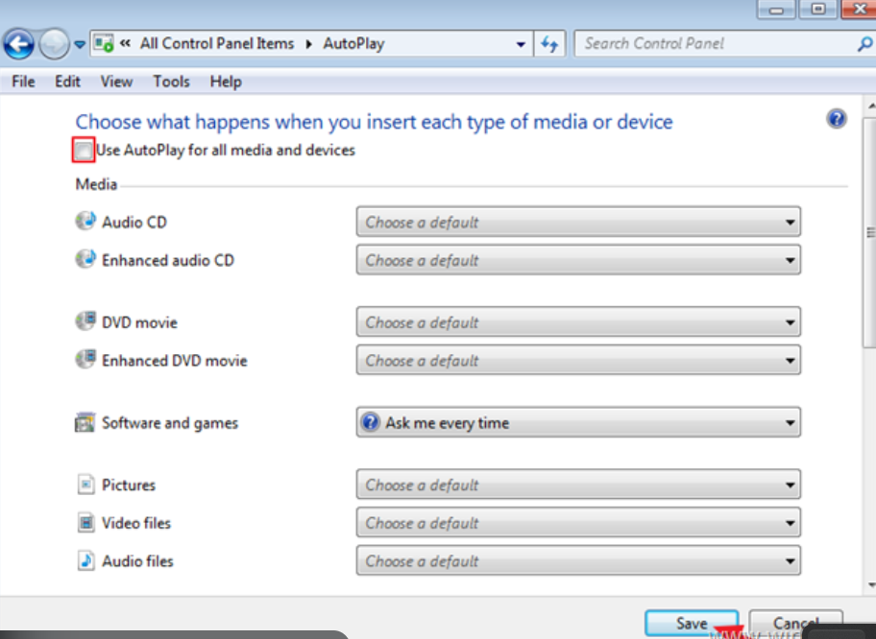
37. Check clipboard setting

