**GAME OF PYMOLI**

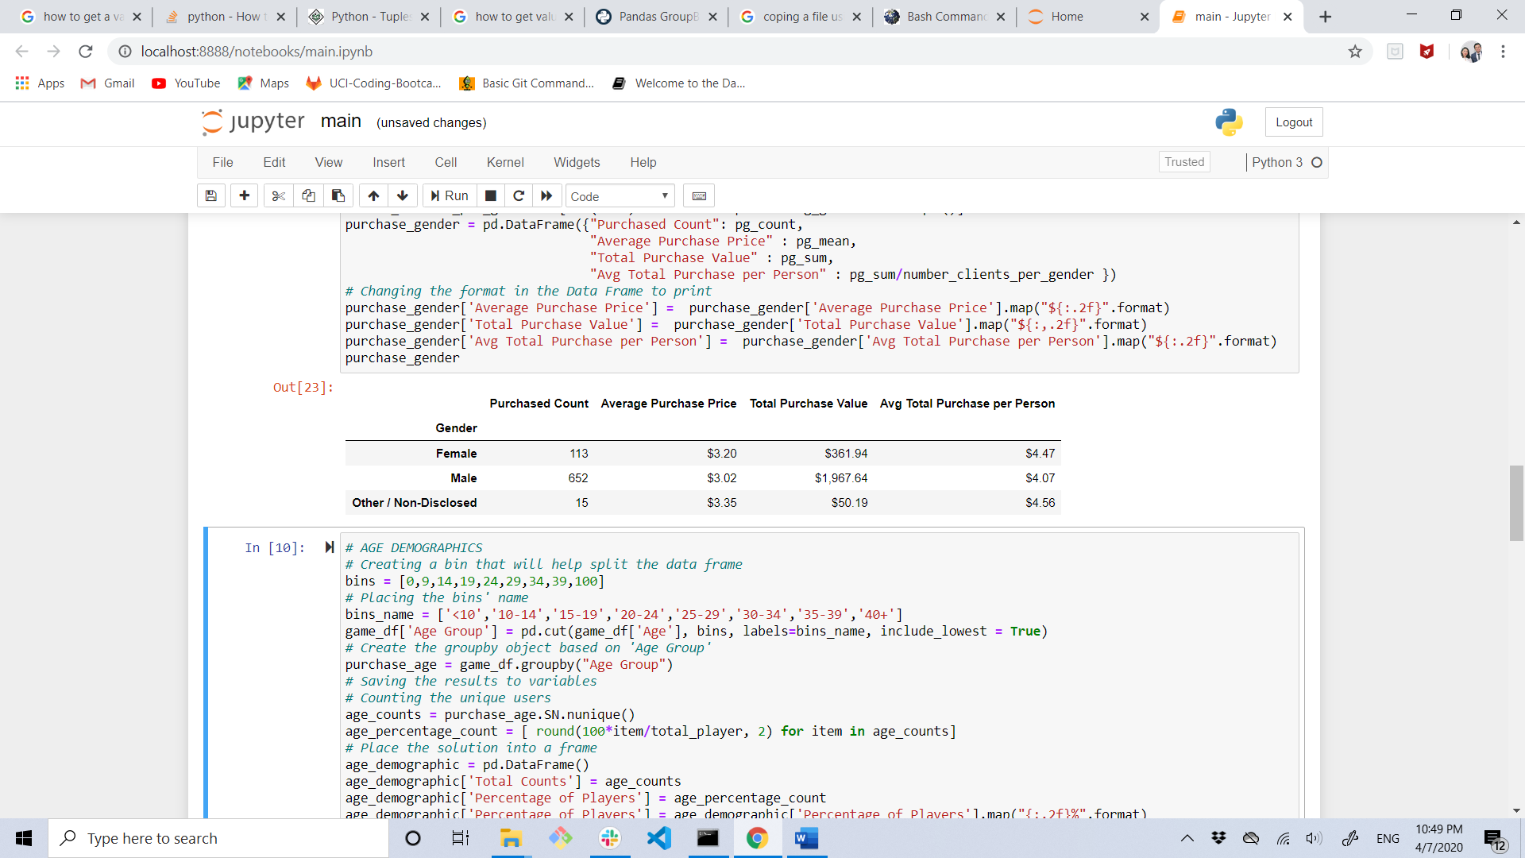

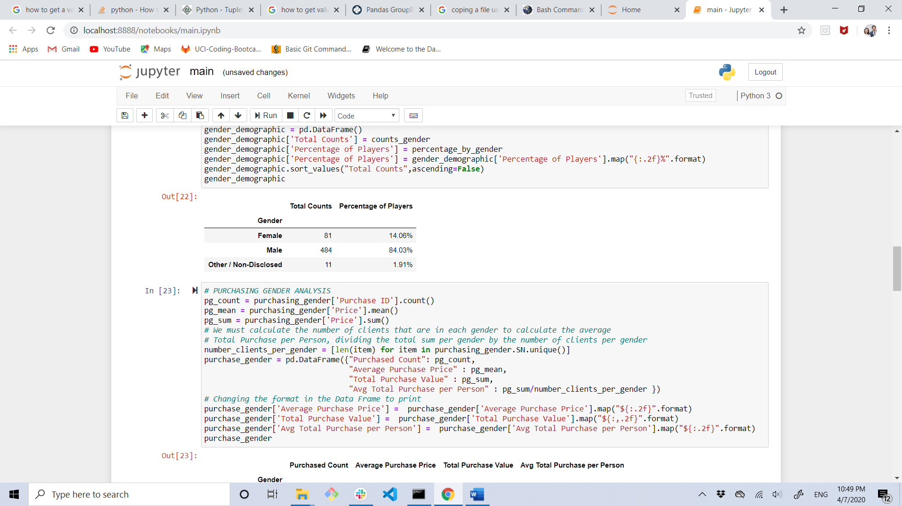

* Based in the tables above presented, the developers may search a way to turn this game more attractive to the female gender, so in the future they would start spending more money into purchasing for the optional items.
* The following two tables let the game’s developers understand that for a while this game will be giving money because, the main purchasing group is people who is able to pay for this optional item. It would be a good option to analyze an increase in the prices.

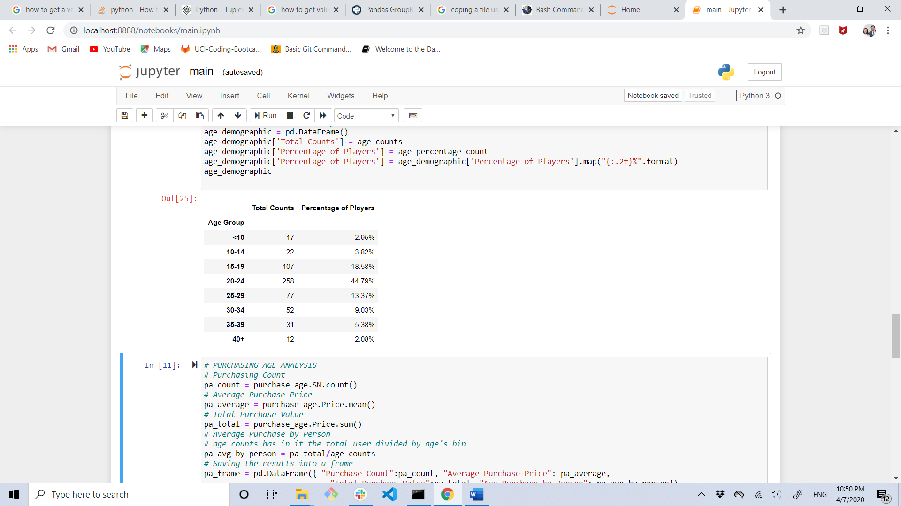

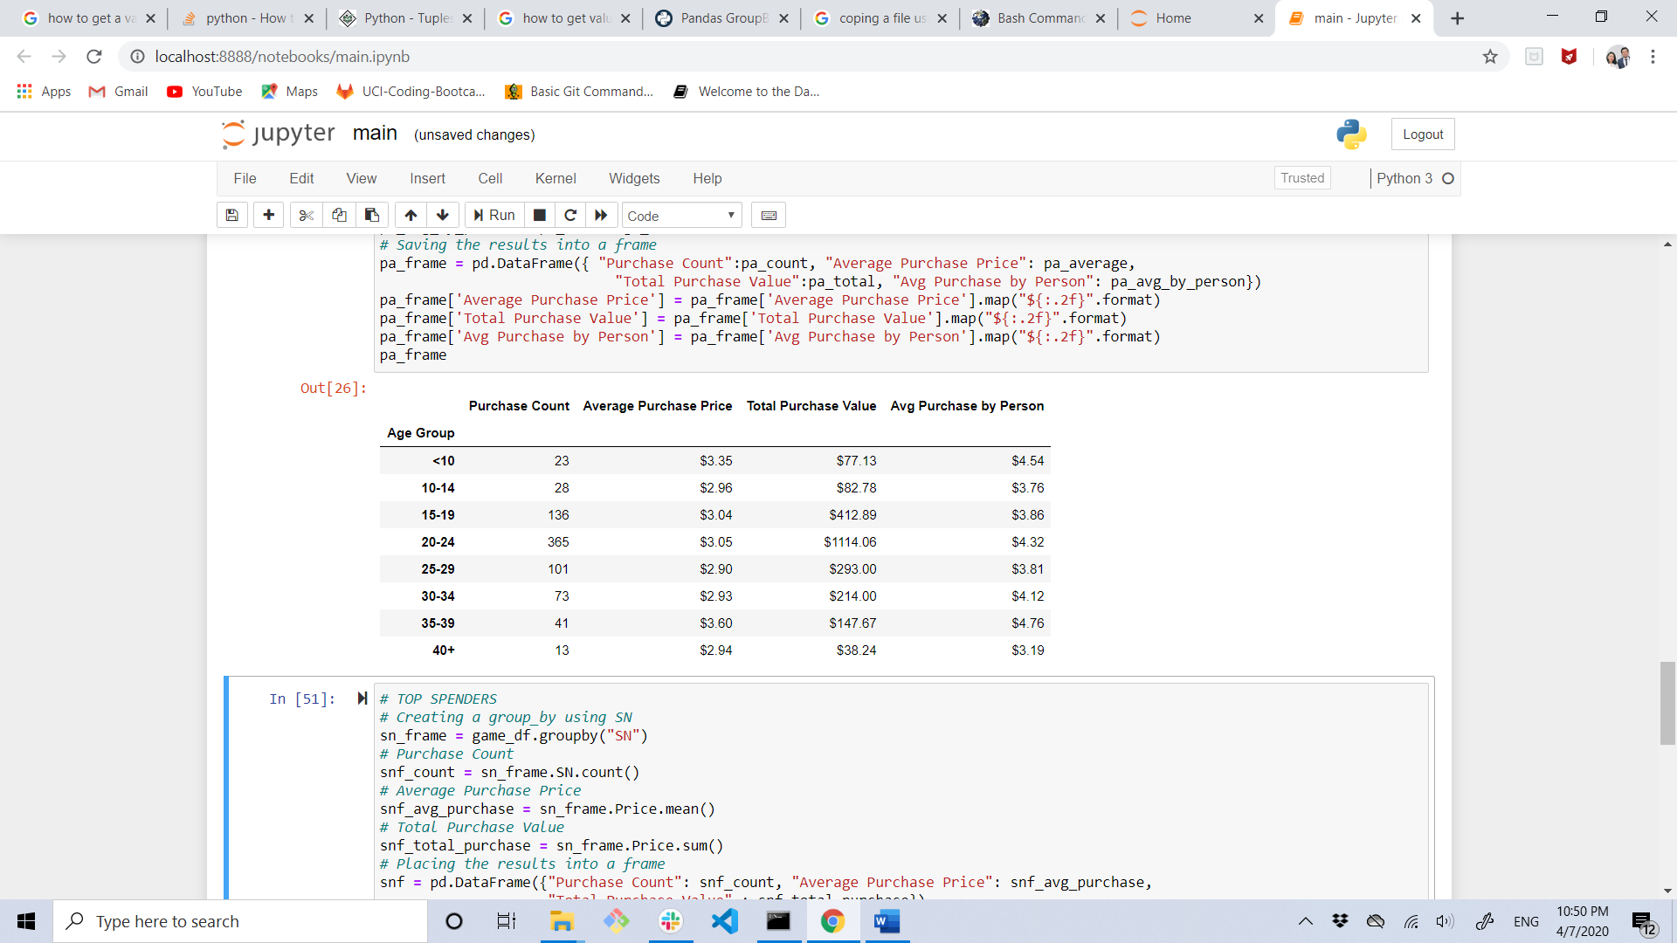

* The value or the most popular and the most profitable items are around the $4.50 dollars, compared to the Total Purchased Value, it doesn’t represent that much of the income. Then it would be a good idea to make more attractive to buy those items with lower price.

