COMP90015: Distributed Systems

Assignment 2 Report
Student ID: 1114028
Jiawei Luo

- Project description
For this project I have built a synchronous whiteboard system based on RMI. In this system, all users can choose to create a whiteboard as a manager or join a whiteboard as a peer. The boards in the same room can synchronise the drawings on the board and chat. manager can do more, such as kick a peer, save the current board file, open the board file, etc.
RMI here enables each of the distributed whiteboards to communicate with each other, where the manager's JVM is used as the server and the peers as the client. All of the whiteboard GUIs (included) can remotely call the Remote method of the JVM located in the manager, and the server can provide feedback and display it on the GUI by making calls to the Remote method of all whiteboard GUIs. In particular, error actions of both peers and managers will be fed back to the user on the GUI as a pop-up (JOptionPanel).
- Project architecture
The overall design structure is shown in Figure 1. The main synchronization functions of this system are implemented in WhiteBoard, it extends the UnicastRemoteObject and a related remote interface IWhiteBoard is implemented by WhiteBoard. Its main functions include, synchronizing the canvas, synchronizing the user list, synchronizing the chat window (only showing the chat content after peers have joined, not the chat history), registering the manager, registering peers, and synchronizing the chat that is being editing, and managing the entry and exit of users.
The remote interface to the interact function of the whiteboard is IClient, which is implemented by ManagerGUI and PeerGUI. The main function of this interface is to be called on the server side after an action has been performed by the user or the system, feeding the actions and information back to the GUI. Its functions include updating the shape on the drawing board, updating the chat box, updating the list of users, updating the users who are editing, and giving feedback on user exits and so on.
A CanvasShape Class is used to store, draw and communicate shapes. It enables shapes to be stored as files and communicate between peers by implementing Serializable. The RMIServer is used to register the remote object and start the server, which is called when the manager wants to create a whiteboard, and then binds the address and port that the manager wants to use.
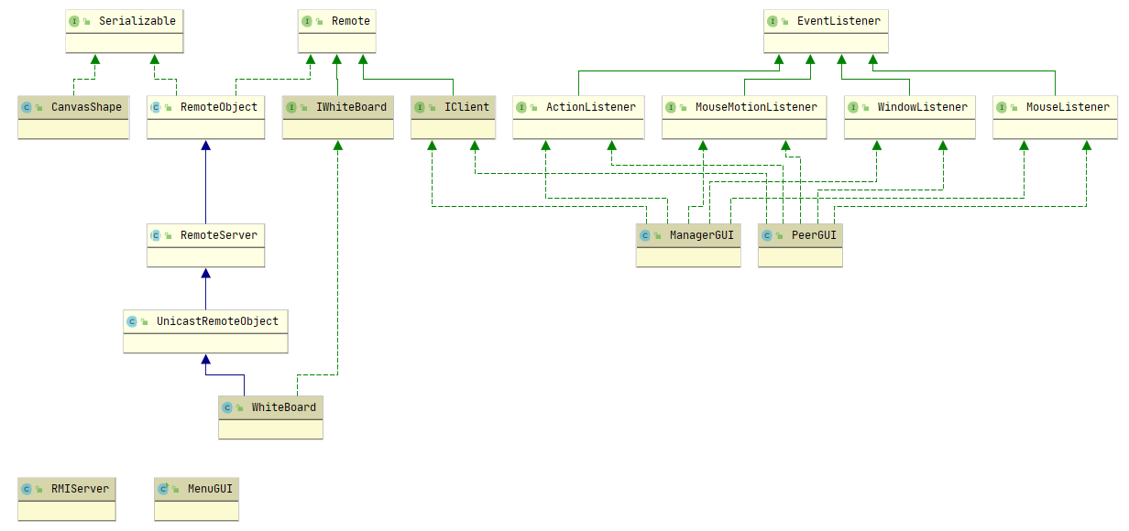
Figure 1. architecture diagrams

MenuGUI is the login screen for this system and it gives the user the option to create a whiteboard or join one. Its GUI show in Figure 2
MenuGUI will then register the IWhiteBoard as the remote object and bind it to the RMI server via the RMIServer with the user's port number, IP address and whiteboard name. Then look up this address to request service from the server and create the ManagerGUI.
When joining a whiteboard, the user is required to provide the IP address, port number, whiteboard name and username of the target whiteboard. The remote object is then requested directly from the address and a PeerGUI is created. Peer GUI and Manager GUI is show in Figure 3 and Figure 4.

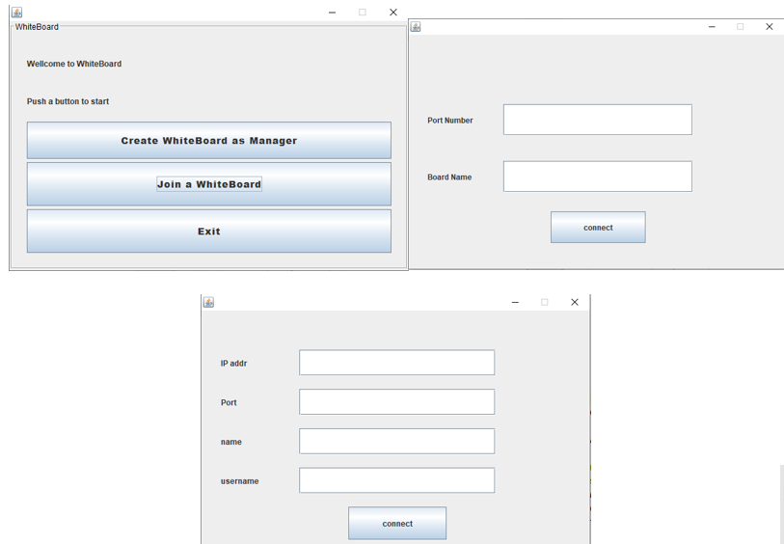
Figure 2. MenuGUI, create a whiteboard with port number and boardname, or join a whiteboard with Ip address, port, boardname and username
- implementation details
3.1. Manager GUI and Peer GUI
Both the Manager GUI and the Peer GUI implement the ability to draw and synchronize the whiteboard to other peers. the basic principle is that it extends MouseListener, MouseMotionListener to capture mouse movements in the drawing board. When the mouse is pressed in the panel, the mousePressed listener records the coordinates of the mouse when it is pressed. When the mouse is released, mouseReleased listener records another coordinate of the mouse. An instance of the CanvasShape is created based on the selected shape, colour, stroke, coordinates etc. and then the instance is synchronised to all users via the IWhiteBoard's synchronisation method. both the Manager GUI and Peer GUI have a drawCanvasShape method which takes the input CanvasShape instance and draw it on the board.
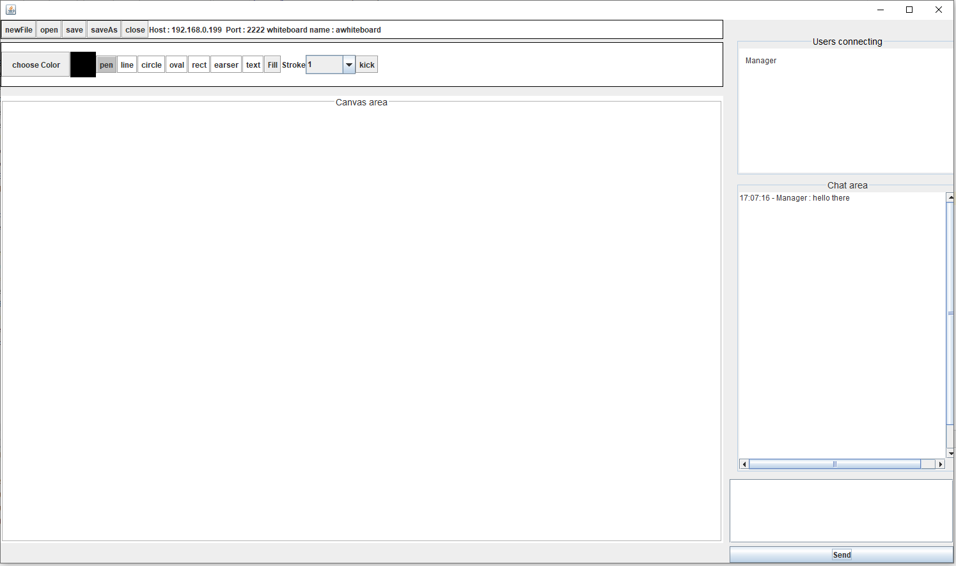
Figure 3. Manager GUI
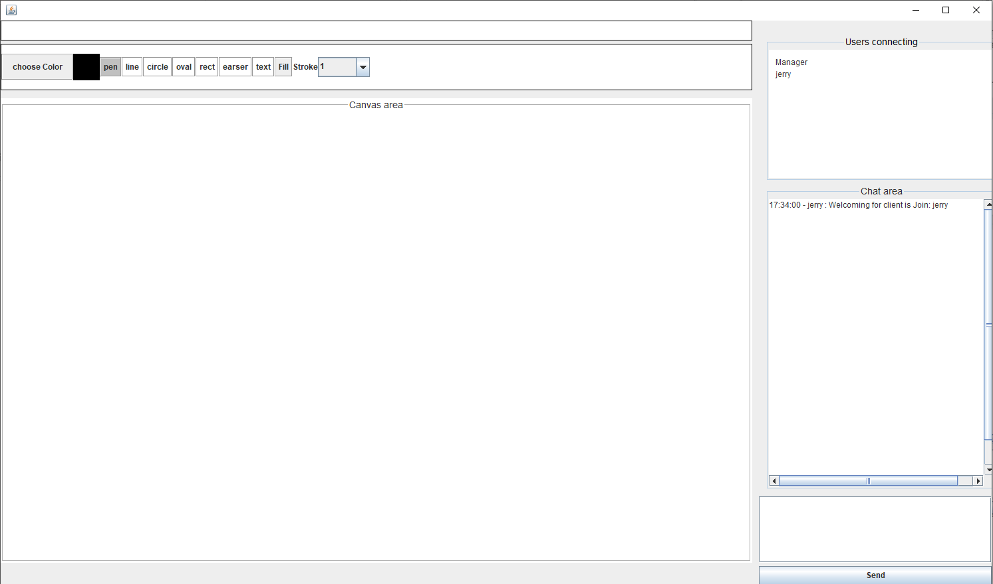
Figure 4. Peer GUI
For pens and erasers, instead of recording two coordinates, it records an ArrayList of Points. when the mouse is moved, it records all the points passed and draws a line between two adjacent points. Erasers always use a white color to cover the canvas.
This whiteboard can be selected from 16777216 colours as it uses JColorChooser for colour selection. It also supports pen, line, circle, oval, rectangle, eraser, and drawing text anywhere on the canvas. He can also select several stroke sizes and can choose whether to fill circle, oval, rectangle or not.
For all GUIs, a chat box and a list of users are provided on the right. Users can send messages to chat, but to protect privacy, users will only see the chat logs since the user came in. Previous chats are not visible. However, the user list is updated every time a user enters or exits.
The manager GUI has more permissions than the peer GUI. manager can open and save, save as file, which is done through JFileChooser. The manager can then also create a new canvas and can kick any peer off the whiteboard.
For each update to the canvas, chat window, user, list, redrawing the canvas and updating the user who is Editing, a new thread is created to complete the action and then the thread is ended when the action is complete.

3.1. Remote services
There are two remote interfaces, IClient and IWhiteBoard. The architecture and its interaction is show in Figure 5. IClient is implemented by ManagerGUI and PeerGUI, it allows the whiteboard server to editing the canvas, the message box, editing user and user list, it can also control the close of peer window, and receive the entry request to manager.
The IWhiteBoard provides the main services to whiteboard, it is implemented by WhiteBoard. WhiteBoard holds three Arraylist – IClient arraylist, message arraylist and CanvasShape arraylist.
Each time a user joins the whiteboard, the user is added to the IClient's array list and removed from the array list when the user exits. The synchronisation methods include synchronising the message, synchronising the canvasShape, synchronising the editing user and synchronising the list of users, all of which are updated by calling the remote methods in IClient for each user in the IClient arraylist. All whiteboards are also synchronised when the manager opens a file or creates a new file. Also, synchronized keywords are used in WhiteBoard server to handle the concurrency problem.
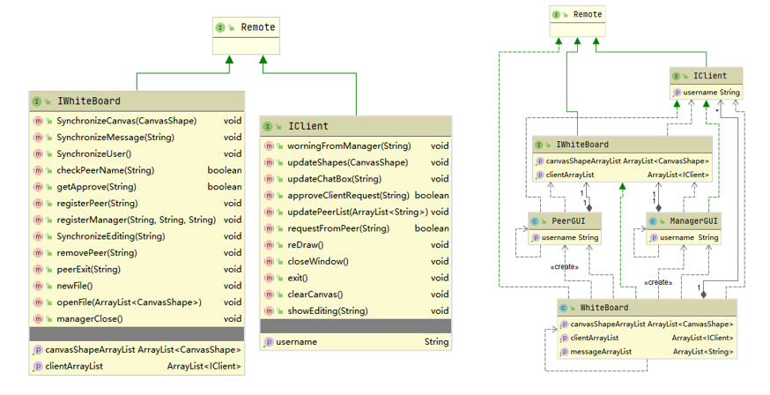
Figure 5. Remote services, IWhiteBoard, IClient and its intercation
- Error handling
Errors include incorrect user input, and Remote errors etc.
Error | handling
Empty port number and whiteboard name | showMessageDialog "Please provide a Port number and a Board name"
Empty port / invalid port | showMessageDialog "Please provide a valid Port number in [1024-65535]"
Empty whiteboard name | showMessageDialog "Please provide a Board name"
Network/remote error when creating manager GUI | showMessageDialog "Can not open Manager GUI, Error!!"
Empty IP address | showMessageDialog "Please provide a valid IP address"
Empty Username | showMessageDialog "Please provide a username"
Repeated username | showMessageDialog "This Username has been used, try again."
Network/remote error when creating peer GUI | showMessageDialog "Cannot connect to whiteboard, please use valid Ip, port and name"
Remote error | showMessageDialog "Remote error occur..."
File not found/class not found when open file | showMessageDialog "can not open this file, try a correct file."
File not found when save file | showMessageDialog "File save error, try again.."
Send empty message | showMessageDialog "plz input your message to send"

- Interaction diagram
The interaction is shown below:
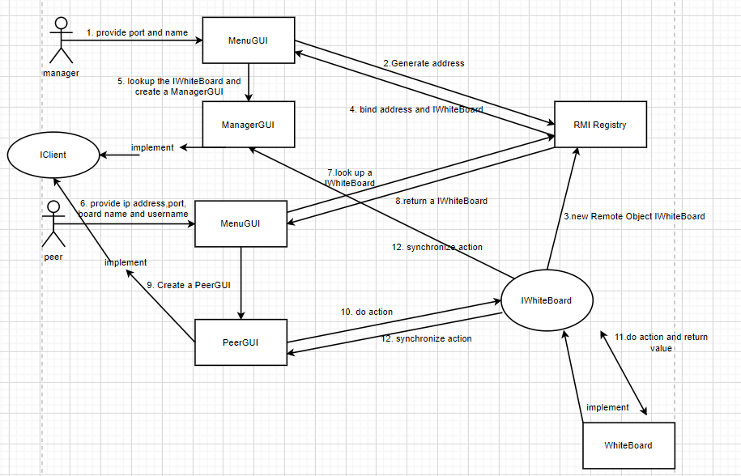
Figure 6. the interaction diagram 1
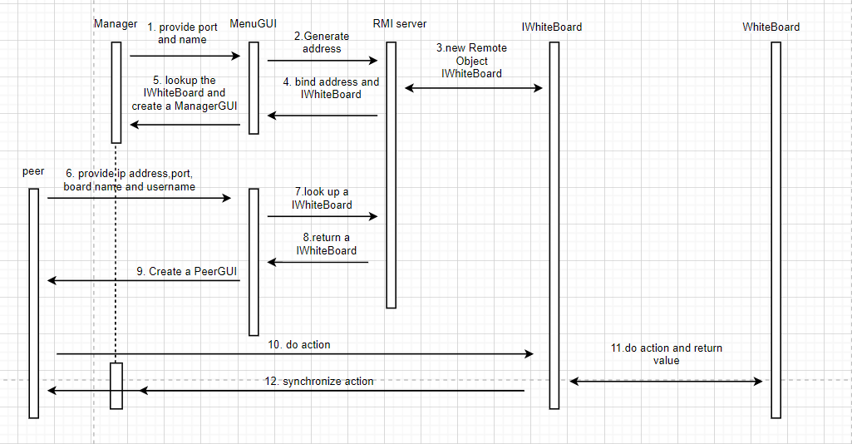
Figure 7. the interaction diagram 2

- Innovations
- A chat window is provided where users can chat. No message logs will be displayed, the user's window will only show the content of the chat since the user joined. This protects the privacy of users who have previously chatted.
- Provides the ability to create, open, save, save as and close the whiteboard for files that only the manager can use.
- The manager can kick out any peer except the manager himself.
- In addition to the basic line, circle, oval and rectangle shapes, a pen and eraser are provided for free drawing and erasing.
- 16777216 kinds of color can be choosing.
- Three running method is provided: run as – “java -jar CreateWhiteBoard.jar <serverIPAddress> <serverPort> boardname” to create a whiteboard, run as “java JoinWhiteBoard.jar <serverIPAddress> <serverPort> username boardname” or “java -jar JoinWhiteBoard.jar <serverIPAddress> <serverPort> username”(should join with default whiteboard name) to join a whiteboard. Or “java -jar WhiteBoard.jar” to open the menu.
- critical analysis
Advantages:
- The java RMI implementation is much simpler and easier to use than the socket. When using RMI, we don't need to pay too much attention to the serialisation and transmission of messages and can use the Remote method as it were a local method.
- RMI can pass objects as parameters and return values, not just predefined data types, and the passed objects must be serializable and implement a Serializable interface.
- For whiteboard systems, as the content to be transferred is a custom shape and an arraylist of shapes, the transmission does not require a large amount of bandwidth, so it is easier to use RMI for synchronisation methods that require remote calls.
- RMI defines security protocols internally, thus safeguarding the program and the user's system in terms of security and reliability
Disadvantages:
- RMI is tied to Java and using RMI requires both the client and server to be developed in Java, which limits the scalability of the system, whereas sockets are scalable in terms of choice of programming language.
- RMI defines the messaging protocol, which can lack some flexibility compared to sockets
- RMI will take up more network bandwidth than sockets when transferring the same message, so it is a good choice when a large amount of data does not need to be transferred between the server and the client. When a large amount of data needs to be transferred, sockets are a better choice.
- Conclusion
In general, RMI offers a design solution with more freedom and convenience than the Client-Server model. During data transfer in RMI, no additional methods are required to convert the data to base types, only that the data is serialisable. The ability to transmit instances of the class CanvasShape as well as Arraylists between our systems reduces a lot of work. Our system is able to synchronise the content of the drawing board, as well as allowing multiple users to draw, chat, etc. simultaneously. However, many aspects such as the GUI, the method of synchronisation and the response to changes in window size could be further optimised.

