LIMKOKWING UNIVERSITY OF CREATIVE TECHNOLOGY

1. Introduction
This assignment implements a stack-based mathematical expression evaluator in Python. The program reads multiple arithmetic expressions from an input text file, evaluates each expression using a stack data structure, and writes the resulting values to an output text file. The assignment specifically requires stack operations such as push, pop and peek, support for the operators +, -, * and /, parentheses, operator precedence, file input and file output.
The design uses two instances of a custom Stack class: a value stack and an operator stack. The value stack stores numeric operands and intermediate results, while the operator stack stores operators and parentheses. This approach makes the implementation demonstrate the Last-In, First-Out (LIFO) behaviour of stacks directly rather than relying on Python's built-in expression evaluation.

2. Data Structures Used

2.1 Stack Data Structure
A stack is a linear data structure that follows the Last-In, First-Out (LIFO) principle. The most recently inserted item is the first item removed. The implementation provides three core operations required by the assignment:
- push(item): inserts an item at the top of the stack.
- pop(): removes and returns the item at the top of the stack.
- peek(): returns the top item without removing it.
The implementation also includes is_empty() and size() helper operations. The stack is backed by a Python list, where append() performs push and pop() performs removal from the end. These operations are O(1) on average, making the stack suitable for expression evaluation.

2.2 Why Stacks Are Appropriate
Stacks are particularly appropriate for arithmetic expression processing because expressions contain nested structures and operators whose order of execution must be controlled. Parentheses require the program to remember an opening delimiter until its matching closing delimiter is encountered. Similarly, operators must be temporarily stored until their precedence permits them to be applied. Both requirements map naturally to LIFO behaviour.

2.3 Stack Operations Demonstrated
Operation | Purpose | Example | Complexity
push() | Places an item on top | operators.push('+') | O(1)
pop() | Removes top item | operators.pop() | O(1)
peek() | Inspects top item | operators.peek() | O(1)
is_empty() | Checks whether stack is empty | stack.is_empty() | O(1)

3. Program Design

3.1 Program Architecture
The program is divided into small functions so that each part has a clear responsibility. The Stack class manages LIFO operations. tokenize() converts an expression into manageable tokens. evaluate_expression() performs the stack-based evaluation. apply_operator() performs one arithmetic operation. format_result() controls how results are written, while process_file() handles the input and output files. main() starts the complete process.

3.2 Expression Evaluation Logic
- Read the expression from the input file.
- Tokenize the expression into numbers, operators and parentheses.
- Place numeric values on the value stack.
- Place operators on the operator stack.
- When an operator is encountered, compare its precedence with the operator at the top of the operator stack.
- Apply higher- or equal-precedence operators before pushing the new operator.
- When a closing parenthesis is found, repeatedly apply operators until the matching opening parenthesis is reached.
- After all tokens have been processed, apply any remaining operators.
- The final value remaining on the value stack is the result.

3.3 Operator Precedence
Operator | Precedence | Associativity
+ | 1 | Left-to-right
- | 1 | Left-to-right
* | 2 | Left-to-right
/ | 2 | Left-to-right
Multiplication and division therefore take precedence over addition and subtraction. Parentheses override normal precedence by forcing their enclosed expression to be evaluated first.

3.4 Pseudocode
ALGORITHM EvaluateExpression(expression)
tokens ← Tokenize(expression)
values ← empty Stack
operators ← empty Stack
FOR each token IN tokens
IF token is a number
values.push(token)
ELSE IF token is "("
operators.push(token)
ELSE IF token is ")"
WHILE top of operators is not "("
ApplyOperator(values, operators.pop())
END WHILE
operators.pop()
ELSE IF token is an operator
WHILE operator stack is not empty
AND top is not "("
AND precedence(top) ≥ precedence(token)
ApplyOperator(values, operators.pop())
END WHILE
operators.push(token)
END IF
END FOR
WHILE operators is not empty
ApplyOperator(values, operators.pop())
END WHILE
RETURN values.pop()
END ALGORITHM

3.5 Flowchart
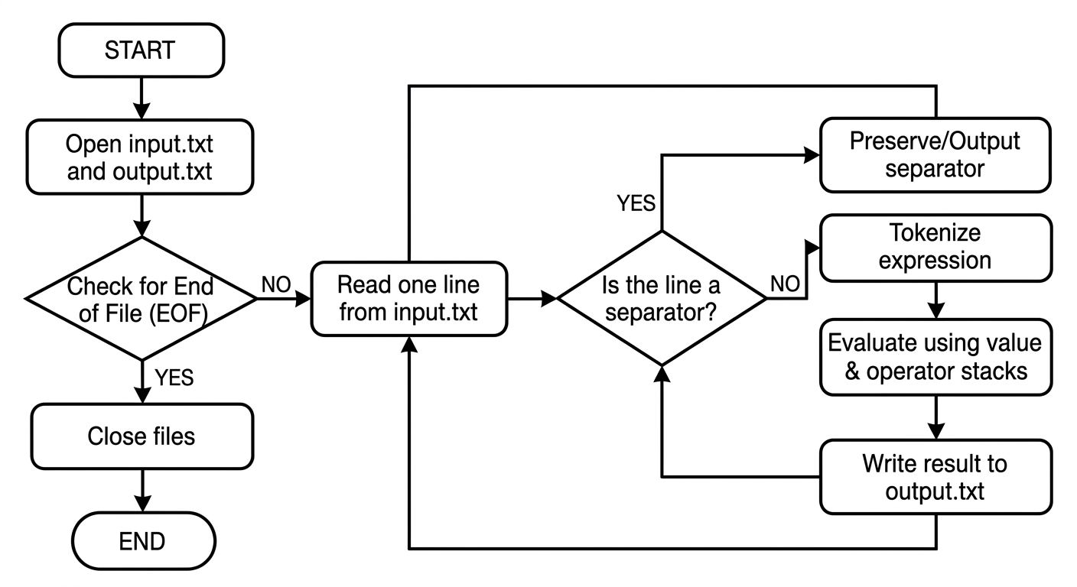

4. Key Program Functions

Function | Responsibility
Stack.push() | Adds an item to the top of the stack.
Stack.pop() | Removes and returns the top item; raises an error when the stack is empty.
Stack.peek() | Reads the top item without removing it.
tokenize() | Separates numbers, operators and parentheses while recognising unary signs.
apply_operator() | Pops the right and left operands, applies the selected operator, then pushes the result.
evaluate_expression() | Coordinates the two stacks and enforces precedence and parentheses.
process_file() | Reads input.txt, evaluates expressions, preserves separators, and writes output.txt.

5. Testing and Results

5.1 Testing Method
Testing was performed using the supplied three-expression assignment example and additional test cases designed to exercise precedence, parentheses, division, negative values, decimal results and error handling. The program was executed from the command line with Python, and the generated output.txt was compared with the expected mathematical results.
Test | Expression | Expected | Result
T1 | 3 + 5 * 2 | 13 | PASS
T2 | (8 / 4) + 7 * 2 | 16 | PASS
T3 | 10 - (2 + 3) * 4 | -10 | PASS
T4 | 5 / 2 | 2.5 | PASS
T5 | -3 + 5 | 2 | PASS
T6 | 3 * -2 | -6 | PASS
T7 | 2 * (3 + 4) | 14 | PASS
T8 | ((2 + 3) * 4) / 5 | 4 | PASS
T9 | 2 + 3 * 4 - 5 | 9 | PASS
T10 | 2 / (1 - 1) | ERROR: division by zero | PASS

5.2 Assignment Sample Results
For the three expressions supplied in the assignment, the program generated the following output:
13
----
16
----
-10
A discrepancy was observed in the scanned assignment sheet: the displayed output appears to show 17 for the second expression, while the expression itself is (8 / 4) + 7 * 2. Applying the required operator precedence gives 2 + 14 = 16. The implementation therefore outputs 16 rather than reproducing the apparent typographical error. This should be clarified with the lecturer if necessary.

5.3 Error Handling
The evaluator handles common input errors without abruptly terminating the entire file-processing task. Examples include invalid characters, invalid numbers, mismatched parentheses, an empty expression, and division by zero. Such cases are written as an ERROR message in output.txt.

6. Complexity Analysis

Let n represent the number of tokens in one expression. Each token is examined a constant number of times. Operators are pushed and popped at most once during the main evaluation process. Therefore, the time complexity is O(n). The value and operator stacks may together contain O(n) items in the worst case, so the auxiliary space complexity is O(n). Individual stack operations are O(1).
Component | Time | Space
push / pop / peek | O(1) | O(1) per operation
Tokenization | O(n) | O(n)
Expression evaluation | O(n) | O(n)
Complete file processing | O(N) | O(n) for current expression

7. Conclusion

The completed program demonstrates how the stack data structure can be applied to a practical computing problem: arithmetic expression evaluation. A custom Stack class provides push, pop and peek operations, while two stacks coordinate operands and operators. Operator precedence and parentheses are handled systematically, and the program integrates file input and output as required. Testing confirms that the implementation produces correct mathematical results for the supplied expressions and additional edge cases. The project is also organised with a README and supporting test files so that it can be executed and reviewed easily from a GitHub repository.

8. References

- Cormen, T. H., Leiserson, C. E., Rivest, R. L. and Stein, C. (2022). Introduction to Algorithms. 4th ed. MIT Press.
- Python Software Foundation. Python 3 Documentation: Built-in Types and Input/Output. Python Software Foundation.
- Limkokwing University of Creative Technology, Department of Information and Communication Technology (2026). DCOMP320 Data Structures and Algorithm — Individual Assignment: Stacks Implementation.

