WORKFLOW AUDIT & AI SETUP REPORT
Assignment 2

1. Weekly Workflow Audit
The purpose of this workflow audit is to identify recurring academic, technical, and professional tasks during a typical week and determine the most appropriate level of AI involvement. The categories used are Just Me, Delegate to AI with Review, Collaborate with AI, and Fully Automate.
No. | Weekly Task | AI Workflow Category | Reason / Review Requirement
1 | Attend lectures and understand concepts | Just Me | Understanding and learning require personal attention and active thinking.
2 | Solve coding practice problems | Collaborate with AI | AI can provide hints and explanations while the student writes and understands the solution.
3 | Debug Python/Flask code | Delegate to AI with Review | AI can identify likely errors and suggest fixes, but the final code must be tested.
4 | Create study notes | Collaborate with AI | AI can structure and simplify notes while the student verifies the technical content.
5 | Summarize research articles/PDFs | Delegate to AI with Review | AI can create a first summary, followed by verification against the original document.
6 | Write internship application emails | Delegate to AI with Review | AI can draft professional emails, while the student checks personal details and accuracy.
7 | Update resume content | Collaborate with AI | AI can improve wording and formatting, while the student decides what information is accurate and relevant.
8 | Apply to internships | Just Me | Application choices and submission of personal information are personal decisions.
9 | Prepare interview questions and answers | Collaborate with AI | AI can generate practice questions and feedback, while the student prepares authentic responses.
10 | Create PowerPoint presentation content | Delegate to AI with Review | AI can create an initial structure and content, followed by factual and formatting review.
11 | Analyze small datasets in Excel/Pandas | Collaborate with AI | AI can help with formulas and code while the student interprets the results.
12 | Draft project documentation | Delegate to AI with Review | AI can organize technical documentation, but project-specific facts must be verified.
13 | Organize weekly tasks/reminders | Fully Automate | Routine scheduling and reminders can be handled automatically.
14 | Generate repetitive code templates | Fully Automate | Standard boilerplate can be generated automatically and then checked before use.
15 | Final review before assignment submission | Just Me | The student should personally verify correctness, completeness, and submission requirements.

Key observation: Tasks involving personal judgment, learning, final verification, and submission of personal information should retain human control. Repetitive or drafting-heavy tasks can receive more AI support.
2. AI Tool Accounts & Anthropic Academy
Evidence Screenshot – Anthropic Academy Module]
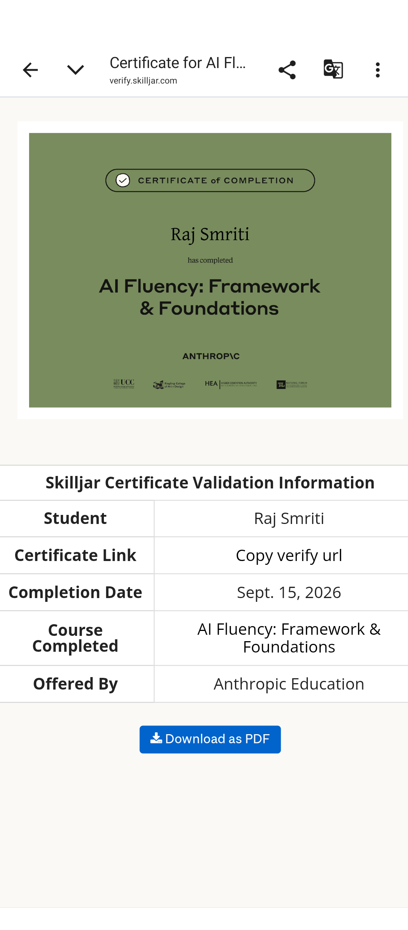
3. Claude Project Setup

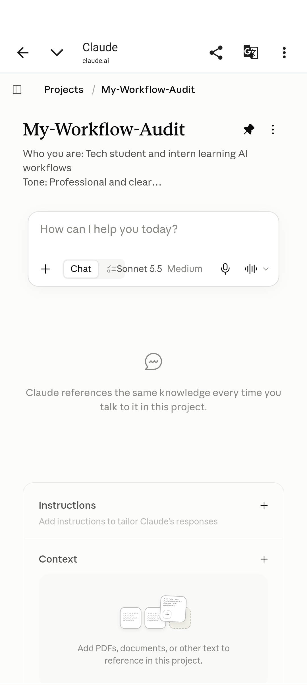
[INSERT SCREENSHOT HERE]
4. Three Target Tasks and “Done Well” Definitions
Target Task | Definition of “Done Well”
Task 1: Research Article / PDF Summarization | The summary should contain no hallucinated information, accurately cover all major points, and remain under 500 words.
Task 2: Code Debugging & Fixing | The AI-assisted code should run without errors after appropriate testing, and the cause of the bug and the logic of the fix should be understandable.
Task 3: Content Drafting / Notes Structuring | The final text should have a clear flow, read professionally, and sound natural rather than unnecessarily robotic.
5. Conclusion
This workflow audit identifies which tasks should remain under direct human control and which can benefit from AI assistance or automation. The objective is not to replace human judgment, but to use AI where it can improve productivity while maintaining accuracy, verification, privacy, and accountability.
.

