# Baseline

**remove all array partition**

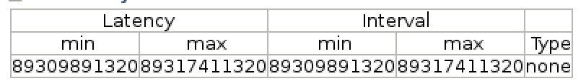

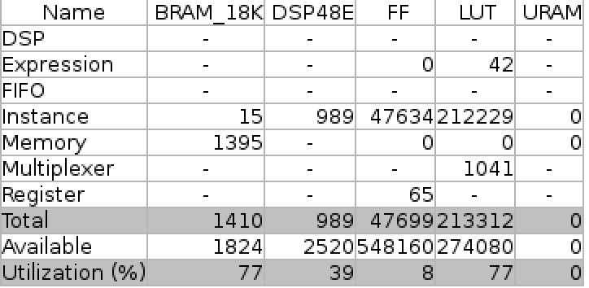

**tanh used half of the dsp ~35%**

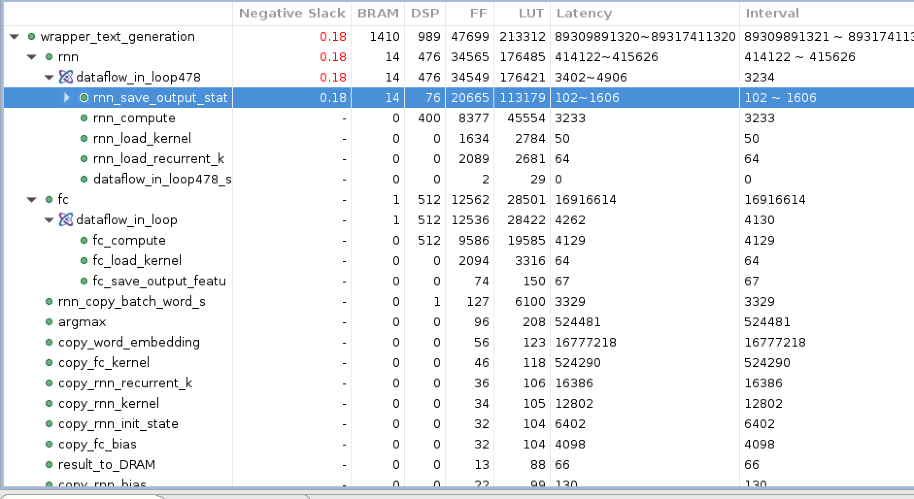

# Optimization

Suppose fixed point tanh

## Only partition prefix sum register 4B

#pragma HLS array_partition variable=rnn_input_state_BRAM cyclic factor=100

#pragma HLS array_partition variable=rnn_state0_BRAM cyclic factor=128

#pragma HLS array_partition variable=rnn_state1_BRAM cyclic factor=128

compute unroll = 4

rnn:

#pragma HLS array_partition variable=output_state_reg factor=4

#pragma HLS array_partition variable=kernel_reg cyclic factor=50

#pragma HLS array_partition variable=recurrent_kernel_reg cyclic factor=64

#pragma HLS array_partition variable=local_reg cyclic factor=32 dim=2

#pragma HLS array_partition variable=local_reg cyclic factor=4 dim=1

fc:

#pragma HLS array_partition variable=output_feature_map_reg factor=4

#pragma HLS array_partition variable=kernel_reg cyclic factor=64 dim=1

#pragma HLS array_partition variable=local_reg cyclic factor=32 dim=2

#pragma HLS array_partition variable=local_reg cyclic factor=4 dim=1

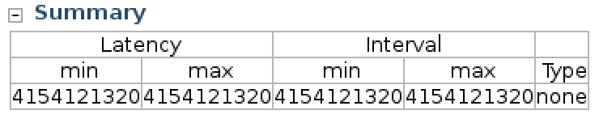

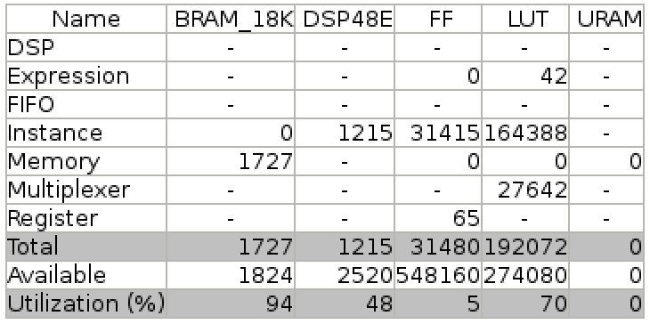

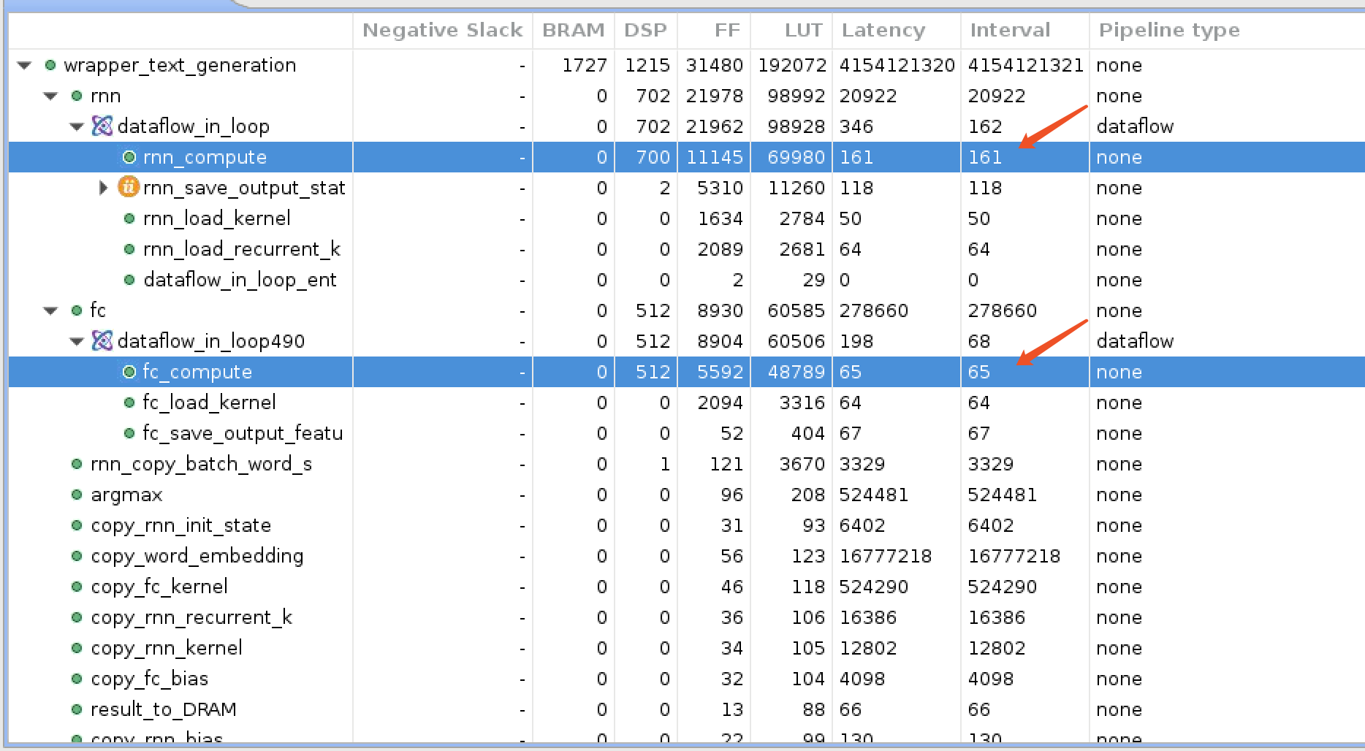



one single tanh takes 50 CC

## 2.More aggressive

more prefix sum unroll:

prefix sum loop unroll factor = **4 -> 8**

在最外层的Loop加上 #pragma HLS UNROLL factor=2

more tanh unroll:

rnn save中：

#pragma HLS UNROLL factor = **4 -> 8**

#pragma HLS PIPELINE

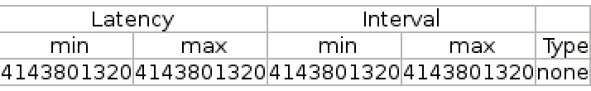

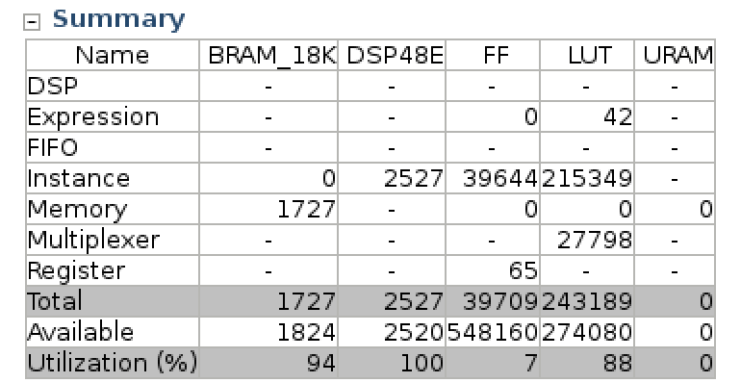

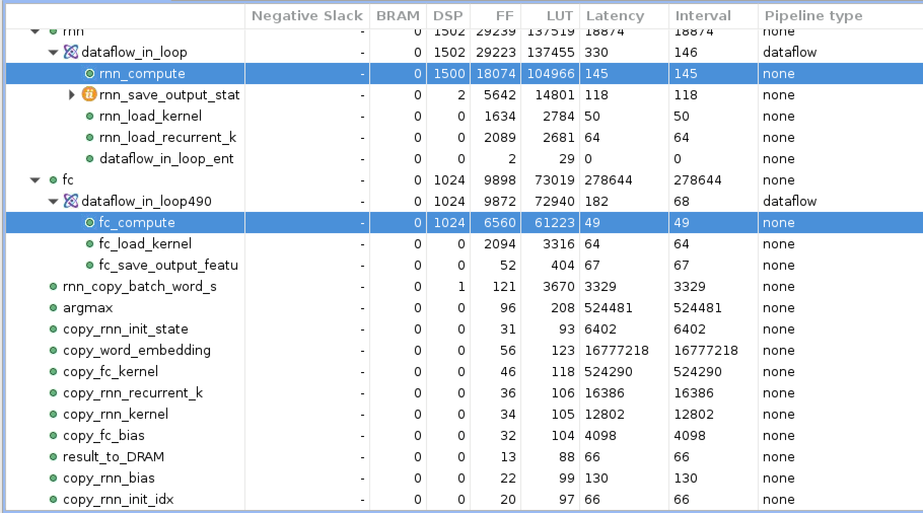

## 3. 改回1000个iter Focus on fc 800M

rnn 20k, fc 280k CC -> optimize fc first

#define FC_COMPUTE_UNROLL 8

FDATA_T local_reg[FC_COMPUTE_UNROLL][FC_INPUT_SIZE];

#pragma HLS array_partition variable=local_reg cyclic factor=32 dim=2

#pragma HLS array_partition variable=local_reg cyclic factor=8 dim=1

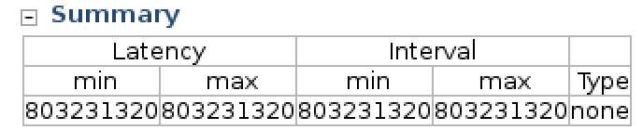

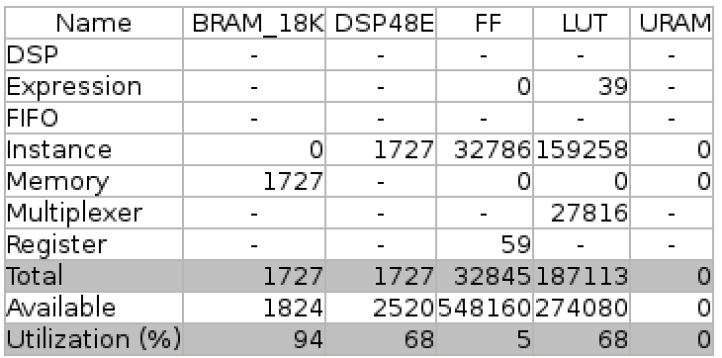

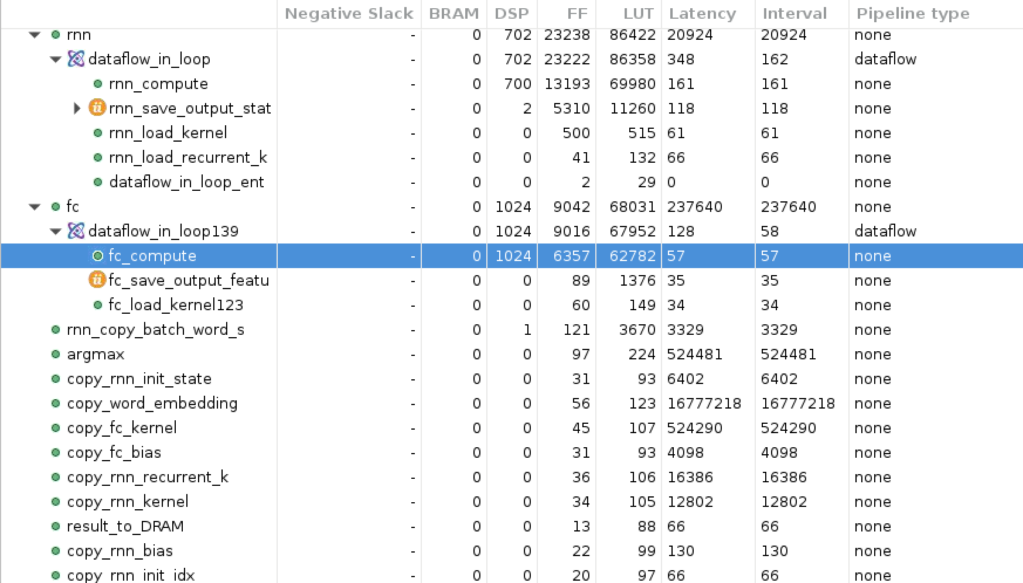

## 4.optimize argmax / float tanh 286M

unroll argmax = 64

改回 float tanh

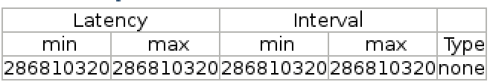

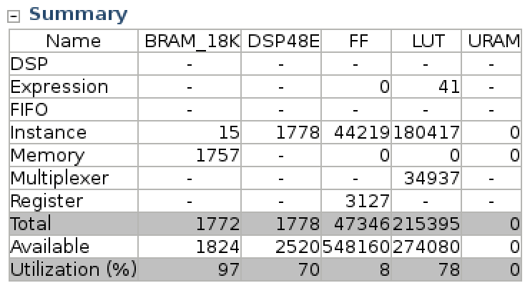

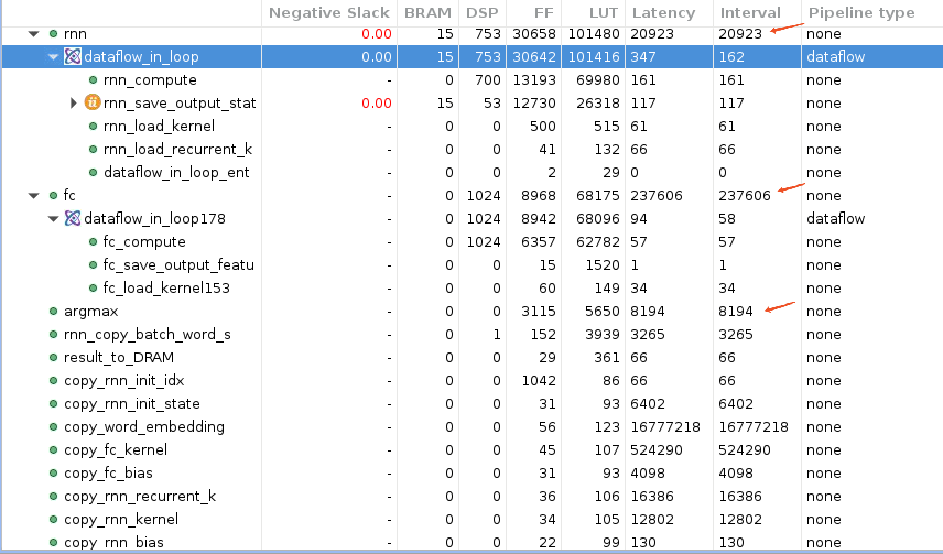

copy部分占了约18M -> x10 = 180M，not negligible

solution: more steps

## 5.改回5000step 1.36B

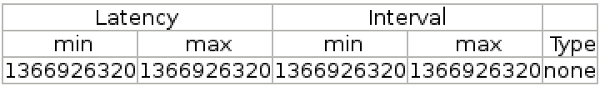

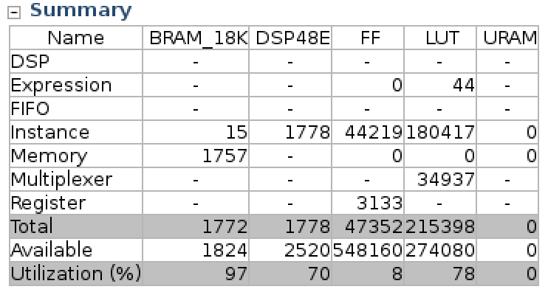ß

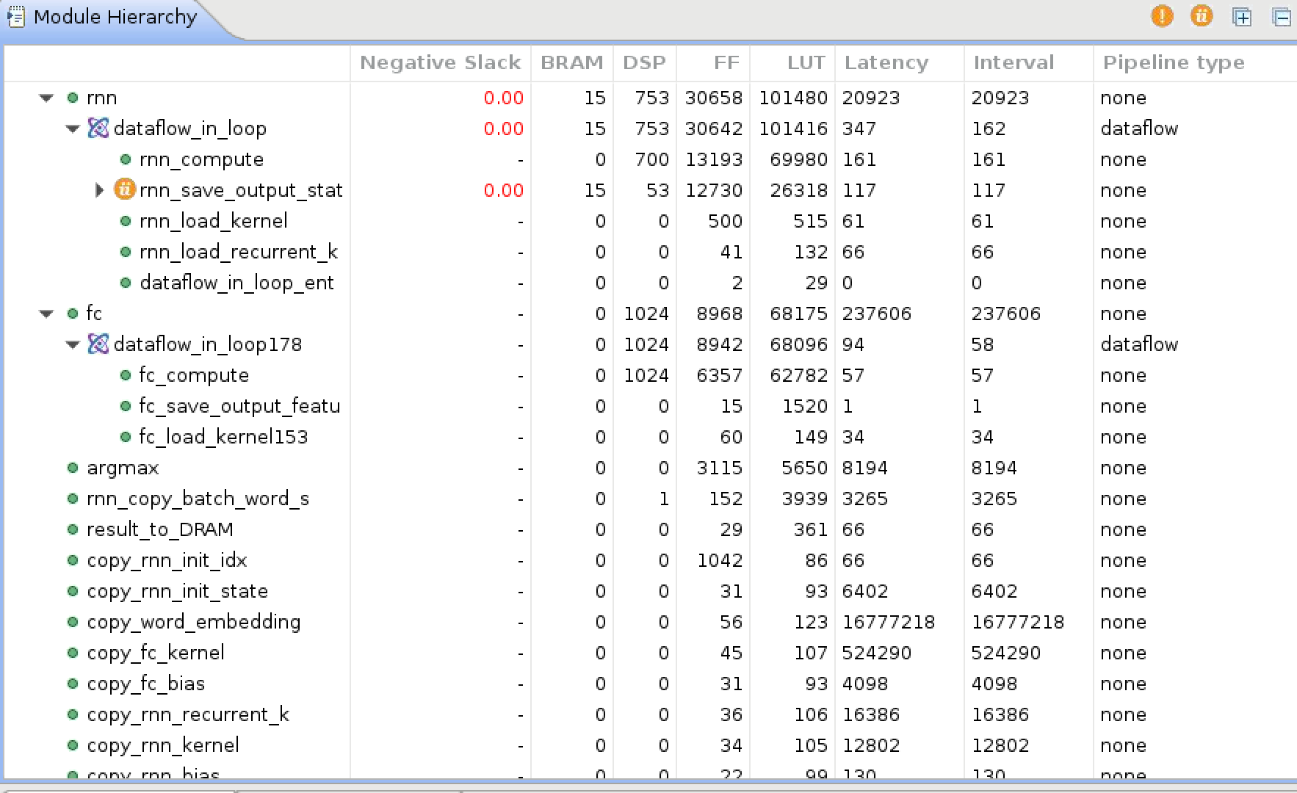

## 6.recompile

RNN input state unroll **100 -> 50，结果居然更快了？**

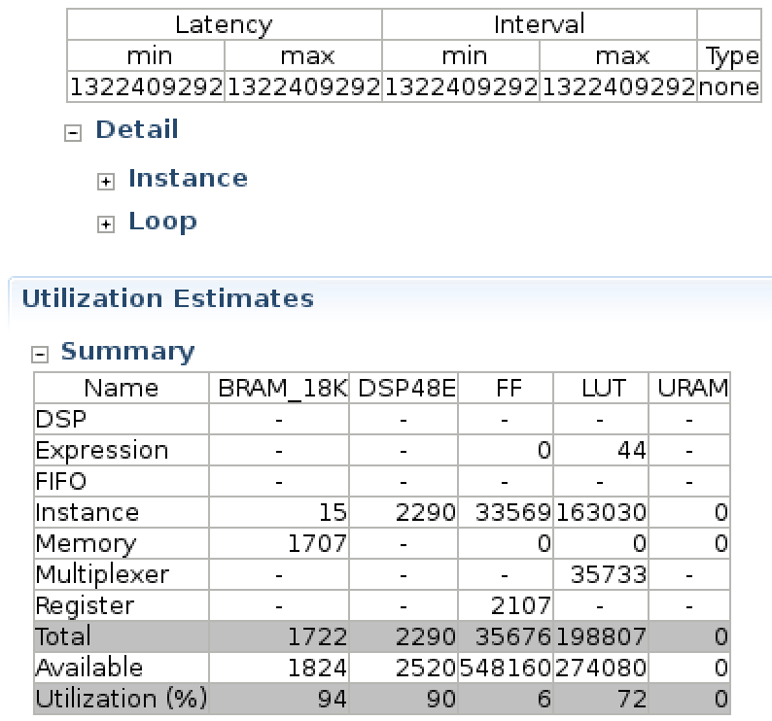

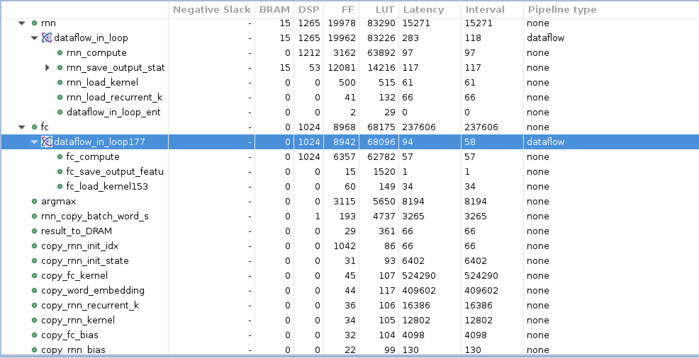

161 -> 97 CC