Homework #3 is an individual work: each student must submit their own work. Use of partial or entire solutions obtained from others or online is strictly prohibited. Electronic submission on Canvas is mandatory.

For problem 1 & 2, you can use latex and submit in pdf format or do problems on paper and attach to docx file. Please do not submit the separate images. The rest problems can be done on Jupyter notebook and submit both the notebook and html files.

**Logistic Regression I [10 pts]**

By using the result for the derivative of the logistic sigmoid, show that the derivative of the error function

for the logistic regression model is given by

where and .



**SVM I [10 pts]**

Consider the logistic regression model with a target variable . If we define where is given by , show that the negative log likelihood, with the addition of a quadratic regularization term, takes the form

where

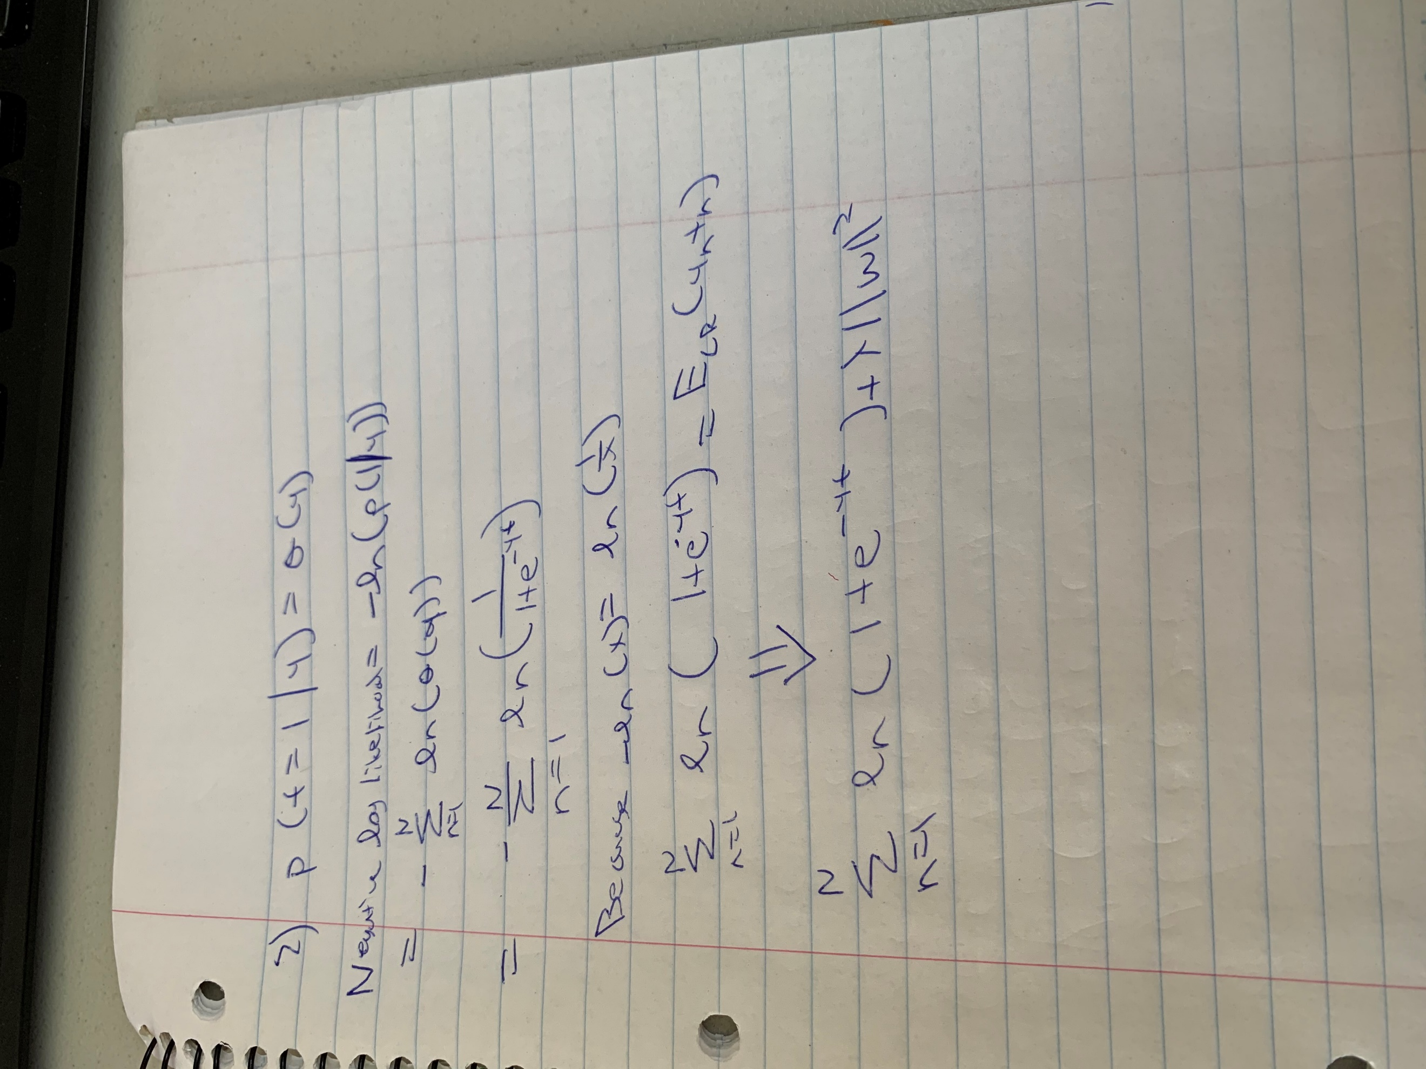

**SVM II [20 pts]**

Given 10 points in Table 1, along with their classes and their Lagrangian multipliers , implement SVM and answer the following questions:

a) What is the equation of the SVM hyperplane ? Draw the hyperplane with the 10 points.

b) What is the distance of from the hyperplane? Is this within the margin of the classifier?

c) Classify the point using from above.

|  |  |  |  |  |
| --- | --- | --- | --- | --- |
| data |  |  |  |  |
|  | 4 | 2.9 | 1 | 0.414 |
|  | 4 | 4 | 1 | 0 |
|  | 1 | 2.5 | -1 | 0 |
|  | 2.5 | 1 | -1 | 0.018 |
|  | 4.9 | 4.5 | 1 | 0 |
|  | 1.9 | 1.9 | -1 | 0 |
|  | 3.5 | 4 | 1 | 0.018 |
|  | 0.5 | 1.5 | -1 | 0 |
|  | 2 | 2.1 | -1 | 0.414 |
|  | 4.5 | 2.5 | 1 | 0 |

**Gaussian Process [20 pts]**

1. Implement Gaussian process regression for univariate variables and :

Use a squared exponential kernel:

where λ is a parameter controlling the kernel width.

Draw some plots of curves sampled from just the prior distribution. Try a handful of different settings for λ to see what effect is has. You will need to add a small value to the diagonal of your covariance matrix to ensure it is invertible.

2. Test your Gaussian process regression with the following example. Generate synthetic data from the model:

Start by generating *x* values randomly uniform on the interval . Then generate your *y* values using and a sample size of .

Plot (1) your raw data, (2) the true answer, (3) your estimated posterior mean function from Gaussian regression, and finally (4) the 95% confidence region for your posterior mean.

**Decision Tree [20 pts]**

Implement own Decision Tree to classify the mpg using auto-mpg.data. Then report the accuracy of classification.