Experiment Report — Vision-Language Web Application (LandMarkFinder)
Jerry Wang
CNIC
CAS
Beijing, China
jerry2003w@gmail.com

Introduction
This experiment aims to implement a vision-language web application powered by a large language model (LLM) capable of image understanding.
The project utilizes Ollama to locally serve a multimodal model (LLaVA) that can process both images and text.
The final goal is to build a simple yet practical web system that accepts an image input and automatically generates a descriptive text output related to the content of the image.

Application Scenario Description
The designed application, LandMarkFinder, focuses on landmark and architectural recognition.
In modern tourism and cultural education, users often capture photos of buildings or monuments but lack immediate contextual information.
This application addresses that problem by allowing users to upload an image of a landmark, after which the AI automatically identifies it and provides a bilingual (English–Chinese) travel guide introduction.
Practical value:
Assists tourists and students in learning about historical and cultural sites.
Can serve as an AI-powered tour guide assistant in travel apps.
Demonstrates how multimodal LLMs can interpret images beyond simple object recognition.

Implementation Process

Environment Setup
Installed Ollama on macOS.
Downloaded the LLaVA model via:
ollama pull llava
Verified the service was running at http://localhost:11434 through:
ollama serve

Web Application Development
Implemented a lightweight HTML + JavaScript front-end interface.
The interface allows users to upload an image and send it as a base64 string to Ollama’s REST API.
Streaming responses are parsed and rendered dynamically in a styled output box.

User workflow:
Open http://localhost:8000 via local HTTP server (python3 -m http.server 8000).
Upload an image of a landmark.
Wait for the AI to identify and describe it.
View the bilingual explanation generated by the model.
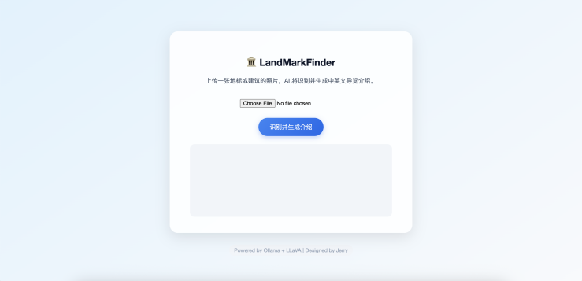

Effect of the Web Application
When tested with real-world landmark images, the system performed well in identifying and describing them.
For example, when an image of the Temple of Heaven (天坛) in Beijing was uploaded, the output included detailed English and Chinese introductions about its history, architecture, and cultural background.
The model generated coherent, contextually relevant paragraphs that demonstrated both visual understanding and linguistic reasoning.

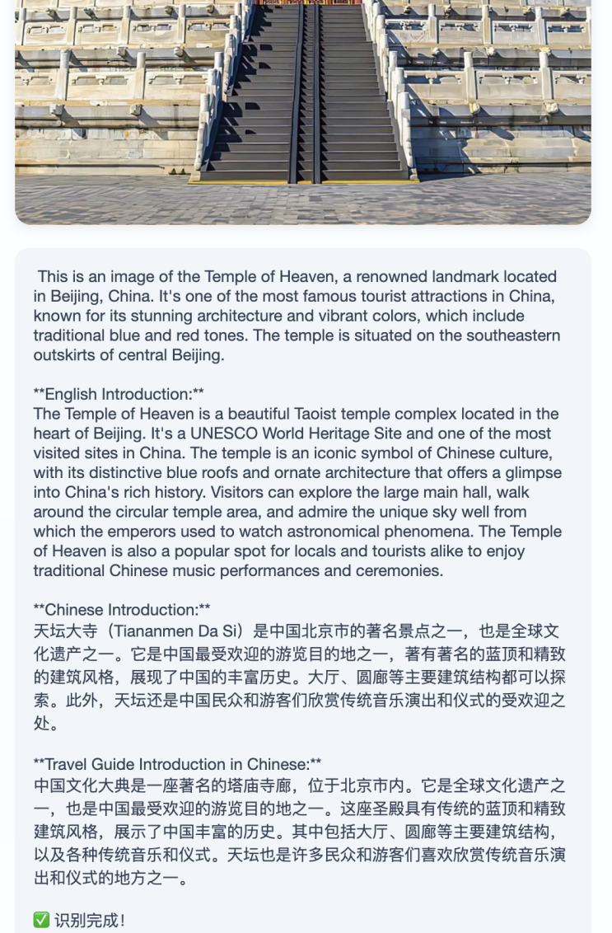

Problems Encountered and Solutions
Problem | Description | Solution
Port Conflict (Address already in use) | When running ollama serve, the default port 11434 was already occupied. | Checked running processes with lsof -i :11434 and confirmed an existing Ollama service; restarted or reused it.
Streaming Output Parsing | The /api/generate endpoint returns multiple JSON lines (one per chunk), causing unformatted or broken output. | Implemented line-by-line JSON parsing in JavaScript with JSON.parse(line) inside a while (true) reader loop.
Cross-Origin Access | Occasionally, the browser blocked local requests to localhost:11434. | Ensured the web page was also served from localhost, avoiding CORS issues.
UI Design | The initial page was visually plain and unprofessional. | Redesigned the page using modern CSS (glassmorphism, gradient backgrounds, rounded buttons, centered layout).

Results and Analysis
Accuracy: The model correctly identified landmarks such as the Temple of Heaven and the Eiffel Tower.
Language Generation: The generated texts were contextually accurate and grammatically correct, often including cultural insights.
Responsiveness: The streaming approach allowed partial results to appear in real-time, improving user experience.
Overall, the system demonstrates that LLaVA (via Ollama) can effectively handle vision-language tasks locally, offering a strong base for educational or tourism-oriented AI applications.

Conclusion
The experiment successfully implemented a practical vision-language web system capable of understanding images and generating bilingual descriptive text.
By combining Ollama’s local LLM serving and a lightweight HTML frontend, this project demonstrates a feasible architecture for deploying multimodal AI systems locally without dependence on cloud APIs.
Future improvements:
Support for multiple images and comparison analysis.
Integration of voice narration for accessibility.
Expansion to recognize artworks, historical figures, and museum exhibits.

References
Ollama Documentation: https://ollama.ai
LLaVA: Large Language and Vision Assistant
W3C Fetch API Specification

启动服务
ollama serve

检查模型是否下载
ollama list

启动网页服务器（新终端
cd /Users/Jerry/Desktop/ISE/ISE_landMarkFinder
python3 -m http.server 8000

测试基本连接（新终端
curl -X POST http://localhost:11434/api/generate \
-H "Content-Type: application/json" \
-d '{
"model": "llava",
"prompt": "Hello, is the server working?",
"stream": false
}'

页面
http://localhost:8000/index.html

