Airbnb Business Analysis Report
Team Group 3 - Machine Learning: Emily Shaibu, Isaac Essam Shalaan, Jeroen Schoemaker, Andrei Tapu Tranga
September 2026

Table of Contents
1. Business Understanding and Business Question 2
2. Data Understanding 2
2.1 Data Preparation 2
2.2 Feature Engineering 3
2.3 Descriptive Statistics 4
3. Methodology 6
4. Results and Findings 7
4.1 Listing Segments 7
4.2 Price-Demand Patterns 8
4.3 Regression Results 10
5. Business Insights and Recommendations 11
6. Limitations 12
7. Conclusions 13
References 13
Appendix A: Description of the dataset 16
Appendix B: Robustness checks 18

1. Business Understanding and Business Question
Airbnb prices vary with property and location characteristics (Gibbs et al., 2018; Wang and Nicolau, 2017), while segmentation can reveal actionable submarkets (Dolnicar, 2020). We therefore ask whether Airbnb could benefit from higher prices in selected New York City segments by examining how advertised price relates to review-based demand and identifying the strongest pricing opportunities.

2. Data Understanding

2.1 Data Preparation
We used the 2019 Inside Airbnb snapshot of New York City (Gomonov, 2019; Appendix A), keeping listings with a positive price, minimum stay of at most 365 days and positive availability: 31,340 listings (Table 1). Listings open under 30 days are unreliable for demand, leaving 26,175.

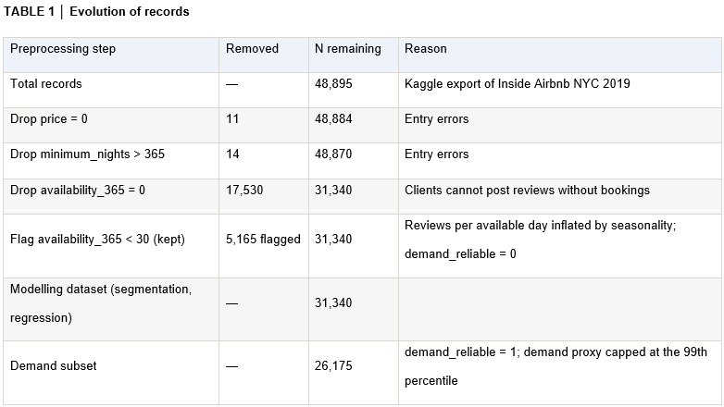

2.2 Feature Engineering
Research explains accommodation prices through listing characteristics and location (Rosen, 1974; Gibbs et al., 2018; Deboosere et al., 2019); with no booking data, several variables were engineered.

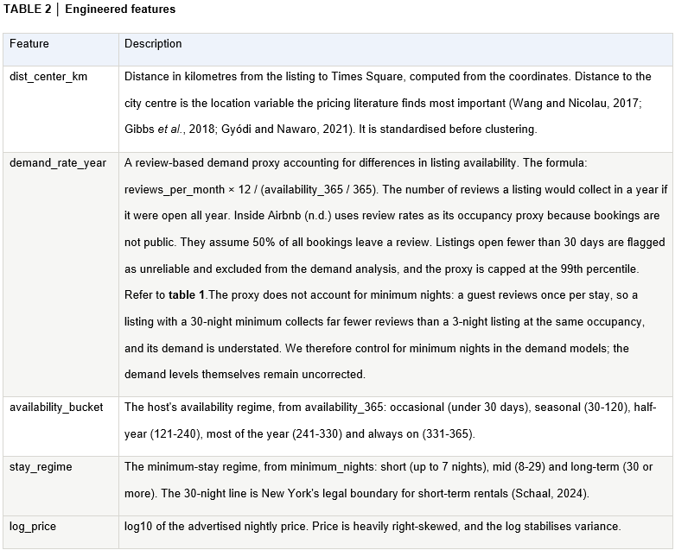

2.3 Descriptive Statistics
- We use log because advertised price is heavily right-skewed (median $112, mean $162, maximum $10,000). Log is significantly more symmetric (Figure 1).
- Kruskal–Wallis tests showed significant differences across all groupings (all p < 0.001; Kruskal and Wallis, 1952), so effect sizes assessed practical importance (Table 3). Room type explained 46% of price-rank variance and distance 21%; neighbourhood explained 31% alone but only 6% beyond these factors, while all others explained 2% or less. Thus, room type and location define market structure, consistent with prior Airbnb pricing studies (Wang and Nicolau, 2017; Gibbs et al., 2018; Deboosere et al., 2019).
- The correlation matrix (Figure 2) confirms this and shows that minimum_nights correlates at −0.38 with the demand proxy because a guest reviews once per stay regardless of length. We will control for it.

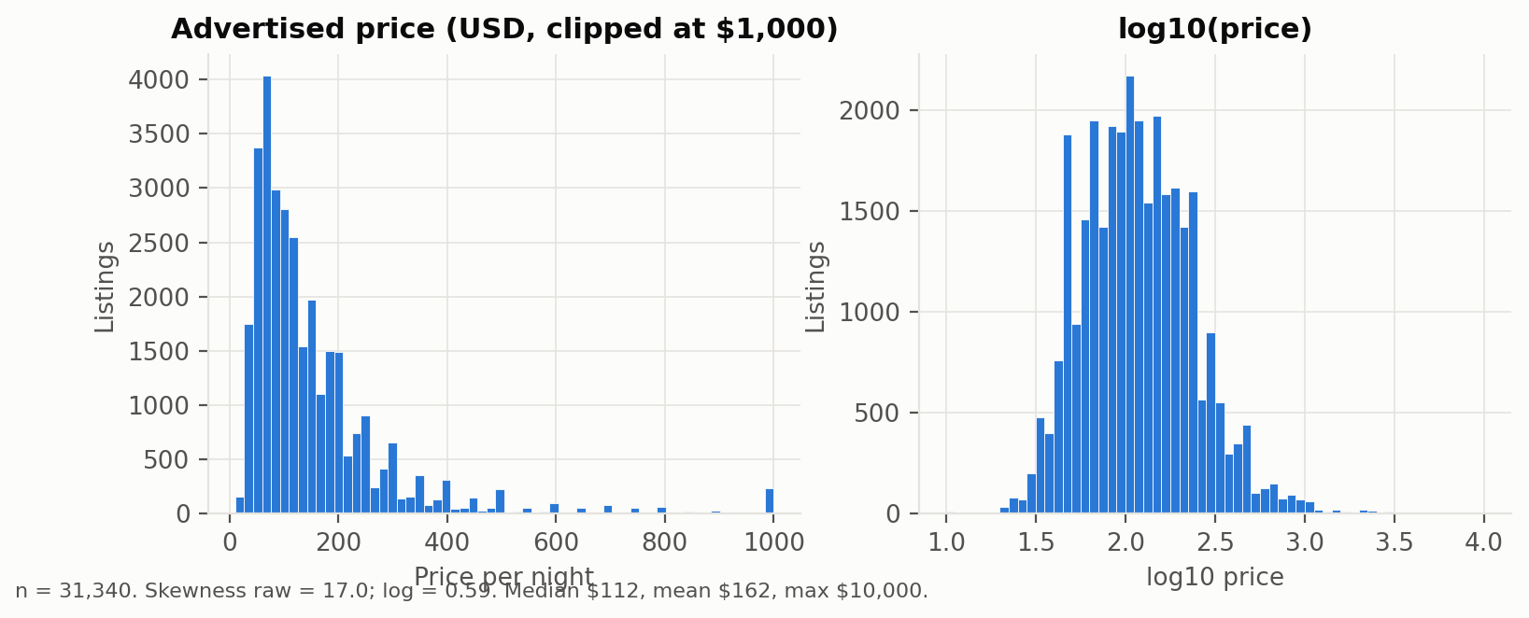
FIGURE 1 │ Advertised price is heavily right-skewed; log10(price) is close to symmetric and is our modelling target.

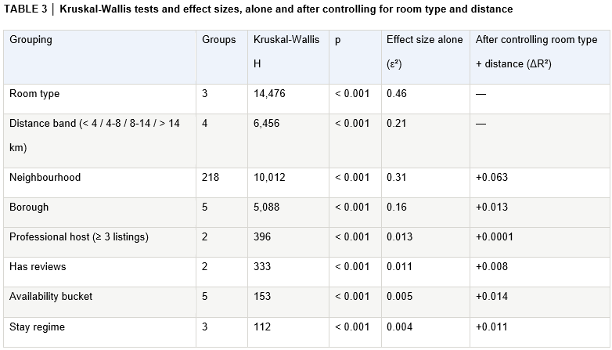

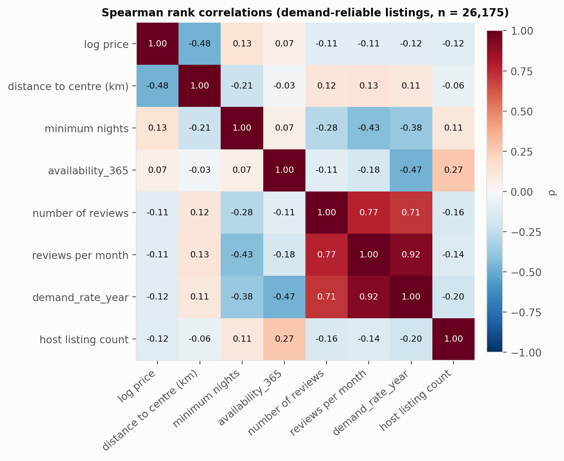
FIGURE 2 │ Spearman rank correlations between the variables used, on the demand-reliable listings (n = 26,175). Log price relates to distance (−0.48) and little else; the demand proxy relates to minimum nights (−0.38) and, by design, to availability (−0.47).

3. Methodology
Three steps. First, K-prototypes clustering (Huang, 1998) segmented listings on room type and distance from the centre (k = 2-8 compared on silhouette, stability, size and interpretability; Rousseeuw, 1987), leaving price and demand out to avoid circularity. Second, price was predicted with a median benchmark, OLS, Elastic Net, Random Forest and CatBoost (80/20 split, five-fold cross-validation). Third, the demand proxy was related to price within each segment and market-wide, with an interaction test and robustness checks.

The code we created for data preparation, clustering, predictive modelling and robustness analysis is available in the project GitHub repository: https://github.com/ishalaan/airbnb-nyc-business-analysis/

4. Results and Findings

4.1 Listing Segments
The clustering confirms Table 3: adding availability and stay behaviour weakened separation (silhouette 0.660 to 0.406, two clusters), so room type and distance were kept. k = 5 had the highest silhouette (0.660, stability ARI 0.763); k = 8 was near-tied and more stable, and five clusters were retained as the balance of separation, market detail and interpretability (Table 4; Dolnicar, 2020). Shared rooms (2.7%) were absorbed into other clusters. γ = 1 was used; 0.75-2 gave the same partition.

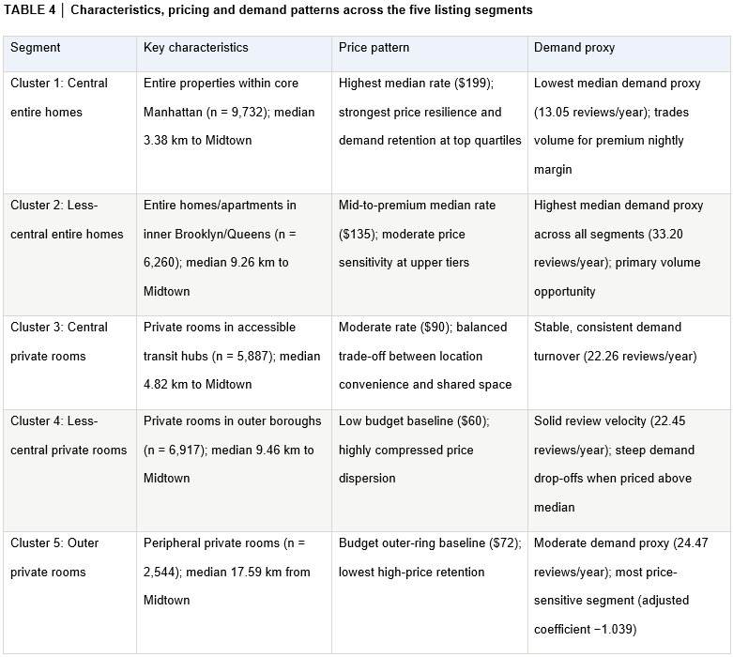

4.2 Price-Demand Patterns
Higher price was associated with lower demand (ρ = −0.12; Figure 2). Controlling for minimum nights, host size, distance, room type and borough, the market-wide log-log coefficient was −0.702, implying about 0.7% lower demand for a 1% higher price. Slopes differed significantly by segment (F-test p = 3.55 × 10⁻¹⁰; Figure 3) and remained robust to alternative demand caps, a 60-day availability threshold and short-stay listings (≤7 nights, n = 20,858). Central entire homes were least price-sensitive (−0.481) and uniquely had higher top-quartile demand than bottom-quartile demand (retention 1.130); outer private rooms were most price-sensitive (−1.039), while less-central entire homes had the highest demand (33.20) but weak top-quartile retention (0.578; Table 6). This ordering is consistent with documented location premiums (Gibbs et al., 2018; Deboosere et al., 2019).

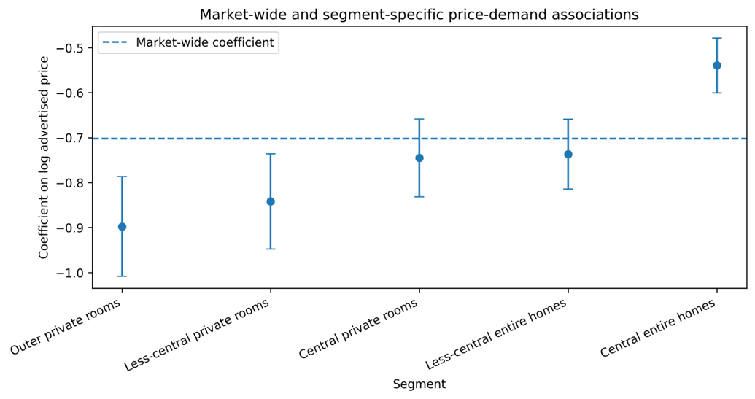

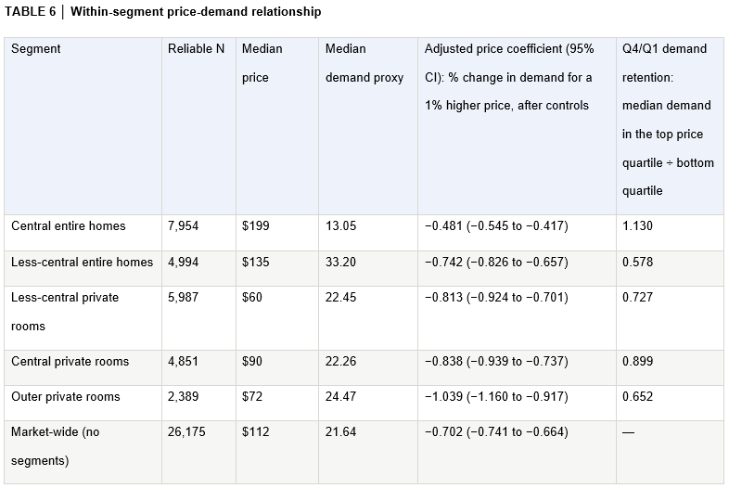

4.3 Regression Results
The regression predicted price from room type, distance, neighbourhood and borough plus minimum nights, availability, host listings and reviews per month; host listings stayed in because Deboosere et al. (2019) find professionalisation matters. CatBoost had the lowest cross-validation RMSE (0.1902), almost tied with Random Forest; both beat OLS and Elastic Net (Table 7, Figure 4). Room type was by far the most important predictor, then distance, as in Table 3.

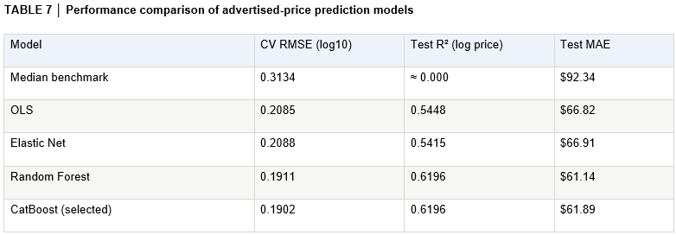

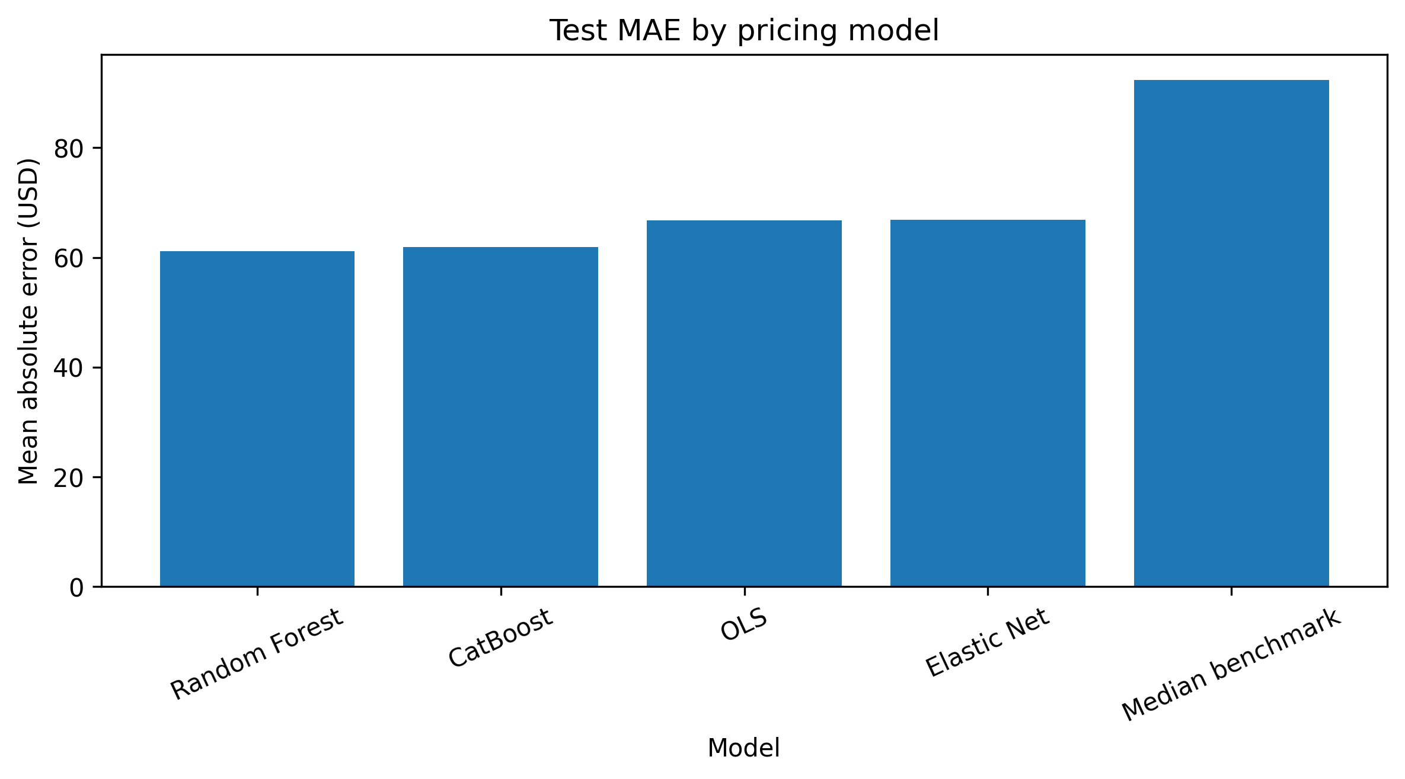
FIGURE 4 │ Model comparison: test MAE by pricing model.

5. Business Insights and Recommendations
Higher advertised price goes with lower review-based demand across New York, but the strength differs by segment, so one rule does not fit the market (Table 8). Central entire homes are the strongest case for premium-price testing; they already command the highest price, yet their demand is least sensitive and holds in the top quartile. Less-central entire homes have the highest demand at a lower price but lose it at the top of their range, here experimentation is required. Outer private rooms are the most price-sensitive and competitive.

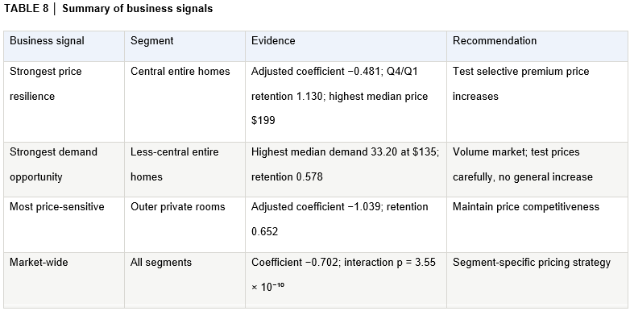

6. Limitations
- Demand is inferred from review volume, capturing about half of completed stays (Inside Airbnb, n.d.).
- Advertised rates exclude cleaning fees, commissions and seasonal discounts; there are no bookings, occupancy or revenue.
- The demand proxy ignores minimum nights (Table 2). Long stay listings collect fewer reviews at equal occupancy, so their demand is understated. It cannot be safely modelled: stay length is unobserved, and converting stays to nights with the minimum (Inside Airbnb, n.d.) assumes every stay equals it. This affects levels, not slopes: segments with many long stays, above all central entire homes, look lower in demand than they are; the coefficients control for minimum nights and the short-stay check (Table 6) leaves the ranking unchanged.
- Shared rooms (861 listings) are too few to separate in cluster.
- The price model describes the market, not individual listings: its error is ten times larger in the top price quartile ($163 against $17), so it is unreliable for premium listings.

7. Conclusions
The analysis supports segment-specific rather than market-wide pricing. Central entire homes offer the strongest case for higher-price testing, while outer private rooms are more price-sensitive and less-central entire homes warrant controlled experimentation. However, because demand is proxied by reviews rather than bookings, occupancy or revenue, the findings indicate where Airbnb should test price increases rather than optimal listing-level prices.

References
Deboosere, R., Kerrigan, D.J., Wachsmuth, D. and El-Geneidy, A. (2019) ‘Location, location and professionalization: a multilevel hedonic analysis of Airbnb listing prices and revenue’, Regional Studies, Regional Science, 6(1), pp. 143–156. Available at: https://doi.org/10.1080/21681376.2019.1592699 (Accessed: 2 September 2026).

Dolnicar, S. (2020) ‘Market segmentation analysis in tourism: a perspective paper’, Tourism Review, 75(1), pp. 45–48. Available at: https://doi.org/10.1108/TR-02-2019-0041 (Accessed: 20 August 2026).

Gibbs, C., Guttentag, D., Gretzel, U., Morton, J. and Goodwill, A. (2018) ‘Pricing in the sharing economy: a hedonic pricing model applied to Airbnb listings’, Journal of Travel & Tourism Marketing, 35(1), pp. 46–56. Available at: https://doi.org/10.1080/10548408.2017.1308292 (Accessed: 20 August 2026).

Gomonov, D. (2019) New York City Airbnb Open Data [Dataset]. Kaggle. Available at: https://www.kaggle.com/datasets/dgomonov/new-york-city-airbnb-open-data (Accessed: 28 August 2026).

Gyódi, K. and Nawaro, Ł. (2021) ‘Determinants of Airbnb prices in European cities: a spatial econometrics approach’, Tourism Management, 86, article 104319. Available at: https://doi.org/10.1016/j.tourman.2021.104319 (Accessed: 2 September 2026).

Huang, Z. (1998) ‘Extensions to the k-means algorithm for clustering large data sets with categorical values’, Data Mining and Knowledge Discovery, 2(3), pp. 283–304. Available at: https://doi.org/10.1023/A:1009769707641 (Accessed: 20 August 2026).

Inside Airbnb (n.d.) Data Assumptions. Available at: https://insideairbnb.com/data-assumptions/ (Accessed: 2 September 2026).

Kruskal, W.H. and Wallis, W.A. (1952) ‘Use of ranks in one-criterion variance analysis’, Journal of the American Statistical Association, 47(260), pp. 583–621. Available at: https://doi.org/10.1080/01621459.1952.10483441 (Accessed: 3 September 2026).

Rosen, S. (1974) ‘Hedonic prices and implicit markets: product differentiation in pure competition’, Journal of Political Economy, 82(1), pp. 34–55. Available at: https://doi.org/10.1086/260169 (Accessed: 2 September 2026).

Rousseeuw, P.J. (1987) ‘Silhouettes: a graphical aid to the interpretation and validation of cluster analysis’, Journal of Computational and Applied Mathematics, 20, pp. 53–65. Available at: https://doi.org/10.1016/0377-0427(87)90125-7 (Accessed: 20 August 2026).

Schaal, D. (2024) ‘Banned in NYC: Airbnb one year later’, Skift, 1 September. Available at: https://skift.com/2024/09/01/banned-in-nyc-airbnb-1-year-later/ (Accessed: 28 August 2026).

Wang, D. and Nicolau, J.L. (2017) ‘Price determinants of sharing economy based accommodation rental: a study of listings from 33 cities on Airbnb.com’, International Journal of Hospitality Management, 62, pp. 120–131. Available at: https://doi.org/10.1016/j.ijhm.2016.12.007 (Accessed: 20 August 2026).

Appendix A: Description of the dataset
TABLE A1 │ Data dictionary of the final dataset (n = 31,340 listings)
Field | Definition | Type | Min | Median | Mean | Max
id | Unique listing identifier | Identifier
name | Listing title written by the host | Text
host_id, host_name | Identifier and first name of the host | Identifier, text
neighbourhood_group | Borough the listing is in | Categorical (5)
neighbourhood | Neighbourhood the listing is in | Categorical (218)
latitude | Latitude of the listing (anonymised by Airbnb to about 150 m) | Numeric | 40.50 | 40.72 | 40.73 | 40.91
longitude | Longitude of the listing | Numeric | -74.24 | -73.95 | -73.95 | -73.71
room_type | What is rented: the entire home/apartment, a private room, or a shared room | Categorical (3)
price | Advertised nightly rate in USD at the time of the snapshot; the source does not say whether it is an average over the year, and it is not the price paid | Numeric | 10 | 112 | 162 | 10,000
minimum_nights | Minimum number of nights a guest must book | Integer | 1 | 3 | 8.0 | 365
number_of_reviews | Total reviews received over the life of the listing, as of the snapshot | Integer | 0 | 10 | 31.9 | 629
last_review | Date of the most recent review; missing means never reviewed (17%) | Date
reviews_per_month | Average reviews per month since the first review; missing set to 0 for never-reviewed listings | Numeric | 0 | 0.92 | 1.51 | 58.5
calculated_host_listings_count | Number of NYC listings the same host operates | Integer | 1 | 1 | 10.3 | 327
availability_365 | Days in the coming year on which the host has opened the calendar | Integer | 1 | 167 | 176 | 365
Statistics are computed after the cleaning steps in Table 1. Field definitions follow Inside Airbnb (n.d.).

Appendix B: Robustness checks
TABLE B1 │ Robustness checks: does the result survive under changing assumptions
Check | What was changed and why | Reliable N | Highest demand | Least price-sensitive (slope) | Most price-sensitive (slope) | Slopes differ by segment (p)
Main analysis | Demand proxy capped at the 99th percentile; listings with at least 30 available days | 26,175 | Less-central entire homes | Central entire homes (−0.54) | Outer private rooms (−0.90) | 3.6 × 10⁻¹⁰
Outliers (1) | No cap on the demand proxy, to see whether a few extreme review rates drive the result | 26,175 | Same | Same (−0.54) | Same (−0.91) | 2.5 × 10⁻¹⁰
Outliers (2) | Stricter cap at the 95th percentile | 26,175 | Same | Same (−0.53) | Same (−0.88) | 4.5 × 10⁻¹⁰
Availability threshold | Only listings with at least 60 available days, to remove short calendars whose review rates are inflated by season timing | 23,163 | Same | Same (−0.48) | Same (−0.82) | 5.1 × 10⁻¹⁰
Minimum nights | Only listings with a minimum stay of 7 nights or fewer, so that a review approximates a booking and the per-stay bias of Section 6 is largely removed | 20,858 | Same | Same (−0.69) | Central private rooms (−0.95); outer private rooms −0.94 | 4.2 × 10⁻⁵

