Unit 8 – Gradient descent and the cost function

Mayo (2017) explains that with 16 weights there are 10⁴⁸ combinations, so trying out all the combinations is not possible at least within a reasonable timeframe. Therefore, gradient descent follows the slope, and the concept of learning rate is introduced which is described as the step size inside the slope. We in practice here at 0.001 learning rate the model needs 6,717 iterations while at 0,08 learning rate the model only needs 83 iterations to reduce the cost of training the data. When the learning rate is small, the weight adjustments take smaller steps for each epoch (smaller adjustments). So based on the data (slope) you have to find the right step that you quickly find the minimum, but not use steps so large that they make adjustments that make errors go in the other direction. In visualization below I illustrate what happens when steps are too large.
Here we are doing line fitting, so I don’t think there is local optima, but Mayo also discusses how to address that.
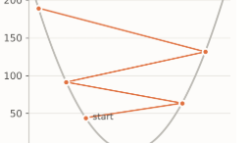

Reference
Mayo, M. (2017) ‘Neural network foundations, explained: updating weights with gradient descent & backpropagation’, KDnuggets, 25 October. Available at: https://www.kdnuggets.com/2017/10/neural-network-foundations-explained-gradient-descent.html (Accessed: 25 September 2026).

