**UNIVERSITY OF ST LA SALLE**

**COLLEGE OF ENGINEERING AND TECHNOLOGY**

**Information Technology Department**

*ITP203 1st Semester AY 2022 – 2022*

***CLE1 Midterm - Learning Task Answer Sheet***

|  |  |
| --- | --- |
| Student ID & Names | 2120076 - Arnado, EJ D,  2120709 - Setera, Jersey Zenith V. |
| Course & Year | BSIT2A |

1. **Introduction**

Our transactional activity is an online jewelry store, using Java AWT and Java Swing Classes. The GUI introduces a jewelry store where you can log in and purchase a single jewelry or a bundle of jewelry.

1. **Program Information or Data**

The data involved in the program are the jewelries, a user’s log in and password, the user’s chosen item and quantity and lastly its total amount purchased.

1. **Classes and Methods**

**JButton** is used to create a labeled button with a platform-independent implementation. **JFrame** gives a window on the screen. In reality, a frame serves as the foundational window onto which other elements such as the menu bar, panels, labels, text fields, buttons, etc. **JPanel** is a container that has the capacity to hold a variety of parts. **JLabel** is a class of java Swing and is used to display a short string. **JTextField** is a text component that allows the editing of a single line text. **JOptionPane** is a class library that makes it simple to open a dialog box with a basic request for the user's input or an information message. **Add** used to add a specific element into a Set collection. **setSize**is used to set the size of a vector. **setLayout** allows you to specify FlowLayout, BorderLayout, GridLayout, null layout, or any other layout you choose for the container's layout, which is frequently a JPanel. **setVisible**(true) method makes the frame appear on the screen. If you forget to do this, the frame object will exist as an object in memory, but no picture will appear on the screen.

1. 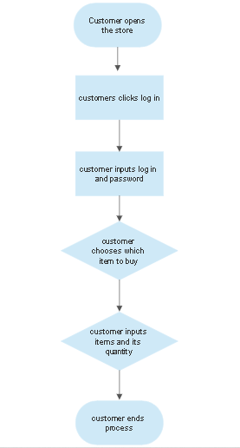**Program Flow Charts**
2. **References**

<https://www.w3schools.com/>

https://stackoverflow.com/

*https://www.halsteadbead.com/articles/pricing-strategy-tips-for-jewelry-business-profitability*

*https://iberjoyausa.com/collections/bracelets?*

*https://andersonsjewelry.com/*

*https://www.icebox.com/results/necklaces*

*https://jewelrymakingjournal.com/jewelry-pricing-formula/*

*https://www.luxegrillz.com/pages/how-much-are-grillz*