Git Commands
Date: July 01, 2025

Git Rebase
Rebase is an action in Git that allows you to rewrite commits from one Git branch to another branch. Essentially, Git rebase is deleting commits from one branch and adding them to another.
1. Initial Setup
- A Git repository was initialized.
- The following commits were made:
1. Initial commit on the main branch:
echo "Hello from main branch" > file.txt
git add file.txt
git commit -m "Initial commit on main"
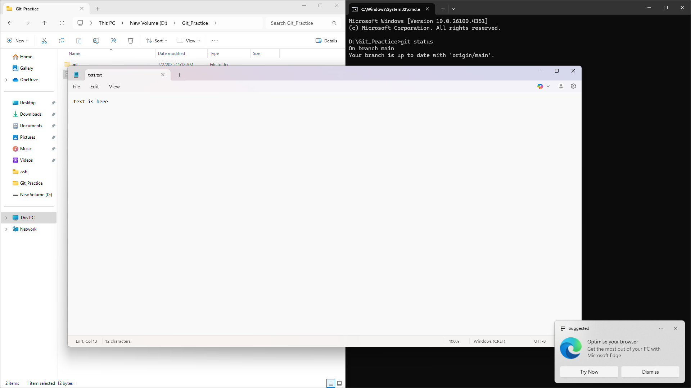
2. A new branch 'Branch2' was created and additional work was committed:
git checkout Branch2
echo "Some feature code" >> file.txt
git add file.txt
git commit -m "Branch2 work 1"
3. Back on main, more work was committed:
git checkout main
echo "Update from main branch" >> file.txt
git add file.txt
git commit -m "Main branch update"
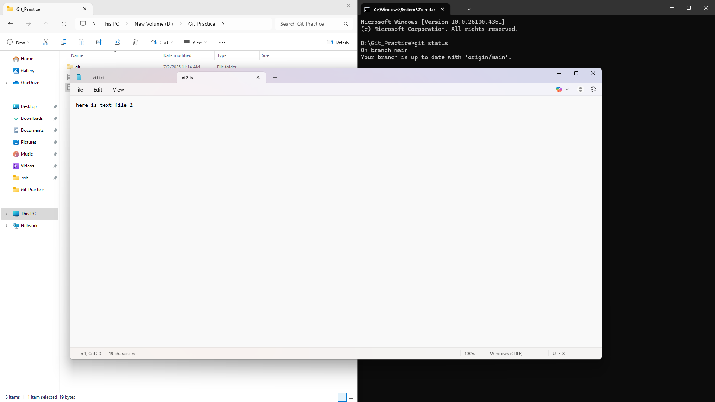
2. Starting the Rebase
- The 'branch2' branch was rebased on top of the updated 'main':
git checkout branch2
git rebase main branch2
3. Result
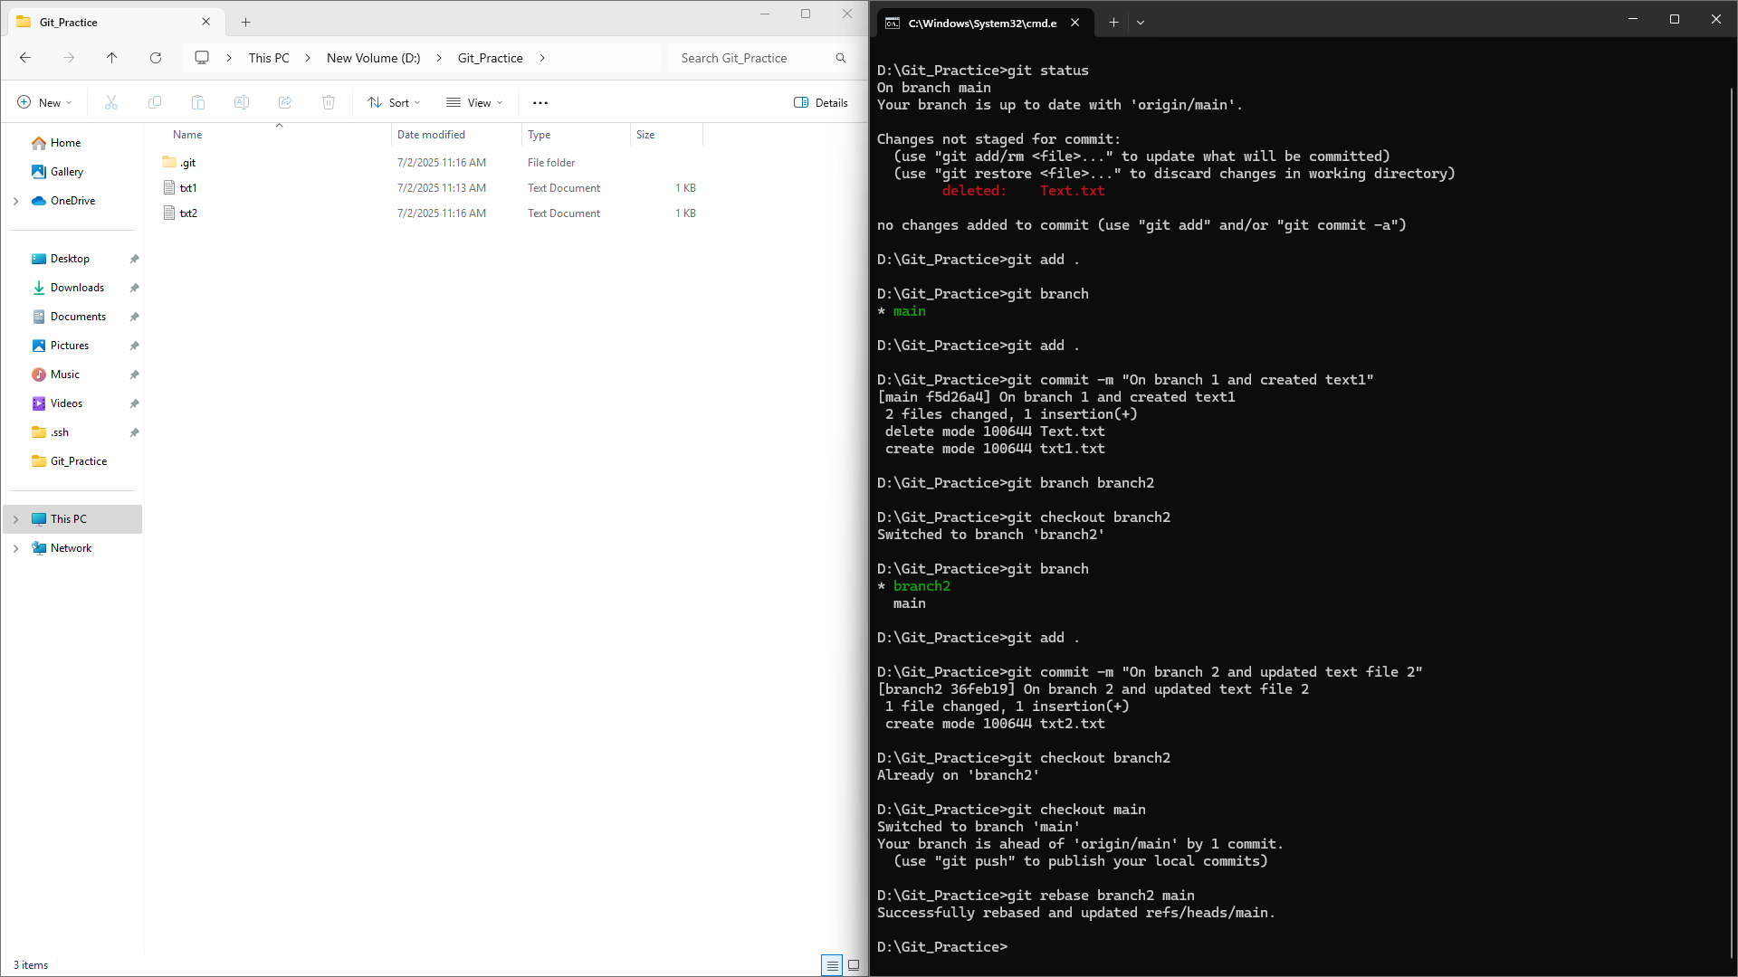

Git Stash

Git stash temporarily shelves changes made to working directory so we can switch branches or run operations like rebase without committing unfinished work. We can later restore those changes exactly where you left them.
- Uncommitted changes were stashed using:
git stash
This saved all modifications in a temporary stack and restored your working directory to a clean state.
- The stash was listed with:
Here is what I have used to resolve this:
git add file.txt
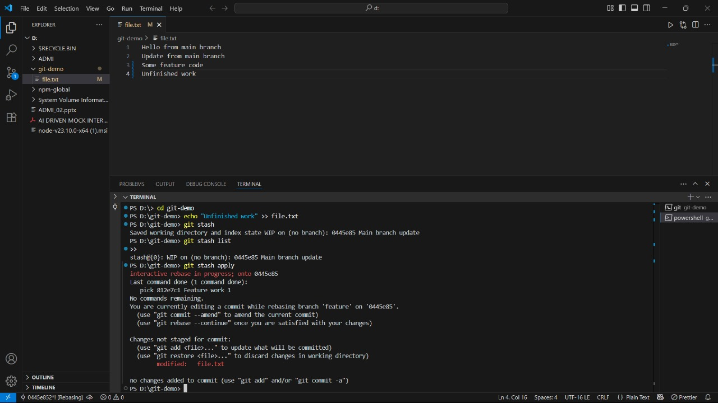
git stash list

and result in:
stash@{0}: WIP on feature: some changes

- Changes were reapplied using:
git stash apply
git stash pop
- Dropped refs/stash@{0} (c4……)
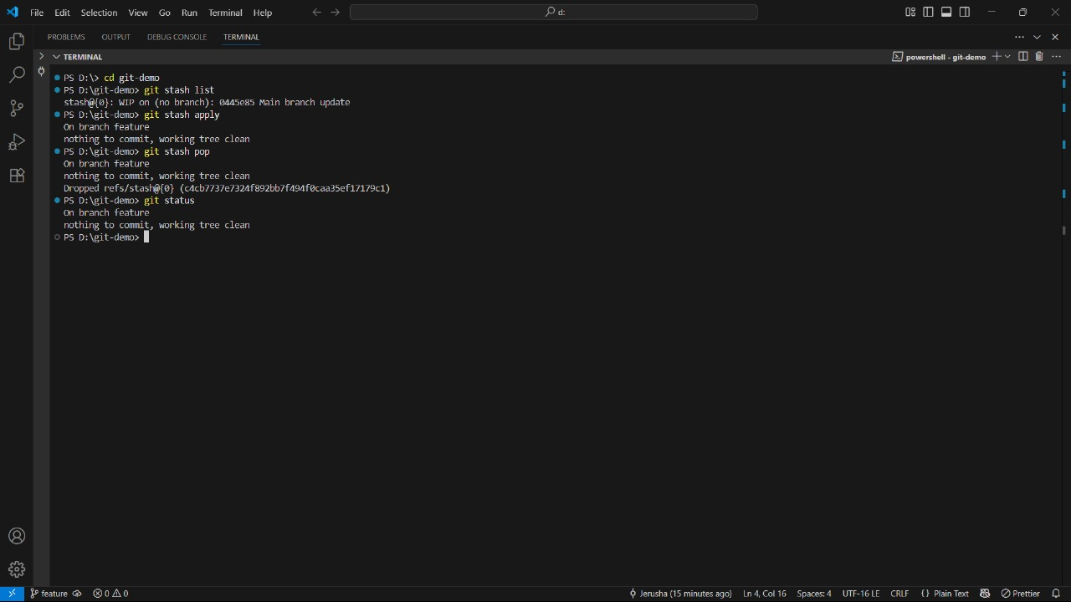

Git Reflog

Git Reflog (short for reference log) is a mechanism that records updates to the tips of branches, commits, and other references. It provides a detailed history of actions performed in the repository, even for changes that are not part of the main commit history.
- The full history of HEAD changes was viewed using:
git reflog
- This helped track commits and changes, including the rebase and stash.
Here I used
git checkout 0445e85
to move to the commit “Main branch update”
It gave result as
- HEAD is now at 0445e85 Main branch update

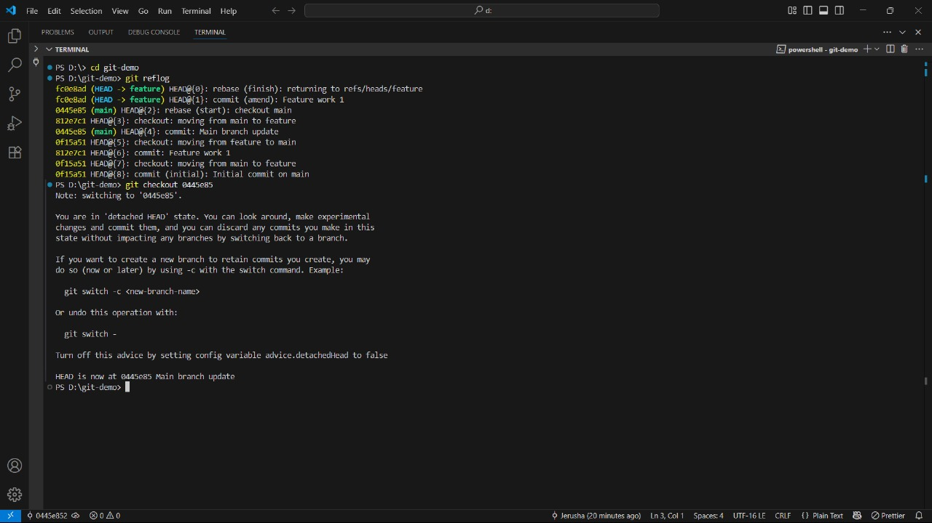

Git Tagging

In Git, a tag is a reference that points to a specific commit, allowing you to label and mark important points in your project's history, like release versions. Think of tags as permanent "sticky notes" on specific commits, making it easy to refer back to them later.
- A version tag was created to mark a successful project state:
git tag -a v1.0 -m "First version after rebase and stash"
- Tag details were verified using:
git show v1.0
