Assignment for Java Memory Management and Java Collection
- Jerusha Rani Tamiri
Java Memory Management
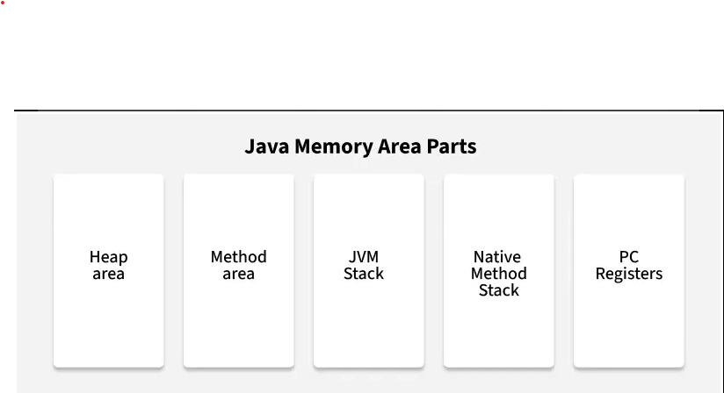
Explain the different memory areas managed by JVM.

The Java Virtual Machine (JVM) plays a key role in running Java applications. One of its main responsibilities is memory management. JVM divides memory into several sections, each with a unique purpose.

- Stack Memory:
This memory is used whenever a method is invoked. Each thread in a Java program has its own stack memory. Whenever a method is called, a stack frame is created in the thread's stack to hold:

- Local variables declared inside the method

- Method arguments passed during the call

- Return address which helps to go back to the calling method after execution finishes

E.g.:
public class Example {
public static void main(String[] args) {
int a = 10; // stored in stack
int b = 20; // stored in stack
add(a, b); // method call creates a new stack frame
}

public static void add(int x, int y) {
int sum = x + y; // variables x, y, and sum are stored in stack
}
}

Every time add() is called, a new stack frame is created. After it finishes, the memory for its local variables is released automatically.

- Heap Memory
This is the area where all objects and class instances are stored. It is a shared memory space across all threads. Objects created using the new keyword live here.

E.g.:

String name = new String("Jerusha");

Here, the String object is stored in heap memory.
Heap memory is managed by Garbage Collector which removes unused or unreferenced objects.
It is larger than stack memory and slightly slower due to its dynamic nature.

- Method Area
Method Area is a special part of JVM memory where all the class-level data is stored. Whenever we create a class or use a method, Java stores some important things in memory. All these things are stored in the Method Area. It is shared memory, which means all threads can use it. If it runs out of memory, you get OutOfMemoryError: Metaspace

Method area can contain:

- Class name and structure (like fields and methods)

- Static variables

- Method code (bytecode)

- Constant values

- Information about parent class and interfaces

E.g.:
static String college = "JNTU"; // Stored in Method Area

- Program Counter (PC) Register
The Program Counter (PC) Register is a small memory area in the JVM that stores the address of the current instruction being executed by the thread. It helps the JVM keep track of execution inside a method. Each thread has its own PC register (because JVM is multi-threaded). If the thread is executing a Java method, PC register holds the address of the next instruction to execute. If it is executing a native method, the PC value is undefined. It is the only JVM memory area that is thread-private and doesn’t throw any OutOfMemoryError.
E.g.:
int a = 10; // PC points here
int b = 20; // then moves here
int c = a + b; // and so on...
The PC Register keeps moving from one instruction to the next while your code is being executed.

- Native Method Stack
A native method stack is a way for a computer program to remember what it is doing when it calls special kinds of functions (called "native methods"). When a program calls a native method, it adds information about that method to the stack. When the method is finished, the information is removed from the stack. The native method stack helps the program run smoothly and prevents errors. It's like a to-do list that helps the program keep track of what it is doing. If the stack gets too full, the program might crash or run slowly. It is like trying to fit too many things on a shelf.
E.g.:
public class Example{
public static void nativeMethod();
public static void main(String[] args){
Example eg = new Example();
Eg.nativeMethod(); //Native method call
}
}

Differentiate between Stack and Heap memory with examples.
Feature | Stack Memory | Heap Memory
Definition | Used for storing method calls, local variables, and reference variables. | Used for storing objects created using new.
Memory Type | Fixed size, organized like a stack (last in, first out). | Large area of memory for dynamic object storage.
Access Speed | Very fast, because it's managed by the CPU. | Slower compared to stack, needs more memory management.
Memory Management | Managed automatically by JVM using stack frames. | Managed by Garbage Collector in JVM.
Lifetime | Memory is removed once method execution is over. | Objects stay in memory until they are no longer used (eligible for GC).
Thread Safety | Each thread has its own stack → safe. | Shared among threads → needs care to avoid issues.
Example | Local variables like int x = 10; | Student s = new Student(); → s is in stack, object is in heap
E.g.:
public class Example {
public static void main(String[] args) {
int a = 5; // Stored in stack
Student s = new Student(); // 's' in stack, object in heap
}
}
class Student {
int id = 101;
String name = "Jerusha";
}

What is Garbage Collection? How does it work in Java?
Garbage Collection
Garbage Collection is a process in Java where the memory used by objects that are no longer needed is automatically cleaned up by the JVM. That means we don’t have to manually delete objects like in C or C++.

Whenever we create an object using new, it takes memory in the heap. But when we are no longer using that object (no references pointing to it), it becomes useless. That’s when Java’s garbage collector comes and removes it from memory.

- checks for objects that have no reference.

- Those objects are marked as garbage.

- Then, garbage collector deletes them from memory.

- This helps to free up space and avoid memory issues.

We can also request garbage collection using System.gc(), but it’s just a request. JVM decides whether to run it or not.
E.g.:
class Sample {
int id;
Sample(int id) {
this.id = id;
}

protected void finalize() {
System.out.println("Object with id " + id + " is deleted");
}
}

public class TestGC {
public static void main(String[] args) {
Sample s1 = new Sample(1);
s1 = null; // Now this object has no reference
System.gc(); // Requesting JVM to perform garbage collection
}
}

In the above example, when I set s1 = null, the object becomes unreachable. So, it's ready to be deleted by the garbage collector. But, we need to remember, it runs automatically, only unreachable objects are collected, helps in efficient memory management, and we don’t have exact control over when it runs.
What are the different types of Garbage Collectors available in Java? Mention any two.
Garbage Collector (GC) helps manage memory automatically by cleaning up objects that are no longer needed, so the program doesn’t run out of memory. There are different types of garbage collectors, but here are two popular ones you might hear about:
1. Serial Garbage Collector
This GC works using just one thread — which means it does all the garbage collection work one step at a time.
Because it uses only one thread, it’s best for small applications or programs running on computers with single-core processors (older or simpler machines).
When it runs, it pauses the entire application to clean up memory. This pause is called a Stop-The-World event, meaning nothing else runs until garbage collection finishes.
Because of this pause, it’s not great for big or complex programs but works fine for simple ones.
command: XX:+UseSerialGC

2. Parallel Garbage Collector (also called Throughput Collector)
This one is more advanced. It uses multiple threads to do garbage collection at the same time, making it faster than the Serial GC.
It’s designed for programs running on computers with multiple cores (most modern computers), so it can make use of all those cores to clean memory quicker.
While it still pauses the application during garbage collection, these pauses are usually shorter because the work is done in parallel.
This collector tries to find a balance between keeping your program running fast and cleaning up memory efficiently.
command: -XX:+UseParallelGC

What is the role of the finalize() method in Java? Is it recommended to use it? Why/Why not?
What is finalize() in Java?
finalize() is a method that Java calls just before the garbage collector removes an object from memory. It gives the object a chance to do some last work, like closing files, releasing network connections, or freeing other resources before the object is completely destroyed. This method is like a cleanup step that happens automatically, but only if the garbage collector decides to run.
Is it recommended to use finalize()?
No, it is not recommended to use finalize() in modern Java programming.
Why not?
- The biggest problem is that we don’t know when or even if the finalize() method will be called. Garbage collection happens at unpredictable times, so relying on finalize() for important cleanup is risky.
- Using finalize() can cause the program to run slower because it makes garbage collection more complicated and expensive.
- There are much better ways to manage resources now, like using try-with-resources or writing your own close() methods that are called explicitly. These ways are more reliable and fast.
- Because of these problems, Java has marked finalize() as deprecated starting from Java 9 and plans to remove it in future versions.
finalize() was originally made to help clean up resources before an object is destroyed, but it is unpredictable, slow, and not reliable. It is better to avoid using finalize() and manage resources explicitly in your code.

Collection Hierarchy & List
Draw a simple diagram (can be hand-drawn) of Java's Collection hierarchy up to List and its child classes.
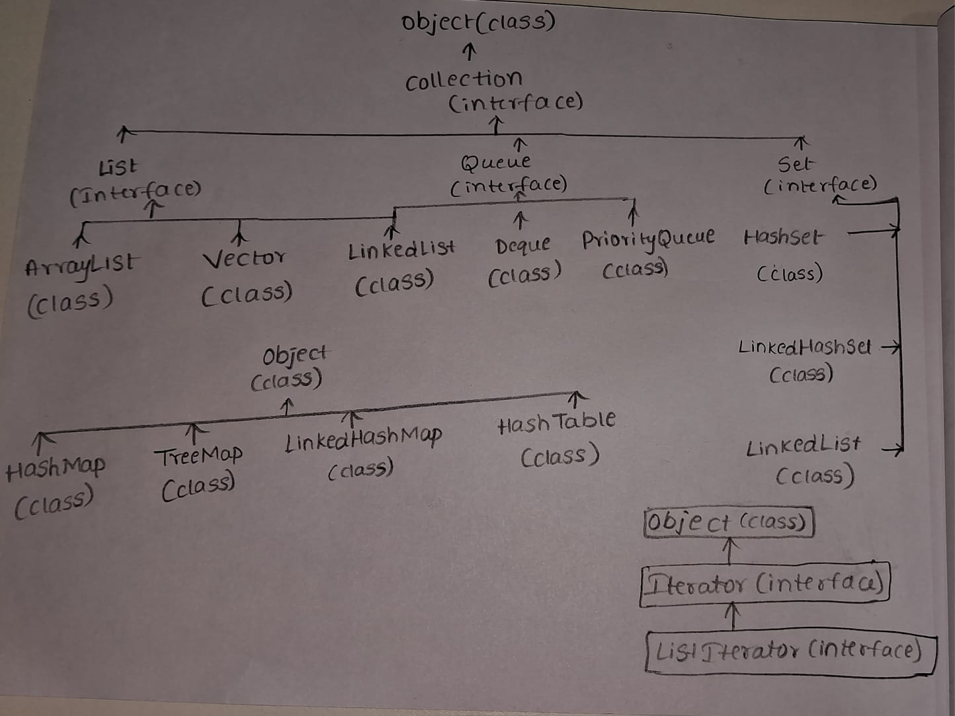

Conceptual & Application
- ArrayList vs LinkedList

Feature | ArrayList | LinkedList
Storage Type | Stores elements in a dynamic array (like a box with slots). Example: [A, B, C, D] | Stores elements as a chain of nodes. Each node has data + link to the next.  Example: A → B → C → D
Accessing Elements | Faster access using an index-like list. get(2). It directly jumps to the element. Time Complexity: O(1) | Slower because it has to start from the beginning and go one by one. Time Complexity: O(n)
Adding at the End | Very fast and efficient (unless resizing is needed). O(1) (amortized) | Fast, link a new node at the end. O(1)
Adding at the Beginning | Slow, as all elements need to be shifted. O(n) | Fast, just change the head pointer. O(1)
Adding in the Middle | Slow, because elements are shifted. O(n) | Fast, just re-link nodes. O(1) if position is known, else O(n)
Removing at the End | Fast. O(1) (amortized) | Fast. O(1)
Removing at the Beginning | Slow, due to shifting elements. O(n) | Fast, update the head pointer. O(1)
Removing in the Middle | Slow, elements shifted. O(n) | Fast, re-link nodes. O(1) if position is known, else O(n)
Memory Usage | Less memory is used. Only data is stored in an array form. | More memory is used. Each node stores data + reference to next (and previous in a doubly linked list).
Best  Use Case | When we need frequent access by index, or mostly add/remove at the end. | When we frequently insert/delete at the start/middle, or use iterators.
Example | ArrayList<String> arrayList = new ArrayList<>(); | LinkedList<String> linkedList = new LinkedList<>();

- Stack vs Vector

Feature | Stack | Vector
Definition | Stack is a special type of Vector that follows Last In First Out (LIFO) order. | Vector is a growable array that can store elements and is thread-safe.
Working Principle | We can only add or remove elements from the top of the stack. | We can add, remove, or access any element using index.
Add/Remove Method | We use push() to add and pop() to remove elements. | We use add() to insert and remove() to delete elements.
Accessing Elements | We usually access only the top element using peek(). | We can access any element using its index.
Order of Elements | Follows LIFO – Last In is removed First. | Maintains the order in which we added elements.
Use Case | Good when we need to store data in reverse order, like undo operations. | Good when we want a thread-safe version of ArrayList.
Thread Safety | Yes, because it extends Vector. | Yes, it is thread-safe (methods are synchronized).
Performance | Slower than non-thread-safe collections due to synchronization. | Same as Stack, slower due to synchronization.
Time Complexity | push() – constant timepop() – constant timepeek() – constant time | add() – constant time (amortized)get() – constant timeremove() – linear time in worst case
Inheritance | Stack is a subclass of Vector. | Vector is the parent class.
Example | Stack<Integer> stack = new Stack<>(); | Vector<Integer> vector = new Vector<>();

- ArrayList vs Vector

Feature | ArrayList | Vector
Definition | It is a resizable array used to store elements. | It is also a resizable array, similar to ArrayList.
Thread Safety | Not thread-safe (used in single-threaded programs). | Thread-safe (all methods are synchronized, used in multi-threaded apps).
Performance | Faster because it is not synchronized. | Slower because every method is synchronized.
Growth Size | Grows by 50 percent of current size when full. | Grows by 100 percent (doubles in size) when full.
Accessing Elements | Fast for getting elements using index. | Also fast for getting elements using index.
Adding Elements | Fast for adding at the end. | Slightly slower due to thread safety.
Removing Elements | Fast for removing at end but slow in middle (needs shifting). | Same as ArrayList.
Use Case | Used in non-threaded programs where speed is needed. | Used in multi-threaded programs where safety is needed.
Time Complexities | get() – constant timeadd() – constant (amortized)remove() – linear | Same as ArrayList, but slower due to locking.
Legacy or Modern | Modern class (part of Java Collections Framework). | Legacy class (older, kept for backward compatibility).
Example | ArrayList<String> list = new ArrayList<>(); | Vector<String> vector = new Vector<>();

Real-life Scenario
Suppose you are developing a browser history feature. Which Java Collection would you use to:
- Store the visited URLs so that you can go back and forward easily?
- Explain your reasoning

I am making a browser history feature where I need to save all the URLs the user visits. The user should be able to go back to previous pages and also move forward if they want.
For this, I would use a LinkedList, specifically a doubly linked list.
A doubly linked list stores elements in order and lets me move easily both backwards and forwards because each URL points to the previous and next one. This is very important for browser history since users go back and forth between pages.
If I used a singly linked list, which only points forward, moving backward would be difficult and slow, because I’d have to start from the beginning every time to find the previous page.
Also, LinkedList is good because it does not need to shift elements when adding or removing URLs — it just changes the links between nodes, making navigation and updates fast.
In summary, I choose a doubly linked list because it allows easy and fast movement both back and forward in the browser history, which fits perfectly for this feature.

