Micro Drone Designing In Fusion 360

In this online workshop, you'll be taken step by step through the process of how to design and 3D Print your own Micro Drone Chassis. Once you have designed your chassis using Fusion 360, you'll export your design as an STL, ready for 3D Printing.

Learning objectives

● Introduction to 3D Printing

● Introduction to Fusion 360

● Understanding the parametric CAD workflow.

○ Sketch – Basic Sketch Modeling.

○ Sketch – Application of Dimensions and Constraints.

○ Feature – Extrude, Revolve, and Fillet.

○ Assembly – Application of Joints and As-Built Joints.

○ Rendering – Scene Setup and Cloud Rendering.

○ Drawings – View Creation, Dimensioning, and Title Block edit

● Difference between a body and a component.

● Basics of Drone Construction.

● Model a drone chassis of manufacturing.

● Creating Drawings, Renders, and Animations

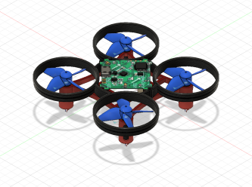

Step 1: Getting Started in Fusion 360

Instructions:

1. You'll need to download the software.

2. Sign in to Fusion 360, if you haven't already got an Autodesk Account you'll need to create one.

3. Start by opening a new design in Fusion 360 by going to file and then a new design. 4. Make sure to save your design. go to file and then save.

5. First, start by going to create and new component. Name the new component 'Drone Chassis’ and press ok.

6. Go to Sketch and then Create Sketch. Select the bottom plane to start drawing your sketch.

7. Start by creating a Center Rectangle around the origin, change the dimensions to 47mm x 47mm.

8. Using a Center Diameter Circle, place the center of the circle on a corner of the rectangle made previously. Change the diameter of the circle to 8.2mm.

9. Draw another Center Diameter Circle on the same corner, this time change the diameter to 6.2mm.

10. Go into the sketch menu and select offset. Use the offset tool to offset the smaller 6.2mm circle inwards by 0.5mm creating a circle with a diameter of 5.2mm.

11. Once you have drawn the three circles, go to the end of the toolbar and stop the sketch.

12. Next, go into the create menu and select extrude. Extrude the outside ring downwards by a distance of -15.5mm and press ok.

13. Go into the Drone Chassis Component and find the Sketch folder. Find sketch 1 and turn on the lightbulb to make it visible again.

14. Again using the extrude tool, extrude the inside ring downwards by -0.5mm, making sure the operation is set to join and press ok. Lastly, go into modifying and select fillet. Select the bottom edge of the motor mount and apply a fillet with a radius of 0.5mm and press ok.

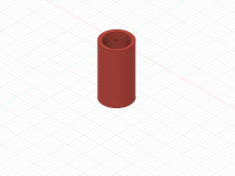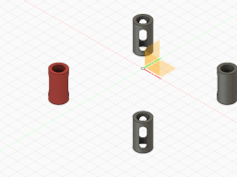

Step 2: Creating the Drone Base

Instructions:

1. Go to create and pattern, select circular pattern.

2. Select the ducting as the object to the pattern, then select the Y-axis (or axis pointing upwards) as the axis to create the pattern around. Change the quantity to 3 to add three more ducting.

3. Go into a sketch and Create Sketch, again choose the bottom plane to sketch on. 4. Using the line tool, draw a line going from the origin along the axis with a distance of 19mm.

5. Next, go into a sketch and down to project, select the project tool and click on the outside edge of the top and bottom ducting on either side of the line. Press Ok when complete.

6. Then go back into a sketch and select 3 point arc. Start by selecting the center of the top ducting, then select the center of the bottom ducting. The third point should be placed on the end of the line drawn previously.

7. Using the offset tool, offset the arc in both directions by 0.75mm to give an overall thickness of 1.5mm.

8. Go into creating and select extrude, then select the arc profiles joining the top and bottom ducting together. Extrude downwards by a distance of -3mm.

9. Again using the circular pattern tool, change the type to features. Select the last feature in the timeline as the feature to pattern and the Y-axis (or axis pointing upwards) as the axis to pattern around.

10. Finally, go into modifying and combine, select the main section of chassis as the target body and then any unselected bodies as the tool bodies. This will create one single body.

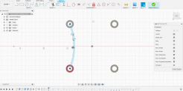

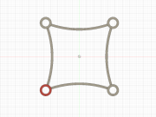

Step 3: Creating the Battery Tray

Instructions:

1. Go to sketch and create a new sketch on the bottom plane or top face of the drone chassis.

2. Start by drawing a center rectangle around the origin, change the dimensions to a width of 20mm and a height of 40mm.

3. Next, select the offset tool, offset the rectangle by 1.5mm outwards.

4. Using the project geometry tool, select the inside edge of the top and bottom arc of the drone chassis.

5. Then use the extrude tool to extrude the two sides of the rectangle downwards by -3mm and press ok.

6. Once complete, go into the inspect menu and select section analysis.

7. Select the side plane ... as the plane to perform a section analysis. Notice how the drone appears cut in half, a new folder called Analysis will have appeared in the browser.

8. Create a new sketch on the same plane as the section analysis.

9. Place a two-point rectangle on the top edge of the drone chassis going downwards, roughly place the rectangle halfway between the origin and ducting. Change the dimensions of the rectangle to 1,5mm wide and 2,5mm high going downwards.

10. Use the dimension tool in the sketch to dimension the rectangle 10mm away from the origin by select the origin and the inside edge of the rectangle. Stop Sketch.

11. Next, use the extrude tool to extrude the rectangle outwards. Change the direction of the extrude to symmetric. Select the inside face of the battery tray. Notice how material only seems to extrude on one side. Make sure to turn the lightbulb next to the analysis folder off.

12. Finally, go to create and select Mirror. Change the type to feature and select the last feature in the timeline. Select the plane running down the center of the drone to mirror the feature.

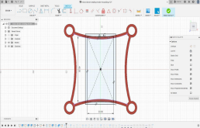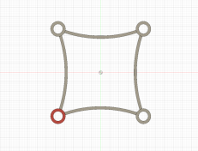

Step 4: Creating the Ducting

Instructions:

1. Now you've completed the bottom section of the drone, go into the bodies folder and hide body 1, we'll turn it back on later.

2. Next, create a sketch on either side plane, start by selecting a two-point rectangle. 3. Following the axis, place the first point away from the origin on the axis. Draw a rectangle with a width of 1.5mm and a height of 6mm going upwards.

4. Go into the sketch and select the dimension tool. Dimension the rectangle 17mm away from the origin and then stop the sketch.

5. Then go into creating and select revolve, select the rectangle as the profile to revolve. Then select the axis pointing upwards as the axis revolves around. 6. Now you've created a ducting, go into modifying and select move. Change the type of move to point. Turn back on sketch 1 in the browser using the lightbulb. Select the ducting as the body to move, then select the origin as the first point. The target point is one of the four corners of the square.

7. Once the ducting is in place, go in to create, pattern, and then select a rectangular pattern.

8. Select the ducting as the body to the pattern, then select a direction. Choose an edge of the square as the direction. Change the quantities in both directions to 2 and the distance to 47mm. The distance may be positive or negative depending on the directions. Check to ensure that each corner of the drone has ducting.

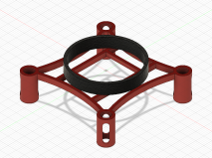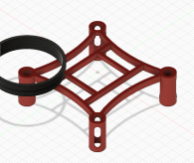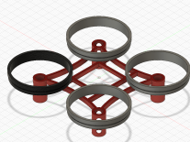

Step 5: Completing the Chassis

Instructions:

1. To complete the chassis, start by creating a new sketch on the bottom plane. 2. Next, select a Center Diameter Circle and draw two circles around the origin, one with a diameter of 36.5mm and another with a diameter of 39.5mm.

3. Then go back into a sketch and find the project geometry tool, select the inside edge of all four ducting.

4. Once the sketch is complete, use the extrude tool to extrude the four profiles connecting the ducting together. Change the distance to 6mm and make sure to change operation to join.

5. Next, go to modify and select fillet. Using a Rule Fillet, select the top face of the drone and apply a radius of 0.75mm.

6. Go back into a sketch and create another sketch on the bottom plane.

7. Draw a Center Diameter Circle on-axis halfway between the origin and the chassis. Change the diameter of the circle to 3mm.

8. Use the Dimension tool to dimension the circle 19mm away from the origin.

9. Extrude the circle upwards by a distance of 6mm, make sure to change the operation to join.

10. Then go to create and select the hole tool. Select the top face of the extruded circle, use the blue circle to move the hole to the center of the mounting. Change the diameter of the hole to 1mm and the depth to 7mm.

11. Using the mirror tool, change the type to features. Select the last two features in the timeline, then select the plane going through the middle of the drone.

12. Finally, turn body one back on using the lightbulb. Go to modify and select the combine tool. Combine the top and bottom of the drone together.

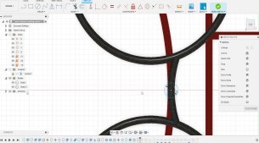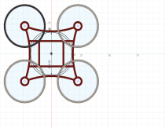

Step 6: Weight Reduction

Instructions:

1. Change the physical materials of the drone chassis from Steel to ABS. 2. Weigh the overall design of the drone chassis by right-clicking on the chassis component and going to properties. Take a note of the weight.

3. Go back into the timeline into the sketch beforetogether the revolve. Take a section of the rectangle by drawing a two-point rectangle in the bottom right corner, change the dimension to 0.75mm wide and 3mm high.

4. Go back into the revolve feature and unselect the rectangle previously drawn in the last step.

5. Then go into the chassis properties and check the weight again. It should have reduced by a couple of grams.

6. Try also to reduce weight in other areas of the drone such as the motor mountings, without compromising the strength and structure of the chassis.

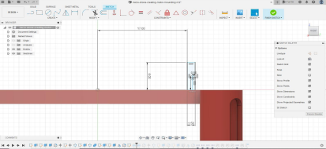

Step 7: Manufacturing Drawings

Instructions:

1. Change your workspace from model to draw, select drawing from design. 2. Stick with the default settings for the sheet.

3. Start by creating a base view of the drone design, you may need to change the orientation and scale of the drone to 1:1

4. Next, try adding a projected view by going to views and projected view. Click on the views you want to add and then press enter on your keyboard to add the views to the sheet.

5. Try adding dimensions to the drawing using the dimension tool.

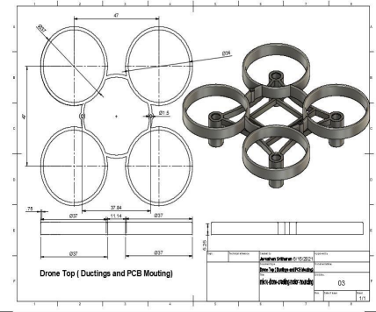

Step 8: Export to 3D Print

Instructions:

1. Once you’re happy with the overall weight and design of your chassis, it’s time to get your drone ready for 3D printing.

2. To export your design as an STL file, go into the toolbar and Make. Then open the 3D print tool.

3. Next, select the body which you wish to export as an STL.

4. Change the refinement of the STL file to high, this will produce a better resolution mesh.

5. If you already have slicing software installed such as Cura. You can export directly to the slicing software by checking the send to the Print Utility box and selecting the relevant software.

6. Alternatively, you can also just export as an STL file by unselecting the Send to Print Utility check box. Press Ok and save the STL file onto your computer.

7. If you don’t know how to slice an STL file, there are plenty of tutorials available on Instructables to guide you through the process.

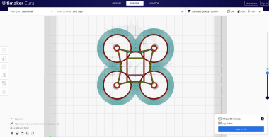

Step 9: Drone Component Assembly

Instructions:

1. Start by downloading the drone components which can found on this Instructables page. You’ll need a clockwise and counter-clockwise propeller, Motors, PCB, and Battery to complete the drone.

2. Once downloaded, go to the data panel and access your project folder. Click on upload and select the downloaded files to place them in your folder.

3. Make sure to activate the top component in your browser by click on the white circle or right-clicking and then activate.

4. Then either drag in all the components, or right-click on the component and insert it into the current design. In some cases, you will need multiple components such as the motors and propellers

5. Use a combination of As-built Joints and Joints to assemble the drone. Follow the video tutorial to learn how the drone is properly assembled.

