LoRaWAN Research Test Results
P1 - Normal operation | 30-minute EMU-01 to gateway to ChirpStack to PostgreSQL to Fabric
Recorded measurements: COMPLETE • Formal repetition: NOT ACCEPTED
The source, ChirpStack, database and Fabric outbox figures below were recorded during the 30-minute window. The recorder stopped before clean finalization; recovered evidence is sealed as RECORDED_WITH_ERRORS, so this run is not an accepted formal P1 repetition. The 119 confirmed outbox records have transaction IDs; independent HRC validation-code-zero and exact-byte digest evidence was not joined to this audit.

1. Test results
Check | Recorded result | Interpretation
Window | 22 Sep 2026, 02:53:04–03:23:04 UTC; 1,800 s | Full measurement window
Scheduled sensor attempts | 120 of 120; 15-second profile | Measured
ChirpStack accepted | 119 unique EMU-01 uplinks | Measured
PostgreSQL | 119 uplink events; 1,547 measurement rows | Measured
Fabric outbox | 119/119 confirmed with TxIDs | Measured; outbox evidence
Sealed evidence | 63 files; SHA-256 and 2 regeneration checks PASS | Reproducible
Recorder finalization | 11 collectors not alive when recovered | RECORDED_WITH_ERRORS

2. Zacarias Chapter 3 measurements
Measurement | Recorded result | Basis
Packet delivery rate | 119 / 120 = 99.17% | Unique ChirpStack accepts / sensor attempts
Sensor → database latency | mean 628.63 ms; SD 165.63 ms | 119 correlated deliveries
Latency range | 386.08–1,144.10 ms | 119 correlated deliveries
Stored-reading throughput | 119 / 1,800 s = 0.0661 readings/s | 3.97 readings/min
Fabric outbox confirmation | 119 / 119 = 100% | Confirmed outbox records with TxIDs; HRC code/digest join not verified
Application → database latency | mean 34.34 ms; SD 21.72 ms | 119 events; supplementary
Duplicate database events | 0 | 119 unique events
Unaccepted in-window uplinks | 1 | Gateway saw 120, ChirpStack accepted 119

Clock correlation: PASS; end-to-start workstation/cloud offset drift 0.069546 s (limit ±0.100 s). The 121 source-log entries include one outside the calibrated 30-minute window. PDR correctly uses 120, not 121. The missing sequence cannot be assigned a precise cause from these aggregate counts alone.

3. CPU and memory measurements
Observed host | CPU average / maximum | Memory average / maximum | Samples
Gateway-01 | 4.90% / 9.89% | 3.41% / 3.58% | 361
ULC-01 | 40.05% / 68.35% | 62.92% / 64.54% | 358
ULC-02 | 60.20% / 84.23% | 55.63% / 56.22% | 358
ULC-03 | 60.74% / 91.12% | 67.54% / 70.25% | 358

Resource percentages are host utilization sampled by the recorder during the run; container-specific utilization is separately retained in raw/ulc*-docker-resource.csv. The Chapter 3 baseline CPU and memory measurements are reported above for the gateway and all three cloud nodes.

4. Actual sensor and network evidence

Sensor serial transmissions — original EMU-01 source-log excerpt
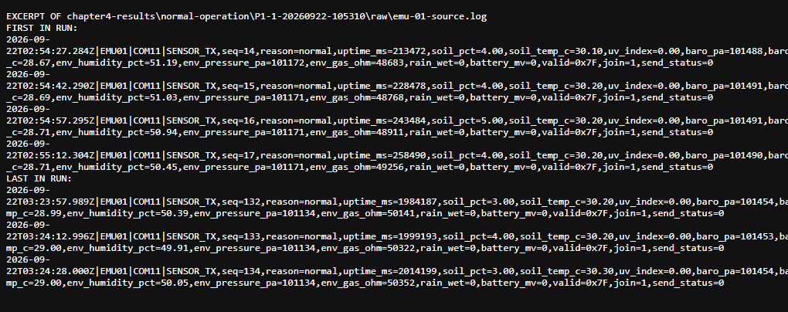

ChirpStack acceptance — original ULC-01 event-log excerpt
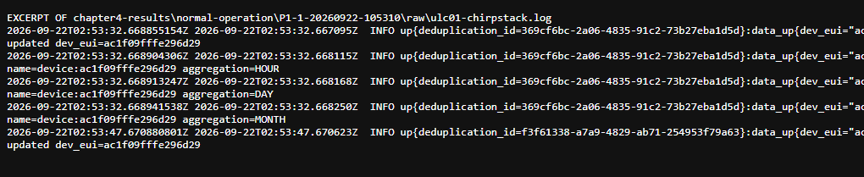

PostgreSQL accepted uplinks — original database export excerpt
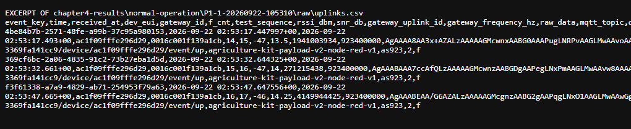

Fabric confirmation and transaction IDs — original outbox export excerpt
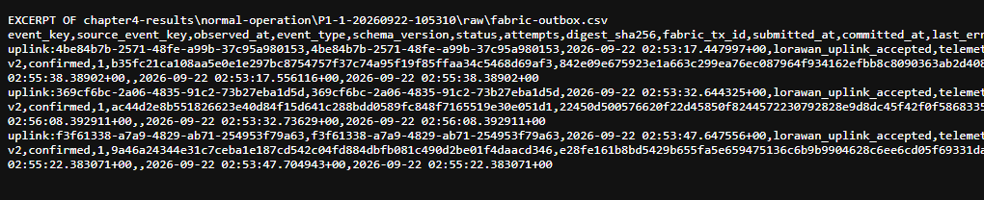

Recorded PDR, latency and throughput — original run-summary.csv
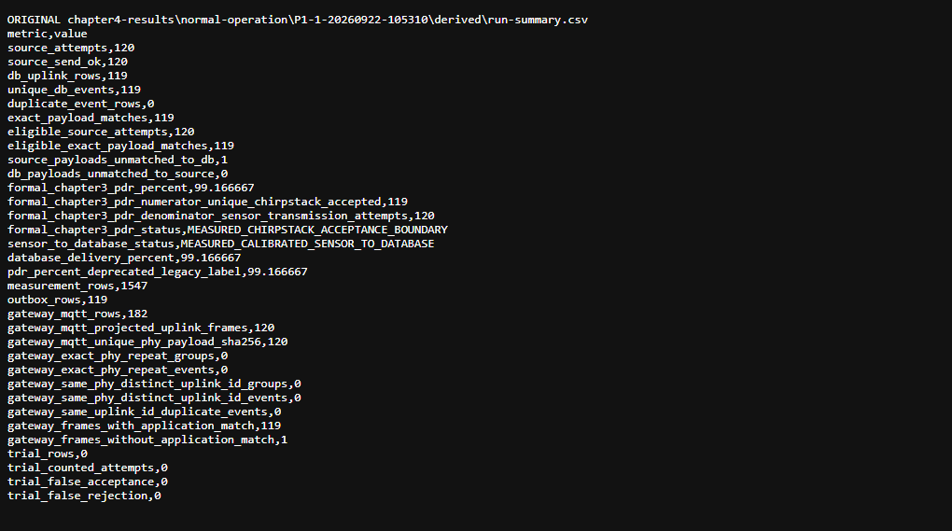

Recorded time correlation, gateway and cloud CPU/memory — run-summary.json excerpt
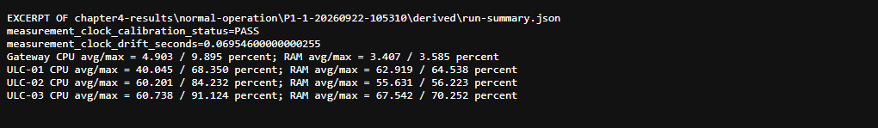

Fabric settlement — 119/119 confirmed in original fabric-settle.json
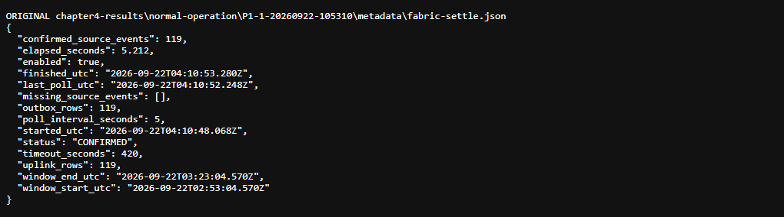

Independent seal and summary verification — 63 files, two identical regenerated summaries
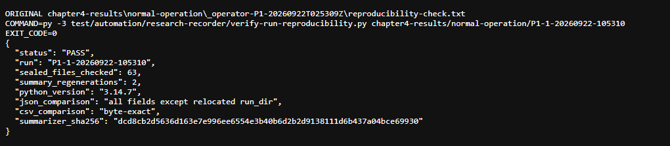

5. Finalization finding

Recorder recovery — 11 collector processes already stopped before finalization
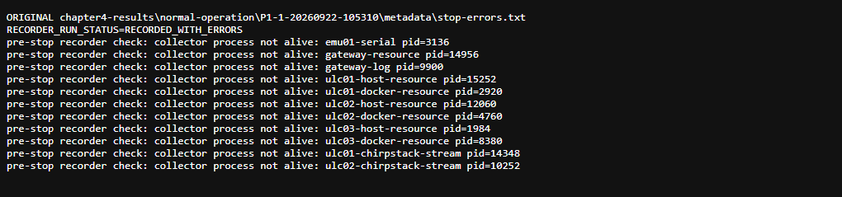
Final recorded state: RECORDED_WITH_ERRORS. The 30-minute observations and 63-file seal are preserved and reproducible; the interrupted recorder supervision prevents counting this attempt as a clean formal P1 repetition. Do not overwrite, reclassify, or delete the original run.

6. Original evidence
Run: chapter4-results/normal-operation/P1-1-20260922-105310/
Operator recovery: chapter4-results/normal-operation/_operator-P1-20260922T025309Z/
Retain source log, both ChirpStack logs, uplinks.csv, measurements.csv, fabric-outbox.csv, host/docker resource CSVs, calibrated run-summary.json, fabric-settle.json, stop-errors.txt, run-status.txt, and SHA256SUMS.csv. Source archive: P1-original-audit-evidence.zip.
For the three formal P1 repetitions required by Chapter 3, run in a persistent PowerShell session through the full 30-minute measurement period, Fabric settlement, and recorder finalization; accept a repetition only when its own exit code, run-status, expected 120 attempts, timing, Fabric confirmation and evidence verification are valid.

P1 missing uplink - ChirpStack deduplication error
Missing reading: EMU-01 sequence 123 / LoRaWAN FCnt 122. The sensor recorded send_status=0; the gateway concentrator received uplink 2736020495 on 923.4 MHz at SF7. The gateway forwarded it over MQTT; gateway event 22753 was recorded at 11:20:18 AM (UTC+8), RSSI -31 dBm, SNR +13.75 dB.
ULC-01 ChirpStack logged reception of the gateway event, followed 0.684 seconds later by: ERROR chirpstack::uplink: Deduplication error error=Zero items in collect set. No application uplink or database reading was created for this transmission. The next reading, sequence 124 / FCnt 123, was accepted.
Loss occurred during ChirpStack uplink deduplication, not at the radio, gateway, LTE/MQTT forwarding, database or Fabric. The available logs do not establish why the deduplication collection was empty.
Recorded originals: raw/emu-01-source.log, raw/gateway.log, raw/gateway-mqtt-events.csv, raw/ulc01-chirpstack.log, raw/ulc02-chirpstack.log and raw/uplinks.csv, under chapter4-results/normal-operation/P1-1-20260922-105310/.
ChirpStack correction: the default 200 ms deduplication delay implies a 400 ms Redis collection lifetime. The observed 684 ms gateway-ingress-to-error interval is consistent with expiry, but does not prove the internal cause. Administrative SSH is not authorized; no server settings were changed. Keep the original 119/120 measurement until a new verified trial.

P1 - Recorder correction check
The 90-second non-counted run manual-P1-rehearsal-20260922-132449 used a persistent managed test process instead of a one-shot command. The whole collection and Fabric settlement finished; the process exited 0.
Check | Actual result
Full run duration | 90 seconds
Scheduled sensor attempts | 6
ChirpStack accepted uplinks | 6 / 6
Database-matched latency | 6 samples; mean 608.099 ms
Fabric outbox confirmed | 6 / 6
ChirpStack deduplication errors | 0 on ULC-01; 0 on ULC-02 during this run
Supervisor | Seven PASS checks; no collector errors
Sealed evidence | 62 files verified; two summaries regenerated identically
Recorder exit | 0; RECORDED_UNCLASSIFIED
Formal P1 repetition | NOT COUNTED - 90-second rehearsal only
The interrupted 30-minute P1 remains 119/120 (99.17%) and RECORDED_WITH_ERRORS. The persistent-process procedure fixes that capture-session failure. The isolated ChirpStack deduplication failure has not been repaired at server configuration level; six clean later readings do not prove that it cannot recur.
P1 Restarted Run Audit — 22 September 2026
Run P1-1-20260922-134254. Formal 30-minute window: 13:42:53–14:12:53 Philippine time. Final disposition: NOT ACCEPTED / RECORDED_WITH_ERRORS; launcher exit code 2. Measured delivery: 120 sensor attempts, 56 unique target uplinks accepted by ChirpStack, formal PDR 46.67%; 56 database events and 728 measurement rows. Gateway MQTT captured 62 unique uplink PHY payloads, so six gateway-received frames did not reach application acceptance. Deduplication audit found zero 'Zero items in collect set' and zero deduplication-error strings in both ChirpStack logs; all 123 supervisor health records were PASS. Fabric settlement caused rejection: 56 outbox rows, 54 confirmed with transaction IDs, 2 pending at bounded timeout. Clock calibration PASS with 0.026362 s start-to-end drift. Calibrated sensor-to-database latency: mean 3926.99 ms, min 427.97 ms, max 79329.29 ms; application-event-to-database mean 40.69 ms, min 10.15 ms, max 242.16 ms. SHA-256 manifest: 63 entries, independently rehashed with 0 mismatches. Earlier power-interrupted P1 evidence remains preserved separately and is not counted.

