

Android Mobile Application

OLBooks

User Guide Manual

**Table of Contents**

**Application Overview** 1

**User Access Level** 1

**Login** 1

**Sign Up** 2

**Forgot Password** 4

**Home Screen** 5

**Search Category** 6

**Personal Profile** 7

**Book Details** 8

**Other Feature** 9

# **Application Overview**

OLBooks stands for Online Books, it is a mobile electronic device which is also known as e-book that contains PDF files allow anyone to view and read. Some of the books you're looking for can be seen in this application. There is no subscription required and all you need to do is to register using your email.

# **User Access Level**

Registered User - is the one who register in the OLBooks application by filling the sign-up form. Registered user can view books, search categories, save books, read books and update profile.

# **Login**

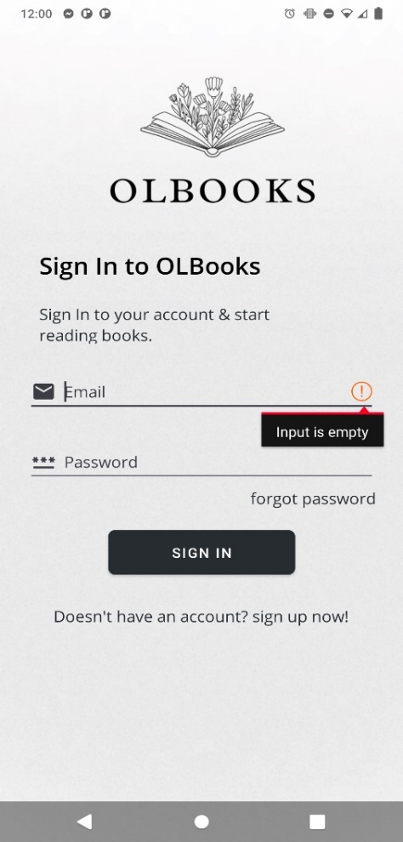

As the application is launch, the **Login** page will be displayed allows the user to login. It has two field, the Email, and the Password. Once the verification complete, the user will proceed to the Main page.

# **Sign Up**

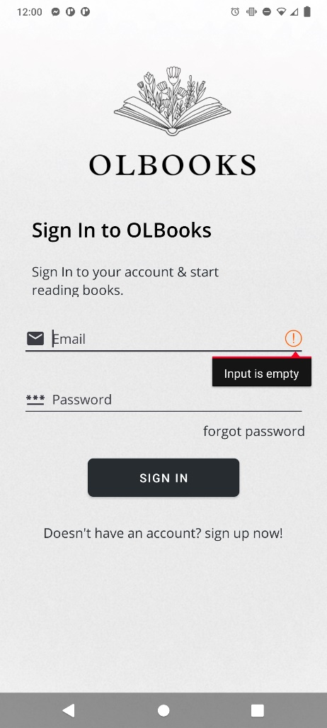

If the User doesn’t have an account, the user can click the **“Doesn’t have an account? Sign up now!”** text and it allow the user to create his/her personal account

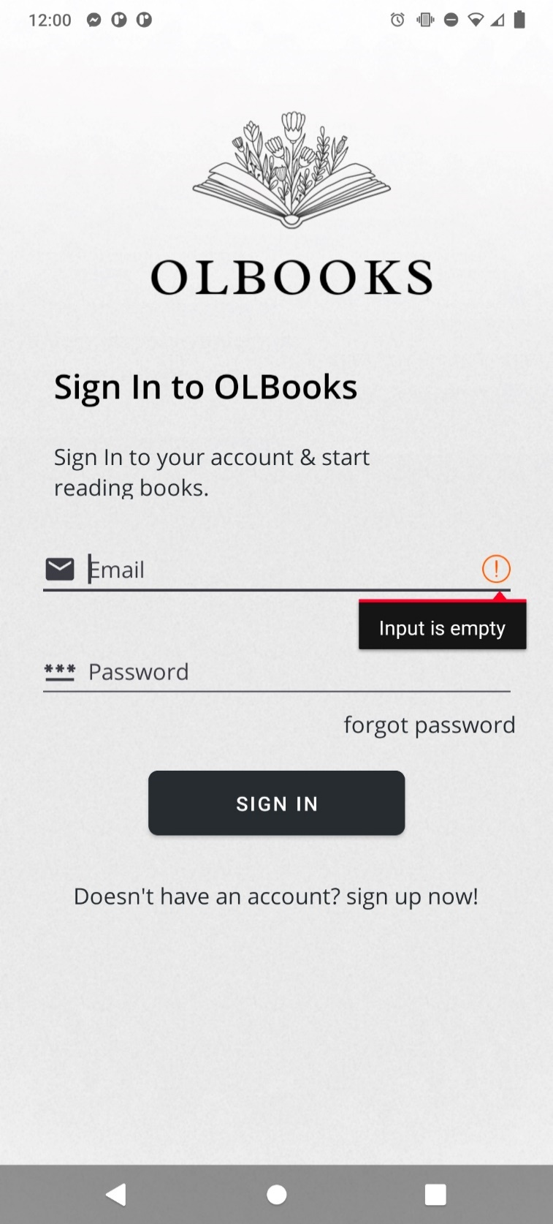

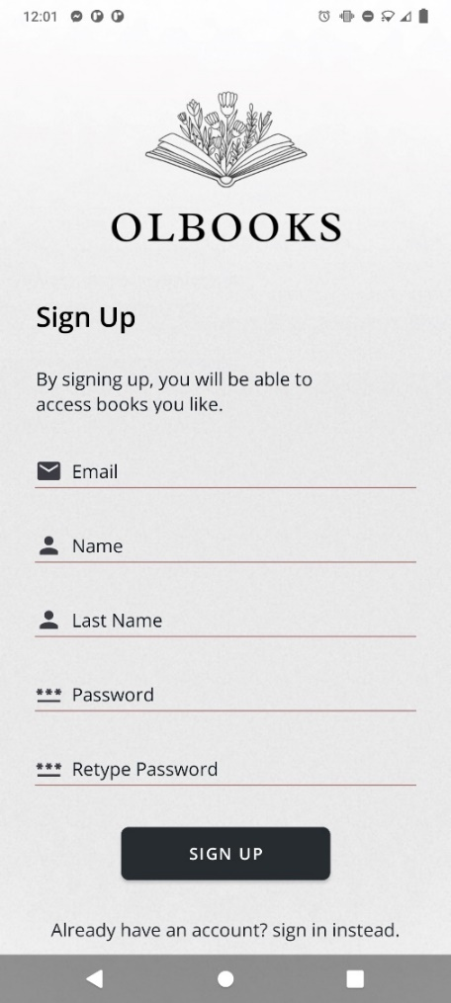

The User need to enter the valid **Email**, **First Name**, **Last Name**, and **Password** then click **Sign Up**

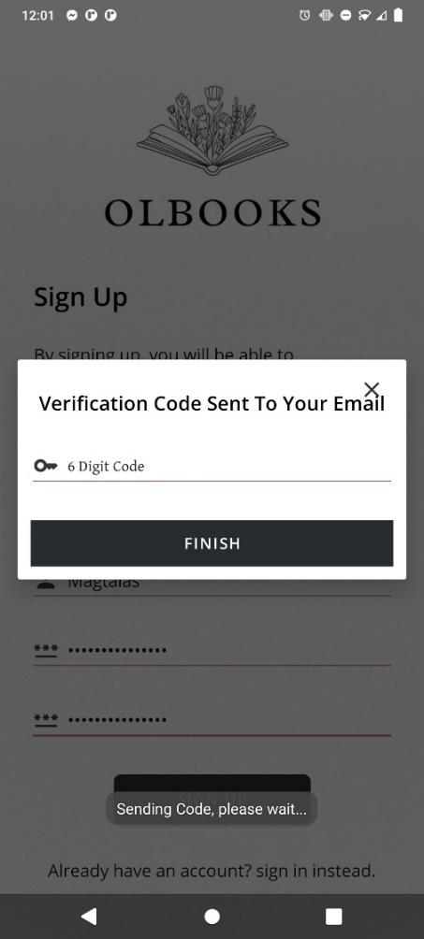

Enter the **Verification Code** after receiving it. Click the button **"Finish"**, then Sign In the new account on the Log In screen

**Email**

The system will send a **Verification Code** to the User’s inputted email

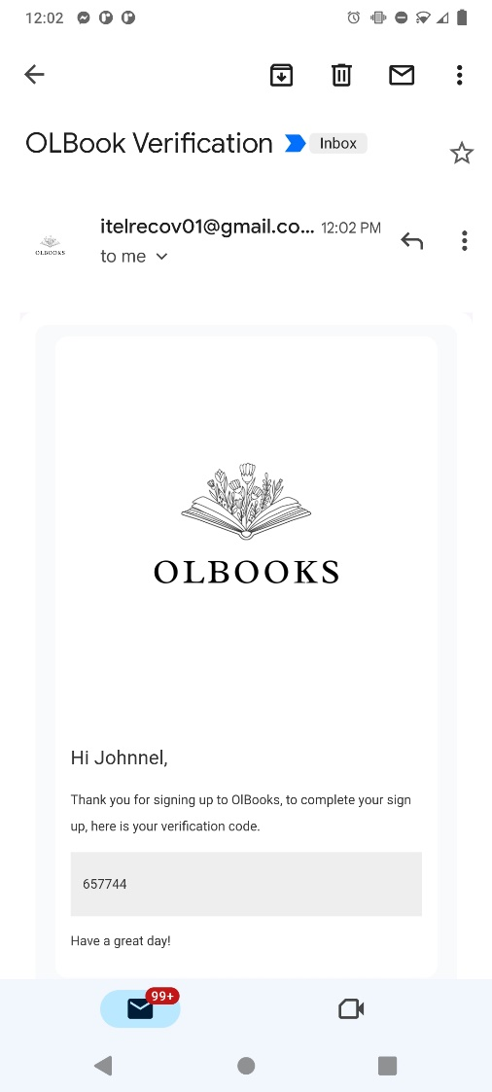



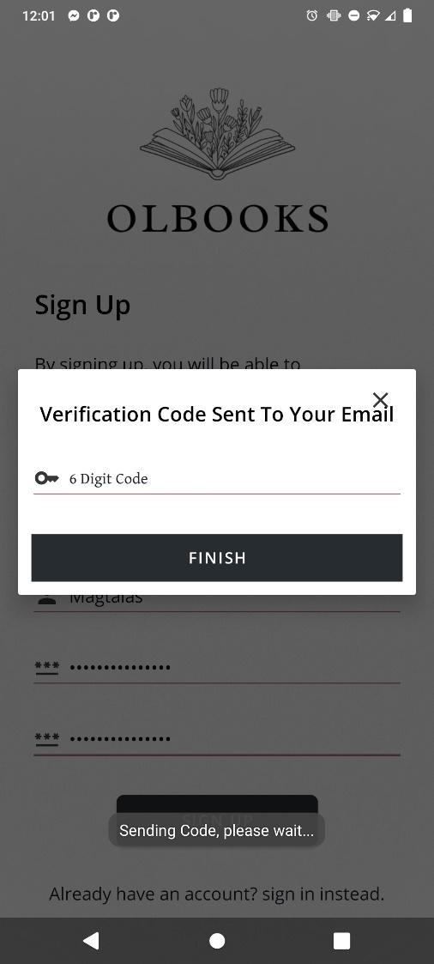

657744

# **Forgot Password**

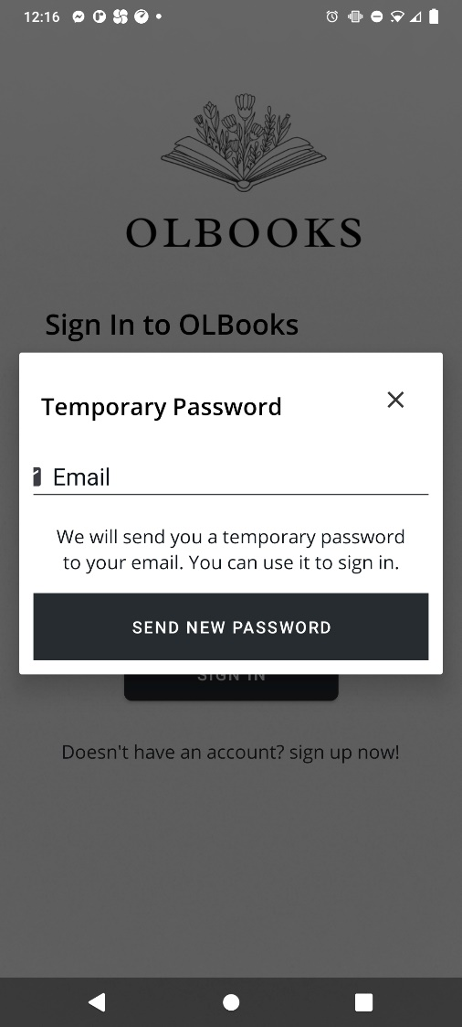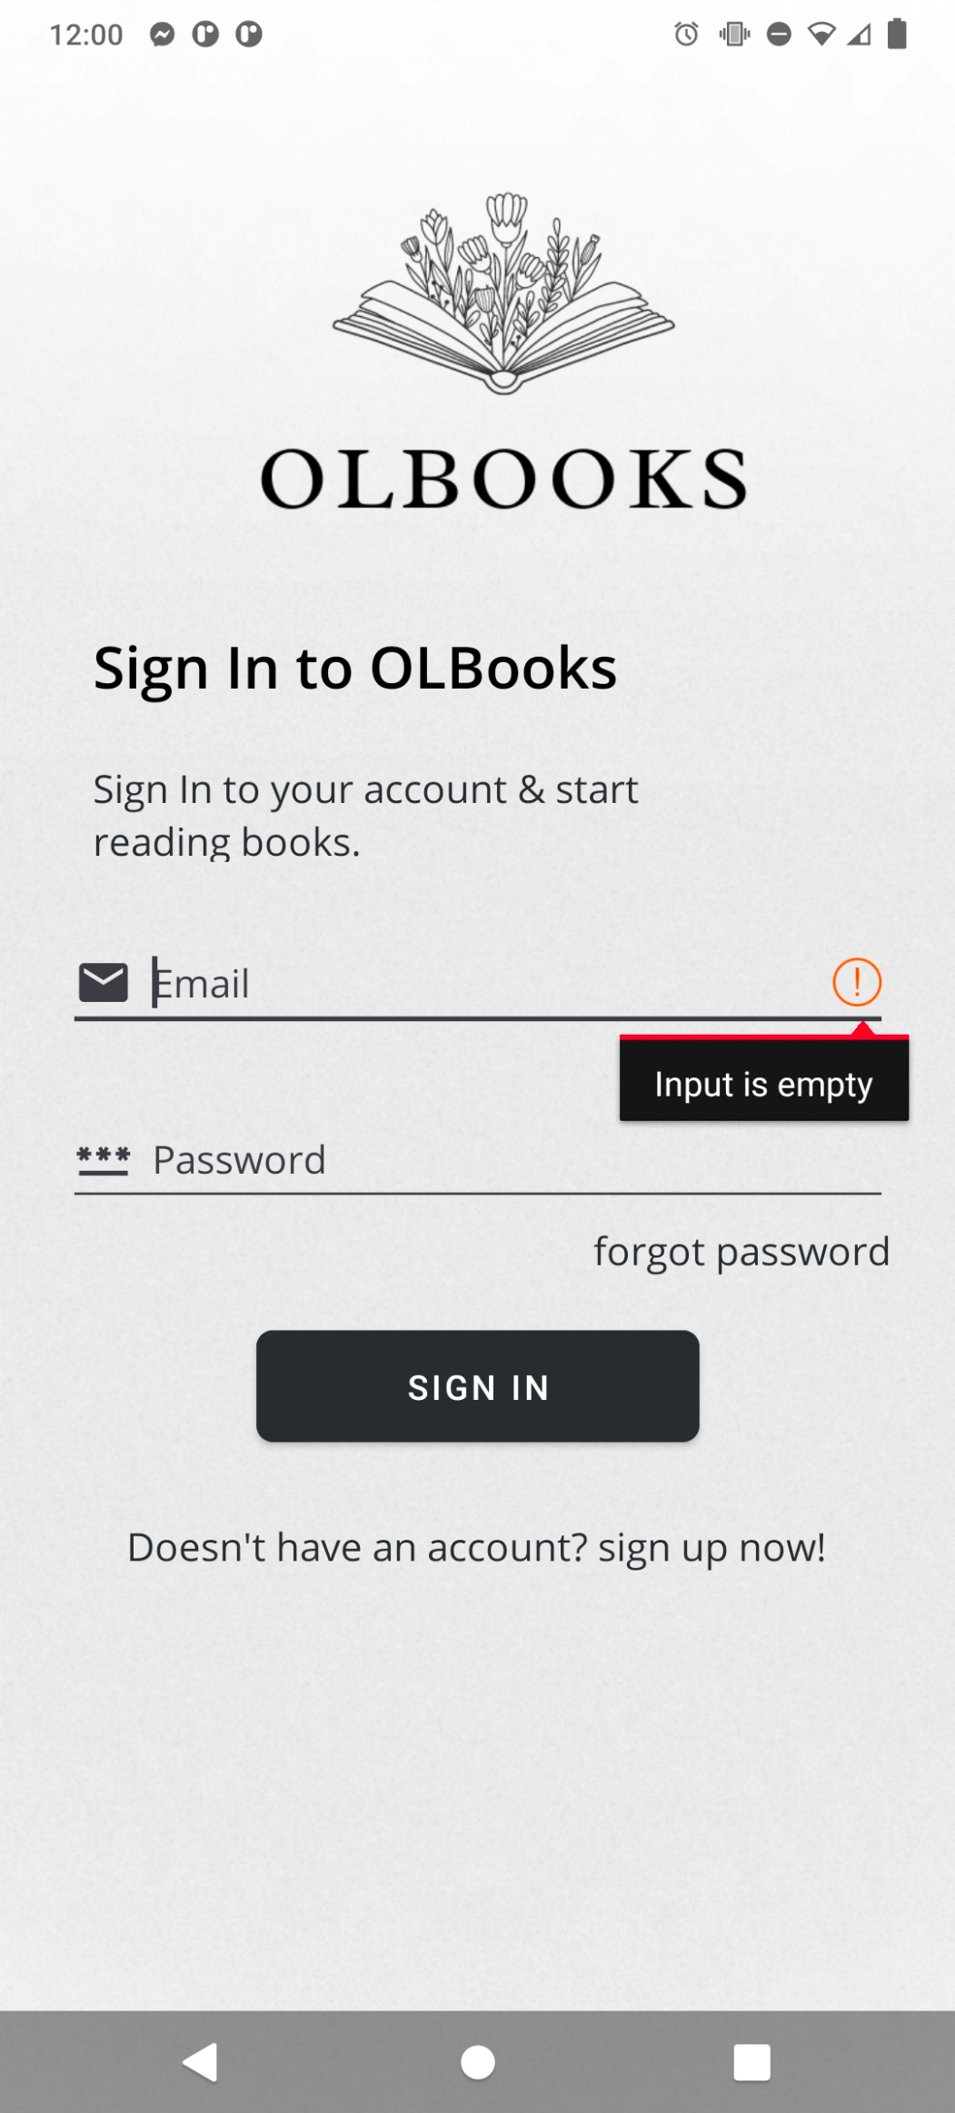

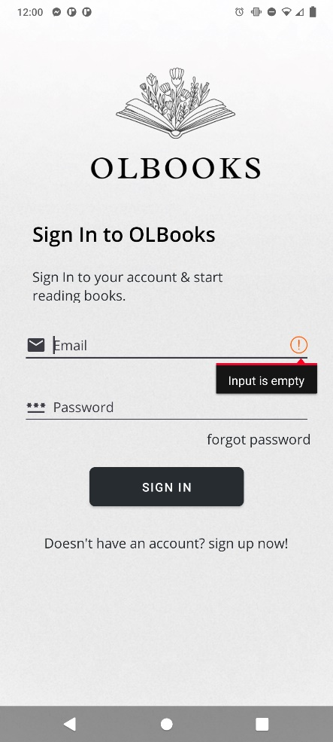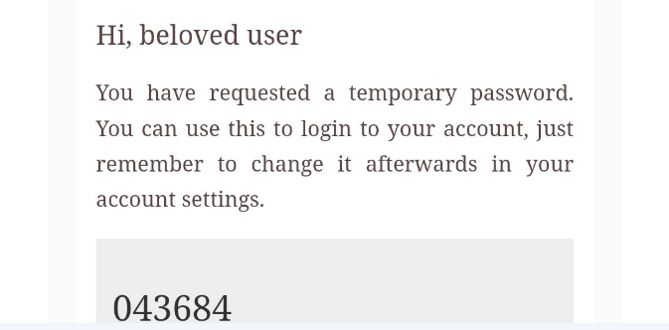

The system will send a new password through **Email**. The code will serve as a **Temporary Password** for the User

In order to generate a new Password, the User must provide their **Email** then click **“Send New Password”**

If the User forgot their Password, the **“Forgot Password”** allow the user to generate new code as a temporary password

# **Home Screen**

On the Main screen, the User may view and modify their profile, they can click book image to view details. User can also search for a book that they are interested to by clicking the **“Search Book”**

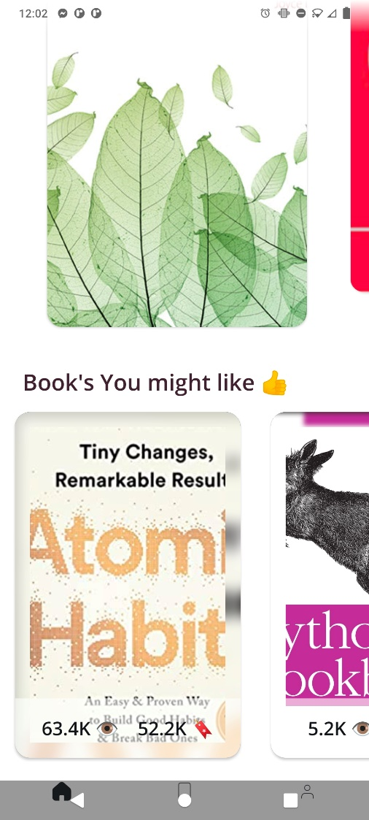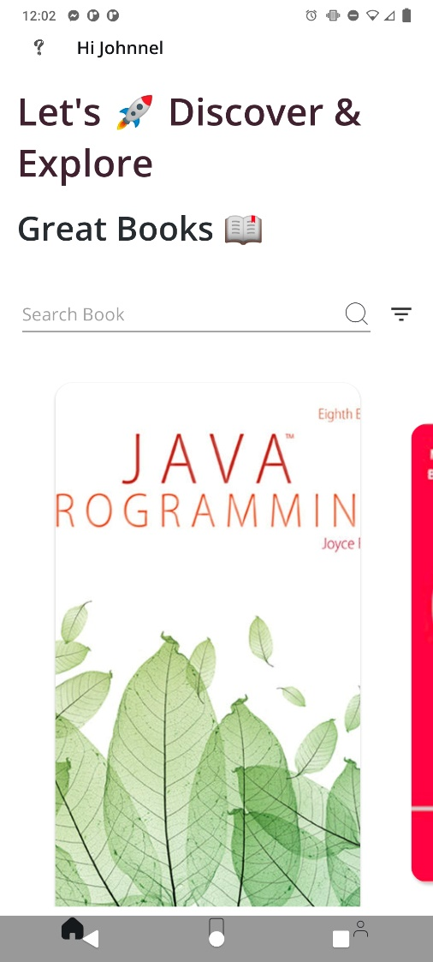

# **Search Category**

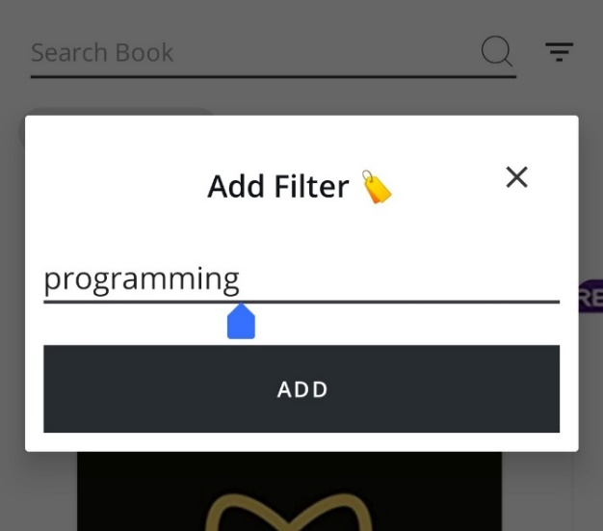

**Filters** can be added by the User to search for particular books, after that click **“Add”** to apply

# 

If the User wants to add more categories, they can add another filter. After the filter applied, it will displayed below the search bar, then click **"Magnifier Icon"** to search what they are looking for

# **Personal Profile**



To access and modify their account, Users can click their **Account Name** on the top left corner

# 

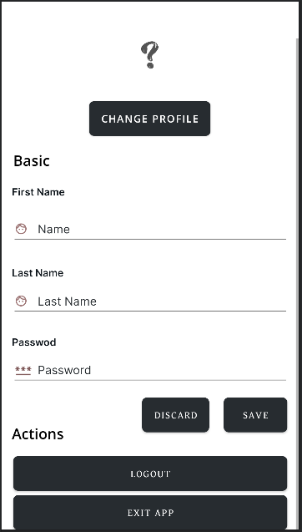

The User can edit their **Information**, upload **Profile Picture**, and change their **Password**

Click **“Logout**” or **“Exit App**” to Sign Out

# **Book Details**

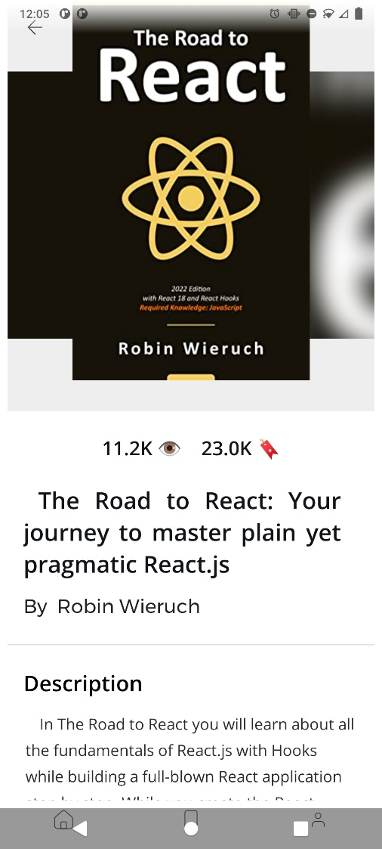

When the user clicks on the book cover, the book details will be displayed. It contains the book's title, a description, the book's cover, information on how many people have viewed and saved the book, when it was published, and the **ISBN-10** and **ISBN-13** of the book

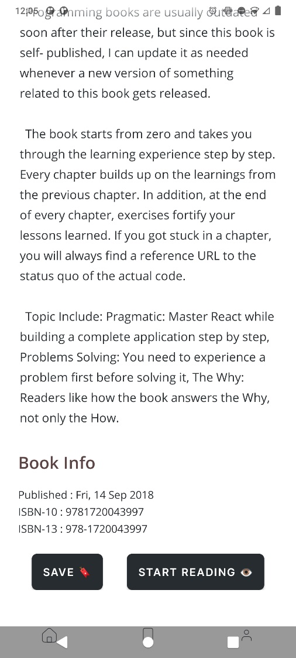

The user can **Save** the book and **Read** the book the clicking the button

# **Other Feature**

The **"Start Reading"** button takes the user to the digital book view. User can switch between night and light modes by clicking "Sun” and “Moon” icon, it minimize and reducing the blue light emitted by smartphone screen.

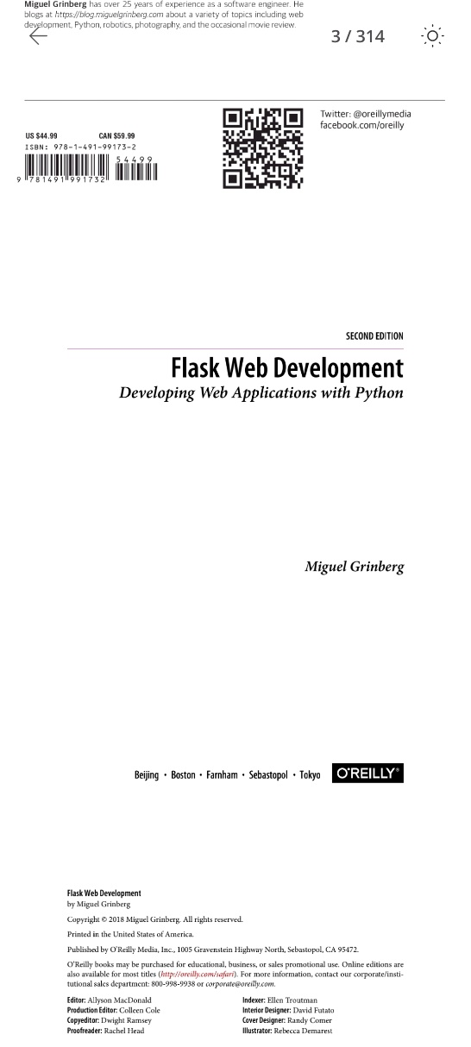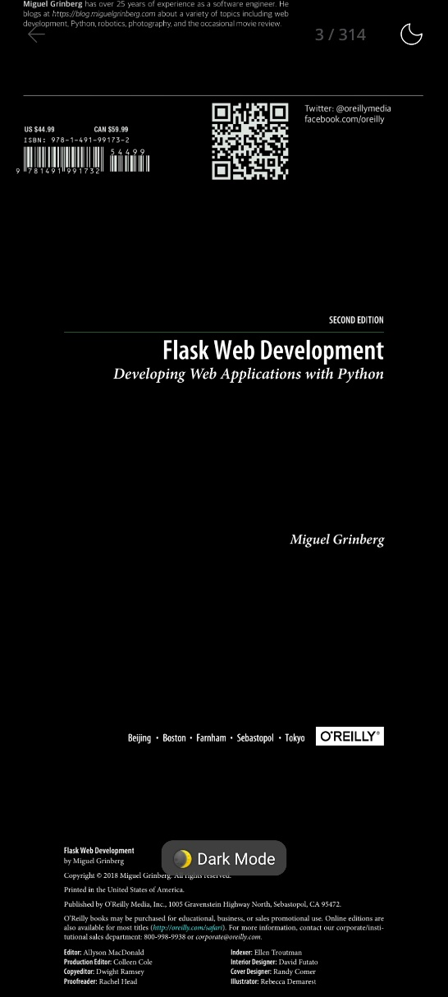

**Night mode**

**Light mode**

**Light/Night Filter**

**Jump Page**

They can also skip to a different page by clicking the "Page number” on the top left of the screen, click “Jump” to direct jump to the page.

