MySQL

Query 1:

[SELECT](http://localhost/phpmyadmin/url.php?url=https://dev.mysql.com/doc/refman/5.7/en/select.html) c.id as id_customer, c.no_telpon as no_telpon, c.produk as produk, s.nama_sales as nama_sales FROM customer as c JOIN sales as s ON (c.id_sales=s.id);

Result 1:

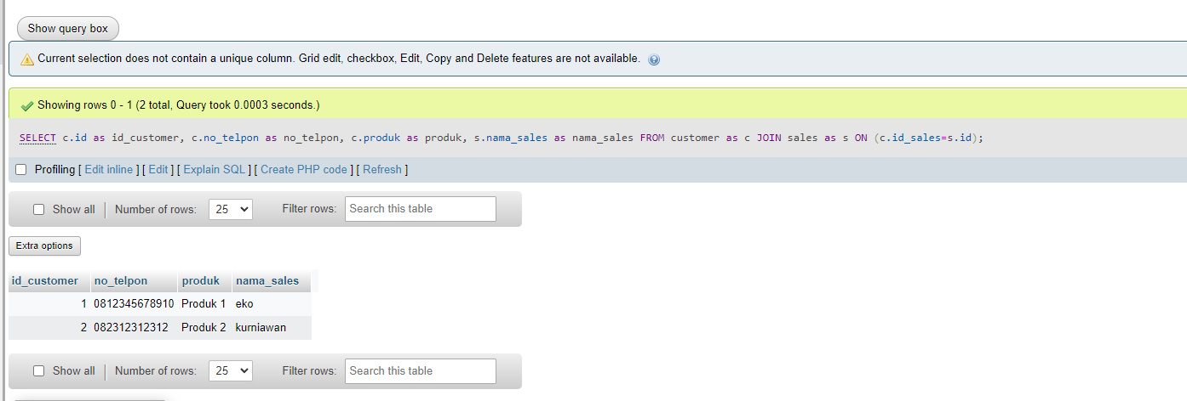

Query2:

[SELECT](http://localhost/phpmyadmin/url.php?url=https://dev.mysql.com/doc/refman/5.7/en/select.html) [COUNT](http://localhost/phpmyadmin/url.php?url=https://dev.mysql.com/doc/refman/5.7/en/aggregate-functions.html%23function_count)(id_customer) as Total_Cast FROM pelangan WHERE jenis_kelamin="Perempuan" [AND](http://localhost/phpmyadmin/url.php?url=https://dev.mysql.com/doc/refman/5.7/en/logical-operators.html%23operator_and) umur>30;

Result2:

