Chapter 04 | Waste Classifier application

Description:
The Waste Classifier user interface is implemented in Python using Streamlit and follows the same containerized deployment model as the API — packaged with Docker and hosted on Google Cloud Run. The service is available on demand but scales to zero when not in use. Users should expect an initial cold start delay of approximately 30 seconds before the first classification result is returned.

Access:
Application is publicly available at the following URL:
https://waste-classifier-ui-943543256910.europe-central2.run.app

Usage:
Once the application has loaded, we can see the main welcome screen. To send an image to the classifier, just click on the ‘Upload’ button and choose an image from your gallery.
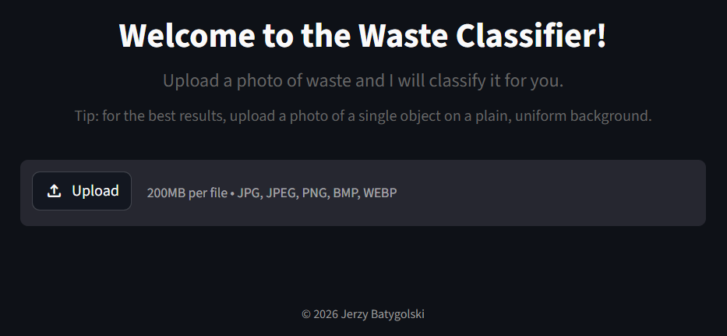
After image upload, application resizes it to 224x224 pixels (keeping aspect ratio and adding grey padding if needed) and sends it to the classifier via an API call. The classifier returns the predicted class along with the probability scores for all 10 recognized classes. An example results are given below:
