# Problem Solving Assignment

**A Cat, a Parrot, and a Bag of Seed**

1. Define the problem: This problem consists of getting a man, a cat, a bird and a bag with just one seed and this man has a boat that needs to cross a river. But the man can only carry one other thing in his boat while he crosses the river. The cat could eat the bird, and the bird could eat the seed. So he needs to cross them over in a specific way that one doesn’t eat the other. The problem says it’s a bag of seed, which leads me to think there’s only one seed in the bag, but I’m not sure. The main goal is to get all 3 and man across the river, whole and/or alive.
2. Constraints: You cannot leave the bird alone with the cat or the bird alone with the seed.  
   Sub-goals: take each one across the river without having one eat the other while left alone.
3. Possible Solutions: At first I thought a possible solution to the whole problem was the bird eat the seed and the cat eat the bird and then technically you could get everything across the river but then after I read the whole problem, it was obvious this couldn’t be a solution.   
   A solution to make sure one thing doesn’t eat the other is to take the things across the river in an order that no one would eat anything. Possibly taking things back and forth until you’re able to get everything across.
4. Evaluate Solutions: Well my first solution wouldn’t work because it defeats the purpose of crossing everything over the river alive.  
   The second solution could work to eventually solve the whole problem and achieve the main goal of crossing everything over in one piece while doing one at a time.
5. Choose Solution & Develop Plan: The theorized solution I evaluated in part four, does in fact work. Follow along with the diagram below.
   1. Step 1: The man, cat, parrot, and seed all start off in the same side of the river.
   2. Step 2: The man takes the parrot across the river.
   3. Step 3: The man crosses the back to the original side of the river and leaves the parrot on the other side.
   4. Step 4: The man takes the seed to the other side of the river while leaving the cat on the original side of the river.
   5. Step 5: The man takes the parrot with him to the original side of the river and leaves the seed on the other side.
   6. Step 6: The man takes the cat to the other side of the river, where the seed is, and leaves the parrot on the original side of the river.
   7. Step 7: The man crosses back to the original side of the river. The parrot is on the original side while the cat and the seed are on the other side.
   8. Step 8: The man lastly takes the parrot to the other side of the river.

Following these steps the man can take everything across the river and nothing will get eaten.  
  
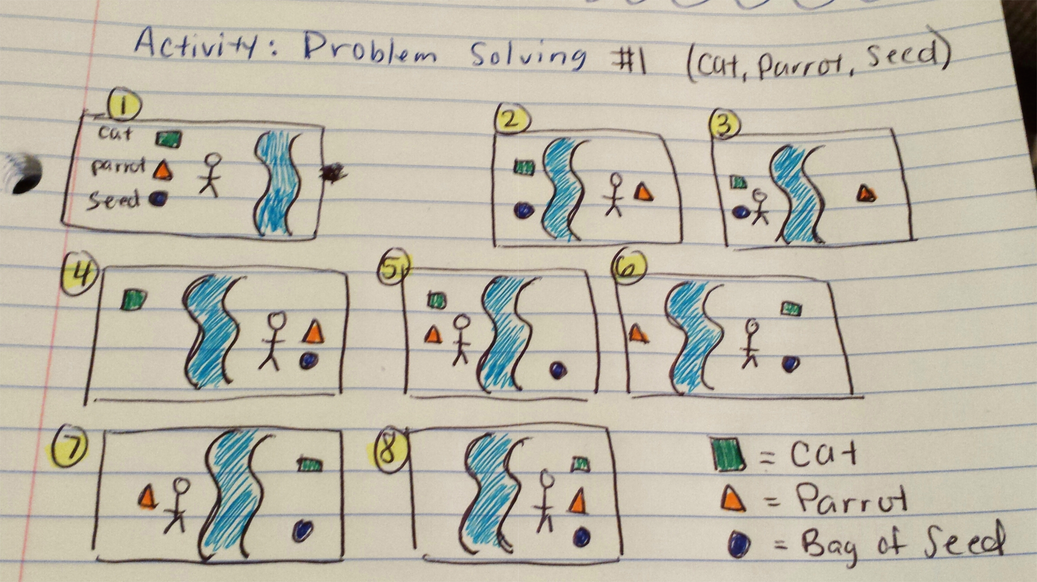

**Socks in the Dark**

1. Define the problem: This
2. Constraints:  
   Sub-goals:
3. Possible Solutions:
4. Evaluate Solutions:
5. Choose Solution & Develop Plan: