**Lab-Assignment#3**

**JavaScript Frameworks**

**Jesbin Jobi - 200588911**

**Rojin Babu – 200587425**

**Submission Date: 6/19/25**

**Contents**

* **Summary**
* **Screen Shot of folder structure inside Visual Studio Code**
* **Screen Shot of VS Code embedded terminal window**
* **Screen Shot of JavaScript Codes**
* **Code Running Screen Shots**
* **Link to the GitHub Repository**

**Summary Of the Project**

in this assignment, we have had an opportunity to work with simple Express.js server creation and implement CRUD (Create, Read, Update, Delete) functionality with JSON data. We developed various API endpoints to show, create, modify, and remove data about fruit. To make the project more realistic, we also learned how to serve static files like CSS and images, and how to properly organize our project folders.

**Screen Shot of folder structure inside Visual Studio Code**

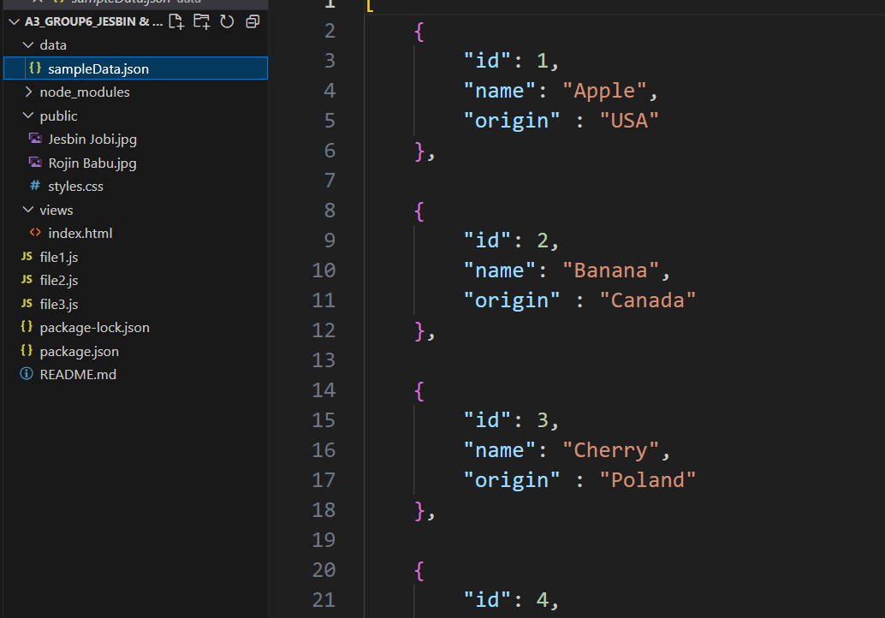

**Screen Shot of VS Code embedded terminal window**

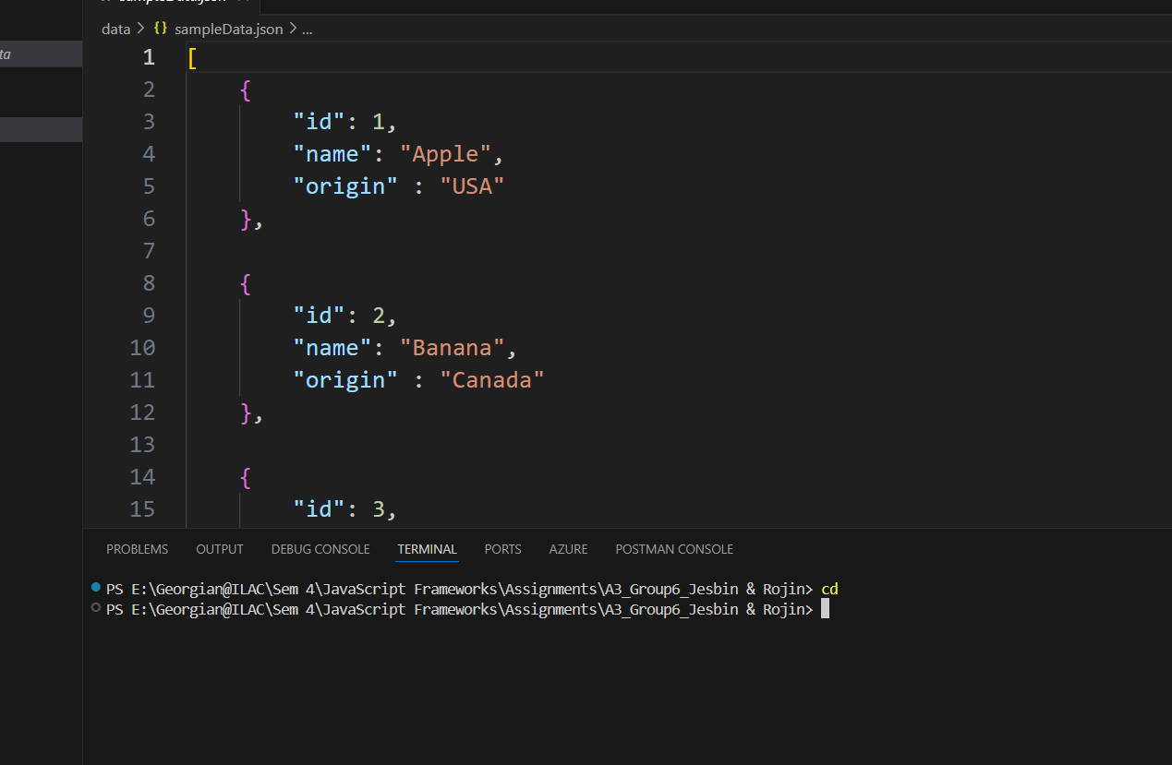

**Screen Shot of JavaScript Codes**

**File.js**

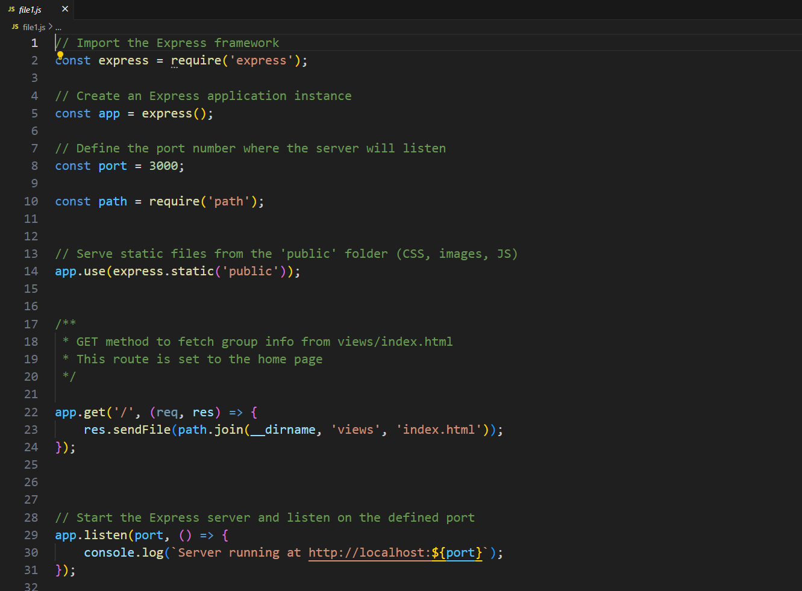

**File2.js**

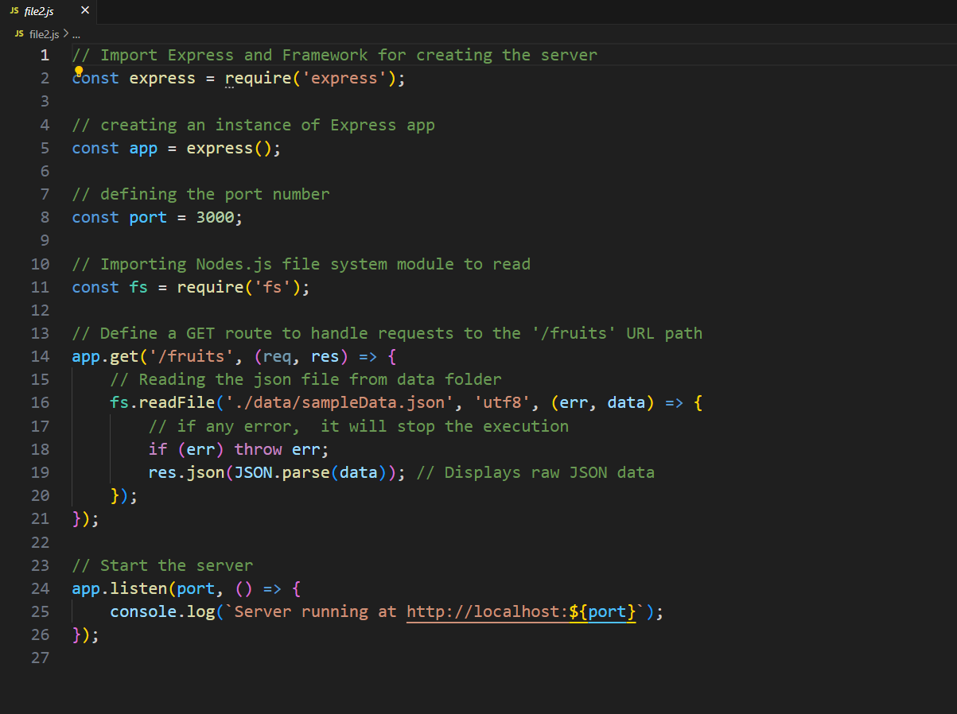

**File3.js**

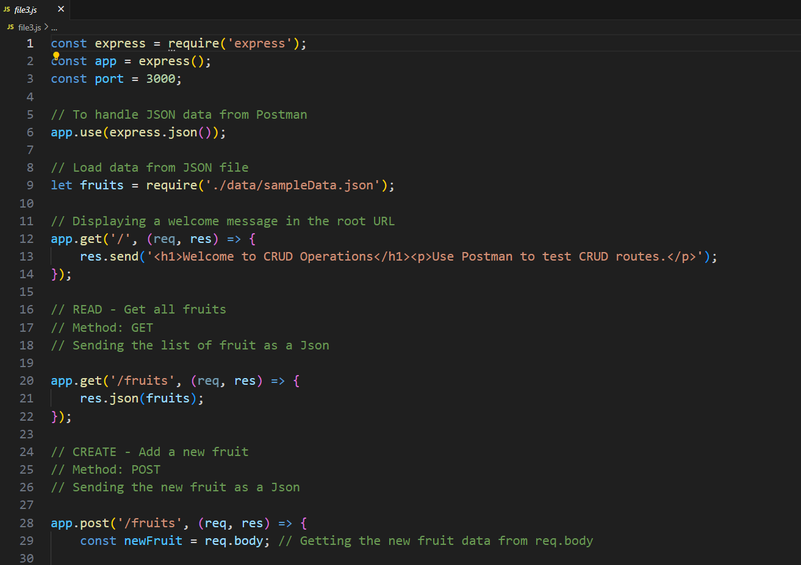

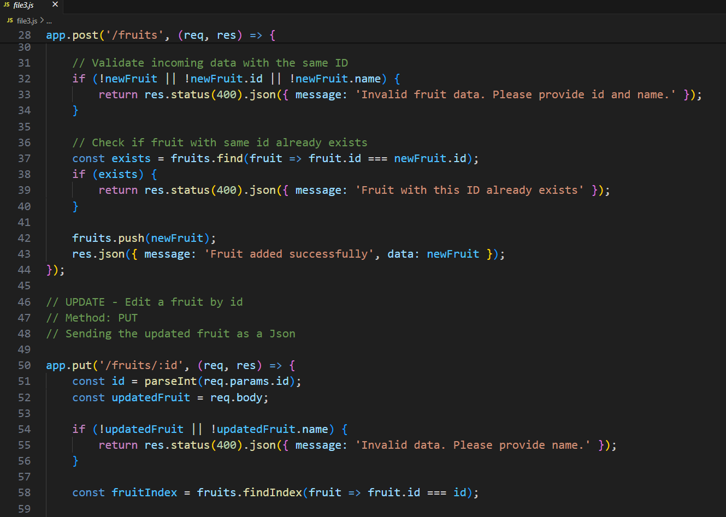

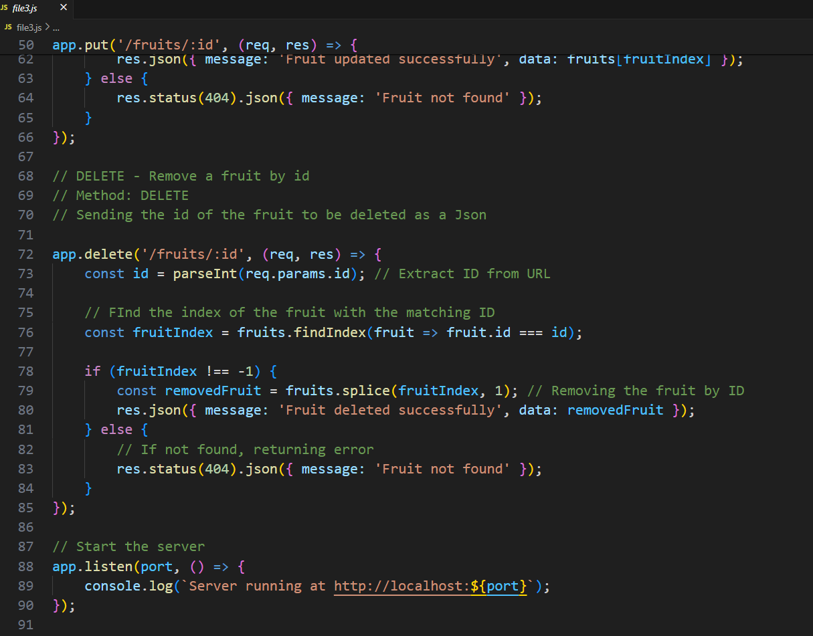

**Index and CSS File**

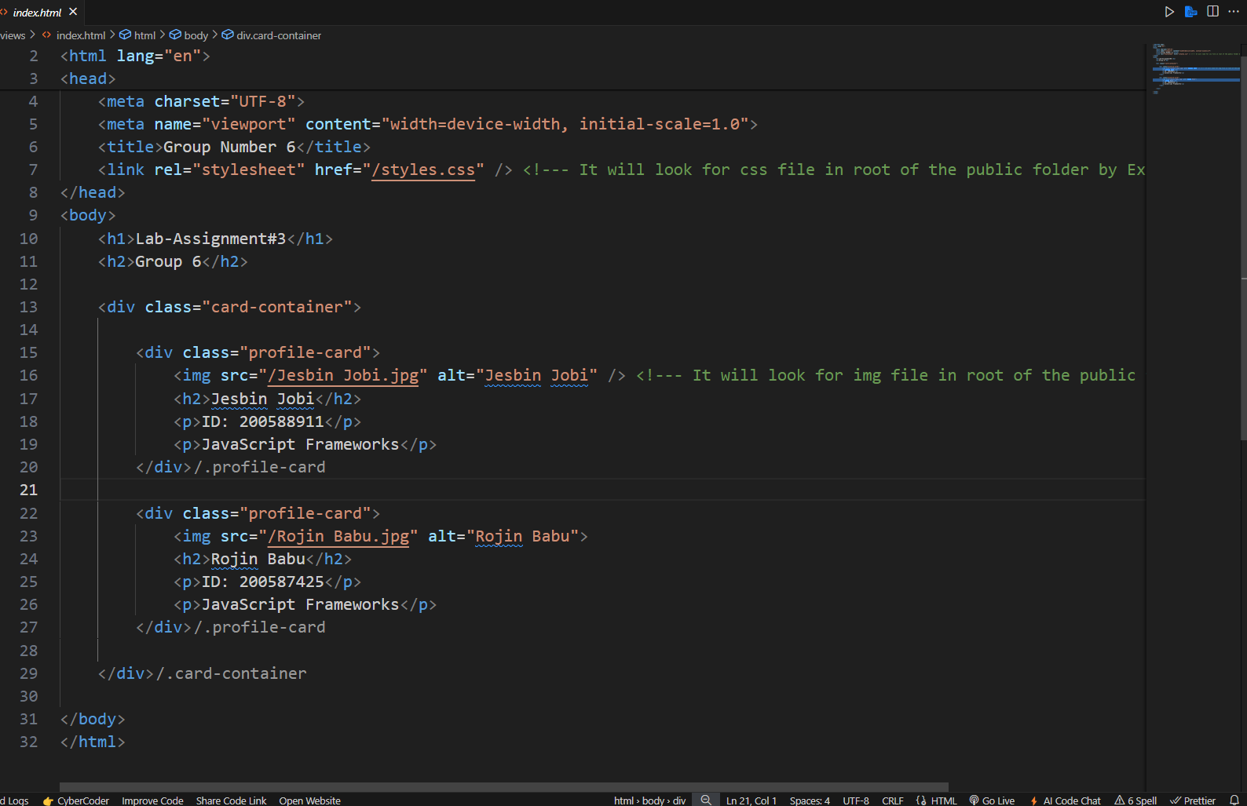

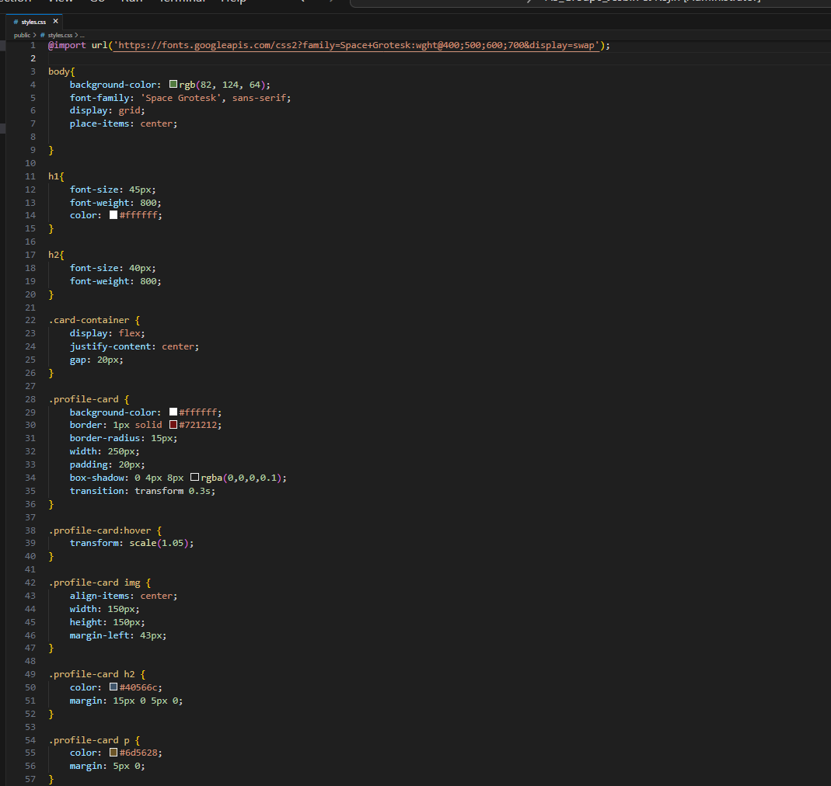

**Nodemon**

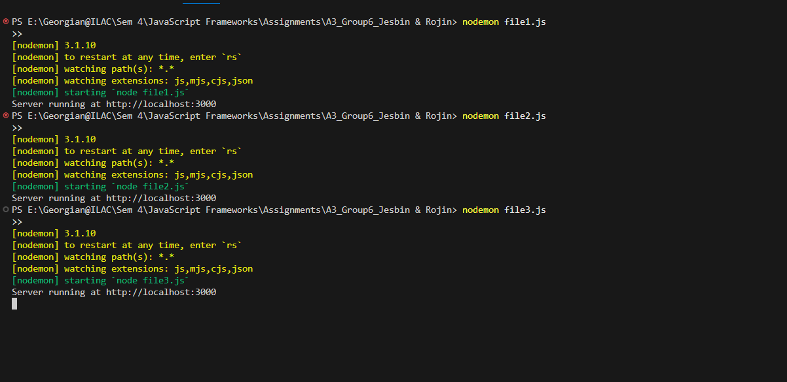

**File1.js**

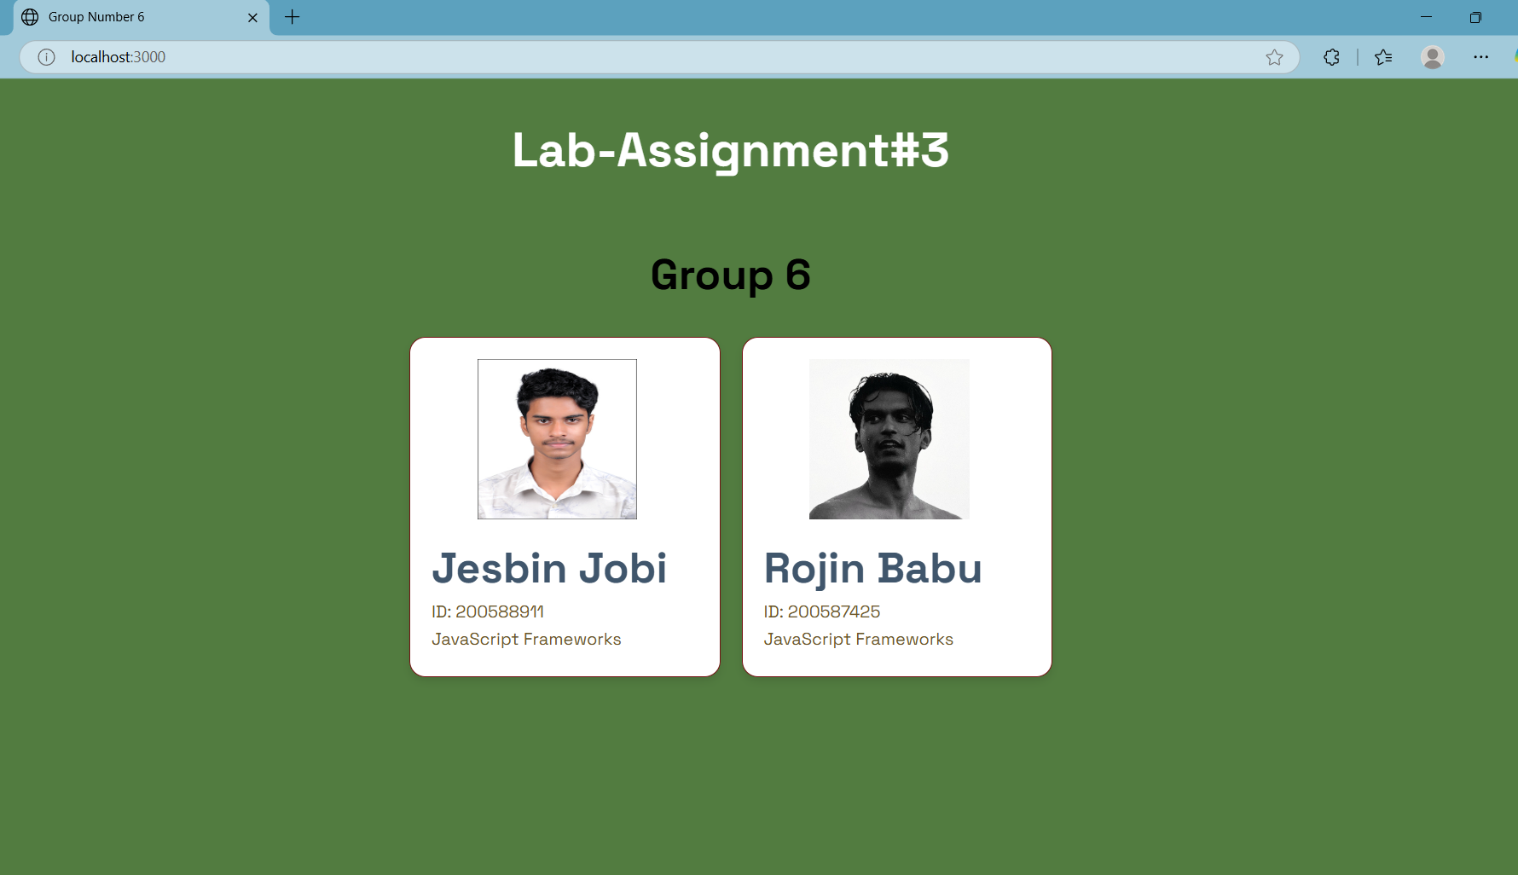

**File2.js**

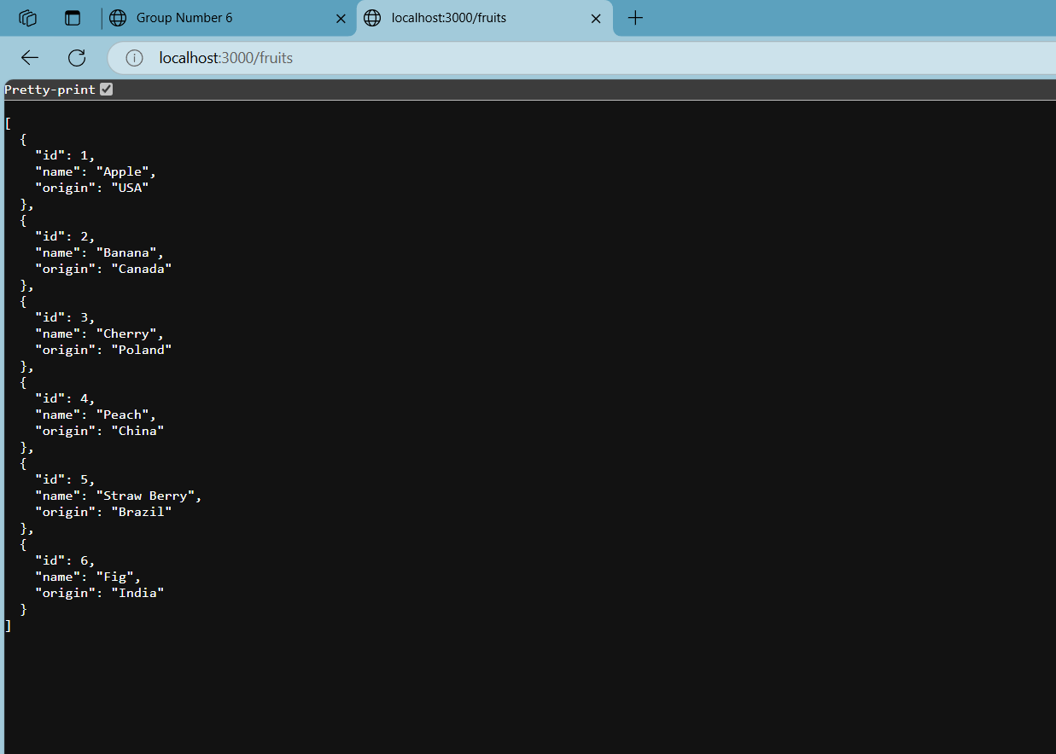

**File3.js in Post man**

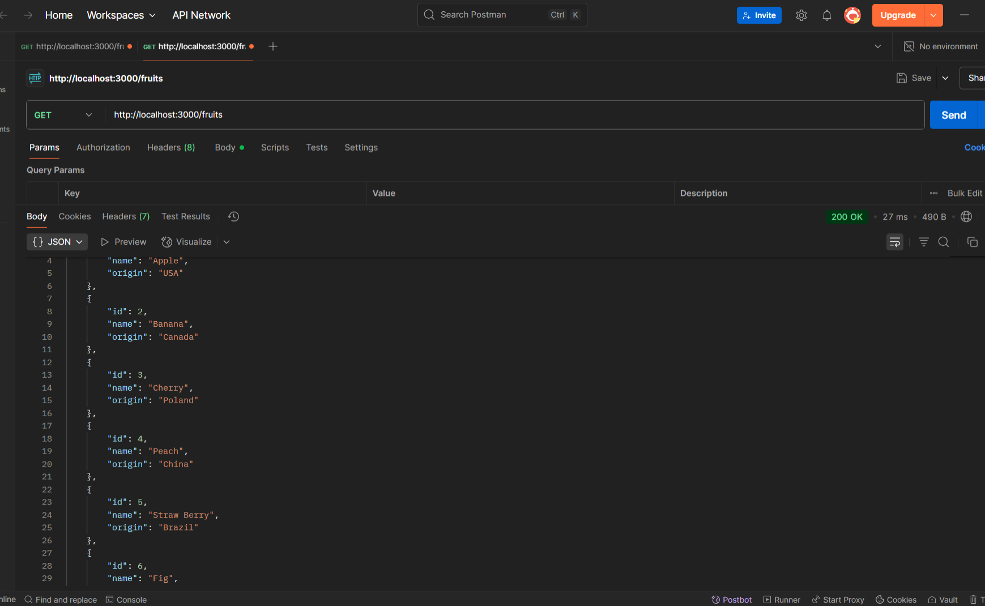

**POST method**

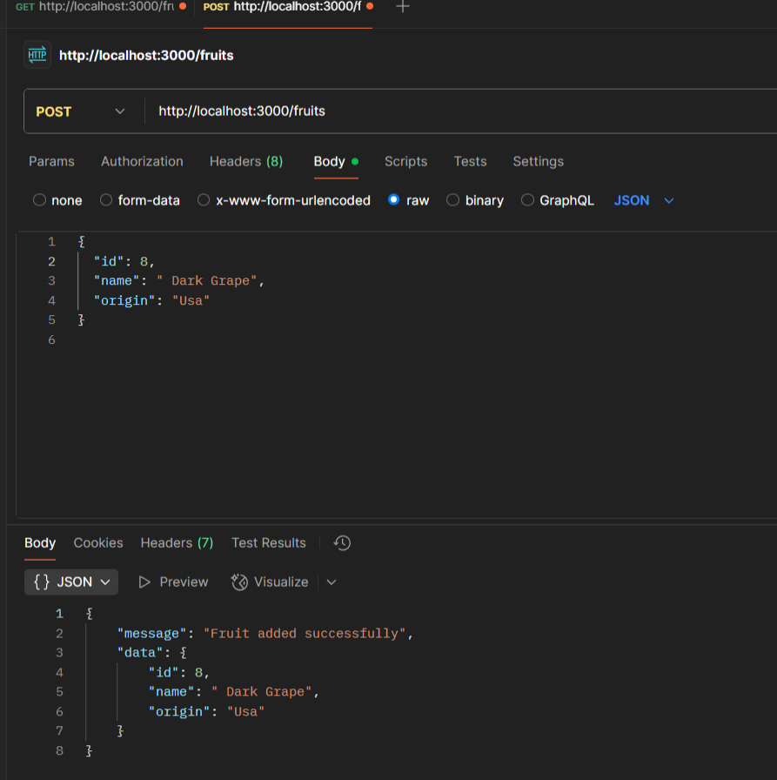

PUT method

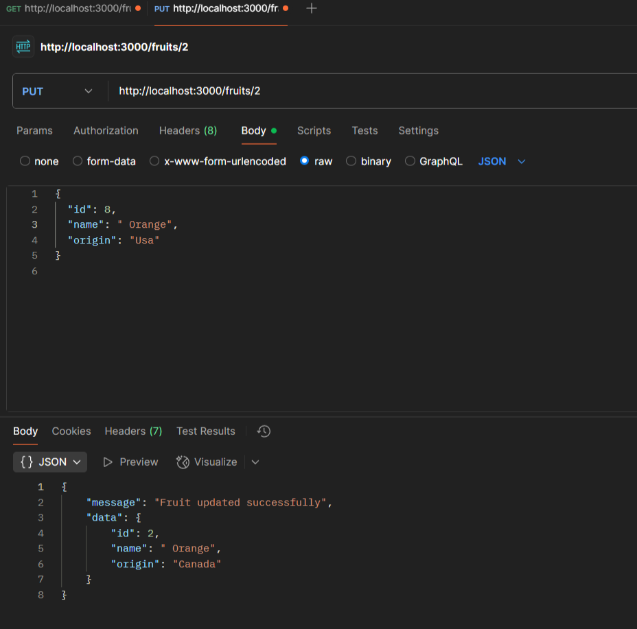

**Link to the GitHub Repository -**