- Write the complete SQL statement for creating a new database called addressbook.
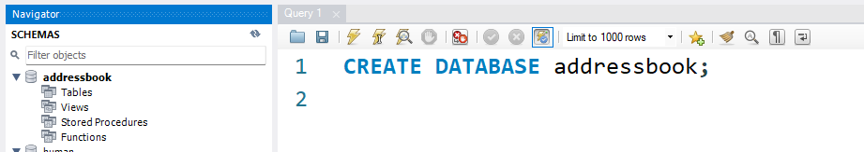
2. Which statement is used to list the information about a table? How do you use this statement?
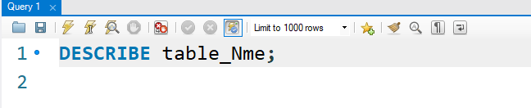
It displays the table structure: column names, data types, NULL allowed, keys, etc.

- How would you list all databases available on the system?
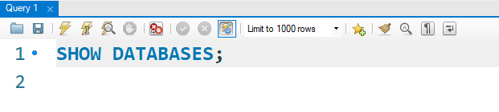
- Write the statement for inserting the following data in employee data table.
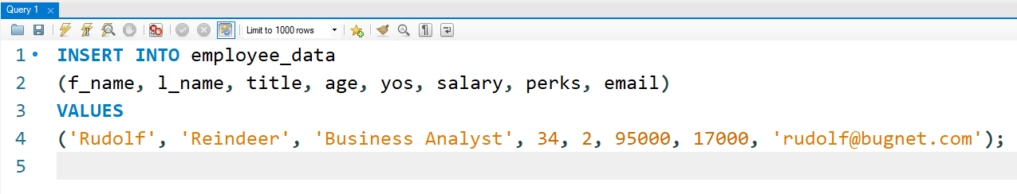

5. Give two forms of the SELECT statement that will list all the data in employee_data table.
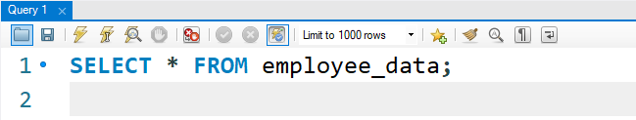
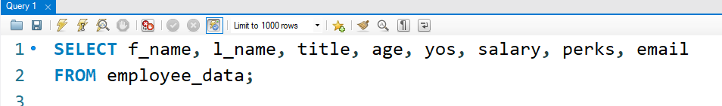
- What will select f_name, email from employee_data; display?
Answer: It displays the f_name and email columns for every row.

- Write the statement for listing data from salary, perks and yos columns of employee_data table.
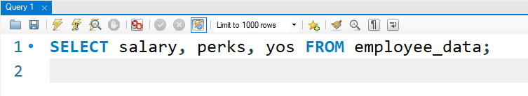
- How can you find the number of rows in a table using the SELECT statement?
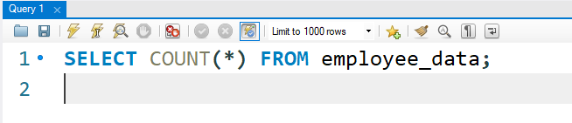
9. What will select salary, I_name from employee_data; display?
It will display the salary and last name (l_name) of every employee in the employee_data table.

