EXERCISE 10

- Display the sum of ages of employees working at Bignet.
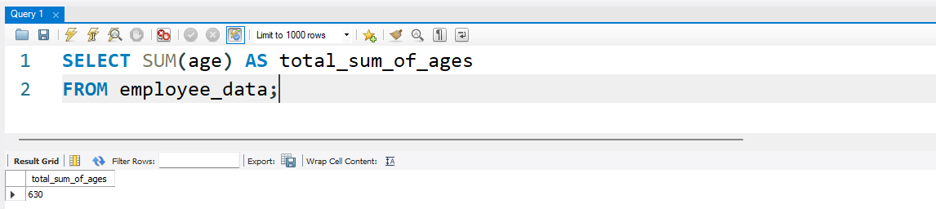
2. How would you calculate the total of years of service the employees
of Bignet have in the company?
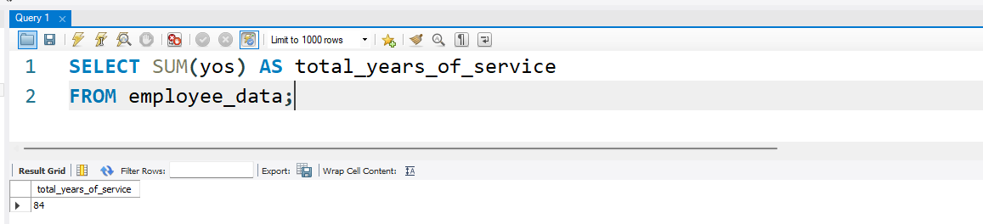
3. Calculate the sum of salaries and the average age of employees who
hold "Programmer" title.
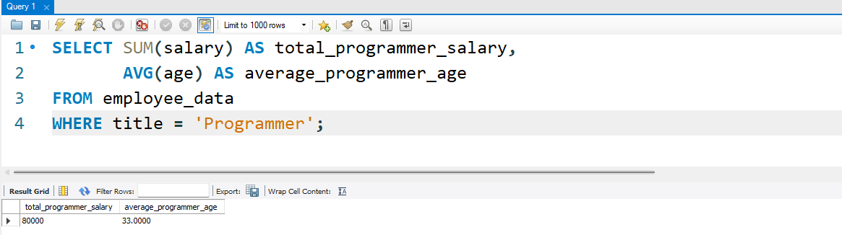
4. What do you understand from the following statement?

select (SUM(perks) /SUM(salary) * 100)
from employee_data;

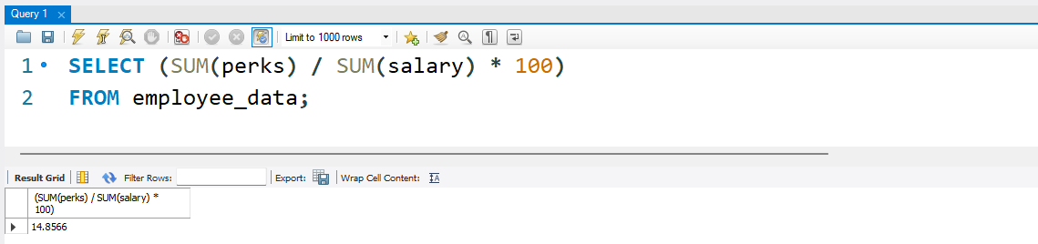

This statement aims to calculate the Total Percentage of Perks compared to the Total Salary of all employees in the company. SUM(perks): This takes the total amount of all perks given to all employees. SUM(salary): This takes the total amount of all salaries of all employees. (SUM(perks) / SUM(salary) * 100): Total perks are divided by total salary, and multiplied by 100 to get the percentage of it.

