EXERCISE 11

1. Count the number of employees who have been with Bignet for four
or more years.
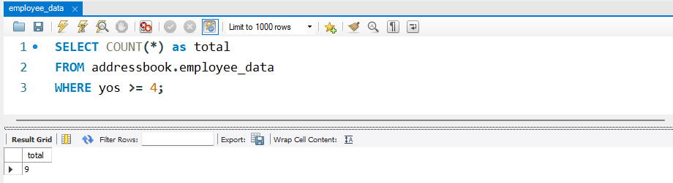2. Count employees based on their ages.
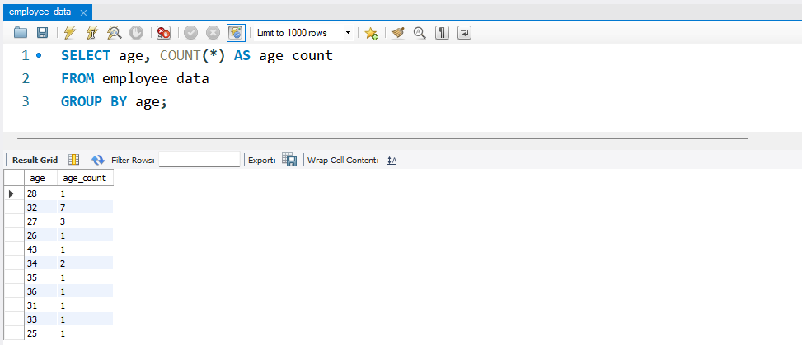
3. Modify the above so that the ages are listed in a descending order.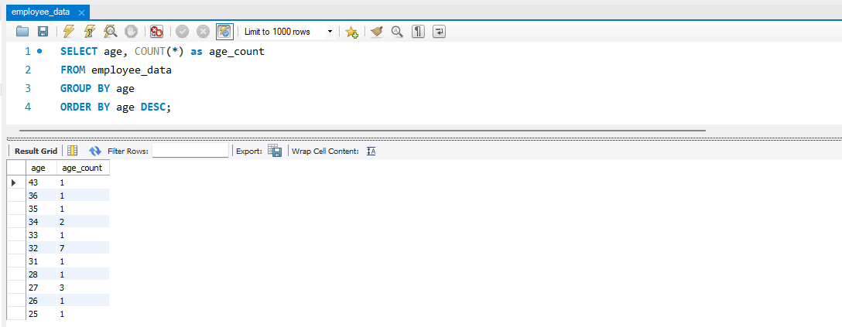
4. Find the average age of employees in different departments (titles).
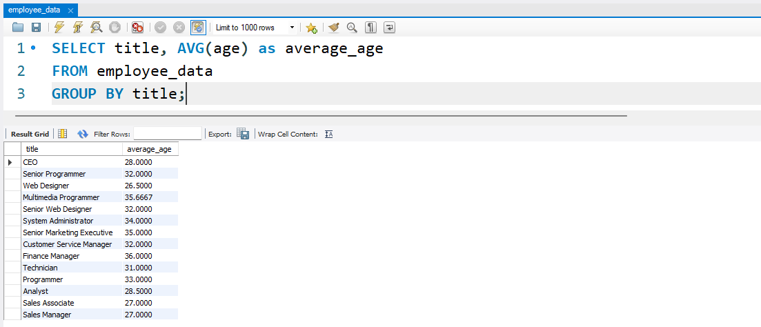
5. Change the above statement so that the data is displayed in a
descending order of average ages.
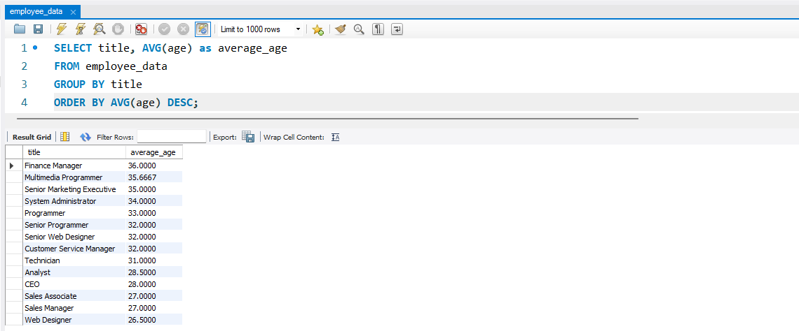
6. Find and list the percentage perk (perk/salary X 100) for each
employee with the % perks sorted in a descending order.
