EXERCISE 13

1. Which command displays the MySQL version?
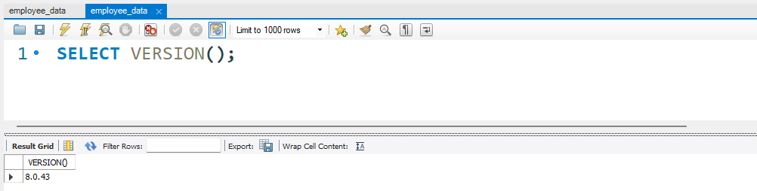
2. Use the SELECT command to evaluate 4 X 4 X 4 and name the
column Cube of 4.
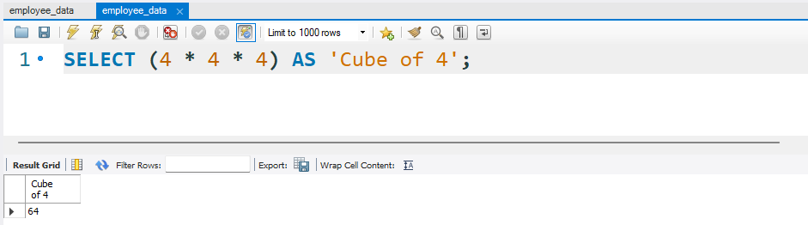
3. Display your name with SELECT.
