EXERCISE 14

1. Our CEO falls in love with the petite Web Developer, Anamika Pandit.
She now wants her last name to be changed to 'Sharma'.
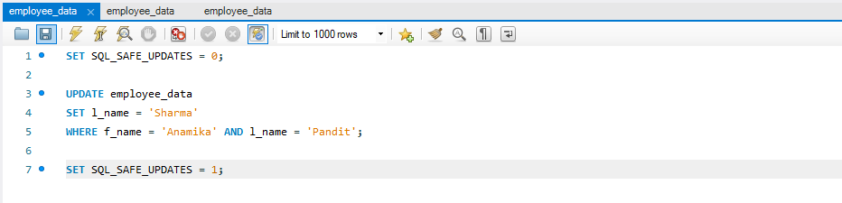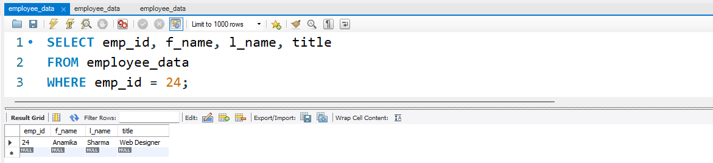
2. All Multimedia Programmers now want to be called Multimedia
Specialists.
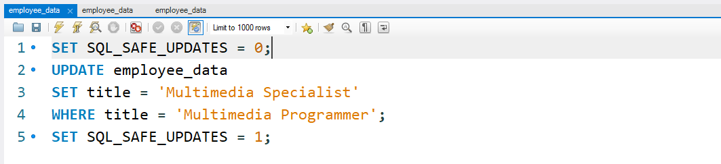
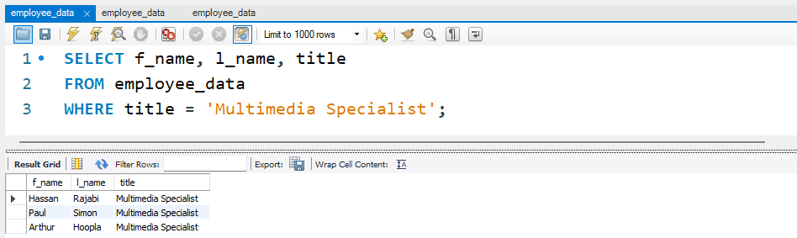

3. After his marriage, the CEO gives everyone a raise. Increase the
salaries of all employees (except the CEO) by $10000.
