EXERCISE 15

1. List all employee ids and birth dates who were born before 1965.
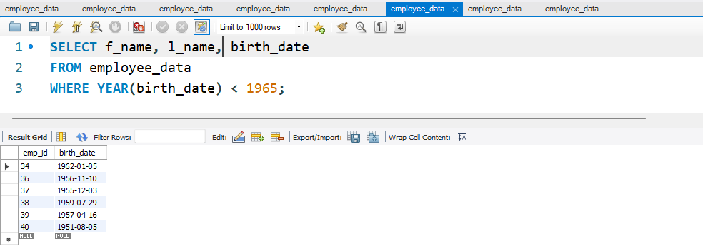
2. Display Ids and birth dates of employees born in and between 1970
and 1972. (This is tricky ... you need to give it a little thought)
