1. Write the SELECT statement to extract the ids of employees who are more than 30 years of age.
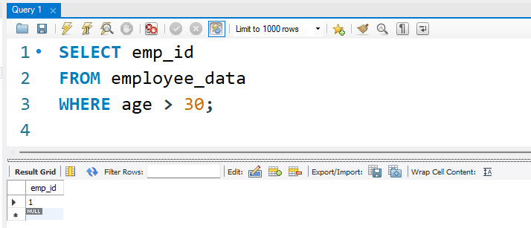
2. Write the SELECT statement to extract the first and last names of all web designers.
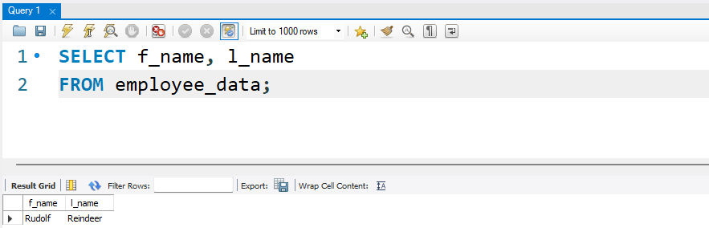
3. What will the following SELECT statement display: SELECT * from employee_data where salary <= 100000;
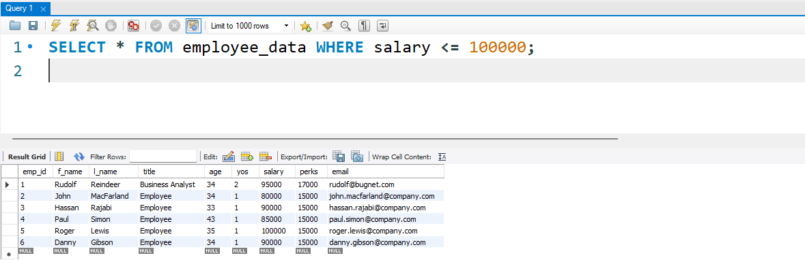
4. How will you display the salaries and perks for employees who have more than $16000 as perks?
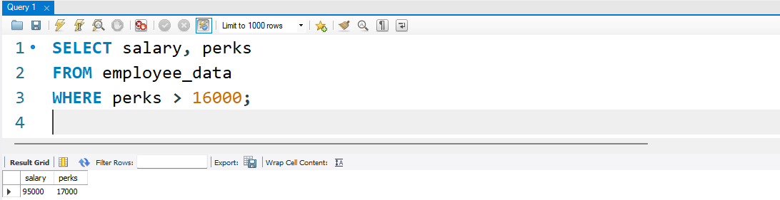
5. List all employee names (last name followed by first name) who hold the title of Marketing Executive.
