1. List all employees whose last names begin with P.
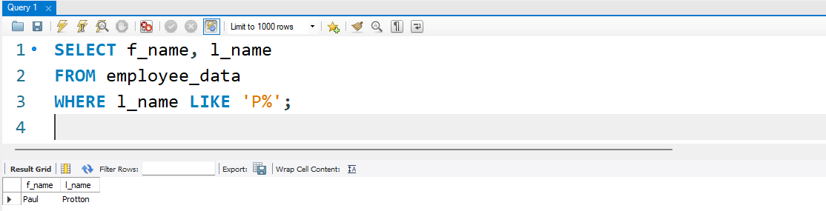
2. Display the names of all employees in the marketing division.
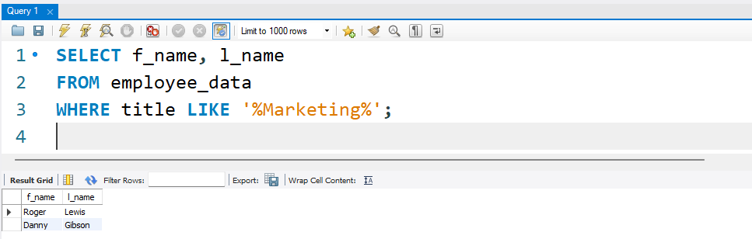
3. What will the following statement display
SELECT f_name, 1_name, salary
From employee data where f name like '%k%' ;
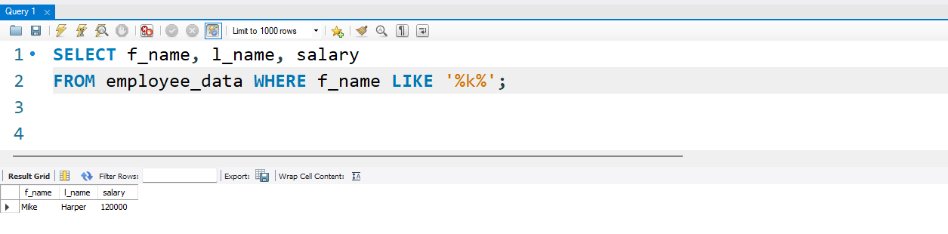
It will display the first name (f_name), last name (l_name), and salary of all employees whose first names contain the letter “k” anywhere.

4. List the last names and titles of all programmers.
