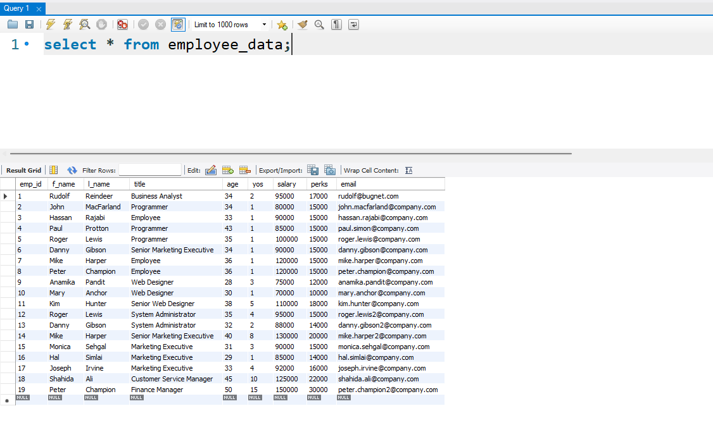
- List the first and last names of all employees who draw less than or equal to $90000 and are not Programmes, Senior programmers or Multimedia programmers.
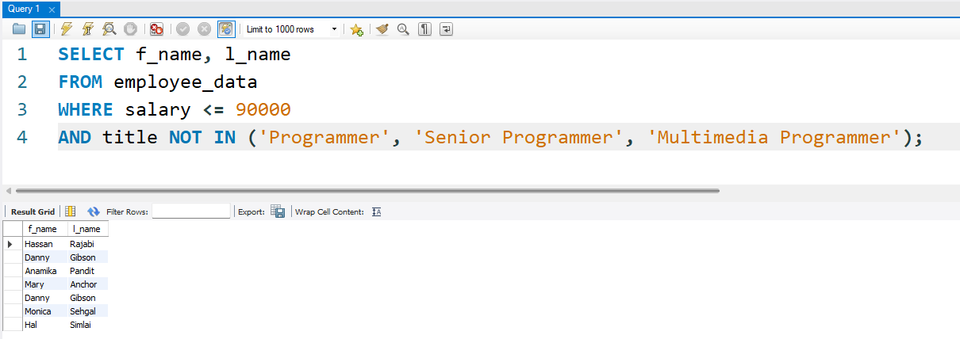
- What is displayed by the following statement?
Answer: The last name (l_name) and first name (f_name) of employees. The title does NOT contain the word 'marketing' anywhere and age is less than 30 years old.
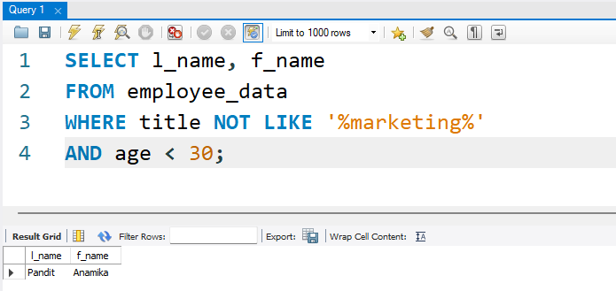
3. List all ids and names of all employees between 32 and 40 years of
age.
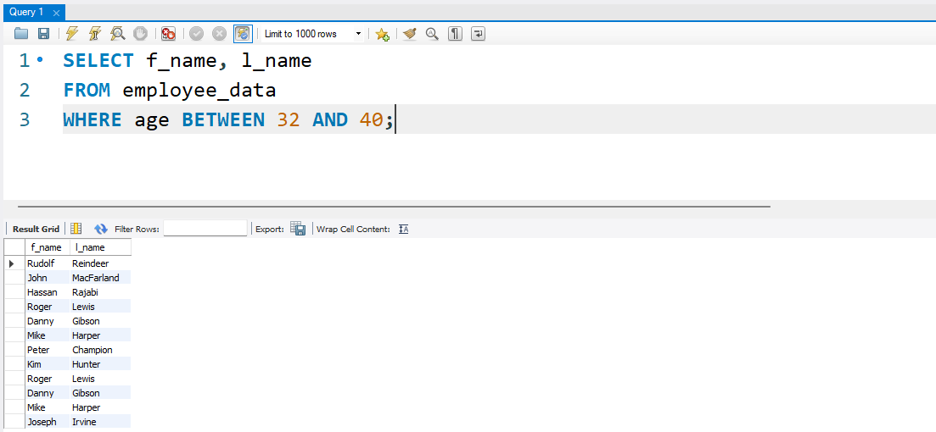

4. Select names of all employees who are 32 years of age and are not
programmers. can you make this

