EXERCISE 5

1. List all employees who hold the titles of "Senior Programmer" and
"Multimedia Programmer".
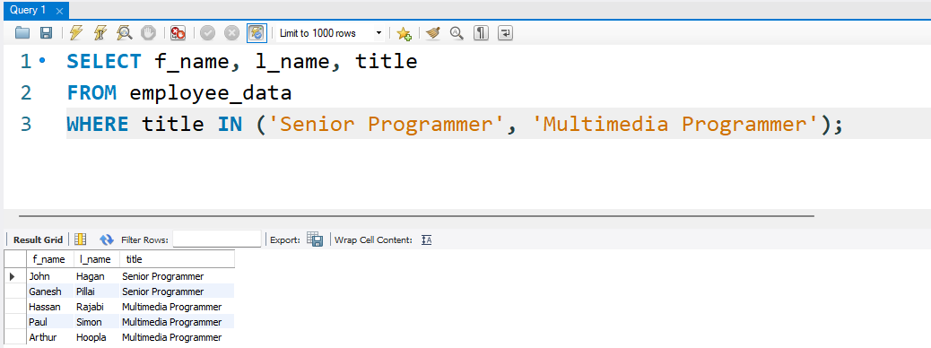

2. List all employee names with salaries for employees who draw
between $70000 and $90000.
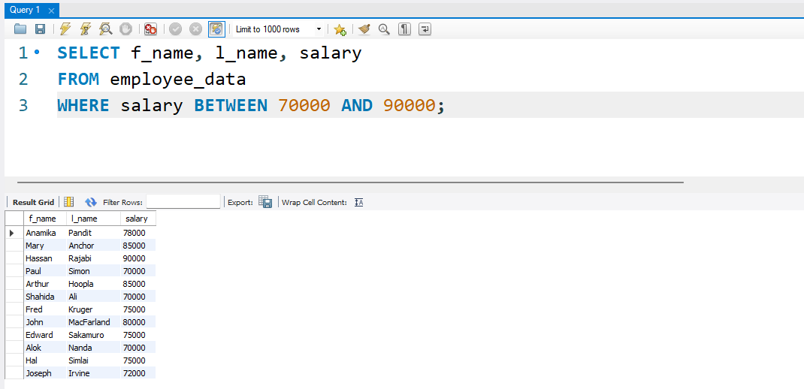
3. What will the following statement display?

SELECT f_name, 1_name, title from
employee_data where title NOT IN
('Programmer', 'Senior Programmer'
'Multimedia Programmer' ) ;
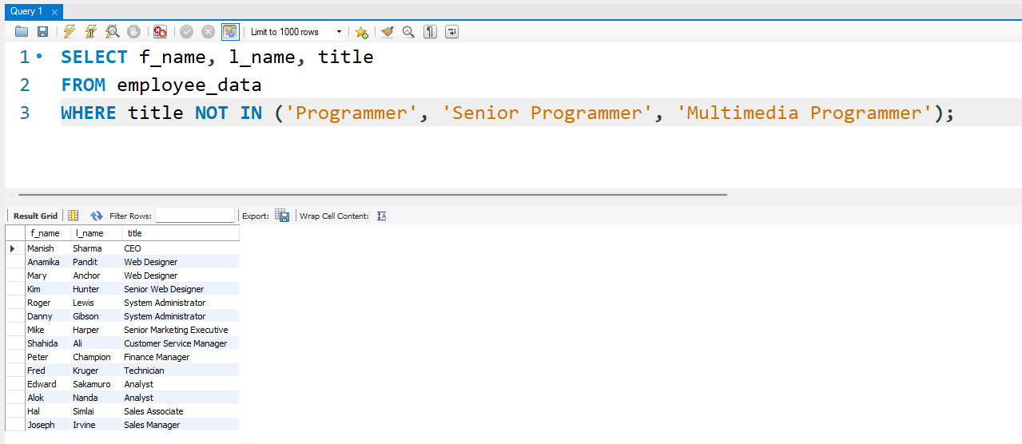

4. Here is a more complex statement that combines both BETWEEN and
IN. What will it display?

SELECT f_name, 1_name, title, age
from employee_data where
title NOT IN
('Programmer', 'Senior Programmer'
'Multimedia Programmer') AND age
NOT BETWEEN 28 and 32;

