EXERCISE 6

- Order all employees on the basis of the salary they draw.
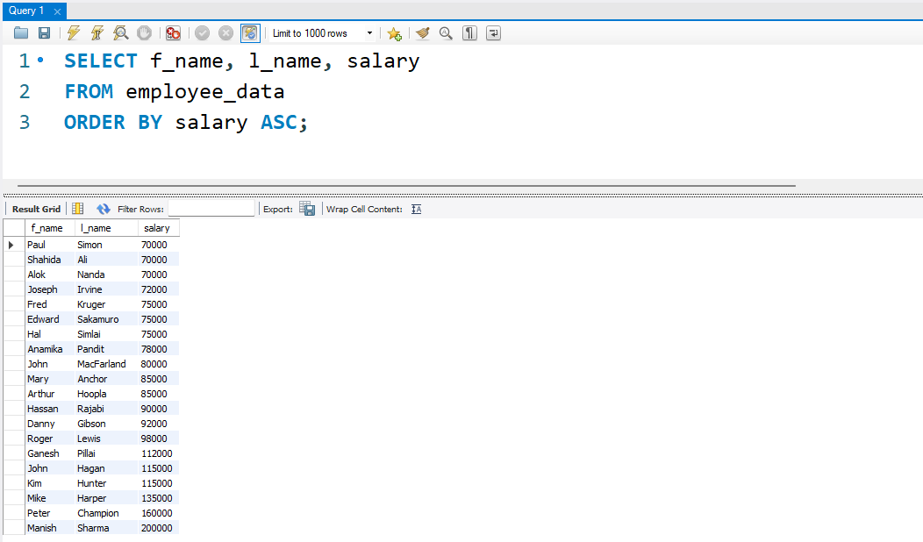
- List all employees in descending order of their years of service.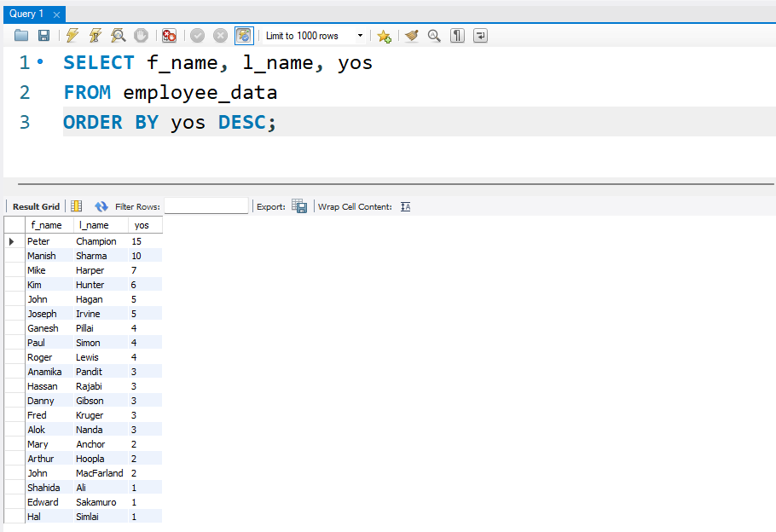
3. What does the following statement display?

SELECT emp_id, 1_name, title, age
from employee_data ORDER BY
title DESC, age ASC;

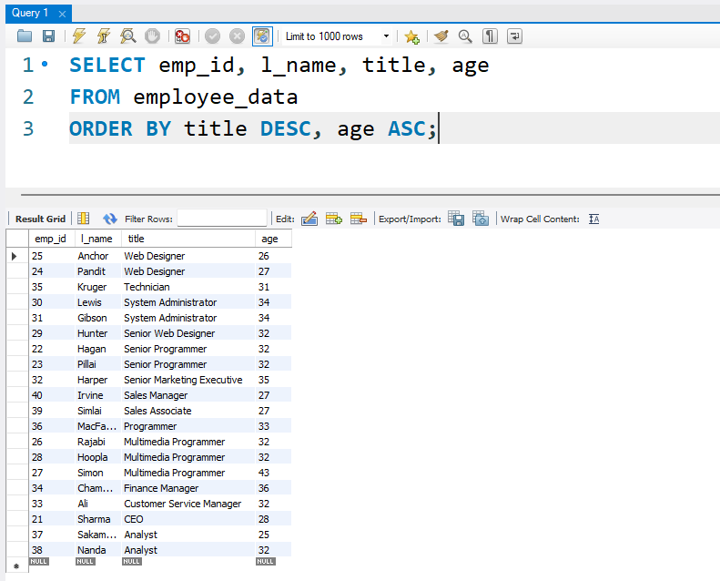
4. Display employees (last names followed by first names) who hold the
title of either "Programmer" or "Web Designer" and sort their last
names alphabetically.
