EXERCISE 7

- List the names of 5 youngest employees in the company.
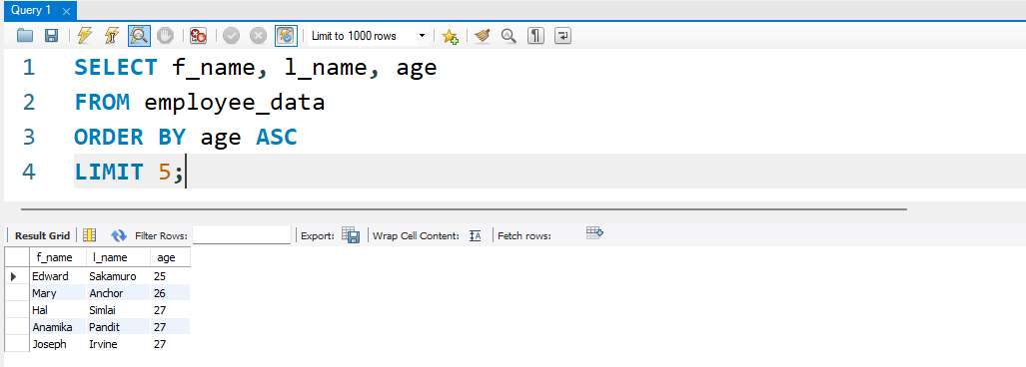
- Extract the next 5 entries starting with the 10 row.
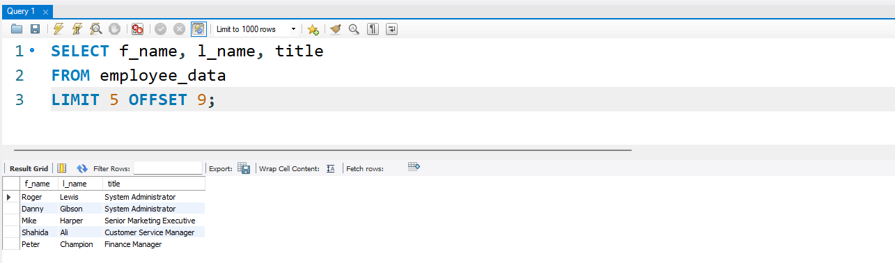
3. Display the names and salary of the employee who draws the largest
Salary
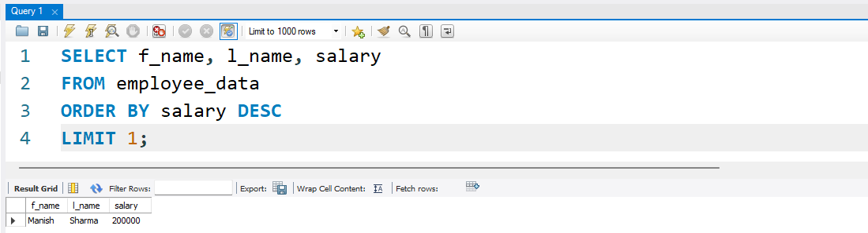
4. What does the following statement display?

SELECT emp_id, age, perks
from employee_data ORDER BY
perks DESC LIMIT 10;
