1. How many unique salary packages does our company, Bignet, offer?
List them is descending order.
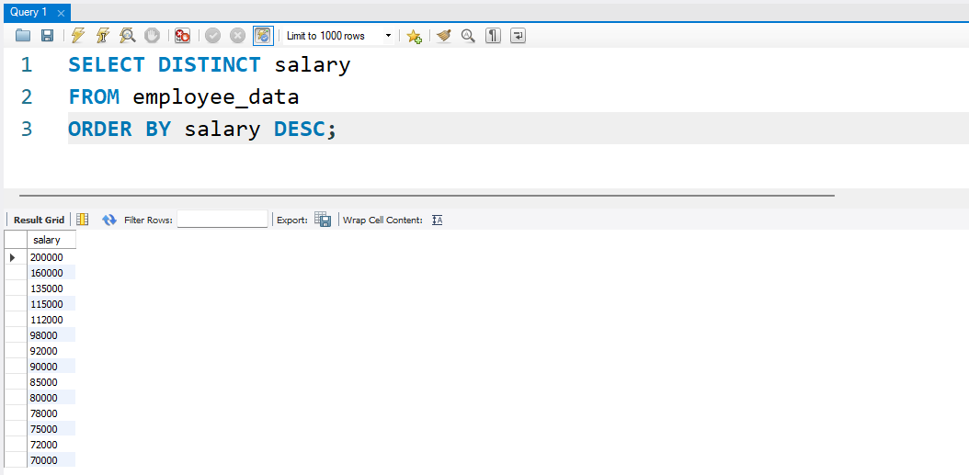
2. How many distinct first names do we have in our database?
