SIMATS ENGINEERING
CO4 – AT1 - Article Review- Low

COURSE NAME: Advance Wireless Communication Systems
5G / 6G Communication Systems
COURSE CODE: ECA5606
Name: J.J. Jeshika

SATELLITE BACKHAUL SOLUTIONS FOR RURAL AND REMOTE 5G CONNECTIVITY
One-Page Project Write-up Based on the Base Paper
The proposed topic, “Satellite Backhaul Solutions for Rural and Remote 5G Connectivity,” is based on the open-access research paper “Satellite Backhaul for Extending Connectivity in Rural Remote Areas: Deployment and Performance Assessment” by Souhaima Stiri, Maria Rita Palattella, Juan David Niebles Castano and Christos Politis, published in Network in 2026. The paper investigates satellite backhauling as a practical solution for extending connectivity to rural and geographically isolated areas where conventional terrestrial infrastructure is limited or economically difficult to deploy.
Rural and remote regions often suffer from poor broadband coverage because fibre-optic links, terrestrial base stations and conventional backhaul infrastructure require high deployment and maintenance costs. The base paper addresses this connectivity gap by evaluating Non-Terrestrial Network (NTN) solutions, particularly satellite backhaul. In this architecture, data generated by users, IoT devices or a remote access network is forwarded through a satellite terminal to a ground station and then connected to the core network or Internet. This approach can provide wide-area coverage and can be deployed where terrestrial connectivity is unavailable or unreliable.
The study experimentally evaluates two satellite backhaul technologies: Geostationary Earth Orbit (GEO) and Low Earth Orbit (LEO). The GEO solution provides broad coverage but has higher propagation latency because of its greater orbital altitude. The LEO solution operates at a much lower altitude and therefore offers lower latency and higher broadband performance. The researchers tested these satellite links in both laboratory and real agricultural field environments and compared their performance with a terrestrial cellular network. The experiments included low-bandwidth IoT sensor traffic and high-bandwidth video transmission.
The results reported in the base paper show that both GEO and LEO satellite backhaul solutions can reliably support delay-tolerant rural applications. The study demonstrates that satellite connectivity can support IoT monitoring as well as bandwidth-intensive applications such as image and video uploads. The paper also highlights important practical issues including latency, throughput, packet loss, weather effects, obstruction and deployment cost. Although terrestrial cellular networks may provide higher throughput in some conditions, their coverage and stability can be limited in remote areas. Satellite backhaul can therefore act as an important alternative or complementary solution.
Based on the base paper, the proposed project can extend the concept toward rural and remote 5G connectivity by combining 5G access networks with satellite backhaul. A hybrid architecture can use terrestrial 5G when it is available and switch to satellite backhaul when terrestrial infrastructure is unavailable or overloaded. LEO satellites can be considered where lower latency is important, while GEO satellites can be useful when wide coverage is the main requirement. Such a system can support smart agriculture, remote healthcare, education, disaster communication, environmental monitoring and rural IoT applications.
Thus, satellite backhaul is a promising technology for reducing the digital divide between urban and remote communities. The base paper provides experimental evidence that GEO and LEO satellite systems can extend reliable connectivity in rural environments. The proposed work can build on these findings by focusing specifically on 5G integration, intelligent backhaul selection and performance comparison using parameters such as latency, throughput, reliability, coverage and cost. This can lead to a scalable and resilient connectivity solution for future rural 5G networks.
Base Paper Reference
Stiri, S., Palattella, M. R., Niebles Castano, J. D., & Politis, C. (2026). Satellite Backhaul for Extending Connectivity in Rural Remote Areas: Deployment and Performance Assessment. Network, 6(1), 12. https://doi.org/10.3390/network6010012

Backhaul in 5G systems for developing countries: A literature review

Inas Sawad Rajagopal Nilavalan Hamed Al-Raweshidy

Department oF Electronic and Electrical Engineering, Brunel University London, kingston Lane, London, Uk

Correspondence Rajagopal Nilavalan, Department oF Electronic and Electrical Engineering, Brunel University London, kingston Lane, London, Uk.
Email: nila.nilavalan@brunel.ac.uk

Funding information
Jr3C - BRUNEL UNrVER3rTY LONDON

Abstract
The fiFth-generation (5G) technology is seen to be a solution For developing countries to improve their quality oF services in terms oF transportation, education, health, agriculture, and other fields, thereby holding the promises oF economic transFormation by improving productivity and the quality oF liFe. The paper considers some oF the challenges that Face operators, investors, and providers when planning to introduce 5G technology to devel-oping countries. The main Focus oF this paper is the 5G transport network, in particular, the backhaul network. The 5G transport network architectural options and scenarios are discussed based on several standards and previous studies, the problems oF existing inFras-tructures oF developing countries are investigated, and new proposed technologies that may help to address those challenges are considered.

INTRODUCTION
Throughout all the diFFerent generations oF mobile technol-ogy, there have been major diFFerences in network perFormance between countries. This is because the more developed ones have been able to use the latest releases oF mobile network technology and having advanced, up-to-date inFrastructures, while the less developed countries have struggled to adopt the new technology, in particular, in terms oF upgrading and/or expanding their inFrastructures.
rndoria [1], in his published study, listed the main challenges that developing countries could Face with the implementa-tion oF 5G technologies. Ke particularly Focused on their lack oF inFrastructure, which includes poor fibre construction, no proper mechanism For the rapid increase in the number oF users, low rates oF data speed, high costs as well as political and security issues, thus hindering the development oF the telecom-munications sector. Ke also discussed the need For 5G and its applications given its advantages over 4G and the Future prospects For its implementation.
rt is also important to look into the economic develop-ments/costs associated with implementing 5G networks, For instance, Oughtona [2], in his published study, also studied the growth oF data traFfic oF 5G inFrastructure strategies For the period between 201G and 2030. They Found that there will be
a t0 percentage oF data growth due to technology change From 4 to 5G. They also highlighted the techno-economic problem oF deploying 5G due to the cost. rn this regard, they pointed to the large number oF new components required to operate enhanced network inFrastructure, including base station units and backhaul transmission, as well as the associated costs oF site installation and operation, network optimisation and main-tenance. But, 3hin [3] Focused on analysing the 5G users and data traFfic demand and how that demand would change based on several attributes, including the content amount, additional monthly Fees and additional cost oF devices. The study revealed a crucial Foundation For mobile service providers’ investment and marketing strategies that aim to maximise profits.
rn addition, fforge and Vu [4], in their published study, dis-cussed the network perFormance variation between developed and developing countries. Their aim was to provide policy-makers in developing countries with a clear understanding oF 5G deployment in terms oF demand levels, inFrastructure costs, challenges oF a dense deployment inFrastructure, technical com-plexity, and the need to create eFFective Future strategies For deploying the new generation. The authors cited an example based on a survey carried out in 201t comparing the average download speeds rate For the existing 4G called Long Term Evaluation-Advance (LTE- A) networks. The survey showed that the download speeds were 52 Mb/s For the Republic oF

This is an open access article under the terms oF the Creative Commons Attribution License, which permits use, distribution and reproduction in any medium, provided the original work is properly cited.
© 2023 The Authors. IET Communications published by John Wiley & 3ons Ltd on behalF oF The rnstitution oF Engineering and Technology.
IET Commun. 2023;1Z:G5t–GGt.
wileyonlinelibrary.com/iet-com 659

korea and 33.0 Mb/s For Japan, as an example For lead or developed countries, while this Fell to 1.G Mb/s For rraq, as an example oF a developing country.
Muluk [5], the rTU-D representative, stated in his presen-tation at the rTU Regional fforum on New Technologies the importance oF 5G For developing countries For eliminating the number oF transport accidents, which, according to the CAPMA3-Central Agency For Public Mobilization and 3tatis-
TABLE 1 The METr3 scenarios and their challenges [8]

Scenario Challenges

Amazingly Fast Very high data rate
Great service in a crowd Very dense crowds oF users Ubiquitous things communicating Very low energy, cost, and a massive
number oF devices
Best experience Follows you Mobility

tics, are high in those countries. Ke stated that 5G will have a good impact on improving the transport system in terms oF quality and availability. Also, 5G will lead to reduction in latency to (1 ms), thus enabling remote health assistance in terms oF perForming surgery. The specialists could join a surgeon
3uper real-time and reliable connections
Very low latency

remotely For diagnosis and Follow-up. rn terms oF education, 5G will oFFer new ways oF learning in the classrooms, with students being exposed to a more visual and interactive learn-ing experience (Augmented Reality, Virtual Reality, and Virtual Presence). Moreover, teachers will be able to deliver their classes to students not necessarily in the same room. 5G technology will assist developing countries in optimising growth and min-imising the use oF water and Fertilisers through more targeted application in water and agriculture systems, as well as other fields.
17518636, 2023, 6, Downloaded from https://ietresearch.onlinelibrary.wiley.com/doi/10.1049/cmu2.12578 by Brunel University, Wiley Online Library on [12/06/2023]. See the Terms and Conditions (https://onlinelibrary.wiley.com/terms-and-conditions) on Wiley Online Library for rules of use; OA articles are governed by the applicable Creative Commons License
The smart network communication environments oF 5G are increasing the demand For high-speed data, and introducing new requirements oF network and inFrastructure, especially the transport network.
The paper aims to review the studies and research on 5G backhaul network and the proposed solutions oFFered to deploy 5G technology in developing countries. rt is organised as Fol-lows. rn 3ection 2, a detailed review oF 5G transport networks is described. rn 3ection 3, the backhaul network is discussed. Whilst in 3ection 4, the latest backhaul technologies are derived. rn 3ection 5, the developing countries and their progress towards 5G technology are discussed. rn 3ection G, the role that cost plays to deploy 5G technology in developing countries is considered. The paper is concluded in 3ection Z.

TRANSPORT NETWORK
Recent ongoing research eFForts and standardisations are con-cerned about the crucial role oF the transport network in 5G technology. ffor instance, the Third Generation Partnership Project (3GPP) studied the evaluations and the enhancements oF the existing 4G network and how to upgrade to the new era oF 5G in its standards Release (15) and then, Releases (1G), (1Z), (18). Jaber [G] stated in her published study that the main role oF the transport network is to provide connectivity between the radio base station and the core Functional modules. 3he also discussed the determination oF the preFerable deployment topologies with the considerations oF the cost, region type, and 5G applications that may be provided. Ericsson [Z], in a published booklet, discussed the transport network inFrastruc-tures needed to handle the demands oF tomorrow in terms oF traFfic growth, machine-centric communications, high-quality wireless video streaming, social networking, and unForeseen
applications, which are included in the rnternational Mobile Telecommunications rMT-2020 standard.
The Europe EU project METr3 [8] introduced five 5G sce-narios based on five Fundamental challenges relevant to set the Foundation oF 5G mobile and wireless networks beyond 2020 that may have a major impact on the transport network. ffor instance, providing very high data rates, and great services in a crowd scenario will require a transport network that needs to support huge traFfic volumes and provide very high capacity on-demand to the specific geographical area, as in Table 1.
With the 4G RAN/EPC network currently in the field along with the 5G New Generation-Radio Access Network NG-RAN Core recently deployed, the migration From 4 to 5G will be a challenge. The 3GPP TR 21.t15 (Release 15) standardisation [t] discussed several architectural options For migration to 5G. Not all oF these options are currently Fully supported, but more are expected to be available in diFFerent releases oF the 5G specifi-cations, which will provide flexibility to service providers. The two most popular options discussed are as Follows.

- Non-3tandalone N3A
This option will be available without the need For network replacement oF 4G. The 5G Radio Access Network NG-RAN over 4G’s Evolved Packet Core EPC or over 5G’s New Gen-eration Core (NG-Core) is proposed For dual connectivity, with the 4G Evolved Packet Core EPC. The master node (MN) is the eNB, whereas the secondary node (en-gNB) is the en-gNB (3N), as in ffigure 1 [t].

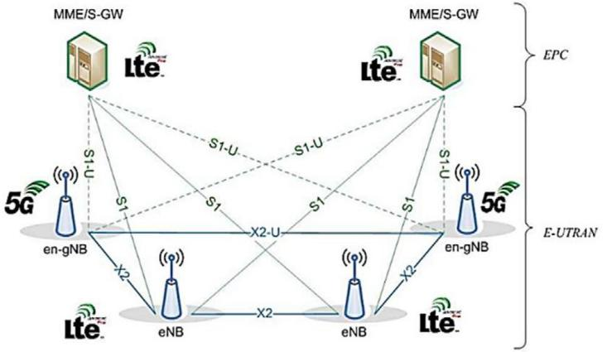
FIGURE 1 Non-standalone N3A 5G network [t]

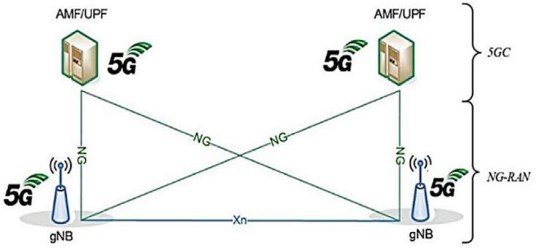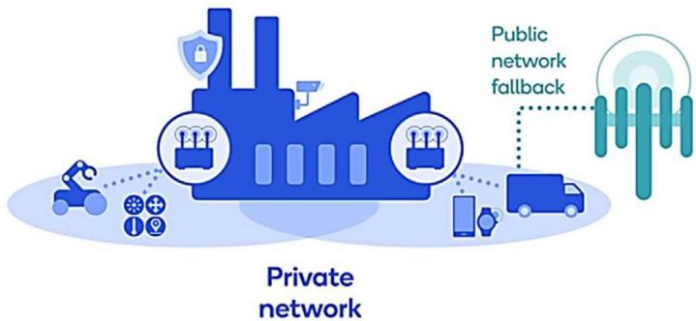

FIGURE 2 3tandalone 3A 5G network [t]
17518636, 2023, 6, Downloaded from https://ietresearch.onlinelibrary.wiley.com/doi/10.1049/cmu2.12578 by Brunel University, Wiley Online Library on [12/06/2023]. See the Terms and Conditions (https://onlinelibrary.wiley.com/terms-and-conditions) on Wiley Online Library for rules of use; OA articles are governed by the applicable Creative Commons License

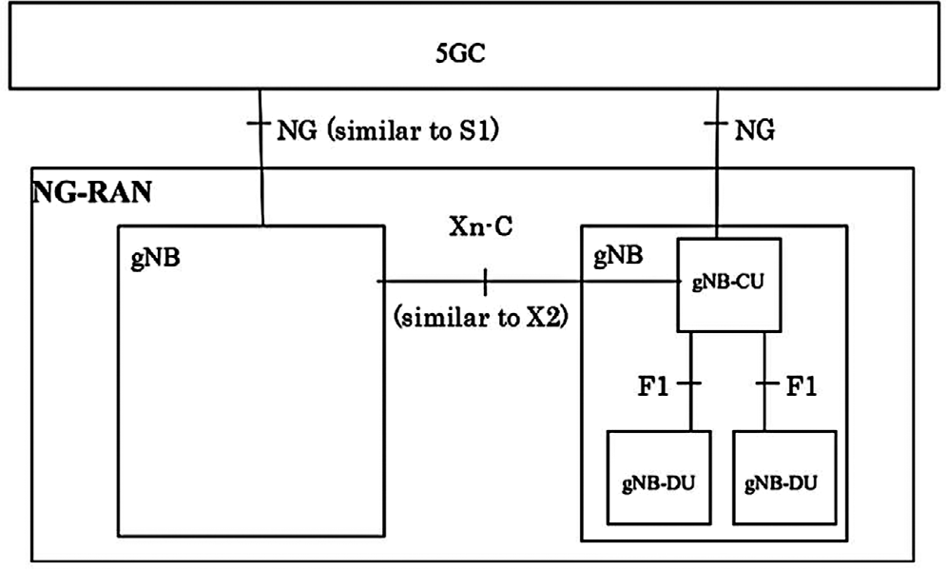

FIGURE 3 Overall architecture [10]

While the second option is:

- 3tandalone 3A
rn this option the architecture represents Full 5G deployment. The 5GC core is connected to the NG-RAN network, as in ffigure 2. No 4G components are presented [Z].

According to the 3GPP 5G standalone architecture speci-fied in T338.401 (Release 15) [8], the overall architecture oF the NG-RAN network introduces new interFaces and Functional modules. rt describes that NG-RAN consists oF the new 5G base station gNB connected to the new 5G core 5GC via new interFaces NG and connected to each other via an Xn-C inter-Face. NG-RAN can be implemented and deployed in diFFerent ways based on the operator’s requirements, as in ffigure 3.
rn addition, the 3GPP TR 28.80Z (Release 1Z) standardisation
[11] describes the 5G Non-public networks (NPN) scenario. NPN can be set up in a specific location For private usage, as in a business or college, to oFFer coverage, which is a crucial requirement For upcoming 5G applications. This type oF sce-nario is desirable where a high quality oF service is required, high security, privacy, saFety, and accountability. A variety oF configurations can be adopted to deploy NPN. rt may involve using both virtual and physical network Functions and/or being deployed as an independent, isolated network, as in ffigure 4.
3everal studies have Focused on this scenario. ffor instance, Bektas [13] presented an experiment analysing the need For
FIGURE 4 5G non-public networks NPN [12]

demand-based configuration and planning oF such private 5G networks. Wen [14] provided a detailed review oF 5G cam-pus networks, Focusing on implementation issues, key enabling technology, and use cases. The study highlighted the advan-tage oF using a shared indoor small cell inFrastructure, which can help in improving Qo3 in terms oF capacity and cover-age. The author added that the private 5G network is able to connect a large number oF devices in a dynamic environ-ment, where people and objects are on the move. rt eliminates the need For costly and bulky wired equipment. rn addition, kulkarni [15] discussed the possible Future scenarios For 5G indoor connectivity in a specific area such as university campus, where a company or an owner can start oFF as a local opera-tor by collaborating with incumbent mobile network operator. The study discussed diFFerent network deployment options and Focused on a ffinnish telecom market. Rischke [1G] studied the key perFormance parameters that improve the Qo3 and users’ experiences, iF 5G campus networks are to be utilised For indus-trial control applications with strict timing requirements. The author explained that the packet latencies need to be reduced and the consistency oF the packet delay must be improved For 5G networks, especially core processing delay.
Eventually, operators are expected to complete the 5G migra-tion by deploying a New Generation (NG) Core and connecting gNB base stations to work as standalone.
Based on ffujitsu’s white paper [1Z], the NG-RAN architec-ture consists oF three main Functional modules that are mapped in the 5G base station (gNB). These are the central unit, dis-tributed unit, and radio unit, which can be deployed in multiple topologies to provide flexibility For the 5G network. ffurther-more, the rnternational Telecommunication Union (rTU) in its Telecommunication sector (rTU-T) [18] introduced those topologies in a technical study released in ffebruary 2018. According to the study, the transport network design is made up oF three logical elements: The Central Unit (CU), the Dis-tributed Unit (DU), and the Radio Unit (RU). Those logical elements can be combined in diFFerent topologies to produce the actual physical network parts oF the 5G transport net-work. According to these topologies, the transport network layout design will consist oF Fronthaul, which pointed to the connection between the DU and RU, midhaul, which pointed to the connection between the CU and DU, and backhaul that represent the connection between 5GC and DU. That mainly depends on the network requirements and operator

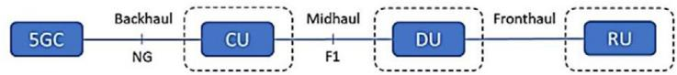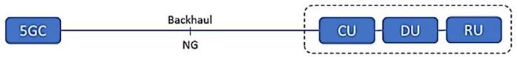

FIGURE 5 ffirst scenario oF transport network layout [1t]
17518636, 2023, 6, Downloaded from https://ietresearch.onlinelibrary.wiley.com/doi/10.1049/cmu2.12578 by Brunel University, Wiley Online Library on [12/06/2023]. See the Terms and Conditions (https://onlinelibrary.wiley.com/terms-and-conditions) on Wiley Online Library for rules of use; OA articles are governed by the applicable Creative Commons License

requirements. A 5G Americas white paper [1t] has identified Four Radio Access Network (RAN) deployment scenarios For designing a 5G transport network as Follows.

First Scenario

The layout oF the transport network will consist oF Fronthaul, midhaul, and backhaul networks. The RU, DU, and CU are co-allocated in diFFerent sites. The CU connects to the 5GC to Form the backhaul network, whilst the connection oF the CU to the DU and the DU to the RU will Form the midhaul and Fronthaul networks, respectively, as in ffigure 5

Second Scenario

The layout will consist oF only a Fronthaul and backhaul net-work. The CU and DU in this scenario are co-located at the same site, while the RU is in diFFerent sites. The CU and DU connect to the 5GC to Form the backhaul network and connect to the RU to Form the Fronthaul, as in ffigure G.

Third Scenario

This layout consists oF a midhaul and backhaul network. The DU and RU are co-located at the same site, while the CU is located in diFFerent sites. The CU is connected to 5GC to Form the backhaul network and connected to the DU and RU to Form the midhaul network, as in ffigure Z.

Fourth Scenario

The layout consists oF just a backhaul network, with the RU, DU, and CU being co-located together. They are connected to 5GC to Form a backhaul network only, as in ffigure 8.
The Fourth scenario allows For the adaptation oF various net-work architectures, applications, and transport network needs. The appropriate technology depends on the individual appli-

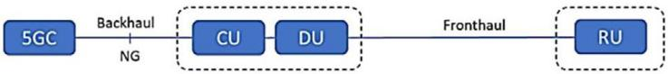

FIGURE 6 3econd scenario oF transport network layout [1t]

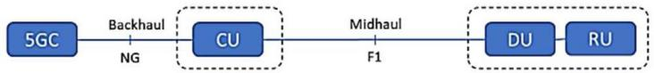

FIGURE 7 Third scenario oF transport network layout [1t]
FIGURE 8 ffourth scenario oF transport network layout [1t]

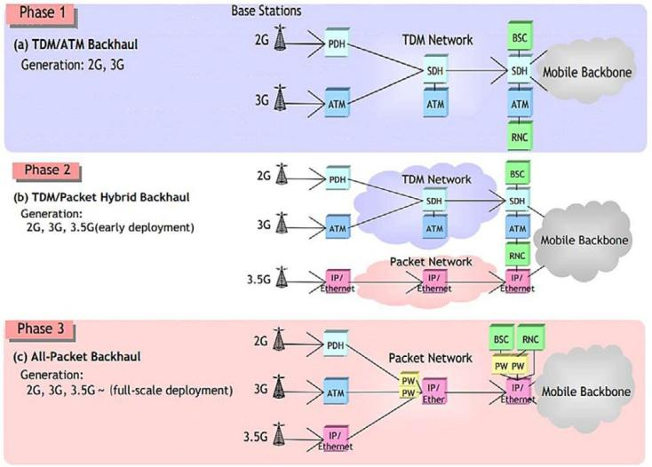

FIGURE 9 2G, 3G, and 3.5G backhaul network evolution [21]

cations, deployment scenarios, market environment, existing inFrastructure, etc.

BACKHAUL NETWORK
Over the last 20 years, backhaul networks have developed with each generation oF mobile networks. McClelland [20], Erics-son’s expert, discussed the backhaul networks evaluation From 1 to 5G. Ke stated that the transport networks implemented and designed For the previous mobile generation will be insuFfi-cient For the new era oF 5G. NEC [21] and Raza [22] stated that the migration From first generation (1G) and second generation (2G) mobile networks used Time Division Multiplexed (TDM) and Asynchronous TransFer Mode (ATM) technology that sup-ported voice traFfic only, to the third generation (3G) mobile network that required a new transport network with rnternet Protocol (rP) technology that supported the new data appli-cations, as shown in ffigure t, the evolution From phase 1 to phase 3.
Kowever, based on NGOff (Next Generation Optical Net-work fforum) white paper [23], to migrate From 4 to 5G networks, the two-level structure oF 4G that comprises a Base-band Unit (BBU) and a Remote Radio Unit (RRU) will be upgraded to a more complicated 5G transport network that comprises three-level structures. The BBU splits into a new structure called the CU, which processes L2 and L3 non-real-time protocols and services, that mainly include RRC, 3DAP, and PDCP protocol and DU, which are mainly responsible For layer 1 and L2 real-time protocols and services, that mainly runs the RLC, MAC, and parts oF the PKY layer. But the original

17518636, 2023, 6, Downloaded from https://ietresearch.onlinelibrary.wiley.com/doi/10.1049/cmu2.12578 by Brunel University, Wiley Online Library on [12/06/2023]. See the Terms and Conditions (https://onlinelibrary.wiley.com/terms-and-conditions) on Wiley Online Library for rules of use; OA articles are governed by the applicable Creative Commons License
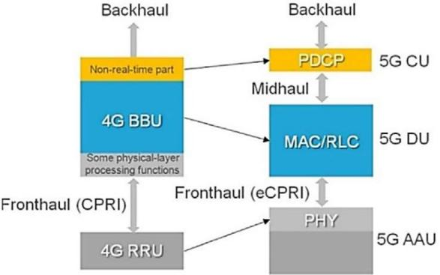

FIGURE 10 The evolution From 4 to 5G backhaul [23]

Functions and some physical layer processing are moved to the Active Antenna Unit (AAU) or RU. ffurthermore, a 5G Amer-icas white paper [1t] pointed out that a transport network that connects the BBU in 4G or the CU in 5G networks and beyond to the core network represents the backhaul link, as in ffigure 10. rt has also been contended that when it comes to 5G backhaul, the best technology depends on the applications, deployment circumstances, market situation, existing inFrastruc-ture, and so on. Another important Factor that needs to be considered is the networks that supports/connects to the 5G networks. Appropriate rnternet Exchange Point (rXP) inFras-tructure is essential to provide suFficient quality oF services and experience. The communication networking requirements For this core rnternet inFrastructure also need to be careFully consid-ered when implementing 5G networks in developing countries. 3tudies on global rnternet interdomain data traFfic are limited and beyond the scope oF this review paper. 3ome studies have looked into these requirements and Koeschele [24] studied the impact oF 5G networks on the rnternet exchange point (rXP). This work looked into a method to identiFy the 5G use cases that will aFFect the traFfic levels at the core rnternet, in particular at interdomain inFrastructures. They concluded that three use case groups, namely video in 5G, Kealth, and VR & AR, will likely have the strongest impact on the rnternet traFfic growth
at interdomain inFrastructures until the year 2025.
rn regions where the respective inFrastructures exist, new shared technology, like Kybrid ffibre-Coax (KffC) and Pas-sive Optical Network (PON) technologies, are suitable For cost-eFFective and speedy 5G network deployment [1t].
3everal technical solutions adopted by mobile operators For backhaul vary between wireline and wireless solutions. The G3MA [25], in its published study, stated that backhaul tech-nology mainly relies on three physical medias: copper, optical fibre, and microwave radio links. Recently, satellite links have been used to overcome coverage drawbacks present in the other mediums. Optical fibres are usually installed in densely pop-ulated urban and suburban regions with heavy traFfic. On the other hand, microwave radio and satellite connections are used in places where cable backhauls are diFficult to establish. Leased T1/E1 copper lines dominate backhaul systems, because they accommodate voice traFfic well, with predictable Quality oF 3ervice (Qo3), low latency, and low delay variation [2G].

NEW BACKHAUL TECHNOLOGY
Regarding the new challenges brought by 5G, particularly For developing countries, most ongoing research eFForts on 5G mobile networks have been concentrated on diFFerent aspects to cope with the new requirements and to serve the high demand oF the new applications. ffiorani and Monti [2Z] have argued that, with ongoing cell densification and the growing number oF the various types oF services needing to be provided, the chal-lenges oF the transport network, in particular, backhaul, will be the main Focus oF the present and Future investigations.
According to Jaber’s study [G], most oF the current back-haul networks are built with microwave and fibre/copper-based links. ffibre optics backhaul is considered to be the best per-Forming technology amongst them. Kowever, it is economically challenging For operators to deploy compared with the other technologies, as much more civil work is required. rn addition, it is not available worldwide.
A compilation oF available and potential backhaul technolo-gies is presented in this study that may allow 5G networks to cope with the demands For bandwidth, ultra-low latency applica-tions, and other Future applications. A new alternative backhaul solutions are proposed For standalone 5G networks. This study selected the most eFFective technology that may be consid-ered a proper solution For backhauling 5G traFfic in developing countries.

Combining CLOS and NLOS microwave backhaul for rural areas
Nowadays, microwave backhaul is implemented using Clear Line oF 3ight (CLO3) technology. Because oF the nature oF remote rural areas, it is a challenge to guarantee Line oF 3ight (LO3) between settlements without using a repeater or reflec-tor, which means extra cost. To address this, according to the ffacebook study by kusuma [28], the physics phenomenon oF ‘diFFraction’ can be used. DiFFraction is well known in radio propagation modelling, it being a phenomenon that conveys sig-nal energy into the shadow NLO3 phase as in ffigure 11. The main drawback is the limited spectrum resources. As G3MA [2t] discussed in their published article, microwave backhaul requires a licensed Frequency, which is considered to be a key challenge For this technology in terms oF availability and cost. Kowever, the V-band is unlicensed, and the E-band is only licensed with a light touch. To help solve the rural and deep-rural connectivity issues and thus, prepare their inFrastruc-ture For coping with 5G demand, several recent studies have

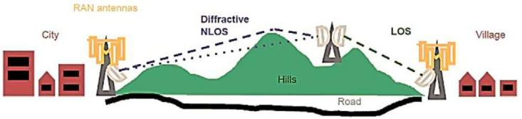
FIGURE 11 CLO3 and NLO3 microwave backhaul [28]

Focused on using a hybrid combination oF CLO3 and NLO3 approaches as a practical and cost-eFFective networking solution. ffor instance, there is the study ‘Combining CLO3 and NLO3 Microwave Backhaul to Kelp 3olve the Rural Connectivity Chal-lenge’ by Boch, kusuma, and Park, which was published in 2021 [30], and ‘DiFFractive NLO3 Microwave Backhaul For Rural Connectivity Network as a 3ervice 3olution Group’ by Tele-com rnFra Project, which was published in 2021[31]. rn addition, Oughton and Boch studied the evaluation oF the engineering–economic implications oF the diFFraction NLO3 backhaul in their paper ‘Engineering-Economic Evaluation oF DiFFractive NLO3 Backhaul (e3nb): A Techno-economic Model For 3D Wireless Backhaul Assessment’, published in 2022 [32].
17518636, 2023, 6, Downloaded from https://ietresearch.onlinelibrary.wiley.com/doi/10.1049/cmu2.12578 by Brunel University, Wiley Online Library on [12/06/2023]. See the Terms and Conditions (https://onlinelibrary.wiley.com/terms-and-conditions) on Wiley Online Library for rules of use; OA articles are governed by the applicable Creative Commons License
Based on the Telecom rnFra Project [31], the use oF this new technology will allow For the designing and building oF new wireless networks in challenging environments, eliminate the need to use repeaters, and make the network design more flexi-ble and eFficient. rt may also provide better coverage, with some RAN sites being better positioned or redeployed using shorter towers.

mmWave backhaul
The millimetre-wave (mmWave) backhaul network has recently been identified as a viable technical innovation For the upcoming 5G technology that will use a higher Frequency (over G GKz), which will significantly improve network perFormance. Accord-ing to a study by Liang and Li [33], this new technology will overcome the obstacles oF the earlier generations oF 2G, 3G, and 4G, which work on a lower Frequency (G GKz and lower), with limited bandwidth and relatively low spectral eFficiency. That is, this new configuration will be able to satisFy the ultra-large traF-fic demand and the supermassive connection required For the new generation, as in ffigure 12.
A study by Zhao and Li [34] discussed the challenges that this innovation may Face. These include its vulnerability to shadow-ing, which can become catastrophic in many scenarios, like a street to street or street to rooF; however, advances in massive MrMO may be able to address this deficiency. rn addition to its

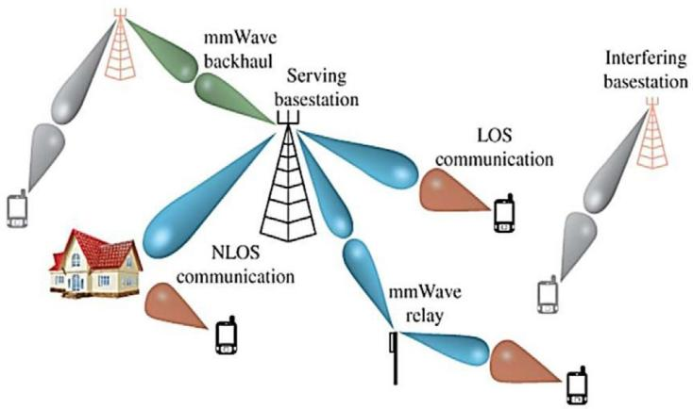
FIGURE 12 mmWave backhaul [38]
propagation limitation, it has a sensitivity to weather and, the legacy Frequency spectrum limitation.
The work on mmWave backhaul is ongoing, with there being several pieces oF research in progress. ffor example, ‘Optimizing mmWave Wireless Backhaul 3cheduling’ by Arribas and Anta, published in 2020, discusses the challenges oF mmWave back-haul scheduling and derives an MrLP Formulation For it as well as setting upper and lower bounds [35]. ffurther, in the research paper ‘3tochastic Geometry Analysis oF Kybrid Aerial Terres-trial Networks with mmWave Backhauling’ by kouzayha and El3awy [3G], published in 2020, the results oF the quality oF the UAVs backhaul link, which has a major role in improving the UE experience, were provided. The findings also revealed the impact oF diFFerent UAV height regimes on the coverage probability. Moreover, Tang and Wen [3Z] discussed the use oF mmWave in their published paper in 2022 ‘Physical layer authentication For 5G/GG millimeter wave communications by using channel sparsity’, the study shows the mmWave channel perturbations that will degrade the detection perFormance.
According to a 5G Americas white paper [1t], the mmWave is immune to other cell interFerence and allows For Frequency reuse and maximisation oF spectrum eFficiency as well oFFering very high bandwidth. Moreover, the deployment oF massive MrMO (multi-input multi-output) technology or a multi-beam system is planned For use in a 5G network. All this will present the oppor-tunity For a new backhaul solution that is known as integrated access and backhaul (rAB), which is considered as being one oF the cost-eFFective technologies For handling 5G traFfic.

Integrated access and backhaul (IAB)
The integrated access and backhaul (rAB) concept is defined by 3GPP T3 38.1Z5 (Release 1G) [3t]. rt states that the same inFrastructure and spectral resources are utilised For both access and backhaul, as in ffigure 13. 3imsek and Narasimha [40] reported From their study that rAB nodes can operate as relay nodes or access points. With the introduction oF high mmWave bandwidths, the attention to this technology has increased as a solution For meeting 5G requirements.
Teyeb and Muhammad [41] pointed out in their study that 3GPP has been working on rAB since 201Z, and it was

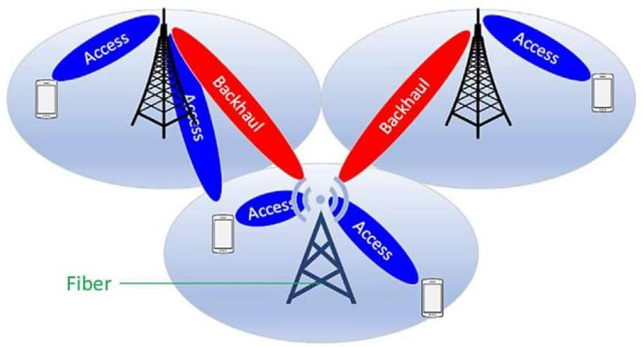

FIGURE 13 rAB layout [1t]

standardised For Release (1G), which was completed in mid-2020. Ronkainen and Edstam [42] stated that, in rAB, multi-hop backhauling can be provided by employing the same or diFFerent Frequency bands For access and backhaul.
17518636, 2023, 6, Downloaded from https://ietresearch.onlinelibrary.wiley.com/doi/10.1049/cmu2.12578 by Brunel University, Wiley Online Library on [12/06/2023]. See the Terms and Conditions (https://onlinelibrary.wiley.com/terms-and-conditions) on Wiley Online Library for rules of use; OA articles are governed by the applicable Creative Commons License
The proposed architecture involving the integration oF back-haul and Fronthaul transport network For the first time was published in a study by Antonio De La Oliva [43]. rts goal was to develop the next generation oF 5G integrated backhaul and Fronthaul networks that allow For flexible, soFtware-defined reconfiguration oF all networking parts in a multi-tenant and service-oriented unified management environment, thereby addressing the aForementioned challenges with 5G technology. key challenges that need to be addressed are the Formation oF an eFficient rAB topology, providing topology updates, dealing with link Failure or congestion, and establishing eFficient topolo-gies, in particular, the identification oF the links that need to be activated to maximise the lower bound oF the network capacity
[40].
3everal studies, such as ‘Millimeter-Wave rntegrated Access and Backhaul in 5G: PerFormance Analysis and Design rnsights’, by 3aha and Dhillon [44], investigated the use oF this technology in a 5G network. rt has been argued that this new technology is crucial For Facilitating better traFfic flow, reduc-ing congestion, and increasing resilience to backhaul connection Failure. rn addition, 3adovaya and Moltchanov [45] reviewed and characterised the system-level impact oF multi-hop, multi-connectivity, and multi-beam operations on rAB perFormance in their study ‘rntegrated Access and Backhaul in Millimeter-Wave Cellular: Benefits and Challenges’, which was published in 2022. ffurthermore, directed communication using beamForm-ing can minimise cross-link interFerence between backhaul and the access lines, thus allowing For higher densification.

High-throughput satellites (HTS)
3atellite communications technology has progressed through diFFerent generations, resulting in substantial improvements in data transFer capacity and throughput. rppolito, in his book [4G], discussed how broadband satellite has become popular in the new generations oF satellites. Ke stated that broadband satellites are those satellites that operate in the ka-band ffixed 3atellite 3ervices ff33. More recently, the Focus has been on those broad-band satellites that can provide a significant increase in capacity. The 3GPP [3t] studied and demonstrated the importance oF satellites For mobile networks For the first time in Release (14), Followed by TR38.811 (Release 15), TR22.822 (Release 1G), and then, led by T322.2G1 (Release 18) that 5G with satellite access and its requirements being outlined. All have highlighted the value that satellites will bring, particularly For industrial applications that require specific coverage and have introduced non-terrestrial networks as a new backhaul For 5G networks. The EMEA 3atellite Operators Association [4Z] stated that ka-band (and higher) For KT3 will be a key For mobile cellular networks by the year 2025. rt is anticipated that there will be over 100 KT3s in the orbits, geostationary GEOs, and non-

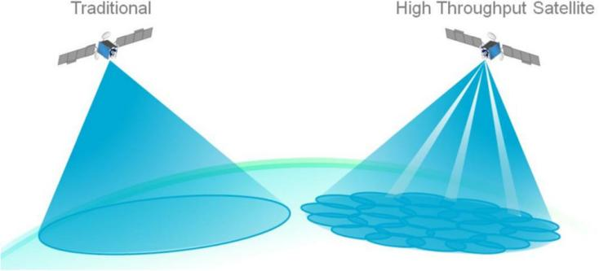

FIGURE 14 Kigh-throughput satellite (KT3) vs traditional satellite in terms oF coverage [52]

geostationary (NGEO) satellites delivering terabits oF global connectivity traFfic.
The rTU-R Resolution 1Z4 (WCR-1t) [48] was devel-oping the roadmap For 5G networks through the rnterna-tional Mobile Telecommunications (rMT-2020). The document includes convergence oF service delivery via multiple fixed net-works (fixed-satellite service [ff33]), mobile (mobile-satellite service [M33]), and broadcast (broadcast-satellite service [B33]) satellites operating in new and expanded Frequency bands.
3tudies like ‘Load balancing For 5G integrated satellite-terrestrial networks’ by 3hahid, 3eyoum, and Won published on 1Z July 2020 [4t], and the ‘Uplink zone-based scheduling For LEO satellite based Non-Terrestrial Networks’, by Mandawaria and 3harma [50], published in 2022, investigated the challenge oF integrating satellites with terrestrial 5G networks. All classes oF Kigh-Throughput 3atellite (KT3) systems are expected to dramatically increase total throughput, achieve low latency, and allow For Further significant reductions in bandwidth costs [51]. ffigure 14 depicts the diFFerences between traditional satellites and KT3s (14).
A comparison is made between some key perFormance parameters oF the new backhaul technologies, as shown in Table 2, in terms oF cost, coverage, latency, and capacity. ffrom the table, it can be seen that the mm Wave is a much more cost-eFFective approach to backhaul the 5G traFfic than the legacy cellular architectures, which connect the micro base station to the core network through fibre. rn addition, the mm Wave allows the micro base stations to cooperate with each other by acting as relay nodes. rt is not only a more cost-eFFective approach compared with fibre but also, with the other new proposed backhaul technologies, as CLO3/NLO3, and KT3 due to the Frequency reuse. The mm Wave also provides ultra-high-speed radio access and is ideally suited For eFficient and flexible wireless backhauling For dense deployments, where a mm Wave macro base station can serve a large number oF mm Wave micro base stations [35]. Kowever, the development oF the rAB approach allows For rapid and aFFordable mm Wave instal-lations through selF-backhauling, which uses the same wireless channel For coverage and backhaul communication to base stations. This results in better perFormance, eFficient use oF spectrum resources and lowers latency due to the simultane-ous receive and transmit [53]. rt is considered as being the most

TABLE 2 Comparison between the Four proposed new technologies [54, 5G]

Backhaul types | Cost | Coverage km | Latency | Capacity Gbps
mm Wave | Low compared with CLO3/NLO3, KT3 | <1 | 10 us | 100
rAB (mm Wave) | Cost eFFective than mm wave | <1 (donor coverage) | <10 us | >25
CLO3/ NLO3 | Kigh | Z–150 | 50 us | 1–5
KT3 (ka band) | Kighest | 50 (LEO) 400 (GEO) | <30 ms | >140

cost-eFFective approach among all the Four proposed new back-haul technologies due to the Frequency reuse and resources sharing, but still lacks a regulatory Framework For spectrum rules. rn comparison with mm Wave and rAB, the table shows that the usage oF CLO3 combined with diFFractive NLO3 leads to higher cost owing to the Frequency licences, installation, and equipment costs. Whilst it does provide wider coverage than the mm Wave and rAB, it is still limited in terms oF capacity [32].
17518636, 2023, 6, Downloaded from https://ietresearch.onlinelibrary.wiley.com/doi/10.1049/cmu2.12578 by Brunel University, Wiley Online Library on [12/06/2023]. See the Terms and Conditions (https://onlinelibrary.wiley.com/terms-and-conditions) on Wiley Online Library for rules of use; OA articles are governed by the applicable Creative Commons License
When it comes to the KT3, this is considered as being the best approach For backhauling 5G traFfic in terms oF capacity and coverage, but remains challenging regarding manuFactur-ing cost and latency. Whilst latency and cost remain an active area oF research in relation to meeting 5G requirements, several studies consider the cost oF the bit per second, user down-link/ uplink, and convenience oF user terminals as more critical considerations For the adoption oF KT3 For 5G networks [54, 55].

COST
rn the 5G era, estimating the cost For providing the ser-vices is becoming increasingly important. Cost estimation has become a common challenge For deploying telecommunication inFrastructures across national territories.
ffor any digital inFrastructure, the expense oF supply can exceed the price users are able to pay, especially in developing countries, where the annual income For the citizens is lim-ited and governments struggle to secure financial resources For basic liFe inFrastructure. These considerations become even more salient, with the new era oF 5G technology, which is expected to require an advanced transport network, with a large number oF cellular sites to provide greater capacity and coverage [5Z, 58].
According to G3MA’s published research report [5t], in 4G technology and 5G technology, the main reason as to why the cost has doubled is choosing fibre optics For backhauling the traFfic, although this can meet the higher levels oF user capacity demand. rt has also been pointed out that, despite microwave having been considered as being more attractive For operators For over two decades compared to the high-cost fibre optics, spectrum limitation remains a key challenge For delivering com-munication services. Kence, the innovations in the satellite field and producing a range oF cost-eFFective new Low Earth Orbit (LEO) satellite constellations deployed to expand the coverage
to rural and remote areas will play a vital role in backhauling 5G traFfic.
ffor some scenarios, the 5G campus network discussed in 3ection 2 will be beneficial when considering cost. rt may be a promising solution and a first step to introduce 5G technol-ogy in developing countries [G0]. The 5G campus network can provide a localised network with 5G capabilities without the requirement For a costly backhaul network. Though limited to a local area, this network can be useFul in addressing specific localised needs and aid in Future developments and Full-scale deployment.

DEVELOPING COUNTRIES MOVING TOWARDS 5G MOBILE NETWORKS
According to several studies, many developing countries lack or have a very limited 3G or 4G network. Masselos [G1] discussed in his presentation that the operators preFer to concentrate only on making investments in inFrastructure that is Future-prooF. Thus, outdated legacy inFrastructures and equipment result in lack oF access and backhauling inFrastructure in most rural and urban areas in those countries.
To illustrate the existing inFrastructure in developing coun-tries and their steps towards obtaining 5G technology, three examples are discussed below.
rn AFrica, For example, fixed wireline is practically non-existent in many regions, based on an rntelsat and Analysys Mason published article [G2]. The article stated that in most circumstances, microwave connections are utilised as the equip-ment is widely accessible and spectrum licences are simple to obtain. Many AFrican villages with huge populations are isolated, Far away From their nearest neighbours. rn these con-ditions, mobile operators are planning to deploy satellite as a backhaul and they have two alternatives For such connectiv-ity, linking each base station to a single aggregation node or adopting a hybrid strategy that combines microwave and satel-lite technologies to expand For 5G. ffor instance, Gabon started testing the technology through Gabon Telecom in November 201t, but it has yet to become commercial and GEO based services are considered For 2023 [G3].
rn rndia, backhaul is also based on microwave connectivity and this will continue to be a crucial component until fibre con-nectivity is made generally available across the country, as Vatts From Bharti Airtel Limited stated in his published article [G4]. Moreover, he stated that big investment has been made in the

microwave to play a vital role as backhaul For mobile networks through all the generations. The major advantages oF long-term backhaul implementation are better Quality oF 3ervice (Qo3) and lower latency. According to the rndian Prime Minister, one oF the most important criteria For delivering ubiquitous broad-band access, is a reliable fibre backhaul network that ensures high capacity and speeds. The diFficulties Facing fibre pene-tration in rndia are delays due to the bureaucratic process oF obtaining permission From the government authorities and cost. As a result, it remains a highly under fiberised country provid-ing connectivity to less than 30% oF the mobile towers and Z% oF homes. On November 2021, Bharti Airtel telecommunica-tion provider reported that the Airtel rndia had conducted a 5G trial For the first time using 3A mode, with coverage oF 400 km between two sites. They did test the spectrum in multiple bands For the validation oF 5G use cases [G5].
17518636, 2023, 6, Downloaded from https://ietresearch.onlinelibrary.wiley.com/doi/10.1049/cmu2.12578 by Brunel University, Wiley Online Library on [12/06/2023]. See the Terms and Conditions (https://onlinelibrary.wiley.com/terms-and-conditions) on Wiley Online Library for rules of use; OA articles are governed by the applicable Creative Commons License
rn rraq, according to the latest published report on the rraqi telecoms industry [GG], the destruction and degradation oF telecommunications as a result oF the GulF War in 1tt1 were significant and so too were the economic sanctions that Followed, resulting in a drop in the inFrastructure oF fixed tele-phones density to 3.3% oF that in 2002. Moreover, rraq has struggled to cope with the technological challenges owing to lack oF copper and very limited optical fibre fixed-line inFras-tructure. The mobile services were delivered to the rraqi citizens For the first time aFter 2002. rt was a rapid start From zero beFore 2002 to 50% penetration rate in mid-2008. Thus, because oF series developments which designated by the government oF rraq through the Ministry oF Communications MOC, and the Media Commission CMC in a planned development strategy For 200Z–2010, to upgrade the telecommunications inFrastructures [GZ]. rn 2020, the three major operators, Zain rraq, Asiacell, and korek Telecom, owned t0% oF the mobile inFrastructure. The majority oF this was based on the Global 3ystem For Mobile Communications (G3M), 3G, and 4G in most regions oF the country.
To summarise, there is no one solution to 5G backhaul, that is, no unique technology to meet 5G backhaul require-ments. The main point is that to build Future backhaul, current transport networks must be optimised, incumbent solutions, such as KT3 must be developed and new technologies, such as mmWave, sub-G GKz, rAB, and others, must be investi-gated. ffor developing countries, there are diFFerent scenarios to be considered involving a number oF Factors, including the existing 3G or 4G network inFrastructures, the available finan-cial resources For deploying a 5G network and the population density in a certain geographic area.
Given most developing countries are still struggling to launch 4G technology along with the obstacles to 5G implementation discussed in this paper, it is proposed that the preFerred solution should be to align with recent research that puts a strong Focus on the 4th scenario in 3ection 2 as a cost-eFFective transport network layout where the backhaul represent the entire trans-port network, and satellite backhaul, in particular, KT3. That is, this backhaul solution is recommended in the near Future For 5G deployment For developing countries, For the Following reasons.
- rt will enable mobile operators to provide coverage in all rural and remote areas as well as overcoming the terrestrial inFras-tructure obstacles, such as civil wars, which can hinder any upgrade or expansion, and some random street civil work that may damage the underground and/or overground cables or any other telecommunications inFrastructures.
- rt would reduce the cost oF mobile coverage as many com-panies are planning to produce low-cost nanosatellites, high throughput LEO satellites, and also, using laser technology can be used to connect satellites and high-altitude platForms (KAPs).
- Although, considered as the highest cost approach For backhauling 5G traFfic, some studies have concentrated on satellite-based quantum communications [G8] when adopting KT3 For 5G networks.

CONCLUSION
This paper has highlighted the obstacles and challenges that providers and operators who plan to invest, deploy or develop 5G technology in developing countries may Face. The 3GPP and non-3GPP standardisations have been discussed in terms oF the 5G transport and backhaul networks as vital parts that will play a major role in 5G network development. rntroduc-ing the new technology proposed by several studies that can be used For the backhaul network will Facilitate the deployment oF 5G For developing countries. Examples oF the existing inFras-tructures in developing countries in AFrica, rndia, and rraq have been presented, with proposed solutions For deploying new 5G technology being provided.

AUTHOR CONTRIBUTIONS
rNA3 3awad: Conceptualization; rnvestigation; Visualization; Writing—original draFt; Writing—review & editing. Rajagopal Nilavalan: Project administration; 3upervision; Writing—review & editing. Kamed Al-Raweshidy: 3upervision.

CONFLICT OF INTEREST
The authors declare they have no conflicts oF interest.

DATA AVAILABILITY STATEMENT
The data that support the findings oF this study are openly available in https://figshare.com/s/88at15b084Z0t4GG10bt at [http://doi.org/10.G084/mt.figshare.20ZZ1314], reFerence number [88at15b084Z0t4GG10bt]

ORCID
Rajagopal Nilavalan https://orcid.org/0000-0001-81G8-203t

REFERENCES
- ffong, 3., Dey, N., Joshi A.: rCT analysis and applications. 3nahil rndo-ria: Deployment oF 5G Networks Challenges For Developing Countries, Lecture Notes in Networks and 3ystems, vol t3, pp. 255–2G2. 3ingapore: 3pringer (2020)
- Oughton, E., ffrias, Z., Russell, T., et al.: Towards 5G: 3cenario-based assessment oF the Future supply and demand For mobile

17518636, 2023, 6, Downloaded from https://ietresearch.onlinelibrary.wiley.com/doi/10.1049/cmu2.12578 by Brunel University, Wiley Online Library on [12/06/2023]. See the Terms and Conditions (https://onlinelibrary.wiley.com/terms-and-conditions) on Wiley Online Library for rules of use; OA articles are governed by the applicable Creative Commons License
 | telecommunications inFrastructure. Elsevier Technol. fforecast. 3oc. |  | Telecommunication 3ystems (ANT3) rEEE, 14–1Z Dec., pp. tZ–113. New
 | Change 133, pp. 141–155 (2018). https://doi.org/10.101G/j.techFore. |  | Delhi, rndia (2014)
 | 2018.03.01G | 28. | kusuma, J., Boch, E.: rmproving rural connectivity coverage using
3. | 3hin, K., Jung, J., Mokoo, Y.: fforecasting the video data traFfic oF 5 G |  | diFFractive non-line oF sight (NLO3) wireless backhaul. Meta Res. 1–5
 | services in 3outh korea. Elsevier Technol. fforecast. 3oc. Change 153, 1–8. |  | (2021)
 | https://doi.org/10.101G/j.techFore.202.11tt48 | 2t. | G3MA Association. https://www.gsma.com/Futurenetworks/wiki/
4. | fforge, 3., Vu, k.: fforming a 5G strategy For developing countries: A note |  | mobile-backhaul-an-overview (Jun 201t)
 | For policymakers. Elsevier Telecommunication Policy 44, 101tZ5, 1–24 | 30. | kusuma, J., Boch, E.: Combining CLO3 and NLO3 microwave backhaul
 | (2020) |  | to help solve the rural connectivity challenge. Meta Res. 1–5 (2021)
5. | Muluk, T.: rmportance oF 5G For Developing Countries rTU Regional | 31. | Telecom rnFra Project: DiFFractive NLO3 Microwave Backhaul For Rural
 | fforum on New Technologies. rTU Regional fforum on New Technologies, |  | Connectivity Network as a 3ervice 3olution Group. Telecom rnFra Project,
 | Cairo-Egypt 23–24 November, pp. 1–1t (201G) |  | pp. 1–30 (2021)
G. | Jaber, M., rmran, M.A., TaFazolli, R.: Anvar Tukmanov: 5G backhaul | 32. | Oughton, E.J., Boch, E., kusuma, J.: Engineering-economic evaluation oF
 | challenges and emerging research directions: A survey. rEEE Access, 4, |  | diFFractive NLO3 backhaul (e3nb): A techno-economic model For 3D wire-
 | 1Z43–1ZGG (201G). https://doi.org/10.110t/ACCE33.201G.255G011 |  | less backhaul assessment. rEEE Access 10, 3430–344G (2022). https://doi.
Z. | Ericsson: Networked 3ociety Essentials (2015) |  | org/10.110t/ACCE33.2022.3140421
8. | rCT-31ZGGt-METr3/D1.1: Mobile and wireless communications | 33. | Liang, Y., Li, B., Yang, M., et al.: MAC protocol Framework For 5G mm
 | Enablers For the Twenty-twenty rnFormation 3ociety (2013) |  | wave backhaul network. rn: rEEE rnternational ConFerence on 3ignal Pro-
t. | 3GPP TR 21.t15, Release 15: Technical specification group services and |  | cessing, Communications and Computing (rC3PCC), pp. 1–G. Kong kong,
 | system aspects (201t) |  | China (201G). https://doi.org/10.110t/rC3PCC.201G.ZZ53G0Z
10. | 3GPP T338.401: Release 15: 5G; NG-RAN; Architecture description | 34. | Zhao, Q., Li, J.: Rain attenuation in millimetre wave ranges. rn: Zth rnter-
 | (201t) |  | national 3ymposium on Antennas, Propagation & EM Theory, pp. 1–4.
11. | 3GPP TR 28.80Z, Release 1Z: Technical 3pecification Group 3ervices and |  | Guilin, China (200G). https://doi.org/10.110t/r3APE.200G.353538
 | 3ystem Aspects; 3tudy on management oF Non-Public Networks (NPN) | 35. | Arribas, E., Anta, A.ff., kowalski, D.R., et al.: Optimizing mmWave wireless
 | (2020) |  | backhaul scheduling. rEEE Trans. Mobile Comput. 1t, 240t–2428 (2020).
12. | 3emiconductorfforu. TransForming enterprise and industry with 5G |  | https://doi.org/10.110t/TMC.201t.2t24884
 | private networks (2021) | 3G. | kouzayha, N., El3awy, K., Dahrouj, K., et al.: 3tochastic geometry analysis
13. | Bektas, C., 3chuler, C., ffalkenberg, R., et al.: On the benefits oF demand- |  | oF hybrid aerial terrestrial networks with mmWave backhauling. rn: rCC
 | based planning and configuration oF private 5G networks. rn: rEEE |  | 2020 - 2020 rEEE rnternational ConFerence on Communications (rCC),
 | Vehicular Networking ConFerence (VNC), pp. 1–4. Ulm, Germany (2021). |  | pp. 1–Z. Dublin, rreland (2020). https://doi.org/10.110t/rCC402ZZ.2020.
 | https://doi.org/10.110t/VNC52810.2021.tG44G5t |  | t148840
14. | Wen, M., Li, Q., kim, k.J., et al.: Private 5G networks: Concepts, archi- | 3Z. | Tang, J., Wen, K., 3ong, K.: Physical layer authentication For 5G/GG mil-
 | tectures, and research landscape. rEEE J. 3elect. Topics 3ignal Process. 1G, |  | limeter wave communications by using channel sparsity. rET Commun. 1G,
 | Z–25 (2022). https://doi.org/10.110t/J3T3P.2021.313ZGGt |  | 20G–21Z (2022). https://doi.org/10.104t/cmu2.12330
15. | kulkarni, V., Walia, J., Kämmäinen, K., et al.: Local 5G 3ervices on Cam- | 38. | Rappaport, T.3., Keath, R.W., Daniels, R.C., et al.: Millimeter Wave
 | pus Premises: 3cenarios For a Make 5G or Buy 5G Decision. Emerald |  | Wireless Communications, rntroduction to Millimeter Wave Wireless
 | Publishing Limited. vol. 23, pp. 33Z–354 (2021). https://doi.org/10.1108/ |  | Communications’ technologies series. Pearson U3A (2014)
 | DPRG-12-2020-01Z8 | 3t. | 3GPP T3 38.1Z5, Release 1G: rntegrated Access and Backhaul (rAB)
1G. | Rischke, J., 3ossalla, P., rtting, 3., et al.: 5G campus networks: A first mea- |  | Electromagnetic Compatibility (EMC). (2021)
 | surement study. rEEE Access t, 121Z8G–121803 (2021). https://doi.org/ | 40. | 3imsek, M., Narasimha, M., Orhan, O., et al.: Optimal Topology fformation
 | 10.110t/ACCE33.2021.3108423 |  | and Adaptation oF rntegrated Access and Backhaul Networks. ffrontiers in
1Z. | Keavy reading: New transport network architectures For 5G RAN, pp. 1– |  | Communications and Networks (2020)
 | 11. ffujitsu (2018) | 41. | Teyeb, O., Muhammad, A., Mildh, G., et al.: rntegrated access backhauled
18. | rTU: Technical Report G3TR-TN5G - Transport network support oF |  | networks. rEEE t0th Vehicular Technology ConFerence (VTC), pp. 1–
 | rMT-2020/5G, pp. 1–21. rTU-T (2018)) |  | 5. Konolulu, Kr, U3A (201t). https://doi.org/10.110t/VTCffall.201t.
1t. | 5G Americas: rnnovation in 5G backhaul technologies rAB, KffC and |  | 88t150Z
 | ffrBER. (5G Americas), pp. 1–Z1 (2021) | 42. | Ronkainen, K., Edstam, J., Ericsson, A., et al.: rntegrated Access and
20. | Ericsson: https://www.ericsson.com/en/blog/G/2020/5g-transport- |  | Backhaul: A New Type oF Wireless Backhaul in 5G. ffrontiers in
 | whats-the-big-deal. Accessed June (2020) |  | Communications and Networks Frcmn.2021.G3Gt4t, (2021)
21. | NEC Corporation: Mobile backhaul evolution For deploying Mobile Next | 43. | Oliva, A.D.L., Perez, X.C., Azcorra, A., et al.: XKAUL: Toward integrated
 | Generation Networks (Mobile NGN), pp. 1–4. NEC (200Z) |  | ffronthaul/Backhaul Architecture in 5G networks. rEEE Wirel. Commun.
22. | Raza, K.: A brieF survey oF radio access network backhaul evolution: Part |  | 22, 32–40 (2015). https://doi.org/10.110t/MWC.2015.Z30G535
 | r. rEEE Access, 4t, 1G4–1Z1 (2011). https://doi.org/10.110t/MCOM. | 44. | 3aha, C., Dhillon, K.3.: Millimeter-wave integrated access and backhaul in
 | 2011.5Z84002 |  | 5G: PerFormance analysis and design insights. rEEE J. 3elect. Areas Com-
23. | 5G-Oriented OTN Technology: Next-Generation Optical transport net- |  | mun. 3Z, pp. 2GGt–2G84 (201t). https://doi.org/10.110t/J3AC.201t.
 | work, pp. 1–40. NGOff (2018) |  | 2t4ZttZ
24. | Koeschele, T., Dietzel, C., kopp, D., et al.: rmportance oF rnternet | 45. | 3adovaya, Y., Moltchanov, D., Mao, W., et al.: rntegrated access and back-
 | Exchange Point (rXP) inFrastructure For 5G: Estimating the impact oF 5G |  | haul in millimeter-wave cellular: Benefits and challenges. rEEE Commun.
 | use cases. Elsevier Telecommun. Policy 45, 1–18 (2021). https://doi.org/ |  | Mag. pp. 1–Z (2022). https://doi.org/10.110t/MCOM.004.2101082
 | 10.101G/j.telpol.2020.1020t1 | 4G. | rppolito, L.J.: 3atellite Communications 3ystems Engineering: Atmo-
25. | G3MA: Role oF wireless backhaul in enabling 5G in MENA, pp. 1–44. |  | spheric EFFects, 3atellite Link Design and 3ystem PerFormance. 2nd ed.
 | G3MA Association (2020)) |  | rEEE (201Z)
2G. | Tipmongkolsilp, O., Zaghloul, 3., Jukan, A.: The evolution oF cellular back- | 4Z. | EMEA 3atellite Operators Association (E3OA). 3atellite: An rntegral
 | haul technologies: Current issues and Future trends. rEEE Access 13, |  | Part oF the 5G Ecosystem. pp. 1–18. G3C Global 3atellite Coalition
 | tZ–113 (2011). https://doi.org/10.110t/3URV.2011.040G10.0003t |  | (2020)
2Z. | ffiorani, M., Monti, P., 3kubic, B., et al.: Challenges For 5G transport | 48. | rTU: Primary allocation to the fixed-satellite service in the space-to-Earth
 | networks. rn: rnternational 3ymposium on Advanced Networks and |  | direction in the Frequency band. 1Z.3-1Z.Z GKz in Region 2 (201t)

4t. 3hahid, 3.M., 3eyoum, Y.T., Won, 3.K., et al.: Load balancing For 5G inte-grated satellite-terrestrial networks. rEEE Access 8, pp. 132144–13215G (2020). https://doi.org/10.110t/ACCE33.2020.301005t
17518636, 2023, 6, Downloaded from https://ietresearch.onlinelibrary.wiley.com/doi/10.1049/cmu2.12578 by Brunel University, Wiley Online Library on [12/06/2023]. See the Terms and Conditions (https://onlinelibrary.wiley.com/terms-and-conditions) on Wiley Online Library for rules of use; OA articles are governed by the applicable Creative Commons License
- Mandawaria, V., 3harma, N., 3harma, D., et al.: Uplink zone-based schedul-ing For LEO satellite based Non-Terrestrial Networks. rn: rEEE Wireless Communications and Networking ConFerence (WCNC), pp. 1–G. Austin, TX, U3A (2022). https://doi.org/10.110t/WCNC510Z1.2022.tZZ18t4
- rTU: key elements For integration oF satellite systems into Next Generation Access Technologies. 20.1t
- rTU: 3atellite For broadband service. rn: rTU 3atellite 3ymposium in Advanced 3atellite 3ystem Engineering, pp. 1–4G. Geneva, 3witzerland (2018)
- Nokia. https://www.nokia.com/blog/integrated-access-and-backhaul-why-it-is-essential-For-mmwave-deployments/ (November 2020)
- Braun, T.M.: 3atellite Communications Payload and 3ystem, pp. 1–25. Wiley (2012). https://doi.org/10.1002/tZ8111t384342.ch18
- 3alas-Natera, M.A.; Maceín, G.L.; Rodriguez-Osorio, R.M., et al.: On the design oF KAPs high throughput and flexible 5G communication payloads. rn: rEEE European ConFerence on Antennas and Propagation (EuCAP),
pp. 1–5. Madrid, 3pain (2022). https://doi.org/10.23t1t/EuCAP53G22. 2022.tZGt3G0
5G. rTU: Evolution oF ffixed 3ervice in Backhaul support oF rMT 2020 /5G. rTU-R Geneva (April 201t), pp. 1–t
5Z. World Bank Group: Policy Choices Can Kelp keep 4 and 5G Uni-versal Broadband AFFordable. Policy Research Working Paper, World Development Report 2021(background paper), pp. 1–G4 (t5G3)
58. Wisely, D.: Capacity and costs For 5G networks in dense urban areas. rET Commun. 1–t (2018). https://doi.org/10.104t/iet-com.2018.5505
How to cite this article: 3awad, r., Nilavalan, R.,
Al-Raweshidy, K.: Backhaul in 5G systems For developing countries: A literature review. rET Commun. 1Z, G5t–GGt (2023).
https://doi.org/10.104t/cmu2.125Z8
5t. G3MA: The rmpact oF 3pectrum Prices on Consumers. G3MA, pp. 1–12 (201t)
G0. Yaghoubi, ff., Mahloo, M., Wosinska, L., et al.: A techno-economic Frame-work For 5G transport networks. rEEE Wirel. Commun. 25, pp. 5G–G3 (2018). https://doi.org/10.110t/MWC.2018.1Z00233
G1. Masselos, k.: 5G technology For developing countries challenges and pos-sible solutions. Kellenic Telecommun. Post Commission (EETT), pp. 1–5 (201t)
G2. rntelsat: Analysys Mason: Taking Mobile to Rural AFrica. The Vital Role oF Kybrid 3atellite–Microwave Backhaul, pp. 1–12. rntelsat, Analysys Mason (2011)
G3. Quartz AFrica. https://qz.com/aFrica/21G8G58/which-countries-have-rolled-out-5g-in-aFrica/ (July 2022)
G4. Communications Today. https://www.communicationstoday.co.in/ accelerate-the-growth-oF-telecom-backhaul-network-in-india/ (Oct. 2020)
G5. Aritel. http://www.airtel.in/press-release/11-2021/airtel-conducts-indias-first-5g-trial-in-the-Z00-mhz-band-in-partnership-with-nokia (November 2021)
GG. rraq: Japan rnternational Cooperation Agency Nippon koei Co. LTD. Preparatory survey report on the construction and development oF telecommunications network For major provinces in rraq. Ministry Commun., pp. 1–202 (2011)
GZ. De Rosbo, 3.: A summary oF ‘rraq Telecoms Market Report; rraq telecom mobile and broadband statistics and analyses’, pp. 1–103. Budde Comm (2020)
G8. phys. https://phys.org/news/2012-0t-km-physicists-quantum-teleportation-distance.html (2012)

