[project**: Fake news detection using nlp**



Phase-3

Development part-1

Begin building the fake news detection model by loading and preprocessing the dataset.

Load the fake news dataset and preprocess the textual data.

Fake news detection using nlp

Tables of content:

* Introduction
* Import libraries load the data
* Loading the dataset
* Preprocessing the dataset
* Sentence segmentation
* Normalization
* Tokenization
* Conclusion

Introduction:

* Fake news is false or misleading information presented as news.
* The proposed study uses machine learning and natural language processing approaches to identify false news—specifically, false news items that come from unreliable sources.
* Fake news and disinformation are ongoing problems that may be found all around us in biased software that amplifies just our viewpoints for a "better" and smoother user experience.
* Fake news and misinformation are becoming more of a problem as the internet and social media platforms become more main stream.

Dataset link:

<https://www.kaggle.com/datasets/clmentbisaillon/fake-and-real-news-dataset>

Given dataset

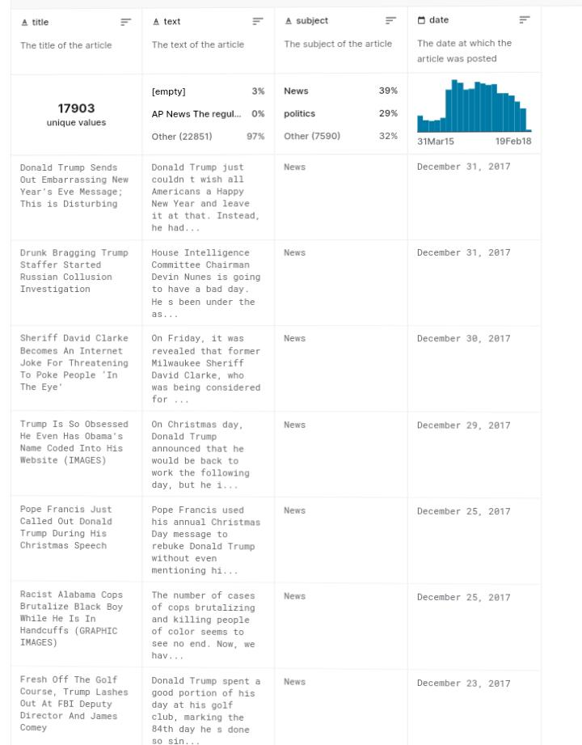

Necessary steps to follow:

1 .Import libraries

* The very basic data science libraries are sklearn, pandas, NumPy etc. and some specific libraries such as transformers.

Program

import NumPy as np

import pandas as pd

import matplotlib.pyplot as plt

import seaborn as sns

import nltk

import re

import string

from sklearn.model_selection import train_test_split

from sklearn. Metrics import accuracy score, confusion matrix, classification report

from sklearn.naive_bayes import MultinomialNB

from sklearn.linear_model import Logistic Regression

from sklearn import SVC

from sklearn. Ensemble import RandomForestClassifier [1]

2.load the dataset:

import pandas as pd

data = pd.read_csv(dataset_path)

print(data. head())

3. Exploratory data analysis (EDA):

* Exploratory Data Analysis (EDA) is essential for understanding the characteristics of the dataset and gaining insights into the data before building models for fake news detection using NLP.
* Here's a basic outline for EDA

# Assuming 'data' is the loaded dataset

# Check the dimensions of the dataset

print("Dataset shape: ", data. Shape)

# Display information about the dataset

print("Dataset info: ")

print(data. Info())

# Check for missing values

print("Missing values: ")

print(data.isnull().sum())

# Explore the distribution of target classes

print("Distribution of target classes: ")

print(data['label'].value_counts())

# Visualize the distribution of target classes

import seaborn as sns

import matplotlib.pyplot as plt

sns.countplot(data['label'])

plt.title('Distribution of Target Classes')

plt. Show()

# Perform basic text analysis

from wordcloud import WordCloud

# Concatenate the text data

text = " ".join(review for review in data.text)

# Create and display a word cloud

wordcloud = WordCloud(width=800, height=400, max_words=150, background color='white').generate(text)

plt.figure(figsize=(10, 5))

plt.imshow(wordcloud, interpolation='bilinear')

plt.axis('off')

plt. Show()

[2]Challenges involved in loading and preprocessing fake news detection using nlp dataset:

1. **Data Quality and Bias**:

Ensuring the dataset is representative and balanced, without any inherent biases that could affect the performance of the model.

1. **Data Size and Scalability**:

Handling large datasets can be computationally intensive, requiring efficient preprocessing techniques and scalable infrastructure for processing.

1. **Feature Extraction:**

Identifying relevant features from text data and converting them into a format suitable for NLP algorithms while preserving semantic information can be complex.

1. **Handling Text Variability:**

Accounting for variations in writing styles, languages, and linguistic nuances when preprocessing data for NLP tasks.

1. **Labeling and Annotation**:

Ensuring accurate and consistent labeling of fake and genuine news instances, which often requires human annotation and expert knowledge to minimize errors.

How to overcome challenge the loading and preprocessing fake news detection using nlp dataset:

* **Data Quality Assurance:**

Implement rigorous quality checks to ensure the dataset is representative and free from biases. Conduct thorough data validation and verification processes.

* **Sampling Techniques:**

If dealing with a large dataset, use appropriate sampling techniques to manage data size and improve processing efficiency.

* **Feature Engineering:**

Leverage advanced feature extraction methods like word embeddings (Word2Vec, GloVe, etc.) or deep learning-based techniques (BERT, GPT, etc.) to capture semantic relationships and contextual information in the text.

* **Language Processing Libraries:**

Utilize powerful NLP libraries like NLTK, SpaCy, or Tensor Flow’s Text module for efficient text processing, tokenization, and stemming.

* **Annotation Guidelines and Crowdsourcing:**

Establish clear annotation guidelines for labeling data accurately. Consider leveraging crowdsourcing platforms for reliable and cost-effective human annotation.

* **Parallel Processing and Distributed Computing:**

Utilize parallel processing techniques and distributed computing frameworks such as Apache Spark to handle large-scale datasets efficiently.

Loading the dataset:

* loading a dataset for fake news detection using NLP can be done using various Python libraries such as pandas, NumPy, and scikit-learn.
* If you already have the dataset available, you can load it into your Python environment using the pandas library.
* Here is an example of how to load a dataset into a pandas data frame.

import pandas as pd

# Assuming your dataset is in a CSV file

data = pd.read_csv('your_dataset.csv')

# Display the first few rows of the dataset to ensure it has loaded correctly

print(data.head())

Preprocessing the dataset:

* Tokenization:-

Tokenization is the process of breaking down a piece of code into smaller units called tokens

import nltk

from nltk.tokenize import RegexpTokenizer

# Create tokens out of alphanumeric characters

tokenizer = RegexpTokenizer(r'\w+')

tokens = tokenizer.tokenize("I think pineapple pizza is gross and not worth $15!")

print(tokens)

# ['I', 'think', 'pineapple', 'pizza', 'is', 'gross', 'and', 'not', 'worth', '15']

* Lemmatization:

:import nltk

from nltk.stem import WordNetLemmatizer

from nltk.corpus import wordnet

lemmatizer = WordNetLemmatizer()

# Convert the nltk pos tags to tags that wordnet can recognize

def nltkToWordnet(nltk_tag):

if nltk_tag.startswith('J'):

return wordnet.ADJ

elif nltk_tag.startswith('V'):

return wordnet.VERB

elif nltk_tag.startswith('N'):

return wordnet.NOUN

elif nltk_tag.startswith('R'):

return wordnet.ADV

else:

return None

# Lemmatize a list of words/tokens

def lemmatize(tokens):

pos_tags = nltk.pos_tag(tokens)

res_words = []

for word, tag in pos_tags:

tag = nltkToWordnet(tag)

if tag is None:

res_words.append(word)

else:

res_words.append(lemmatizer.lemmatize(word, tag))

return res_words

* Stemming

# Using Porter Stemmer implementation in nltk

from nltk.stem import PorterStemmer

stemmer = PorterStemmer()

def stem(tokens):

return [stemmer.stem(token) for token in tokens]

tokens = ['jumped', 'jumps', 'jumped']

print(stem(tokens))

# ['jump', 'jump', 'jump']

Conclusion:

We can print a confusion matrix to gain insight into the number of false and true negatives and positives

The passive-aggressive classifier performed the best here and gave an accuracy of 93.12%.

Fake news detection techniques can be divided into those based on style and those based on content, or fact-checking. Too often it is assumed that bad style (bad spelling, bad punctuation, limited vocabulary, using terms of abuse, ungrammaticality, etc.) is a safe indicator of fake news.

Designed by

L.kowsalya

S.jeshiya

V .sharmila

D.Anandhavali

1.
2.