**Table of Contents**

1. Introduction
   1. Project Overview
   2. Objectives
2. Project Initialization and Planning Phase
   1. Define Problem Statement
   2. Project Proposal (Proposed Solution)
   3. Initial Project Planning
3. Data Collection and Preprocessing Phase
   1. Data Collection Plan and Raw Data Sources
   2. Data Quality Report
   3. Data Exploration and Preprocessing
4. Data Visualization
   1. Framing Business Questions
   2. Developing Visualizations
5. Dashboard
   1. Dashboard Design File
6. Report
   1. Story Design File
7. Performance Testing
   1. Utilization of Data Filters
   2. Number of Calculation Fields
   3. Number of Visualizations
8. Conclusion / Observation
9. Future Scope
10. Appendix
    1. Source Code (if any)
    2. GitHub & Project Demo Link

# Introduction

* 1. **Project Overview**

This project explores global inflation trends from **1980 to 2024** using an interactive Power BI dashboard. It features **DAX-driven KPIs**, **continent-level mapping**, **category segmentation** (High, Moderate, Low), and a **dynamic narrative layer** to deliver contextual insights. Developed as part of a **virtual internship with SmartInternz**, in collaboration with **TheSmartBridge**, the project simulates real-world data analytics delivery standards.

* 1. **Objectives**
     + To design a clean, executive-level Power BI dashboard for professional use.
     + To apply **Power Query** and **DAX** techniques in a real-world data analytics scenario.
     + To transform raw data into actionable insights using dynamic visuals and interactive filters.
     + To communicate insights effectively through **data storytelling** and well-structured visual narratives.

# Project Initialization and Planning Phase

* 1. **Define Problem Statement**

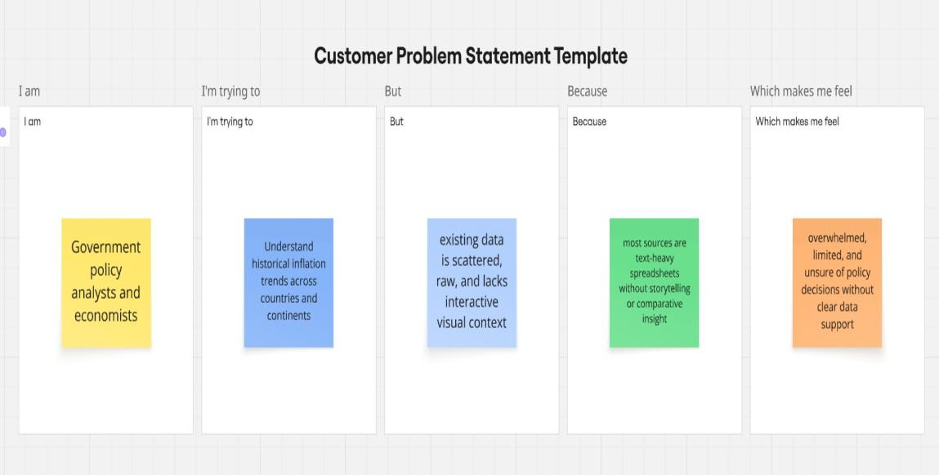

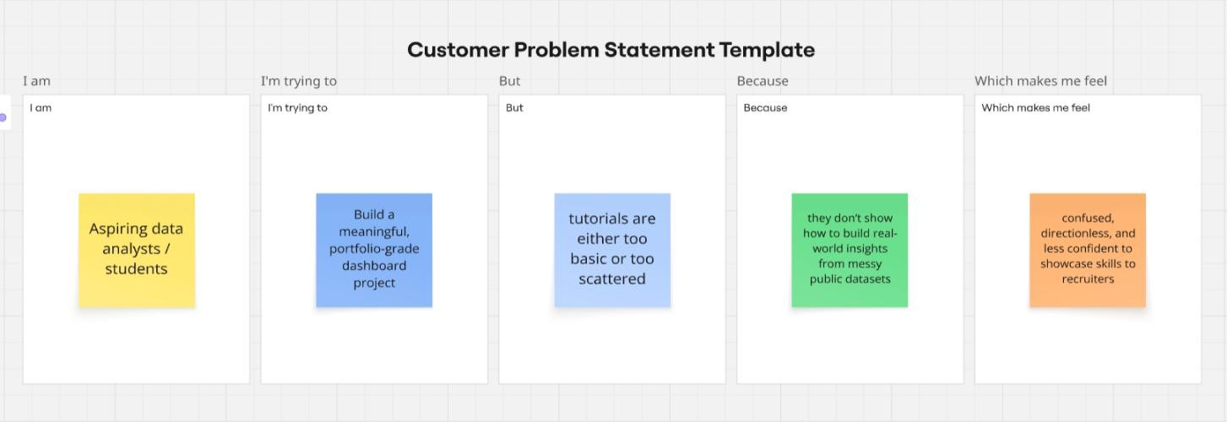

|  |  |  |  |  |  |
| --- | --- | --- | --- | --- | --- |
| **Problem Statement (PS)** | **I am (Customer)** | **I’m trying to** | **But** | **Because** | **Which makes me feel** |
| PS-1 | Government policy analysts and economists | Understand historical inflation trends across countries and continents | existing data is scattere d, raw, and lacks interacti ve visual context | most sources are text-heavy spreadsheet s without storytelling or comparativ e insight | overwhelmed, limited, and unsure of policy decisions without clear data support |
| PS-2 | Aspiring data analysts / students | Build a meaningful, portfolio- grade dashboard project | tutorials are either too basic or too scattere d | they don’t show how to build real-world insights from messy public datasets | confused, directionless, and less confident to showcase skills to recruiters |

* 1. **Project Proposal (Proposed Solution)**

|  |  |
| --- | --- |
| **Project Overview** | |
| Objective | To design an interactive, executive-ready Power BI dashboard that visualizes global inflation trends across countries and regions from 1980 to 2024, enabling data-driven decisions and insights. |
| Scope | The project covers data collection, transformation, analysis, and visualization of global inflation data. It includes DAX-based KPIs, regional comparisons, category segmentation, and an insight narrative, all presented through a clean, two-page Power BI dashboard. |
| **Problem Statement** | |
| Description | Inflation data is often raw, fragmented, and hard to interpret, especially across global time periods and geographic regions. Analysts and decision- makers lack a centralized, visualized tool to explore inflation dynamics effectively. |
| Impact | A dashboard that brings together cleaned, categorized, and interactive inflation metrics empowers students, economists, and analysts to understand patterns, derive insights, and make more informed decisions across sectors. |
| **Proposed Solution** | |
| Approach | Use Power BI to connect, model, and visualize global inflation data. Preprocess data in Power Query, design DAX measures to calculate KPIs (avg, max, delta), apply category thresholds, and build visual dashboards with slicers, maps, and smart narratives. |

|  |  |
| --- | --- |
| Key Features | * Dynamic KPI cards (Avg/Max/Δ Inflation Rate) * Filterable country-wise and region-level visuals * Inflation category segmentation (High/Moderate/Low) * Page 2 insights with narrative text, donut charts, and maps * Professional formatting for resume/portfolio readiness |

**Resource Requirements**

|  |  |  |
| --- | --- | --- |
| **Resource Type** | **Description** | **Specification/Allocation** |
| **Hardware** | | |
| Computing Resources | Local machine for Power BI Desktop | 4-core CPU, integrated GPU |
| Memory | RAM | 8 GB |
| Storage | Disk space | 5–10 GB (datasets, PBIX, visuals) |
| **Software** | | |
| Frameworks | Visualization Platform | Power BI Desktop |
| Libraries | Data prep, DAX, PQ functions | Built-in DAX & Power Query |
| Development Environment | Report Design + GitHub Documentation | Power BI + VS Code / Git for README |
| **Data** | | |
| Data | Sourced from Kaggle:   * global_inflation_data.csv (1980– 2024 inflation by country) | CSV format, ~63.8 KB total size |

|  |  |  |
| --- | --- | --- |
|  | * continents.csv (region mapping) |  |

* 1. **Initial Project Planning**

|  |  |  |  |  |  |  |  |  |
| --- | --- | --- | --- | --- | --- | --- | --- | --- |
| **Spri nt** | **Functional Requireme nt (Epic)** | **User Story Numb er** | **User Story / Task** | **Stor y Poin ts** | **Priorit y** | **Team Membe rs** | **Spri nt**  **Start Date** | **Sprint End Date**  **(Planne d)** |
| Sprin t-1 | Project Initializatio n | PBIA- 1 | As a data analyst, I want to define the problem statement and planning document s to scope the dashboard objective clearly. | 2 | High | Jeshma S J | 19  June 2025 | 19 June  2025 |
| Sprin t-2 | Data Collection & Preprocessi ng | PBIA- 2 | As a data analyst, I will identify, clean, and preproce ss global inflation and region data for further analysis. | 3 | High | Jeshma S J | 19  June 2025 | 19 June  2025 |
| Sprin t-3 | Data Modeling & DAX | PBIA- 3 | As a data analyst, I will | 3 | High | Jeshma S J | 20  June 2025 | 20 June  2025 |

|  |  |  |  |  |  |  |  |  |
| --- | --- | --- | --- | --- | --- | --- | --- | --- |
| **Spri nt** | **Functional Requireme nt (Epic)** | **User Story Numb er** | **User Story / Task** | **Stor y Poin ts** | **Priorit y** | **Team Membe rs** | **Spri nt**  **Start Date** | **Sprint End Date**  **(Planne d)** |
|  |  |  | create DAX  measures to calculate KPIs like Avg/Max  /Δ inflation rate and prepare data for visuals. |  |  |  |  |  |
| Sprin t-4 | Dashboard Design (Page 1) | PBIA- 4 | As a data analyst, I will create the main dashboard page with KPIs,  charts, and slicers with responsiv e layout and formatting  . | 3 | High | Jeshma S J | 20  June 2025 | 20 June  2025 |
| Sprin t-5 | Dashboard Insights (Page 2) | PBIA- 5 | As a data analyst, I will build a second report page with donut charts, region maps, and smart  DAX- | 3 | Mediu m | Jeshma S J | 21  June 2025 | 21 June  2025 |

|  |  |  |  |  |  |  |  |  |
| --- | --- | --- | --- | --- | --- | --- | --- | --- |
| **Spri nt** | **Functional Requireme nt (Epic)** | **User Story Numb er** | **User Story / Task** | **Stor y Poin ts** | **Priorit y** | **Team Membe rs** | **Spri nt**  **Start Date** | **Sprint End Date**  **(Planne d)** |
|  |  |  | based narratives. |  |  |  |  |  |

# Data Collection and Preprocessing Phase

* 1. **Data Collection Plan and Raw Data Sources**

|  |  |
| --- | --- |
| **Section** | **Description** |
| Project Overview | The project aims to analyse global inflation patterns across countries and regions from 1980 to 2024 using Power BI. The goal is to build an interactive dashboard with dynamic KPIs, regional insights, and category-based inflation segmentation. |
| Data Collection Plan | Data was collected by independently sourcing structured CSV files from Kaggle. This includes inflation data across 40+ years and a corresponding country-to-region mapping file. These datasets were curated, cleaned, and modeled using Power Query and DAX inside Power BI. |
| Raw Data Sources Identified | Two raw datasets were identified: (1) historical inflation data per country by year, and (2) a region mapping file that assigns countries to continents for better aggregation in Power BI visualizations. |

**Raw Data Sources Template**

|  |  |  |  |  |  |
| --- | --- | --- | --- | --- | --- |
| **Source Name** | **Descri ption** | **Location/URL** | **For mat** | **Siz e** | **Access Permiss ions** |

|  |  |  |  |  |  |
| --- | --- | --- | --- | --- | --- |
| global_inflation  _data.csv | Contain s inflatio n rates by country and year from 1980 to  2024.  Used as the primary dataset for analysis  . | [https://www.kaggle.com/datasets/sazi](https://www.kaggle.com/datasets/sazidthe1/global-inflation-data) [dthe1/global-inflation-data](https://www.kaggle.com/datasets/sazidthe1/global-inflation-data) | CSV | 44.  6  KB | Public (Kaggl e) |
| continents.csv | Countr y-to- contine nt mappin g referenc e for regiona l | [https://www.kaggle.com/datasets/andr](https://www.kaggle.com/datasets/andradaolteanu/country-mapping-iso-continent-region) [adaolteanu/country-mapping-iso-](https://www.kaggle.com/datasets/andradaolteanu/country-mapping-iso-continent-region) [continent-region](https://www.kaggle.com/datasets/andradaolteanu/country-mapping-iso-continent-region) | CSV | 19  .2  K B | Public (Kaggle  ) |

|  |  |  |  |  |  |
| --- | --- | --- | --- | --- | --- |
|  | analysis in Power BI  visuals. |  |  |  |  |
| … | … | … | … | … | … |

* 1. **Data Quality Report**

|  |  |  |  |
| --- | --- | --- | --- |
| **Data Source** | **Data Quality Issue** | **Severity** | **Resolution Plan** |
| global_inflation_data.csv | Inflation data was spread across multiple year columns (wide format) | Moderate | Unpivoted year columns in Power Query to convert the dataset into long format: Country, Year, InflationRate. |
| global_inflation_data.csv | No unique row identifier | Low | Added an Index column in Power Query to uniquely identify each row post- transformation. |
| global_inflation_data.csv | Some columns were redundant or incorrectly named | Low | Removed unnecessary columns, cleaned and renamed column headers consistently |

|  |  |  |  |
| --- | --- | --- | --- |
|  |  |  | (e.g., Country_name → CountryName). |
| global_inflation_data.csv | Adjusted Inflation Rate was missing | Low | Created a new column AdjustedInflationRate = InflationRate * 0.01 using Power BI calculated column. |
| global_inflation_data.csv | Inflation category classification was missing | Moderate | Created a DAX-calculated column InflationRateCategory based on value thresholds (Low  < 2, Moderate < 5, else High). |
| continents.csv | Extra columns unrelated to analysis present | Low | Removed all extra columns, retained only CountryName and Region for clean joining. |
| continents.csv | Mismatch in country name spellings across datasets | Moderate | Standardized country names in both files within Power Query to enable accurate mapping and merging. |
| continents.csv | No relationship with main dataset | Low | Performed a left join in Power BI using CountryName as key to enrich dataset with regional context. |

* 1. **Data Exploration and Preprocessing**

|  |  |
| --- | --- |
| **Section** | **Description** |
| Data Overview | The dataset includes year-wise inflation data from 1980–2024 for various countries (global_inflation_data.csv) and a mapping of countries to regions (continents.csv). These datasets were combined and processed to enable continent-level, time-based inflation analysis. |
| Data Cleaning | Removed unnecessary columns, promoted headers, standardized column names (Country_name → CountryName), and added an Index column for unique identification. There were no missing values or duplicates, so no imputation was required. |
| Data Transformation | In Power Query, the year columns (1980–2024) were unpivoted to normalize the dataset into long format with fields: CountryName, Year, InflationRate. A calculated column AdjustedInflationRate = InflationRate * 0.01 was also created in Power BI. |
| Data Type Conversion | Converted Year to numeric data type, ensured InflationRate and AdjustedInflationRate are of decimal type. CountryName and Region fields were kept as text type to allow for relational mapping. |
| Column Splitting and Merging | Region dataset (continents.csv) was trimmed to retain only CountryName and Region. No actual column splitting or merging was required beyond schema alignment for joining. |
| Data Modeling | A one**-**to**-**many relationship was established between continents [CountryName] and GlobalInflationData [CountryName]. Calculated DAX measures were created for KPIs: Average InflationRate, Max InflationRate, and InflationRate Change. |
| Save Processed Data | The processed dataset was saved within Power BI’s internal data model as part of the .pbix file (InflationAnalysis_SiddharthChauhan.pbix).  Final datasets were not exported separately but used directly for dashboard and reporting visuals. |

# Data Visualization

* 1. **Framing Business Questions & Visuals**

1. **What is the global average, maximum inflation rate, and number of regions represented in the dataset?**
   * + **Visualization:** KPI Cards (Average, Maximum, Region Count)
     + 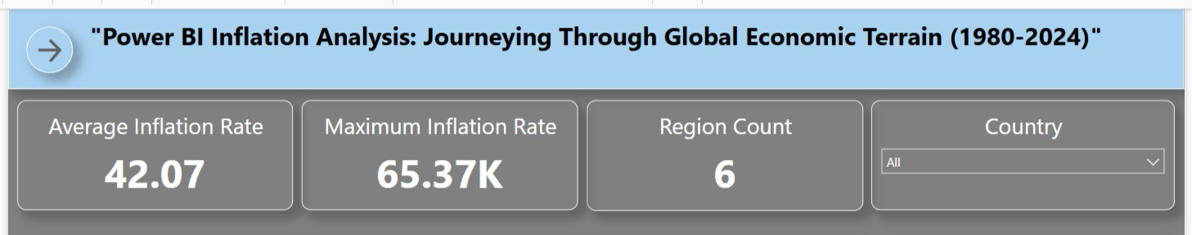**Screenshot:**
2. **How has the inflation rate changed globally between 1980 and 2024?**
   * + **Visualization:** Line Chart (Sum of Inflation Rate over Years)
     + 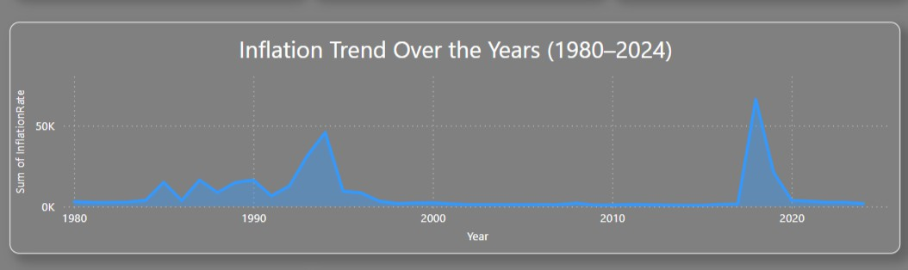**Screenshot:**
3. **What is the global distribution of inflation categories (High, Moderate, Low)?**
   * + **Visualization:** Pie Chart (Category share breakdown)
     + **Screenshot:**

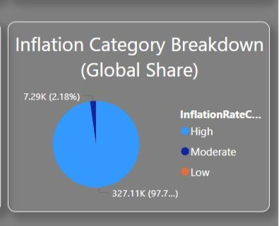

1. **Which countries contributed the most to inflation in the latest year?**
   * + **Visualization:** Donut Chart (Top 3 Countries – Latest Year)
     + **Screenshot:**

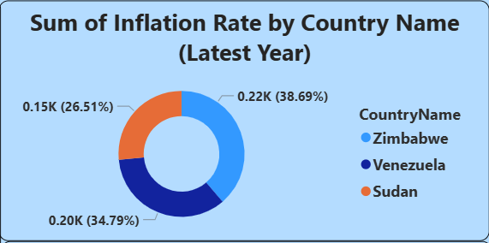

1. **What is the distribution of countries by continent or global region?**
   * + **Visualization:** Filled Map Chart (Region → Country Mapping)
     + **Screenshot:**
2. 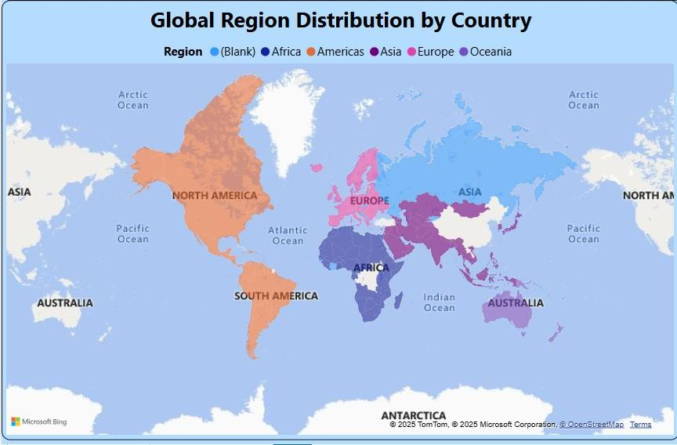**How does inflation rate differ between ‘High’ and ‘Low’ category segments?**
   * + **Visualization:** Bar Chart (High vs Low Sum of Inflation)
     + **Screenshot:**

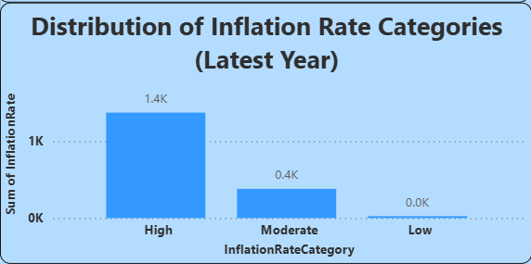

1. **How does Adjusted Inflation Rate relate to the original inflation rate?**
   * + **Visualization:** Scatter Plot (Inflation vs Adjusted Inflation)
     + **Screenshot:**

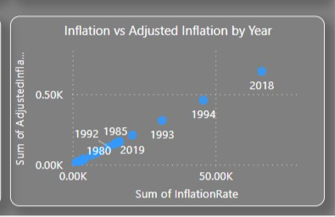

1. **What are the yearly peaks in inflation and where did they occur?**
   * + **Visualization:** Column Chart (Annual Sum of Inflation Rate)
     + **Screenshot:**
   1. **Developing Visualizations**

This project applies professional dashboard design principles to ensure

clarity, engagement, and usability for end-users — whether they are students, analysts, or executives.

Key design choices include:

* + - **Clear and Intuitive Layout**: Two cleanly structured pages with consistent grid layout, readable fonts, and minimal distractions.
    - **Appropriate Visualizations**: Line charts, donut charts, pie charts, KPIs, maps, and scatter plots selected based on data patterns.
    - **Color and Theming**: Dual-tone color schemes (cool blue + gray) for contrast, readability, and visual appeal.
    - **Interactive Filters and Slicers**: Country slicers and cross-filtering ensure user- driven exploration.
    - **Drill-Down Ready Design**: Visuals are positioned for future drill-down or tooltip integration.
    - **Responsive and Balanced**: Uniform card sizes, chart spacing, and padding deliver responsive balance.
    - **Smart Narratives**: Dynamic insight text powered by DAX to highlight summary findings.
    - **Icons and Infographics**: Custom back button, page headers, and chart annotations for enriched user experience.

# Dashboard

* 1. **Dashboard Design File**

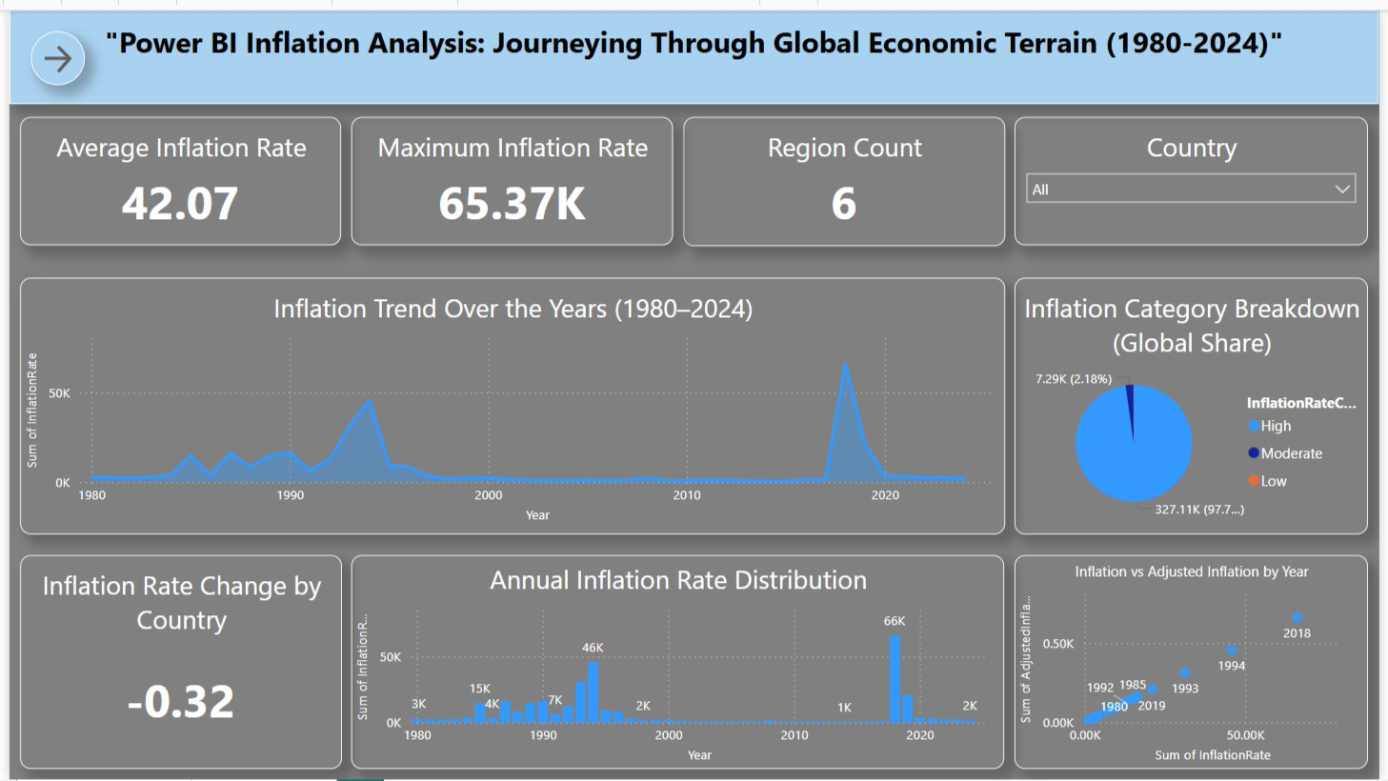

**Major Dashboard Outcomes**

1. **Global Average Inflation**: The dashboard displays an average inflation rate of

**42.07** across 40+ years and 150+ countries.

1. **Yearly Trends Identified**: Inflation spikes are clearly visible around **1990 and 2018**, helping flag potential economic shifts.
2. **Category Breakdown (High/Moderate/Low)**: Pie chart and bar charts show

**High** inflation dominates at over **97%** globally.

1. **Top Contributing Countries**: Donut chart ranks **Zimbabwe, Venezuela, and Sudan** as the top inflation contributors in 2024.
2. **Smart Summary Narrative**: Automatically generated narrative highlights key facts, including the **5436.29% gap** between high and low categories.
3. **Region Mapping**: Countries are color-coded by continent using Power BI’s **filled map** visual.
4. **Adjusted vs Raw Inflation**: Scatter plot compares **raw vs adjusted rates**, offering cross-perspective interpretation.
5. **Polished UI**: Shadowed card KPIs, font hierarchy, icon buttons, and consistent section spacing make it **executive-presentation ready**.

# Report

* 1. **Story Design File**

**Overview**

This Power BI report page focuses on the **latest year (2024)** to provide a sharp, regional and categorical breakdown of global inflation. The layout is tailored for stakeholders who want to immediately identify key contributors, patterns across continents, and inflation category trends — all on a single, interactive screen.

It integrates geospatial visuals, categorical comparisons, and a smart DAX-driven narrative to deliver executive-level insights with clarity.

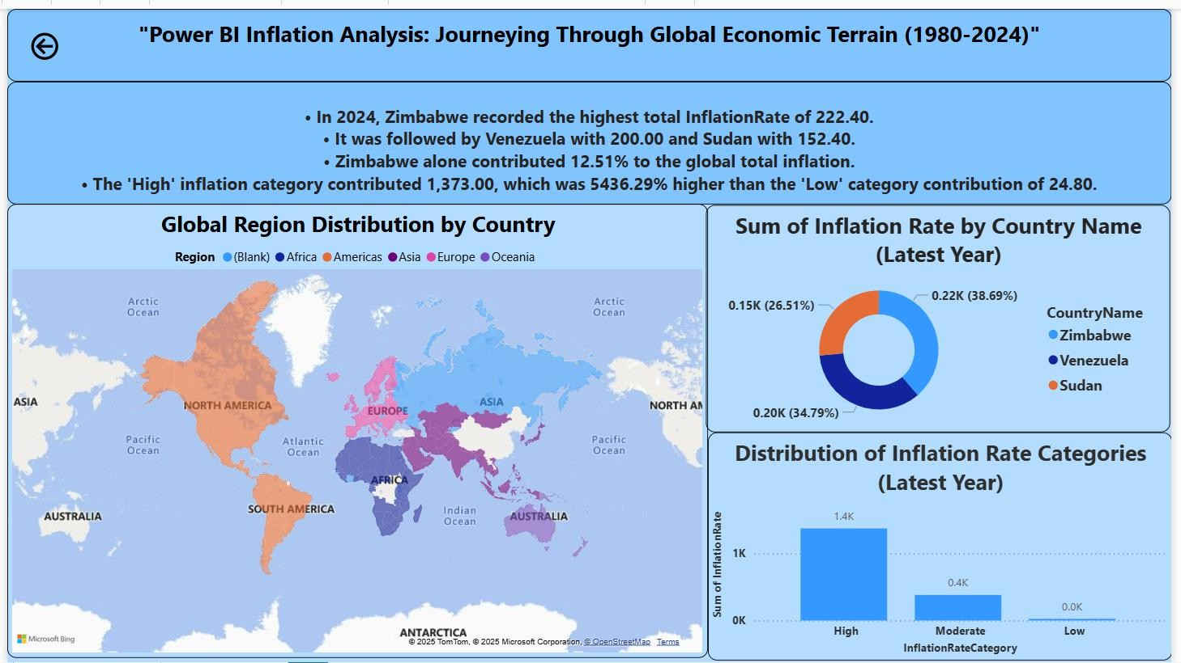

**Key Observations from the Power BI Report**

1. **Top Countries by Inflation Contribution (2024):**
   * **Zimbabwe** led globally with an inflation rate of **222.40**, followed by

**Venezuela (200.00)** and **Sudan (152.40)**.

* + These three countries cumulatively contributed a substantial share of 2024's global inflation — Zimbabwe alone made up **12.51%** of the total.

1. **Smart Narrative Summary (Auto-Generated via DAX):**
   * The high inflation category contributed **1,373.00**, which was a staggering

**5436.29%** higher than the low category (24.80).

* + This automated narrative allows stakeholders to grasp critical insights instantly without analyzing visuals individually.

1. **Global Region Mapping:**
   * Countries are visually grouped into regions (Africa, Americas, Asia, Europe, Oceania) via a filled map.
   * This helps users understand regional spread and identify continent-wise inflation distribution at a glance.
2. **Donut Chart – Country-Level Contribution:**
   * The donut chart provides a proportionate view of the **top 3 countries’ inflation rates**, highlighting the steep imbalance and emphasizing countries with recurring economic volatility.
3. **Inflation Category Distribution (Latest Year):**
   * A bar chart presents a breakdown by **High**, **Moderate**, and **Low** categories:
     + **High:** 1.4K
     + **Moderate:** 0.4K
     + **Low:** 0.0K
   * The visualization clearly signals that most of the world in 2024 experienced extreme inflation rates.

# Performance Testing

* 1. 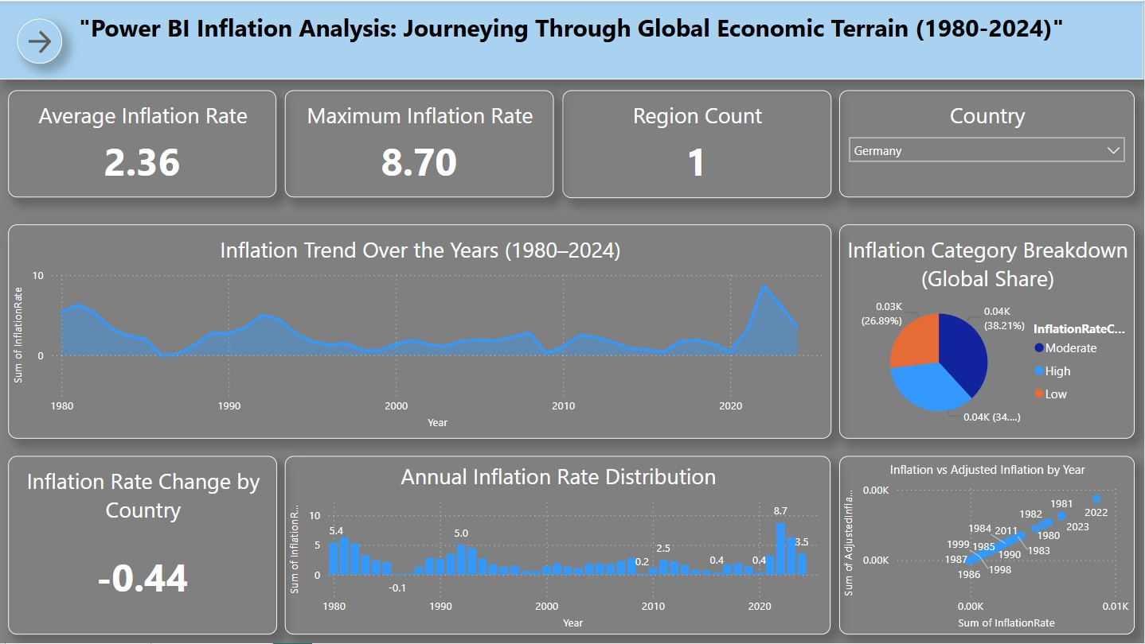**Utilization of Filters**

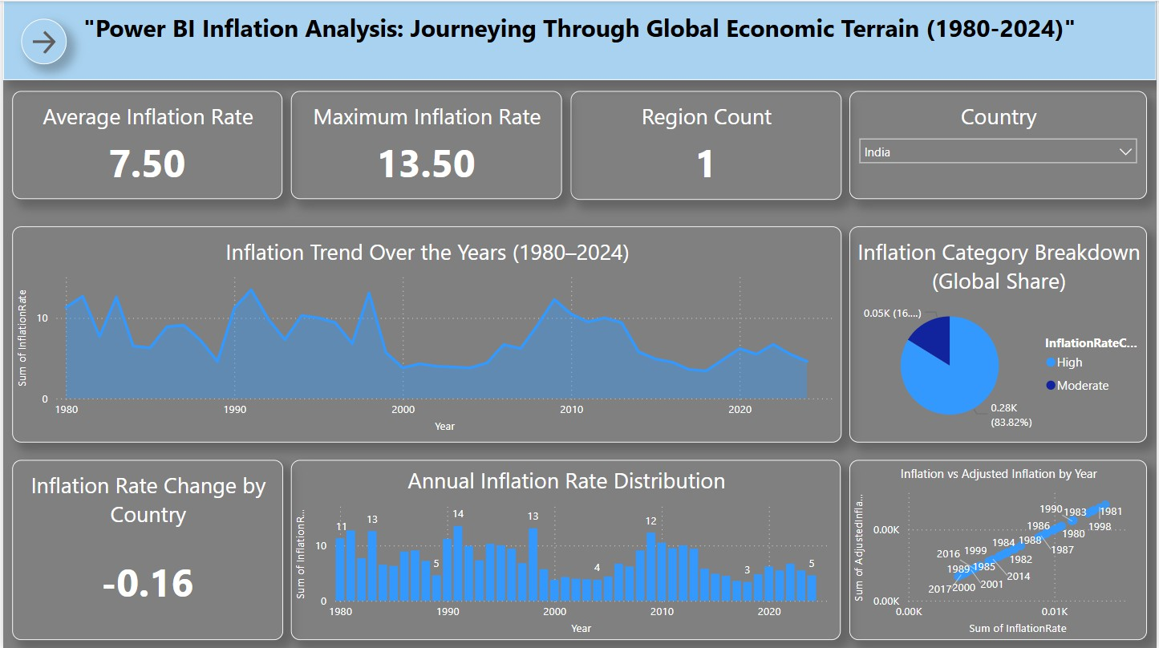**Selected Country: Germany**

**Selected Country: India**

* 1. **Number of Calculation Fields**
     + **Conditional Columns**
       - AdjustedInflationRate

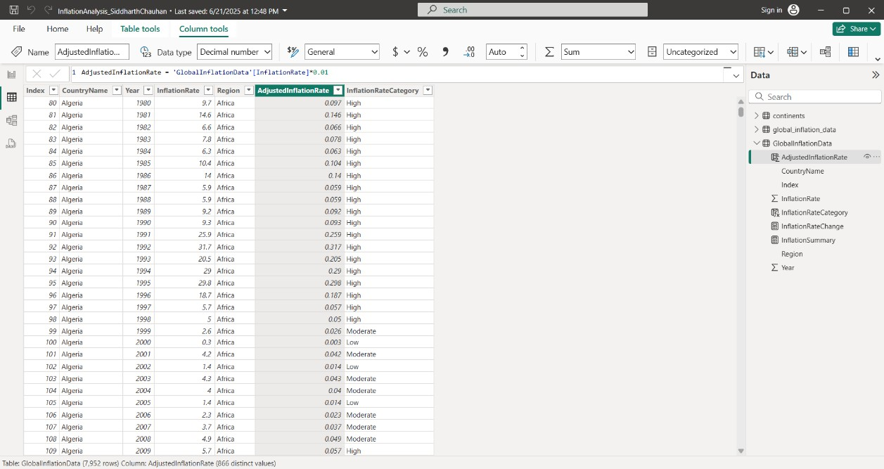

* + - * InflationRateCategory

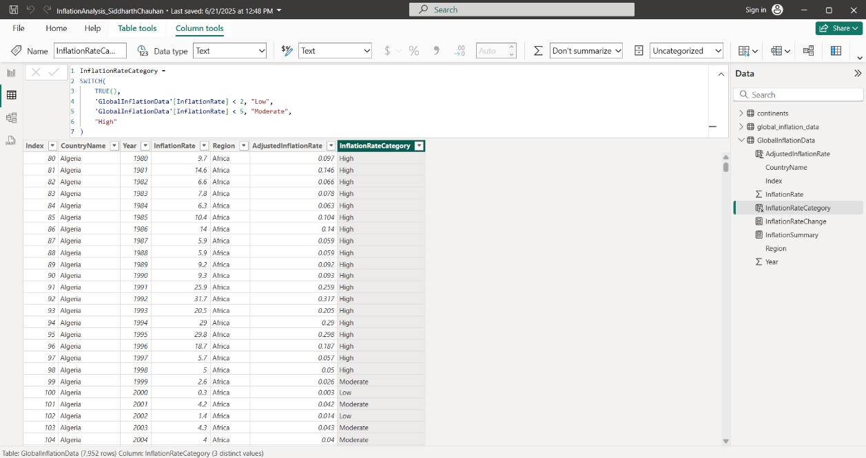

* + - **Measures**
      * InflationRateChange

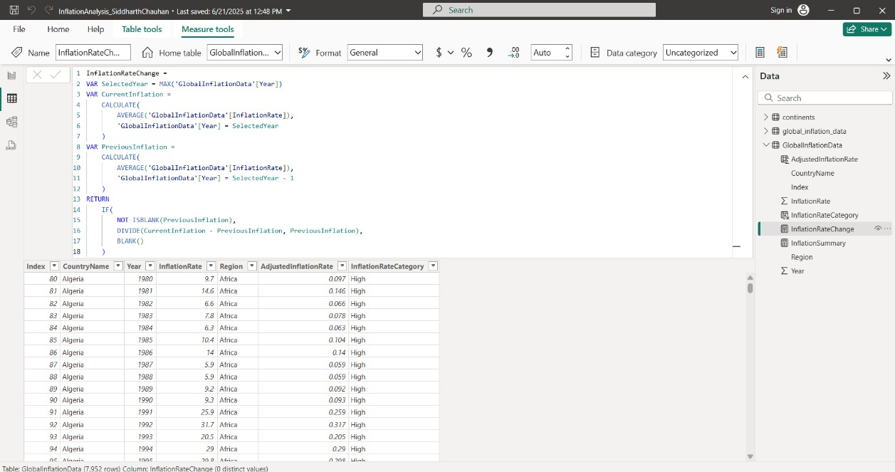

* + - * InflationSummary

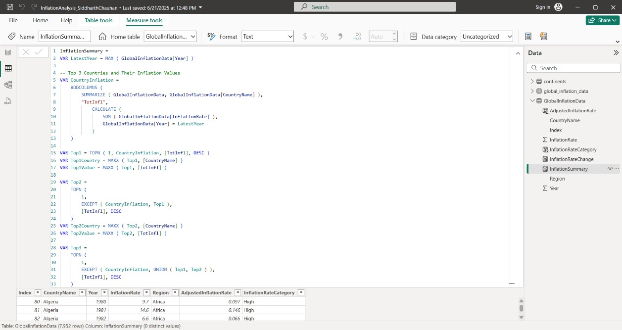

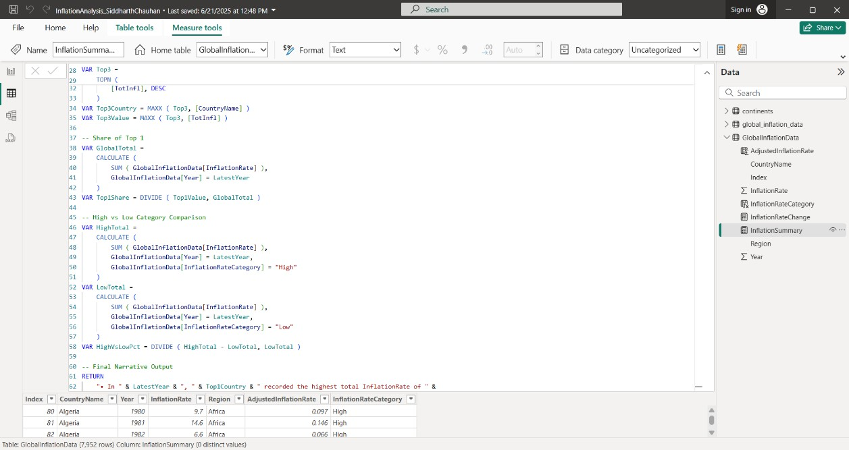

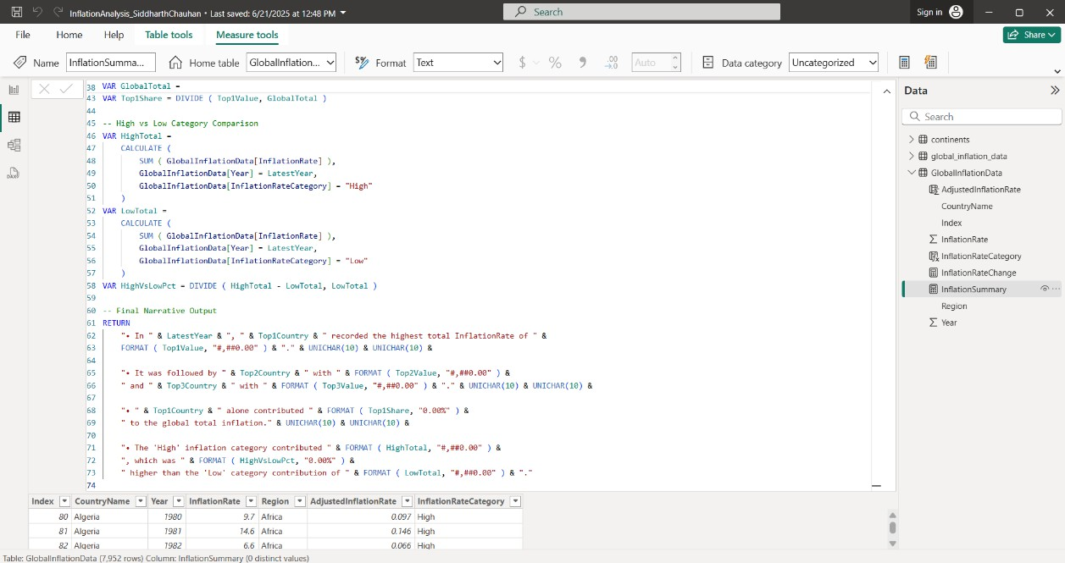

* 1. **Number of Visualizations**

## Dashboard Page (Page 1)

1. KPI Card – Average Inflation Rate
2. KPI Card – Maximum Inflation Rate
3. KPI Card – Region Count
4. Country Slicer – Dropdown Filter
5. Line Chart – Inflation Trend Over the Years (1980–2024)
6. Pie Chart – Inflation Category Breakdown (Global Share)
7. Card – Inflation Rate Change by Country
8. Column Chart – Annual Inflation Rate Distribution
9. Scatter Plot – Inflation vs Adjusted Inflation by Year

## Report Page (Page 2)

1. Smart Narrative – Key Observations (Top Contributors + Category Contribution)
2. Map – Global Region Distribution by Country
3. Donut Chart – Sum of Inflation Rate by Country Name (Latest Year)
4. Bar Chart – Distribution of Inflation Rate Categories (Latest Year)

# Conclusion / Observation

The dashboard transforms complex macroeconomic inflation data into a clear, interactive narrative. By combining dynamic visuals, region-based mapping, and smart KPI indicators, it enables users to explore patterns, identify top contributing countries, and understand category-level inflation dynamics. Whether for a quick overview or an in-depth analysis, this solution delivers both clarity and context for decision-making.

# Future Scope

* **Integrate Additional Economic Indicators**: Incorporate metrics such as GDP, CPI, and unemployment rates for multi-variable analysis.
* **Drill-Through Functionality**: Enable users to explore data at deeper levels — by year, country, or region — for targeted insights.
* **Forecasting Capabilities**: Apply Time Intelligence DAX to build predictive models for inflation trends.
* **Power BI Service Integration**: Publish to Power BI Service with automatic refresh for real- time insights and collaboration.

# Appendix

* 1. **Source Code**

All development was done using **Power BI Desktop**. The .pbix file includes all DAX measures, calculated columns, and visuals used in the project.

* 1. **Project Links**
     + .˘*˘˘**GitHub Repository**:

https://github.com/Jeshma2005/POWERBI_INFLATION_PROJECT.git

* + - _. **Video Demonstration**:

https://drive.google.com/file/d/1oe-4FG2uJfrQRPB3S32erE7BKSN_0Ee7/view?usp=drive_link