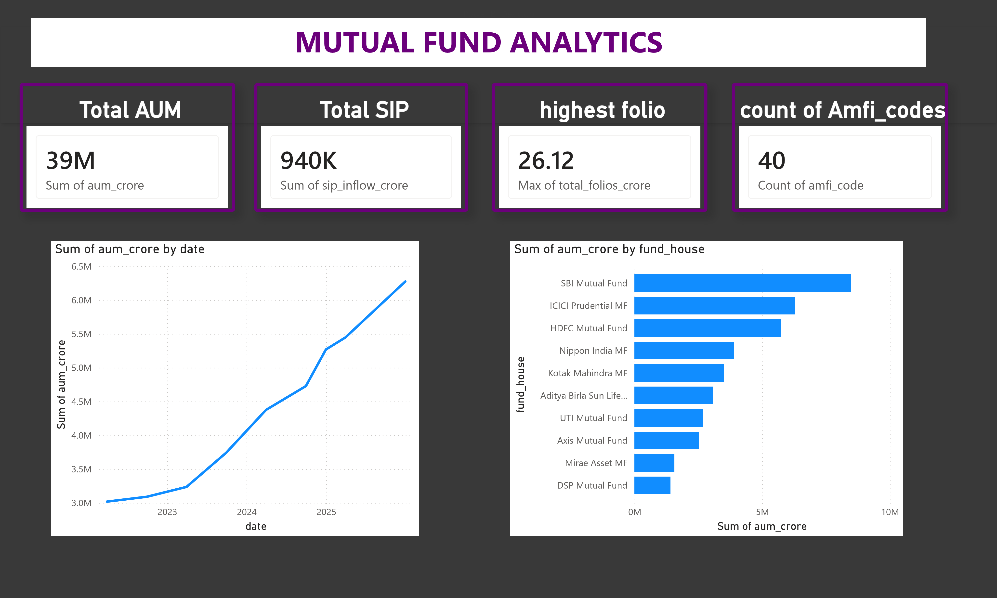
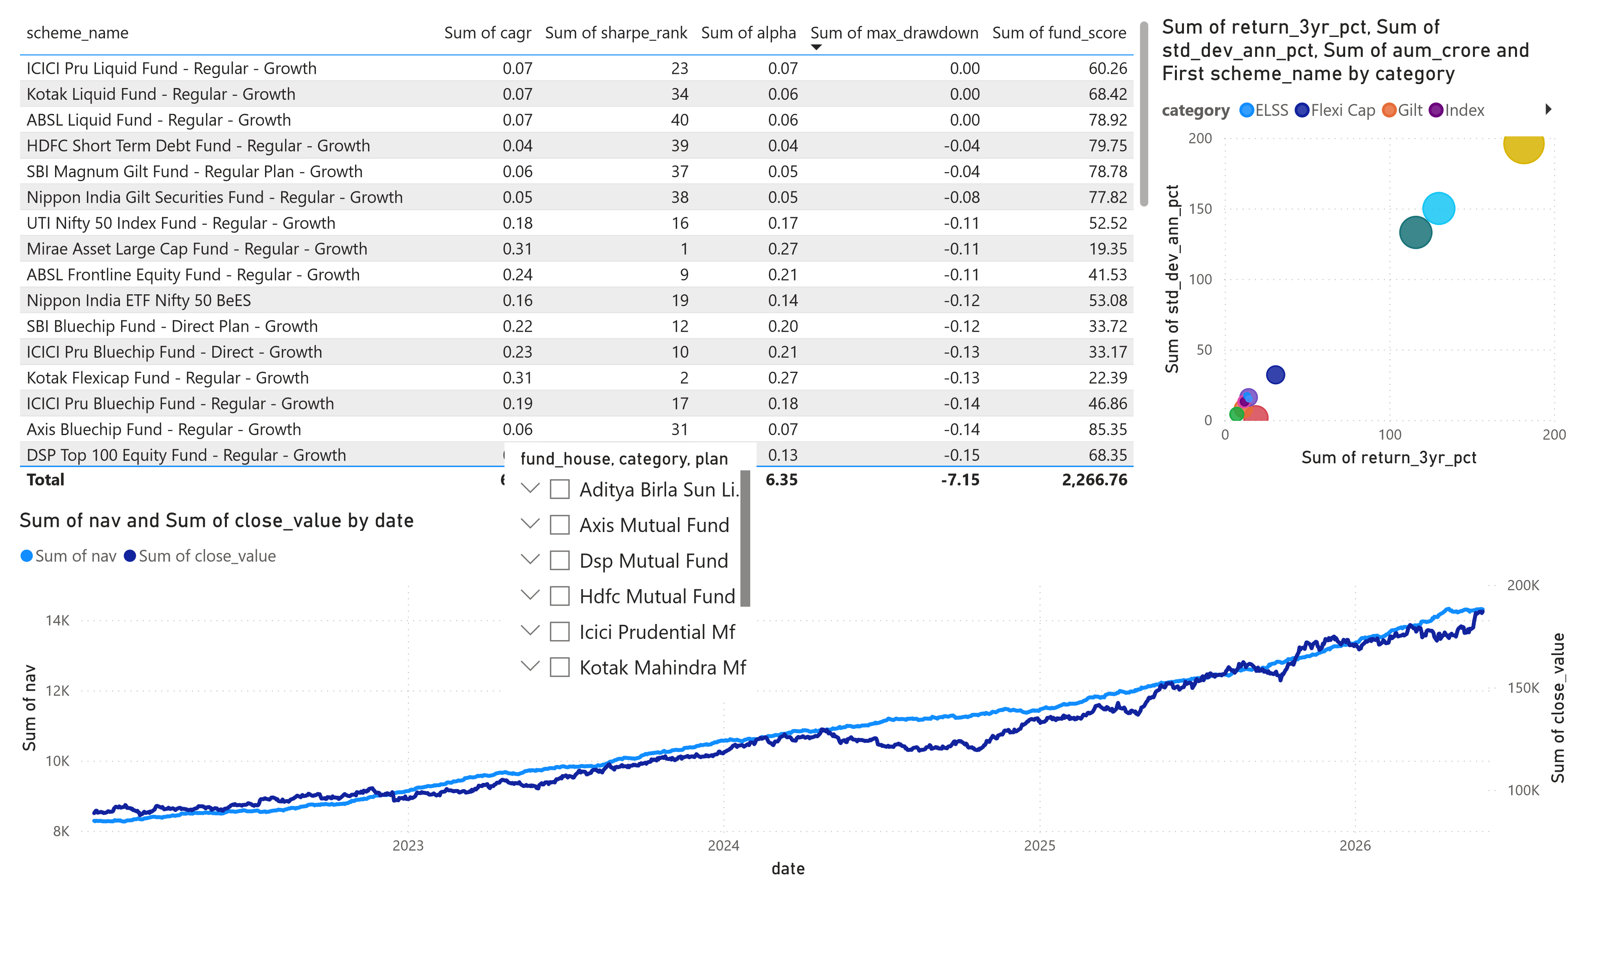
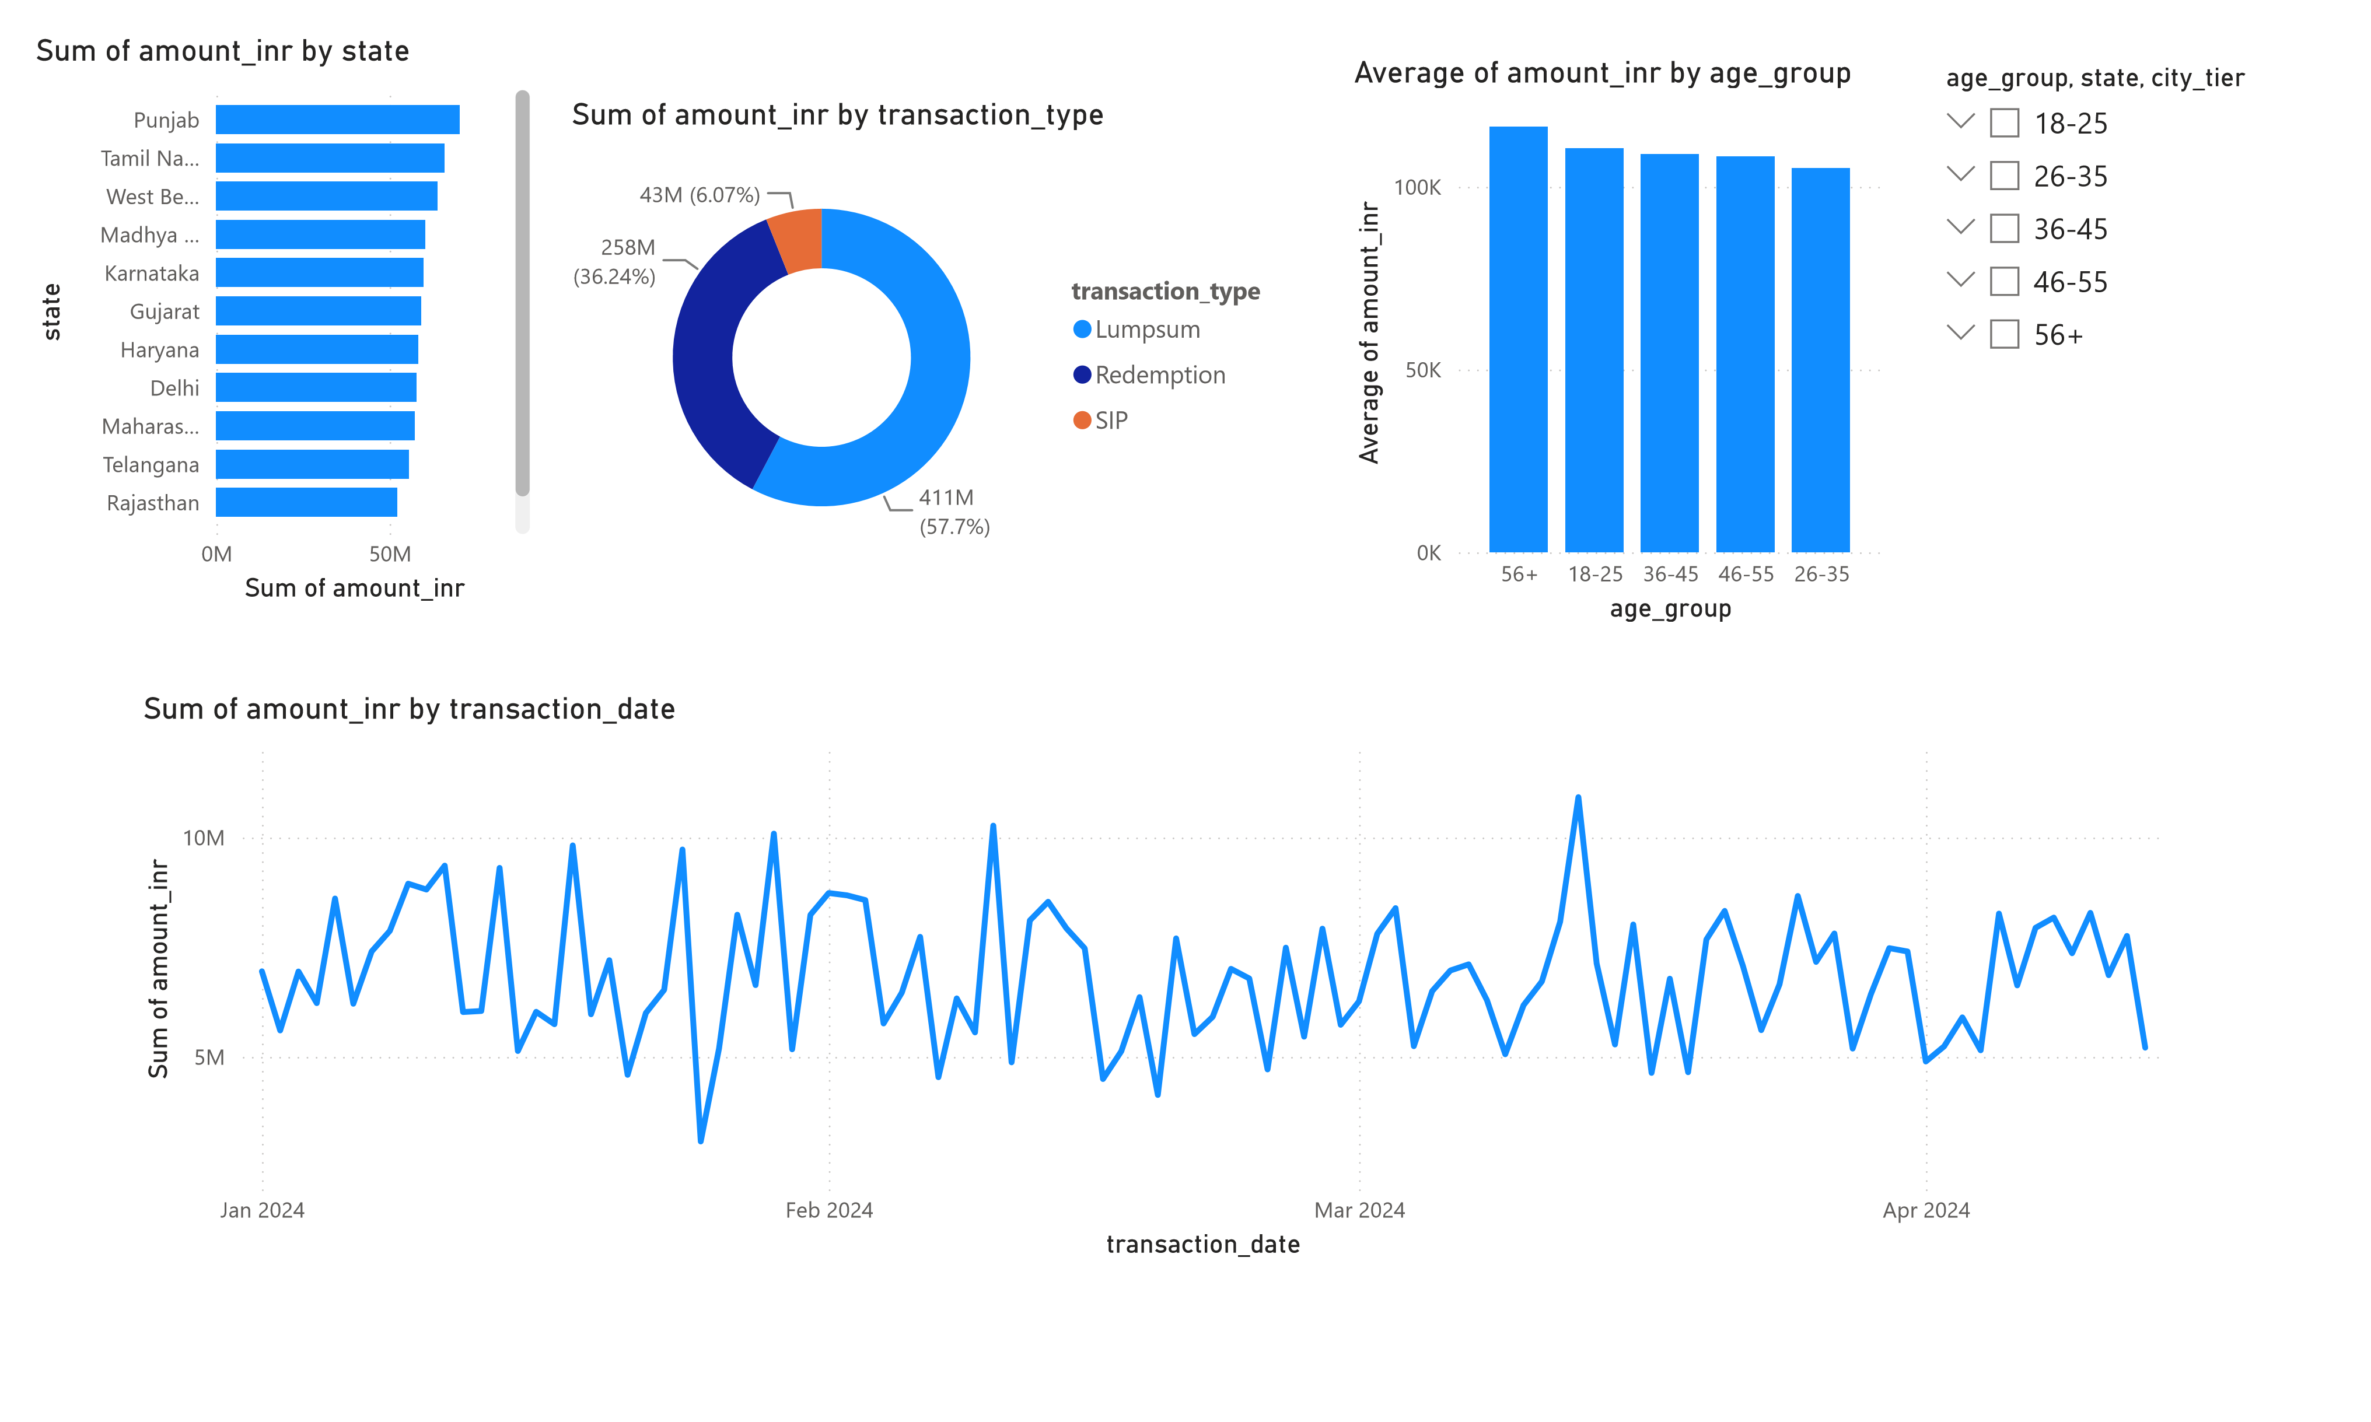

 |  |  |  |  |  |  |  |  |  |  | Power BI Desktop
40  S  u  m  of  s  i  p  _i  nf  l  ow  _…  20 | Sum of sip_inflow_crore  K  K  0K |  | index_name, First Month, First | Sum of sip_inflow_crore, Count of category and Sum of Year by Mont |  |  |  | Count of index_na… | …  500  0 | Cou  nt of  i  nd  ex  _na  … | Top 5 Categories by Net Inflow (FY25) Year  2022 2025  category Wednesday, January 01, 2025 Saturday, February 01, 2025 Satur  Liquid  33892  32374
 |  |  |  |  |  |  |  |  |  |  | Sectoral/Thematic | 7893 9215
 |  |  |  |  |  |  |  |  |  |  | Flexi Cap | 5603 6068
 |  |  |  |  |  |  |  |  |  |  | Large & Mid Cap | 4816 5524
 |  |  |  |  |  |  |  |  |  |  | Mid Cap  Total | 4316 4819  56520 58000
 | D  e  c  2  … | N  ov  … | O  c  t  2  …  M | onth  S  e  p  2  … | J  u  l  2  0  …  Year | A  u  g  … | J  u  n  2  … | M  a  y  …
category
 Index
 Index/ETF
 Small Cap

Large & Mid Cap

Large Cap

Liquid

Mid Cap

Short Duration
Average of sip_inflow_crore
19.58
K
Sum of sip_inflow_c
ror
e
94
0
K
 Value

