**Software Requirements**



**Specification**

**For Airline Reservation**

**Version 2.2**

|  |  |  |
| --- | --- | --- |
|  |  | **Prepared by** |
| **Dhruv Chawla** | **21IT21** | **dhruvchawla765@gmail.com** |
| **Jesilda Braganca** | **21IT31** | **jesildabraganca@gmail.com** |
| **Maeve Vas** | **21IT36** | **maevevas@gmail.com** |
| **Sadiya Shaikh** | **21IT27** | **shaikhsadiya1109@gmail.com** |
|  |  |  |

**Instructor: Okstynn Rodrigues**

**Course: Computer Software Lab**

**Lab Section: *IT Lab3.***

***Date: 13/12/22.***

**Contents**

**REVISIONS .................................................................................................................................................................. 3**

1. **INTRODUCTION ............................................................................................................................................... 1**
   1. DOCUMENT PURPOSE ................................................................................................................................ 3 1.2 PRODUCT SCOPE .............................................................................................................................................. 3

1.3 INTENDED AUDIENCE AND DOCUMENT OVERVIEW............................................................................................ 3

1.4 DEFINITIONS, ACRONYMS AND ABBREVIATIONS ............................................................................................... 4

1.5 DOCUMENT CONVENTIONS ................................................................................................................................ 4

1.6 REFERENCES AND ACKNOWLEDGMENTS ......................................................................................................... 4

1. **OVERALL DESCRIPTION .............................................................................................................................. 5**
   1. PRODUCT PERSPECTIVE ............................................................................................................................ 6 2.2 PRODUCT FUNCTIONALITY ......................................................................................................................... 6 2.3 USERS AND CHARACTERISTICS........................................................................................................................ 6

2.4 OPERATING ENVIRONMENT .............................................................................................................................. 7

2.5 DESIGN AND IMPLEMENTATION CONSTRAINTS .............................................................................................. 8

2.6 USER DOCUMENTATION .................................................................................................................................. 8

2.7 ASSUMPTIONS AND DEPENDENCIES .............................................................................................................. 9

1. **SPECIFIC REQUIREMENTS .......................................................................................................................... 9**
   1. EXTERNAL INTERFACE REQUIREMENTS................................................................................................... 10 3.2 FUNCTIONAL REQUIREMENTS ...................................................................................................................... 13
   2. BEHAVIOUR REQUIREMENTS ....................................................................................................................... 14
2. **OTHER NON-FUNCTIONAL REQUIREMENTS ......................................................................................... 16**

## 4.1 PERFORMANCE REQUIREMENTS .............................................................................................................. 16 4.2 SAFETY AND SECURITY REQUIREMENTS ................................................................................................. 16 4.3 SOFTWARE QUALITY ATTRIBUTES ................................................................................................................ 16

**5** **OTHER REQUIREMENTS ............................................................................................................................. 17**

**APPENDIX A – DATA DICTIONARY .................................................................................................................... 18**

**APPENDIX B - GROUP LOG ................................................................................................................................. 19**

# Revisions

|  |  |  |  |
| --- | --- | --- | --- |
| **Version** | **Primary Author(s)** | **Description of Version** | **Date Completed** |
| 1.0 | Jesilda | Project: Arline Reservation | 26/08/22 |
| 1.1 | Maeve | REQUIREMENT PHASE | 09/09/22 |
| 1.2 | Sadiya | DATA DICTIONARY AND DFD | 16/09/22 |
| 1.3 | Dhruv | USER CASE DIAGRAM | 23/09/2022 |
| 1.4 | Jesilda | ACTIVITY DIAGRAM | 30/09/2022 |
| 1.5 | Maeve | CLASS DIAGRAM | 07/10/2022 |
| 1.6 | Sadiya | SEQUENCE DIAGRAM | 21/10/2022 |
| 1.7 | Maeve | SQL DATABASE | 28/10/2022 |
| 1.8 | Jesilda | LOGIN TABLE | 04/11/2022 |
| 1.9 | Sadiya | LOGIN PAGE | 11/11/2022 |
| 2.0 | Jesilda | REGISTRATION PAGE | 18/11/2022 |
| 2.1 | Maeve | ADMIN PAGE | 25/11/2022 |
| 2.2 | Jesilda,sadiya Maeve dhruv | COMPLETION OF IEEE DOCUMENT | 25/11/2022 |

## 1.1 Document Purpose

This report is a project of development of online ticket reservation system .It can help us to save time while booking our air tickets . This project will enhance the process and make it more efficient. Automation of the airline reservation system helps users to book tickets at any time , any place. The user will have to login with their username and password and can access the functions. Users can compare airfare and book the more efficient one.

## Product Scope

The scope of this project is to ensure customers get Hassel free service at booking Arline tickets, which includes searching for different airlines , convenient dates etc.

It is not confined to one airline

Flexible dates

Shows lowest prices

Cancellation policies

## 1.2 Intended audience and Document Overview

People wanting to book tickets, admin and airline database.This document gives us an insight to how the building if an airline reservation system works

## 1.2 Definitions, Acronyms and Abbreviations

SRS–Software Requirements Specification

SQL –Structural Query Language

*OS – Operating System GUI – Graphical User Interface*

HTML –Hypertext Markup Language

## 1.3 Document Conventions

The document is prepared using Microsoft Word 2013 and has used the font type ‘Arial’. The fixed font size that has been used to type this document is 12pt with 1.5 line spacing. It has used the bold property to set the headings of the document. UML diagrams have been created according to UML 2.0 standards. Standard IEEE template is the template used to organize the appearance of the document and its flow.

## 1.4 References and Acknowledgments

Books lanSommerville Software Engineering & edition. Pearson education, 2008.

Gerald W. Latin, Modern hotel management, W.H.Freeman, 2011.

Software Requirement Specifications from Internet.

Software Requirement Specifications, Airline Reservation System.

IEEE (Institute of Electrical and Electronics Engineers) Guide to Software nd CSS Guide, Fifth Edition World Wide Web: <http://surl.li/eawec>

<https://www.slideshare.net/SanjanaAgarwal13/airline-reservation-report><https://www.scribd.com/document/139701695/Airline-Reservation-System>

Acknowledgement:

We are grateful to God, our parents, our friends for this guidance. We would like to express a special thanks to our software teacher Okstynn Rodrigues for her support and guidance in completing the project.

# 2 Overall Description

## 2.1 Product Perspective

Airline reservation systems **(**ARS**)** are systems that allow an airline to sell their inventory (seats). It contains information on schedules and fares and contains a database of reservations (or passenger name records) and of tickets issued (if applicable). ARSs are part of passenger service systems (PSS), which are applications supporting the direct contact with the passenger.

## 2.2 Product Functionality

Make Reservations

Search flights• Add Payment

Issue Bills

Manage travellers (Add, Update )

Manage flight Details (Add, Update, Delete) Manage Staff (Add, Update, Delete, View) Manage Inventory (Add, Edit, Delete) • Set Rates

Retrieve Reports (Staff payment, Income)

Manage Users (Add, Update, Delete)

Taking Backups

E-mail Notifications

## 2.3 Users and Characteristics

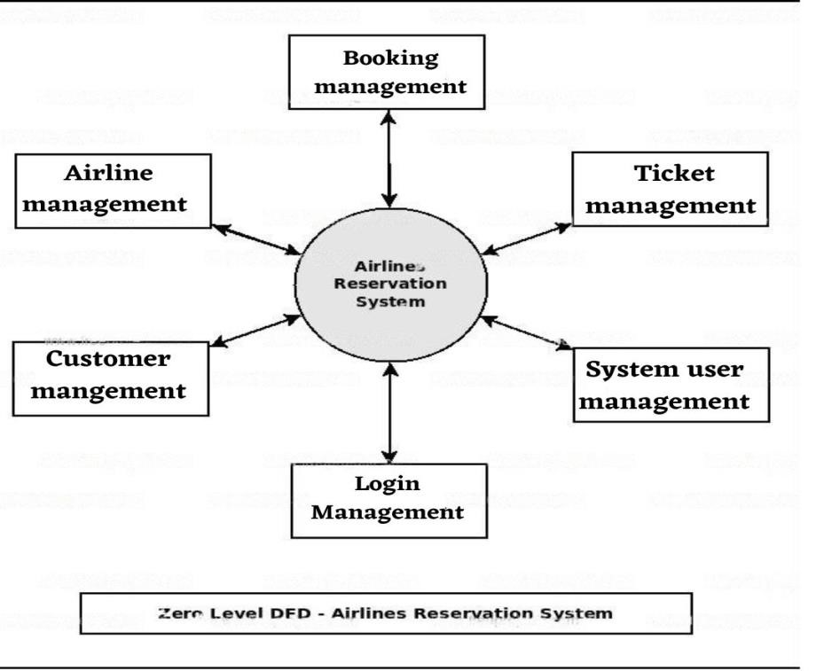

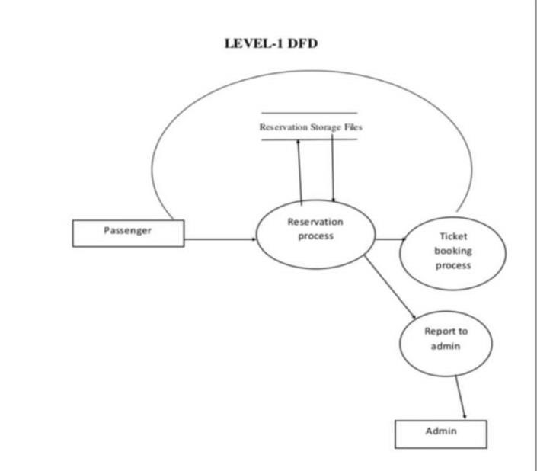

Class

Diagram

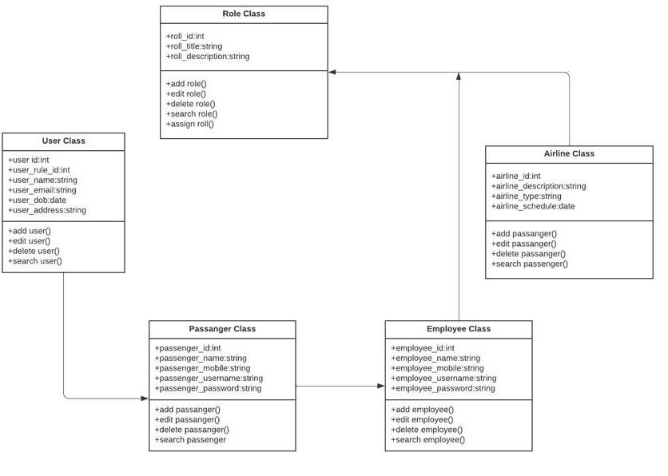

## 2.4 Operating Environment

Hardware and software requirements

Hardware:-

1. Operating System Supports all known operating systems, such as Windows, Linux 2. Computer 512MB RAM, monitor with minimum resolution of 1024x768, keyboard, and mouse

1. Hard Drive should be in NTFS file-system formatted with minimum 10 GB of free space
2. A Laser printer will need to be used to print these reports and notes

Software:-

1. Software is designed to run on any platform above Microsoft Windows 7 (32bit).
2. Microsoft .NET Frameworks 4.0 or above
3. Microsoft SQL Server Management Studio Express 2010.

## 2.5 Design and Implementation Constraints

Software development crew provides their best effort in developing the system. In order to maintain the reliability and durability of system, some design and implementation constraints

are applied. Availability of an android app for hotel management system could make the system portable but due to time constraint it is not possible. System will need a minimum memory of 512MB. But it is recommended to have a memory of 1GB. When designing interfaces of system, we had the capability of work with new tools such as Dev Express. Considering the client's budget we decided to create those interfaces in a simple realistic manner using affordable technology.

## 2.6 User Documentation

User manual provide to the client will give a clear idea in interacting with the system .A hard copy of the user manual will be delivered to the client with the delivery of system. It will be written in a simple understandable language concealing the inner complexity of the system.

## 2.7 Assumptions and Dependencies

Some software used in implementing the system is with high cost and the client has agreed to afford the amount of money needed to purchase them. It's assumed that client won't change that decision on the next phases of the software development. Although we assume that client is using windows 7 or windows 8. Otherwise if client use an open source operating system, there is a need of changing the SRS accordingly.

**Specific Requirements**

## 2.8 External Interface Requirements

### 2.8.1 User Interfaces

The user is going to interact with the system through different interfaces.

Client Registration Client login/logout

**Login page**

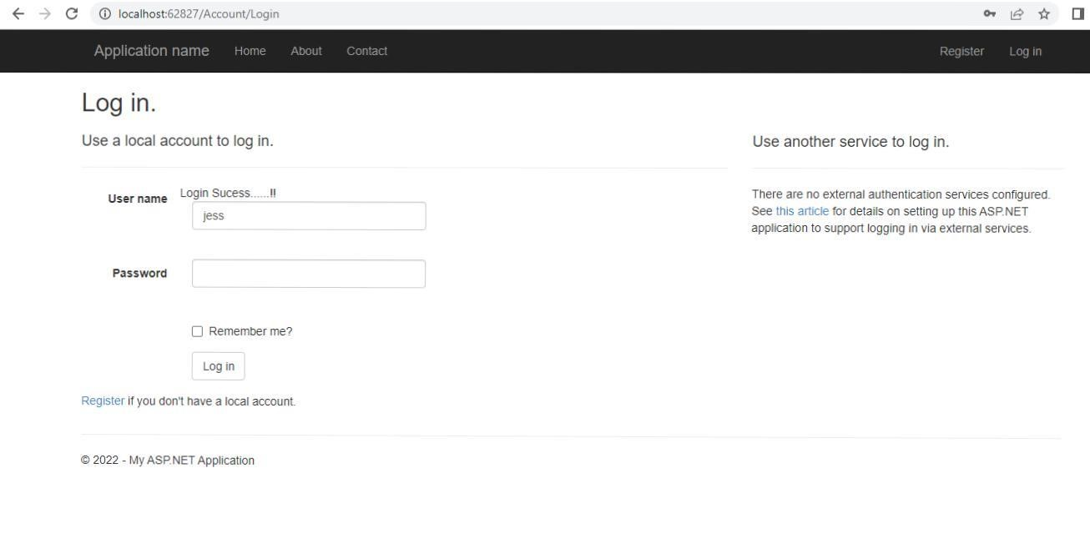

REGISTER PAGE:

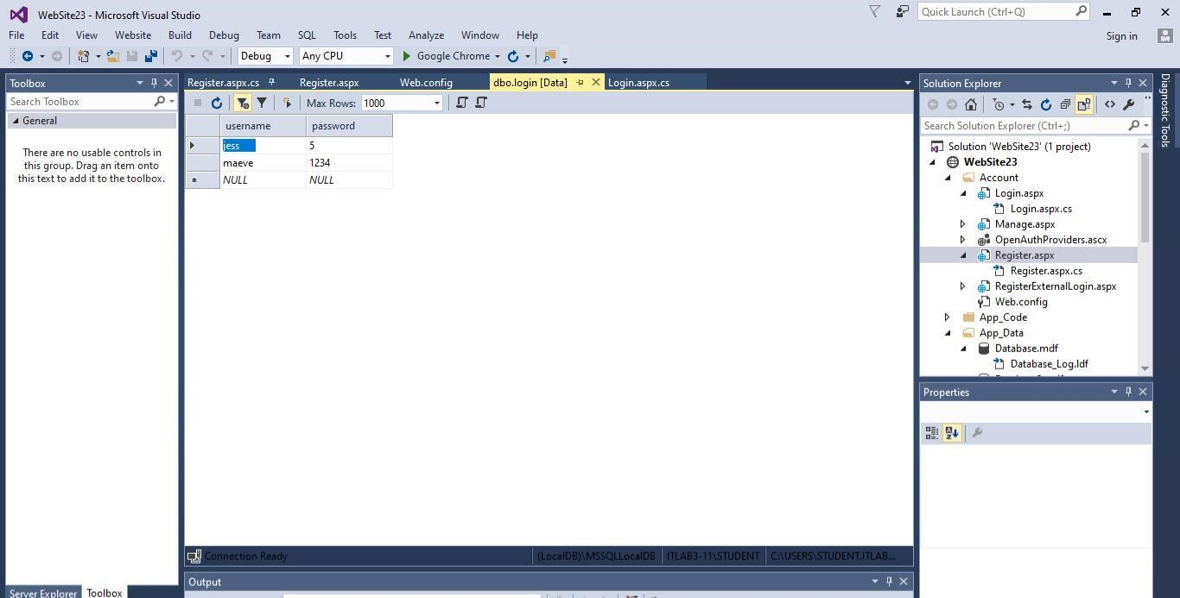

**2.8.2 Hardware Interfaces**

Not applicable.

### 2.8.3 Software Interfaces

In web.config file include the following content:

<connectionStrings>

<add name="casablanca" connectionString="Data

Source=(LocalDB)\MSSQLLocalDB;AttachDbFilename=C:\Users\STUDENT.ITLAB312\Documents\Visual Studio 2015\WebSites\WebSite10\App_Data\CB.mdf;Integrated Security=True"/>

</connectionStrings>

DATABASE:

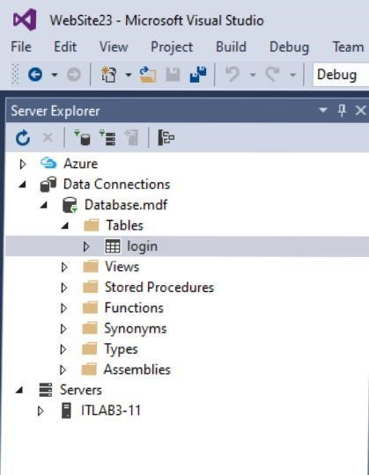

LOGIN TABLE:

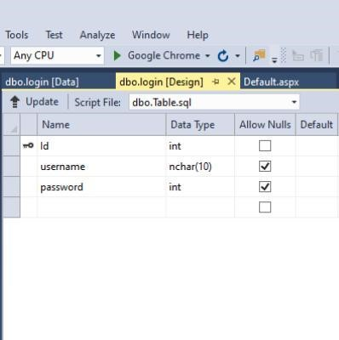

**Admin page**

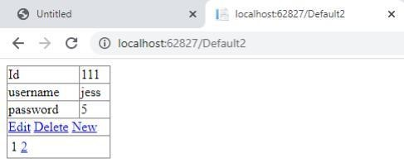

**2.8.4 Communications Interfaces**

Not applicable.

## 2.9 Functional Requirements

1. Reservation

* + record reservations
  + record the customer’s first name
  + record the customer’s last name
  + record the number of destination
  + record the seat number
  + display the flight rate
  + record the customer’s phone number
  + display whether or not the flight is guaranteed
  + generate a unique confirmation number for each
  + record the expected travel date and time
  + The system shall record the expected landing date and time
  + The system shall allow reservations to be modified without having to reenter all the customer information
  + The system shall record customer feedback

•

1. Management

* + display the flight occupancy for a specified period of time (days; including past, present, and future dates).
  + display projected occupancy for a period of time (days)
  + allow for the addition of information, regarding flight, rates, flying dates,prices, and user profiles
  + allow for the deletion of information, regarding flight, rates, prices, and user profiles
  + allow for the modification of information, regarding flight, rates , prices, and user profiles
  + allow managers to assign user passwords

## 2.10 Behaviour Requirements

### 2.10.1 Use Case View

Sequence Diagram

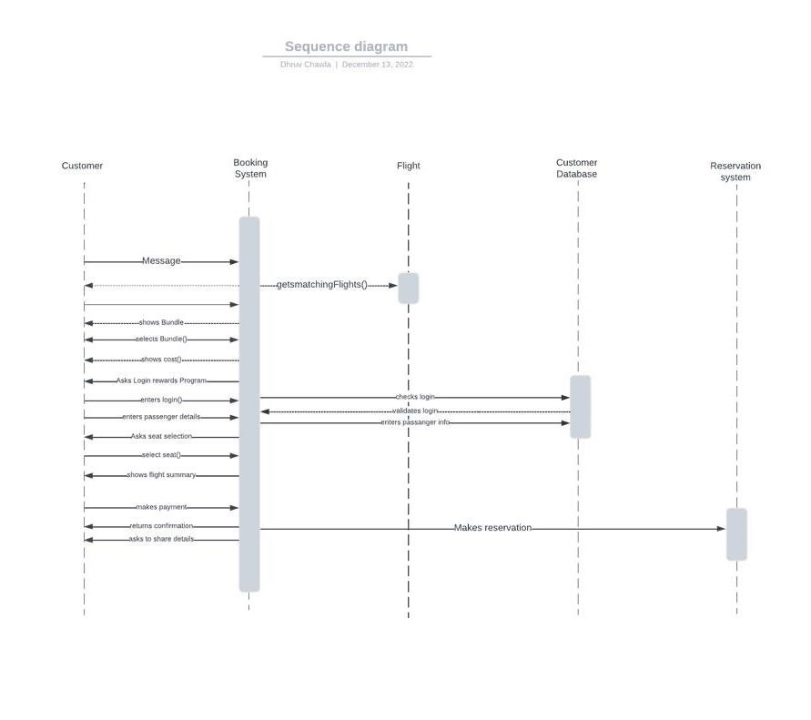

Use case Diagram

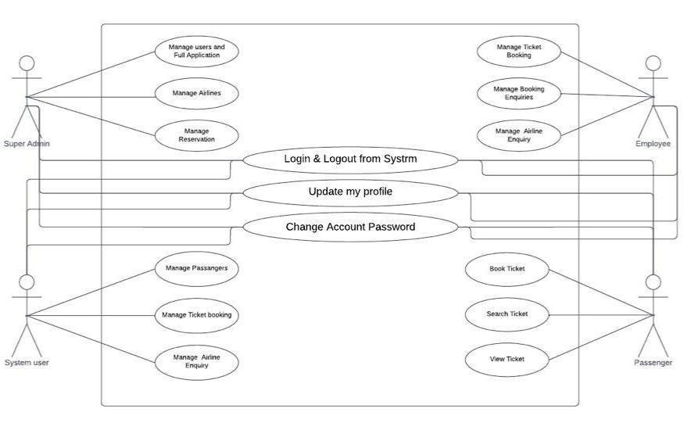

Class diagram

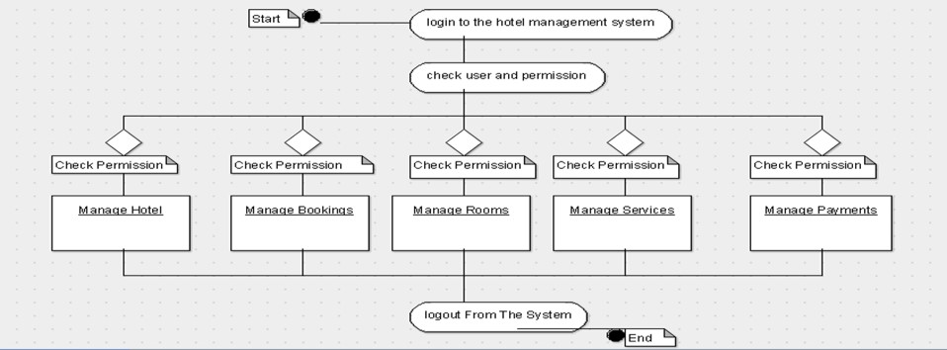

# 4 Other Non-functional Requirements

## 4.1 Performance Requirements

The performance requirements are:

1.There will be various cancellation policies depending on the day when the ticket is

Cancelled

2.There will be various deals and offers

3.Response time will be less

4.Reduces effort of the customer

5.Will have data backup

## 4.2 Safety and Security Requirements

The dealer’s will be verified , therefore no frauds

Customer will receive an email from the airline to confirm the booking

Personal information of the customer will be safeguarded and shall not be any risk. Customer Service Representatives will have access to the Reservation/Booking and subsystems. Managers will have access to the Management subsystem as well as the Reservation/Booking subsystems. Owner has the maximum privilege to all subsystems.

## 4.3 Software Quality Attributes

This software shall be open to users 24/7 , any user can book any ticket in any time zone .

Availability: -The system shall be available during normal hotel operating hours Efficiency: How much less number of resources and time are required to achieve a particular task through the system.

Flexibility; - Ability to add new features to the system and handle them conveniently. Integrity: - How the system would insecure the information in the system and how it avoids the data losses. Referential integrity in database tables and interfaces

Reusability: What is the ability to use the available components of the system in other systems as well.

Usability: How easily a person can be taken the benefits of the system and the user friendliness.

Robustness:- Strength of the system to handle system functions accurately and maintain the database without facing to unexpected failures

# 5 Other Requirements

When the system is completely developed and submitted to the client, few sessions will be required to make the users of the system understand about the functionality of it and some time to adapt to the system. After those sessions, it's required that a member from the development team should spend sometime in the system background for an agreed time period. That time period will be used in identifying new bugs that could not be reached in the earlier phases of the development process. Client should have a valid e-mail account in order to receive reservation e-mail notifications.

# Appendix A – Data Dictionary

**Customer Reservation**

|  |  |  |  |  |
| --- | --- | --- | --- | --- |
| **name** | **Data type** | **Field size** | **description** | **example** |
| Client_ID | int | 10 | Client id auto generated | 12345 |
| Client_name | text | 20 | Name of client | Tony Dias |
| Contact_no | int | 15 | Mobile no. | 9922288823 |
| Email_ID | varchar | 20 | Email of client | avengers@gmail.com |
| Client_age | int | 3 | Age of client | 44 |
| Client_gender | text | 3 | M/F/others | male |
| Client_add | int | 30 | Address of client | Stark Towers |

**Staff**

|  |  |  |  |  |
| --- | --- | --- | --- | --- |
| **Field name** | **Data_type** | **Field size** | **description** | **examples** |
| First_name | varchar | 10 | Name of staff | Peter |
| Last_name | varchar | 10 | Surname of  staff | Parker |
| nin | int | 10 | National identification nos. | 2468 |
| position | varchar | 10 | Current position | waiter |
| Department_id | int | 8 | Employee dept | 1001 |
| gender | char | 3 | M/F/others | male |
| Employee_id | int | 10 | Employee id | 666 |
| Employment_start | varchar | 20 | First date of work | 25/08/2021 |
| Employment_end | varchar | 20 | Last date of work | 30/08/2021 |

**Billing/payment**

|  |  |  |
| --- | --- | --- |
| **Field name** | **Data type** | **Description** |
| Client id | Int | Client’s id |
| Client name | Text | Name of client |
| Flight no. | Int | Room no. |
| Payment id | Varchar | Payment no. |
| Payment date | Int | Date of payment |
| Bank details | Varchar | Bank details |
| price | int | Total amount |

***Page 19***

**Appendix B - Group Log**

***Refer to APPENDIX A.***