**DAY – 1**

**Challenge 1**: List all files (including hidden ones) in your home directory and sort them by modification time.

Answer: 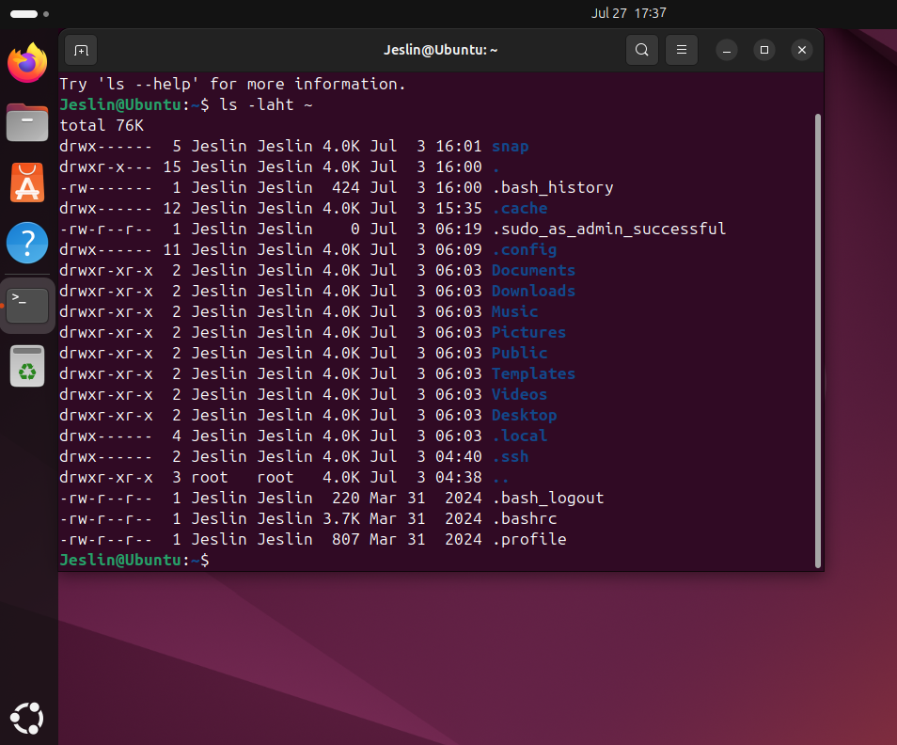

ls -laht ~

Explanation:

ls → List directory contents

-l → Use a long listing format

-a → Show hidden files (files starting with .)

-h → Display sizes in human-readable format (e.g., KB, MB)

-t → Sort by modification time (newest first)

~ → Home directory

**✅ Challenge 2:** Create a directory named devops_challenge_day_1, navigate into it, and create an empty file named day1.txt.

Answer: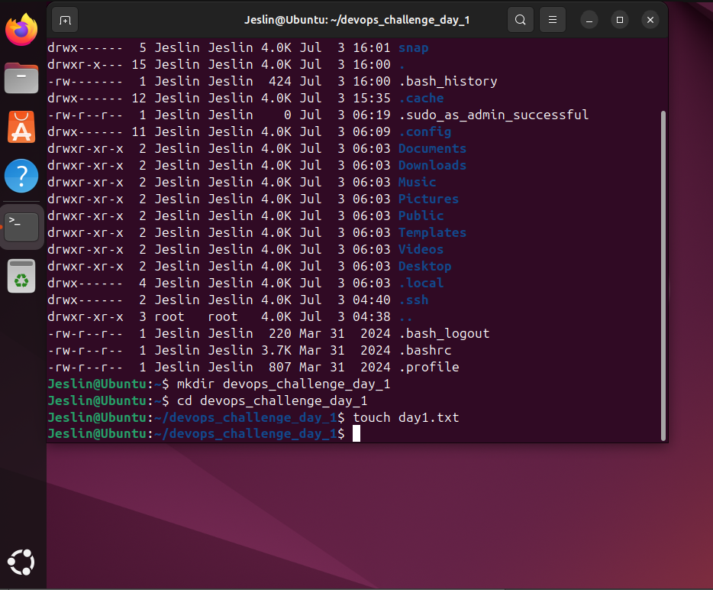

# Step 1: Create a directory named devops_challenge_day_1

mkdir devops_challenge_day_1

# Step 2: Navigate into the directory

cd devops_challenge_day_1

# Step 3: Create an empty file named day1.txt

touch day1.txt

**✅ Challenge 3:** Find the total disk usage of the /var/log directory in human-readable format.

Answer: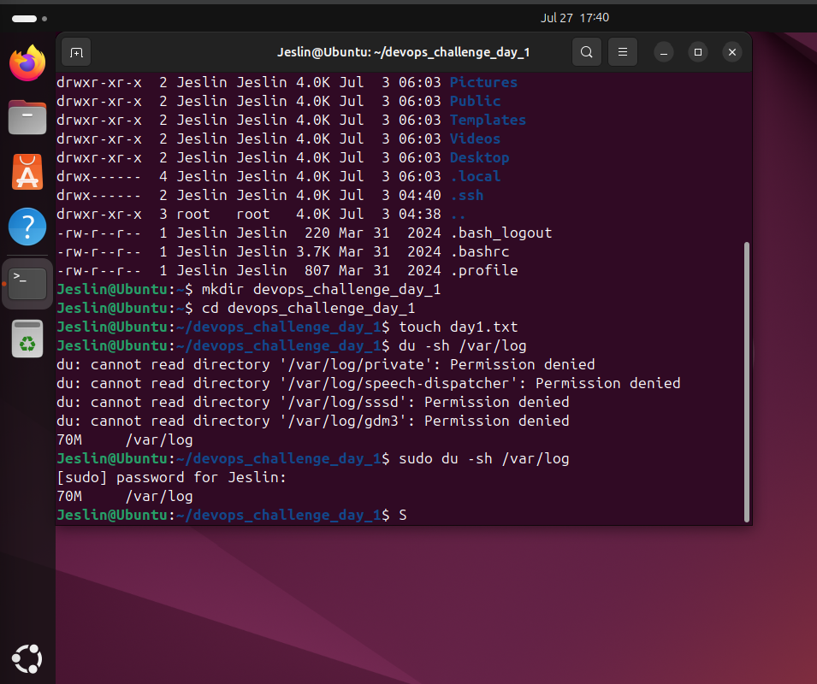

du -sh /var/log

Explanation:

du → Disk usage command

-s → Summarize total size instead of listing all files

-h → Human-readable format (e.g., KB, MB, GB)

**✅ Challenge 4:** Create a new user called devops_user and add them to the sudo group.

Answer: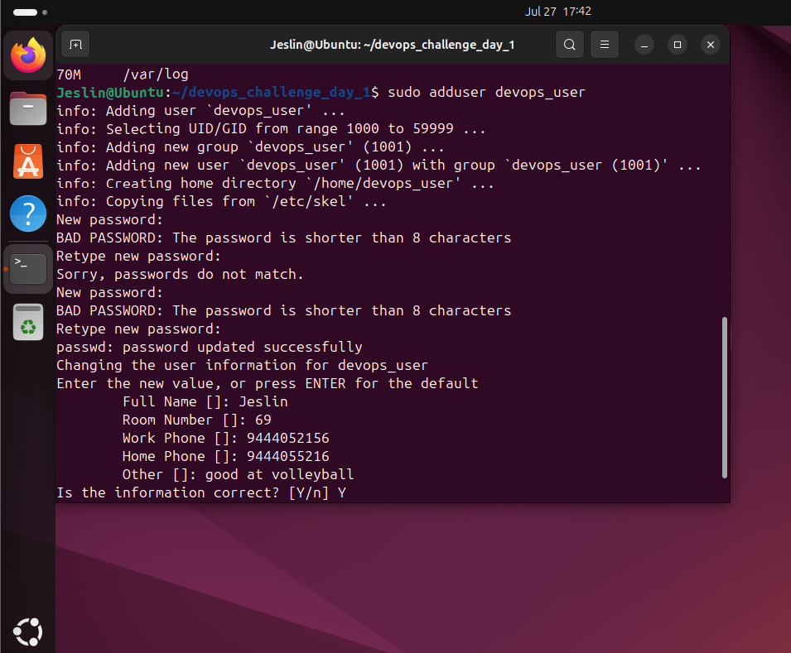

# Step 1: Create a new user called devops_user

sudo adduser devops_user

# Step 2: Add the user to the sudo group

sudo usermod -aG sudo devops_user

# Optional: Verify the user is in the sudo group

getent group sudo

Run the below command to verify it:

id devops_user

Explanation:

sudo useradd -m -s /bin/bash -G sudo devops_user

useradd → Creates a new user.

-m → Creates a home directory for the user.

-s /bin/bash → Sets Bash as the default shell.

-G sudo → Adds the user to the sudo group for administrative privileges.

devops_user → The username being created.

sudo passwd devops_user

Sets a password for devops_user (you’ll be prompted to enter a password).

**✅ Challenge 5:** Create a group called devops_team and add devops_user to that group.

Answer: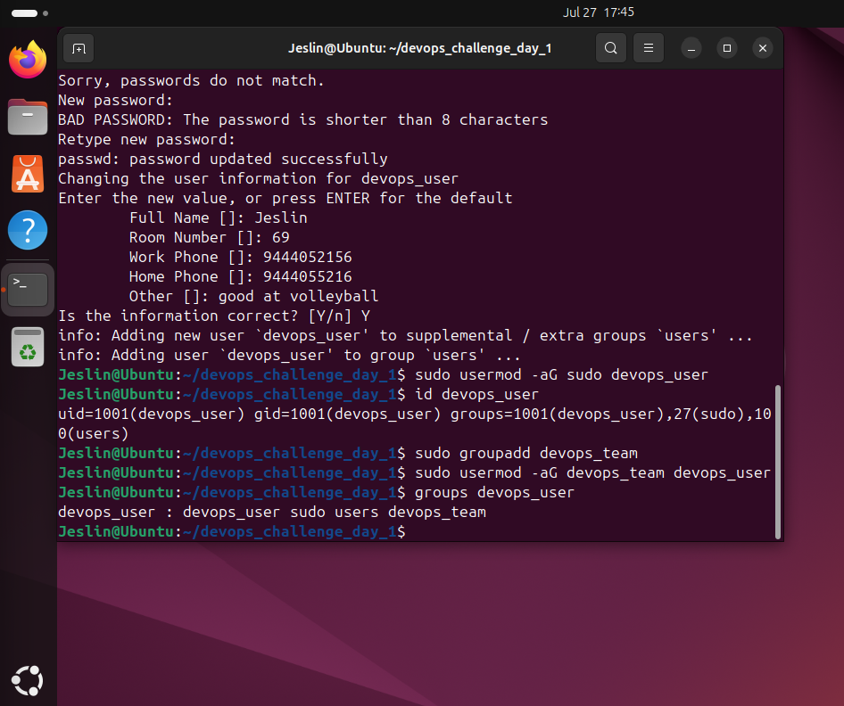

sudo groupadd devops_team

sudo usermod -aG devops_team devops_user

Verify using the below command:

groups devops_user

Explanation:

sudo groupadd devops_team

Creates a new group named devops_team.

sudo usermod -aG devops_team devops_user

Adds devops_user to the devops_team group.

-aG → Appends (-a) the user to the specified group (-G devops_team) without removing them from other groups.

**✅ Challenge 6:** Change the permissions of day1.txt to allow only the owner to read and write, but no permissions for others.

Answer: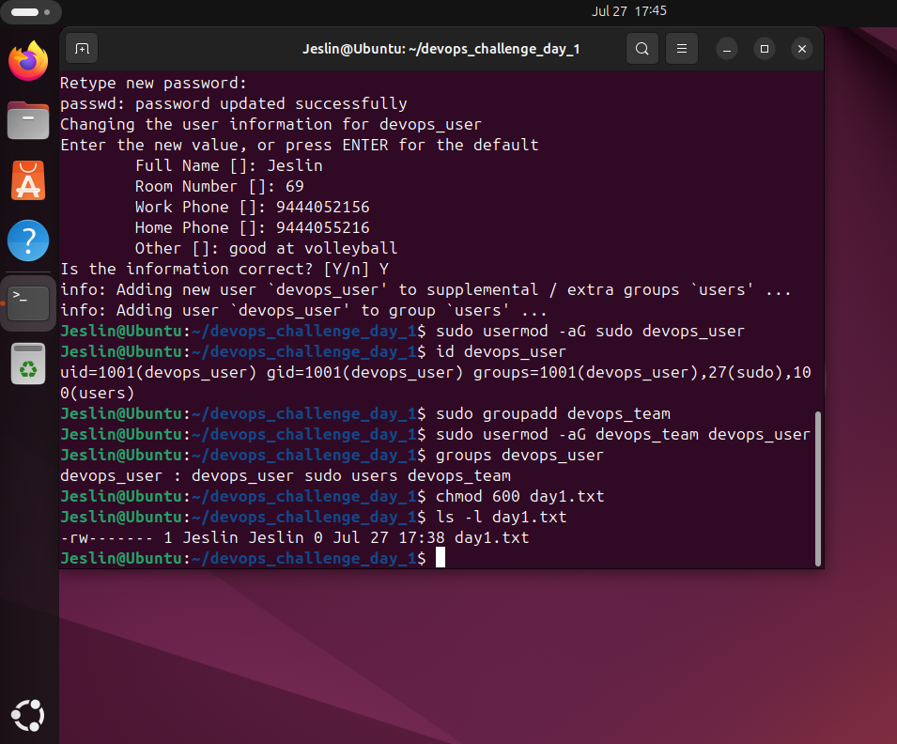

chmod 600 day1.txt

Verify using the command:

ls -l day1.txt

Explanation:

Octal Symbolic Description

000 ---------- No permissions (no read, write, or execute)

100 --x------ Execute only for owner

200 -w------- Write only for owner

300 -wx------ Write and execute for owner

400 r-------- Read only for owner

500 r-x------ Read and execute for owner

600 rw------- Read and write for owner (commonly used for private files)

700 rwx------ Full access for owner

644 rw-r--r-- Read/write for owner, read-only for group and others (text files)

655 rw-r-xr-x Read/write for owner, read/execute for group and others

660 rw-rw---- Read/write for owner and group, no access for others

664 rw-rw-r-- Read/write for owner and group, read-only for others

666 rw-rw-rw- Read/write for everyone (not recommended for security reasons)

700 rwx------ Full access for owner (private executables)

744 rwxr--r-- Full access for owner, read-only for group and others

755 rwxr-xr-x Full access for owner, read/execute for group and others

770 rwxrwx--- Full access for owner and group, no access for others

775 rwxrwxr-x Full access for owner and group, read/execute for others

777 rwxrwxrwx Full access for everyone (very insecure, not recommended)

Key Points:

First digit: Owner permissions

Second digit: Group permissions

Third digit: Others' permissions

r (4) = Read permission

w (2) = Write permission

x (1) = Execute permission

Sum of values (rwx = 4+2+1 = 7) = All allowed

**✅ Challenge 7:** Find all files in /etc that were modified in the last 7 days.

Answer: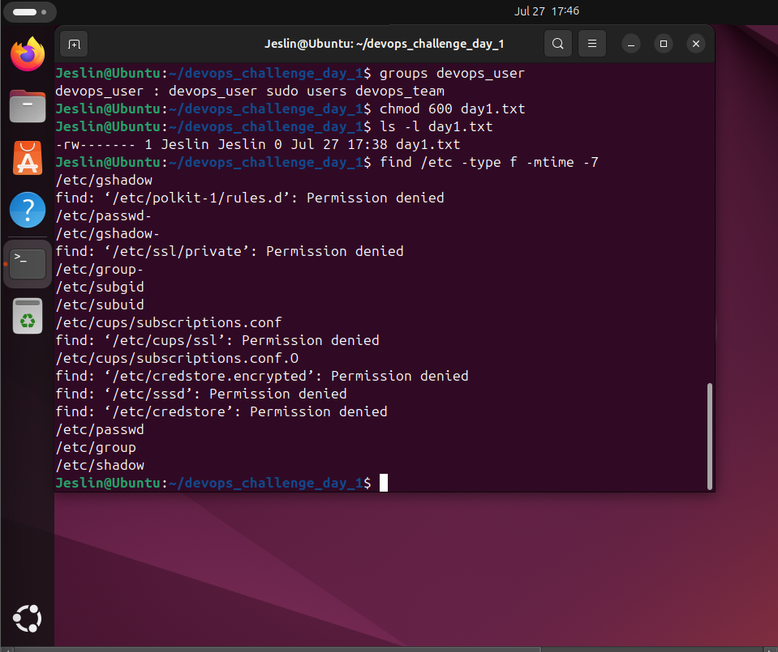

find /etc -type f -mtime -7

Explanation:

find → Command to search for files and directories.

/etc → The directory to search in.

-type f → Searches for files only (not directories).

-mtime -7 → Finds files modified in the last 7 days (-7 means less than 7 days old).

**✅ Challenge 8:** Write a one-liner command to find the most frequently used command in your shell history.

Answer:

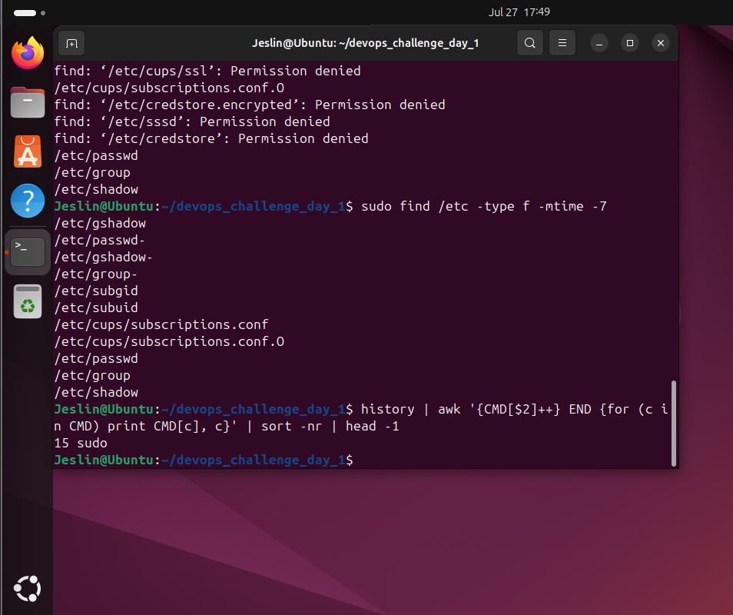

history | awk '{CMD[$2]++;} END {for (a in CMD) print CMD[a], a;}' | sort -nr | head -1

Explanation:

history → Lists the command history.

awk '{CMD[$2]++;} END {for (a in CMD) print CMD[a], a;}'

Extracts and counts occurrences of each command.

sort -nr → Sorts the commands by frequency in descending order.

head -1 → Displays the most frequently used command.