# Day 3 – #60DaysOfDevOps Challenge

Today's focus was mastering Git fundamentals, including branch operations, merging strategies, conflict resolution, and working with Git history. Here's a breakdown of the challenges completed:

## ✅ Challenge 1: Clone Your Fork

Use the terminal to clone your forked GitHub repository:  
git clone <https://github.com/Jeslinanista/eks-auto-mode-workshop.git>

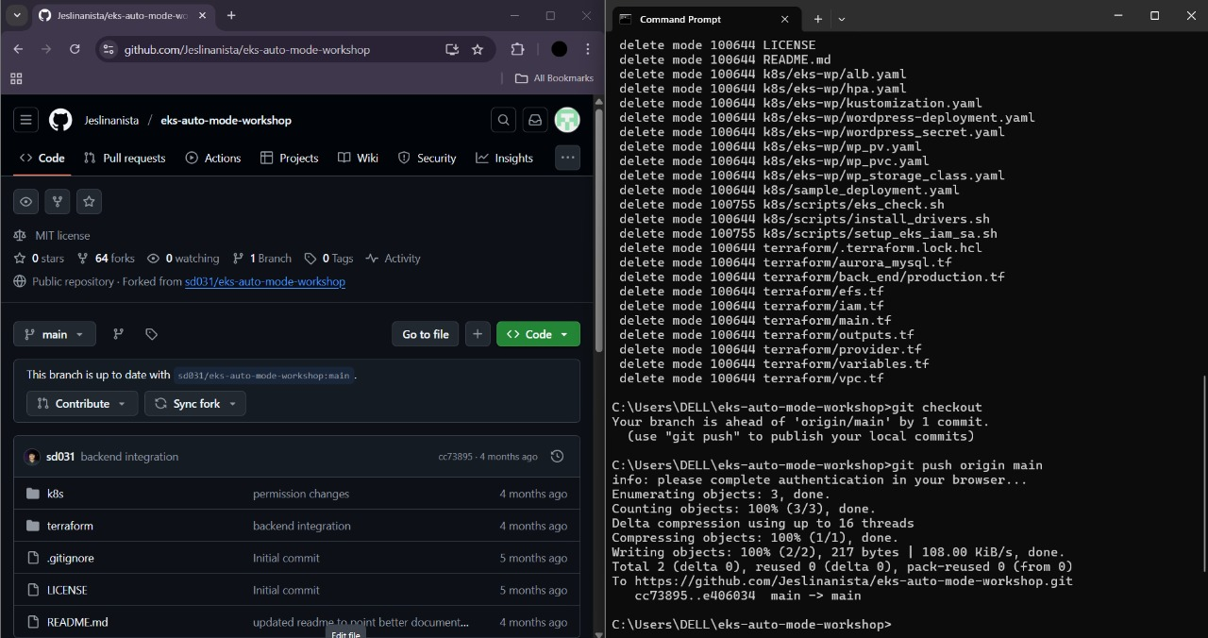

## ✅ Challenge 2: Create a Feature Branch

Create and switch to a new branch:  
git checkout -b feature-branch

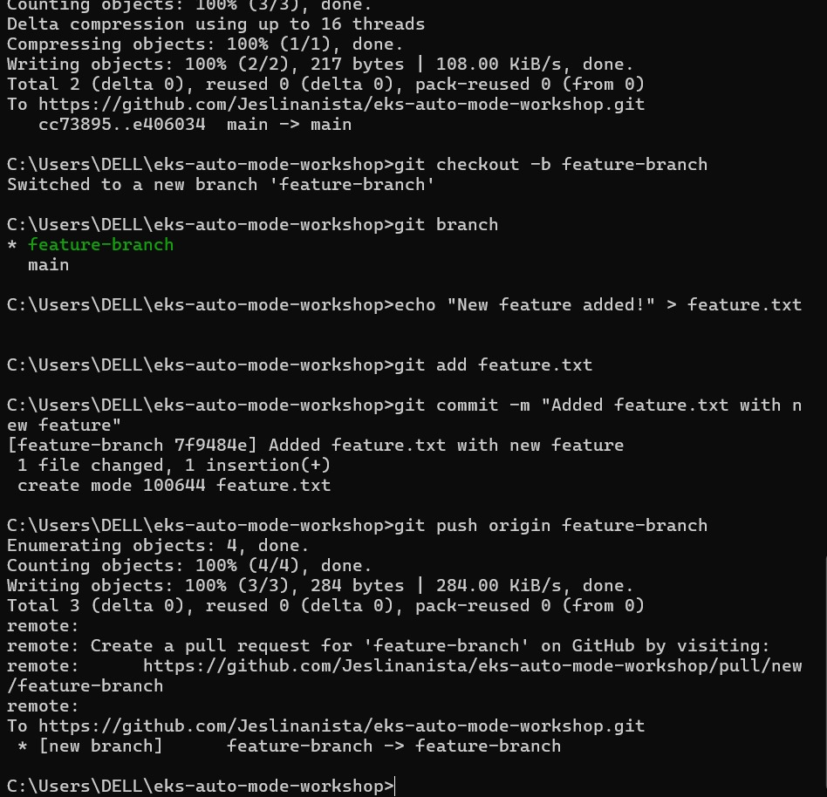

## ✅ Challenge 3: Make a Change

Add a new file with a greeting:  
echo "Hello from Jeslin's feature branch!" > jeslin.txt  
git add jeslin.txt  
git commit -m "Added jeslin.txt with a greeting"

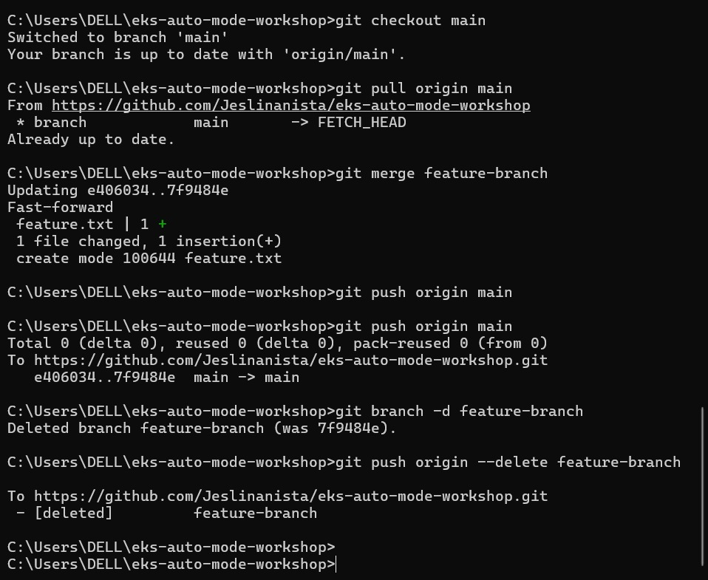

## ✅ Challenge 4: Push the Branch

Push the new branch to GitHub:  
git push origin feature-branch

## ✅ Challenge 5: Open a Pull Request

Navigate to your GitHub repository, and open a Pull Request from `feature-branch` to `main`.

## ✅ Challenge 6: Merge the PR

After reviewing, merge the Pull Request and delete the `feature-branch` if desired.

## ✅ Challenge 7: Explore Git History

View commit history and experiment with Git commands:  
git log --oneline  
git reset --soft HEAD~1  
git revert <commit-hash>  
git commit --amend