**PMGT 1850 Notes**

**Week 1: Introduction to Project Management**

**1. What is a Project?**

* **Definition**: A project is a temporary organization established to solve a unique task within a specified timeframe to create future value.
* Projects have a **definitive start and end**.
* Example: Building a bridge, launching an app, organizing an event.

**2. Project Management (PM)**

* Integration and application of multiple skills, knowledge areas, and processes to achieve better project delivery.
* PM is **goal-oriented** and follows structured methodologies.

**3. The Project Economy**

* More organizations rely on projects to achieve strategic goals.
* **Harvard Business Review** states that projects are the backbone of modern economies.

**4. Projects as Interventions**

* Projects address sustainability, natural resource management, and societal impact.
* Connection to **UN Sustainable Development Goals (SDGs)**.
* Example: Renewable energy projects contribute to sustainability.

**5. Mindset in Project Management**

* Attitude → Thought → Behavior → Impact.
* A growth mindset leads to better project execution.

**6. The Project Management Industry**

* Many industries require PM professionals (construction, IT, healthcare, finance, etc.).
* **PM Salary Guide**: Salaries vary based on industry and country.

**Week 2: Projects, Business Strategy & Selection**

**1. Strategic Planning in Project Management**

* Projects must align with an organization's **vision, mission, and strategy**.
* **Strategic Objectives** → **Flow-down Objectives** → **Projects**.
* Example: Government initiative for 200,000 new jobs → Training center project.

**2. Business Case & Project Selection**

* **Project Proposal**: Outlines the **"what"** – high-level idea to initiate discussion.
* **Business Case**: Justifies **"why"** the project is necessary, including cost, benefits, risks, and alternatives.
* **Grant Application**: Mix of both; aligns project with funding organization’s goals.

**3. Organizational Strategy & Projects**

* **SWOT Analysis** (Strengths, Weaknesses, Opportunities, Threats) helps in project planning.
* Companies must analyze **internal (controllable)** and **external (uncontrollable)** factors.
* Example: Kodak invented the digital camera but failed to adapt → Bankruptcy.
* Example: Nokia relied on hardware over software → Market loss to Apple & Android.

**4. Portfolio & Program Management**

* **Program**: A group of related projects (e.g., multiple renewable energy projects in a country).
* **Portfolio**: A collection of programs (e.g., all energy projects in a corporation).

**5. Public-Private Partnerships (PPPs)**

* Collaboration between **government and private sector** for large-scale projects.
* Example: M8 Motorway in Sydney (Transurban & NSW Govt.).

**6. Financial Justification for Projects**

* **Net Present Value (NPV)**: Future cash flows adjusted for present value.
* **Return on Investment (ROI)**: Profitability measure.
* **Benefit-Cost Ratio**: Compares project benefits to costs.
* **Payback Period**: Time taken to recover the investment.

**7. Project Selection Methods**

* **Financial models**: Used for screening viable projects.
* **Weighted Scoring Model**: Evaluates multiple criteria beyond financials (e.g., risk, social impact).

**Week 3**

**1. Organisational Structures in Project Contexts**

This document discusses different organisational structures and their impact on project environments. It introduces key types of organisational structures and their characteristics:

* **Functional Organisation**:
  + Employees report to a single superior based on specialisation.
  + Functional managers control budgets, decisions, and communications.
  + Common in traditional businesses with well-defined roles.

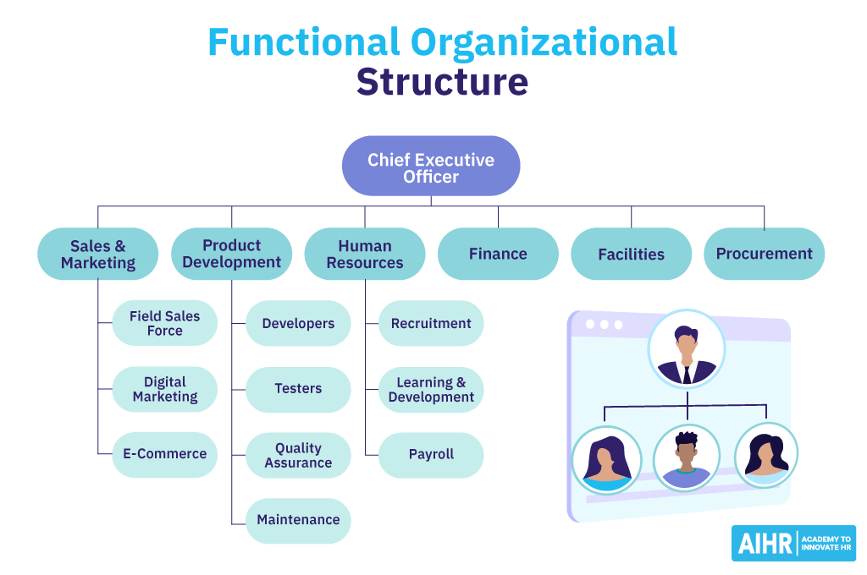

* **Projectized Organisation**:
  + The project manager has full authority over budgets, personnel, and decisions.
  + Team members report directly to the project manager.
  + Suitable for organisations focused on project execution.

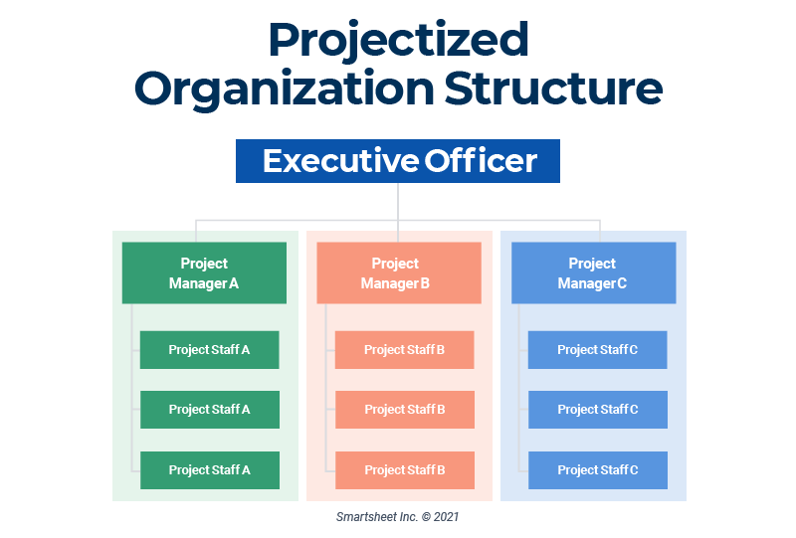

* **Matrix Organisation**:
  + A hybrid model where project managers share authority with functional managers.
  + Employees report to both managers.
  + Balances project focus with technical expertise.

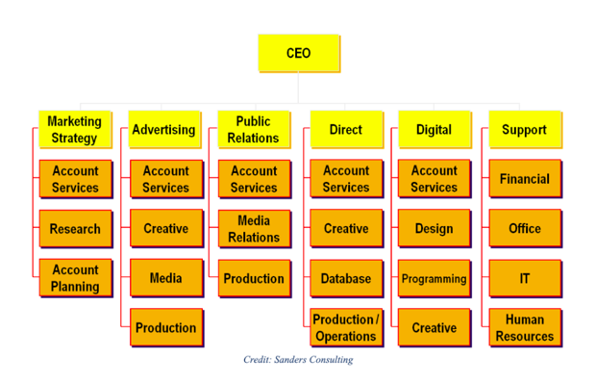

Each structure has advantages and challenges depending on the project type and organisational goals.

**2. How Work Gets Done**

This document explores communication, collaboration, and knowledge-sharing in organisations.

* **Key Themes**:
  + **Traditional vs. Networked Structures**:
    - Traditional organisational charts are hierarchical.
    - Networked models are more fluid, focusing on collaboration.
  + **Hidden Power of Networks**:
    - Employees who leverage professional networks can gain strategic advantages.
    - Bottlenecks in communication can hinder project efficiency.
  + **360-Degree Performance Reviews**:
    - Evaluates employees based on both individual performance and network effectiveness.
    - Categories include high performers, hidden talent, underutilised talent, and marginalised employees.

The document highlights the importance of understanding informal networks to improve project collaboration.

**3. Importance of Culture in Project Environments**

This document covers the role of organisational culture in project success.

* **Impact of Organisational Culture**:
  + Shapes communication, motivation, and ethical behaviour.
  + Influences conflict resolution, cooperation, and reward systems.
* **Types of Organisational Culture**:
  + **Power Culture** – Authority is centralised; leaders control decision-making.
  + **Role Culture** – Defined responsibilities dictate structure.
  + **Task Culture** – Goal-oriented and flexible.
  + **Person Culture** – Prioritises individual growth and employee well-being.

**4. Project Approaches & Lifecycles**

This document explains different project management methodologies and lifecycle models.

* **Project Life Cycles**:
  + Initiating → Planning → Executing (includes monitoring & control) → Closing.
  + Different industries adapt life cycles to their needs (e.g., construction vs. software development).
* **Traditional (Waterfall) vs. Agile**:
  + **Waterfall Model**:
    - Linear, phase-based approach.
    - Common in construction and engineering projects.
  + **Agile Approach**:
    - Iterative and flexible.
    - Developed in response to unpredictable work environments.
    - Core values include collaboration, customer feedback, and adaptability.
* **Agile Manifesto**:
  + Prioritises individuals, working solutions, collaboration, and responsiveness to change.

The document highlights that project managers must choose an approach based on the project’s complexity, uncertainty, and required flexibility.

**5. Roles in Project Contexts**

This document outlines the roles and responsibilities in project management.

* **Key Roles**:
  + **Executive Level**: Steering team, sponsor, chief projects officer (CPO).
  + **Managerial Level**: Project managers, functional managers.
  + **Associate Level**: Core team members, subject matter experts (SMEs).
* **Project Sponsor**:
  + Ensures that the project meets stakeholder needs.
  + Provides financial and strategic support.
  + Often mentors the project manager.
* **Project Manager**:
  + The primary point of accountability for a project.
  + Manages planning, execution, and closure.
  + Requires strong leadership, communication, and risk management skills.
* **Functional Managers & Core Team Members**:
  + Functional managers allocate resources and ensure departmental alignment.
  + Core team members carry out project tasks from start to finish.

The document emphasizes the importance of clearly defining roles to ensure project success.

**Final Thoughts:**

These documents provide a comprehensive overview of key project management concepts, including:

1. **Organisational structures and their impact on projects.**
2. **The role of informal and formal communication networks.**
3. **How organisational culture influences project success.**
4. **Different project management approaches and lifecycle models.**
5. **Key roles and responsibilities in project environments.**

Each document highlights important principles that project managers must consider when working in different organisational settings. Let me know if you need further details on any specific section!

**Week 4**  
• **Scope** = **Product Scope** (features and functions that characterise a product, service or result) + **Project Scope** (work required to deliver a product, service or result)

• **Scope Planning**: Defines project deliverables, acceptance criteria, and constraints.

• **Scope** ( define scope - process of developing a detailed description of the project and product)

• Aligns with project charter and objectives.

• Clearly states inclusions, exclusions, and assumptions.

• reason to define scope:

* + Conforms to project charter and project objectives
  + States deliverables (SMART objectives), constraints and assumptions
  + Establish boundaries of work (inclusion and excusion)

• **Scope Creep**:

• Occurs when work or activity has expanded beyond initial agreement, and has been poorly defined entry and exit criteria

• when customer asks for additional features of products or services to be added

• Prevent by defining good project and product scope.

**To define scope**

• Identify deliverables and their boundaries. (determine acceptance criteria)

• Establish project boundaries (in scope, out of scope, understand constrains)

**entry & exit criteria** for project tasks.

• Use a **Statement of Work (SOW)** to formalize scope. (create work statement)

**2. Requirements Gathering**

• **Project Charter**: Defines project purpose, objectives, and governance structure.

• **Collecting Requirements**:

• Use **Voice of Customer (VOC)** techniques. (ask questions, place yourself in the customer’s situation)

• Identify business needs, stakeholders, and project constraints.

• gather stakeholder input

• **Requirements Matrix**:

• Ensures requirements are **traceable, clear, measurable, and prioritized**.

**Best Practices**

* Ask: **What, Why, Impact, Action Items, and Dependencies?**

• Clearly define **assumptions & constraints**.

• Poorly elicited requirements can lead to **scope creep & project failure**.

**3. Work Breakdown Structure (WBS)**

• **WBS**: Divides project work into smaller, manageable components.

• identify deliverables to outcome (what are the components of this deliverable of outcome)

• a framework for communication, planning, execution, control

• **Purpose**:

• Improves **planning, execution, and control**.

• Helps in cost estimation, resource allocation, and risk management.

• add discipline and visibility to project planning

• determining where and why problem occur

• **Components**:

• **Project → Phases → Deliverables → Work Packages**.

• Work Packages should be **mutually exclusive** and **focused on outcomes**.

• **WBS Dictionary**: Describes each WBS element for clarity.

• WBS component / element - entry in the WBS that can be at any level

• Use **top-down** approach & brainstorm with **Subject Matter Experts (SMEs)**.

**Work Packages**

• element at the lowest level

•The point from which a set of activities

– are defined & makes no sense to break down further

– can be estimated & allocated

– can be schedule is formed

– Can be allocated resources (i.e. control, authority & responsibility are assigned)

• **80-hour rule**: Work packages should not exceed the reporting period (~2 weeks).

WBS

– Include a subject matter expert (SME)

– Use a top down approach

– Consider WBS from a previous project as a starting point

– Use brainstorming

– Remember: Focus on outcomes, deliverables or product.

– Ask: What am I producing? (at the end…of this phase, …of this product, …of this project?)

* Design Principles:
  + **Plan for Outcomes** or **Results** not activities or actions
  + Product development projects -> Product Breakdown Structure
  + Professional service projects -> Deliverable-oriented WBS
  + **Work**/**Effort** to be **Assigned to the work packages** not to its parent
  + Mutually exclusive elements (**no overlap** of scope/work between other elements)
  + Use a **coding scheme** (e.g. *1.1.2 Air-condition System* reveals the component is at the 3 WBS level)
  + Must cover 100% of **Scope** **of Works**
  + Consider the parent-child concept
  + Have between 3 and 9 child elements for each parent
  + Uniquely name each component in the WBS
  + Assign a unique number to each component
  + When all is well and done...the WBS presents a project plan, saved as a baseline.
  + **baseline** – *“the approved plan for a project plus or minus approved changes.”* **PMBOK® Guide**

**4. Change Management【25†source\*\***

• **Change Control System**:

• Manages project changes in a structured way.

• Requires approval from the **Change Board**.

• Includes impact analysis and rollback plans.

* + Formal procedures that documents:
    - changes to project deliverables
    - impact to other project deliverables
    - approval by the change board
    - usually includes a rollback plan (when things go awry)

• **Change Request Process**:

• Documents requested change.

• Assesses impact on **scope, cost, time, and quality**.

• Requires formal approval before implementation.

• Expect **uncertainty** and plan for change.

• Implement a **formal change request process**.

• Communicate changes effectively to all stakeholders.

**Summary: Scope Definition and Management**

**Scope Definition** is the most critical task in project planning as it outlines what will and will not be included in the project. It serves as the foundation for scheduling, budgeting, quality control, resource allocation, and procurement.

**Key Concepts of Scope Management**

1. **Scope, Time, Cost & Quality - The Project Constraints**

• Changes to one aspect (e.g., increasing scope) affect others (e.g., higher costs, longer timelines, or lower quality).

• Example: Adding an extra bedroom to a house project increases costs and timeline, potentially affecting quality.

2. **Three Tools to Plan Scope**

• **Goal Statement** – A concise project description stating objectives, constraints, and boundaries.

• **Scope Boundary Table** – Defines what is included (IN) and excluded (OUT) to manage stakeholder expectations.

• **Work Breakdown Structure (WBS)** – A structured breakdown of project work for detailed planning.

**Goal Statement**

• A precise, memorized statement summarizing project goals, major constraints, and required collaborations.

• Should be **less than a minute long** when spoken.

• Example:

*“This project aims to study Green Bellied Wasp infestation in the NSW/Victorian border region, for a report to the International Task Force by December 2018, within a $75,000 budget, using resources from the University of Sydney and the University of Melbourne.”*

**Scope Boundary Table**

• Clearly separates **what is included (IN) and what is excluded (OUT)**.

• Helps manage stakeholder expectations early, reducing conflicts later.

• Ensures that disagreements over scope are addressed in advance.

**Example: Green Bellied Wasp Project**

| **What is IN** | **What is OUT** | **Assumptions/Constraints** |
| --- | --- | --- |
| Sampling Green Bellied Wasps within the defined area | Sampling outside the defined area | Research personnel will be available |
| Preparing a report for the conference | Preparing presentation slides | Approved $75,000 budget is sufficient |
| - | Negotiating project funding | - |

**Agile vs. Traditional Scope**

• **Agile Approach**: More flexible scope, adapting to changes.

• **Traditional (Predictive) Approach**: Fixed scope with defined deliverables.

**Final Thoughts**

• Clearly defining **scope boundaries** prevents scope creep and unrealistic stakeholder expectations.

• Using **goal statements and scope boundary tables** improves communication and project alignment.

• Managing scope effectively ensures **successful project execution** within constraints.

**Summary: Work Breakdown Structure (WBS) in Scope Management**

The **Work Breakdown Structure (WBS)** is a fundamental project management tool that provides a **hierarchical breakdown** of all the tasks required to complete a project. It refines the **scope definition** by detailing project deliverables and breaking them into manageable components.

**Why Use a WBS?**

• Defines what is **IN scope** more precisely than the **Scope Boundary Table**.

• Helps in **accurately predicting schedules and budgets**.

• A well-defined WBS **reduces risk** and improves project planning.

**How to Create a WBS**

1. **Start with a single node** representing the whole project.

2. Identify **major deliverables or products** (e.g., reports, documentation, event planning).

3. Break each deliverable into **smaller component parts**.

4. List **specific activities** needed for each part.

• Use **verb + noun** format (e.g., “write report”, “test software”).

5. **Estimate time and cost** for each task.

6. If a task is too vague or hard to estimate, **break it down further**.

7. Use a **hierarchical numbering system** (e.g., 1, 1.1, 1.1.1).

**Challenges in Estimating Time & Cost**

• Some activities (e.g., **writing reports**) can be adjusted for time constraints.

• Others (e.g., **research or creative work**) are harder to predict.

• **Solution**: Break complex tasks into sub-components and **add buffer time** for uncertain tasks.

**Best Practices for a Useful WBS**

1. **Ensure 100% of project activities are covered** – No missing elements.

2. **Keep activities distinct** – Avoid overlap for better time and cost estimation.

3. **Start with sticky notes** before structuring it digitally – Easier to reorganize tasks.

4. **Use a hierarchical numbering system** (e.g., **1, 1.1, 1.1.1**) to maintain clarity.

**Example: Green Bellied Wasp Project WBS**

A **Work Breakdown Structure** for a study on Green Bellied Wasp migration may include:

1. **Research Planning**

• 1.1 Define study area

• 1.2 Obtain permits

2. **Data Collection**

• 2.1 Conduct field sampling

• 2.2 Record environmental factors

3. **Analysis & Reporting**

• 3.1 Analyze migration data

• 3.2 Prepare conference report

**Final Takeaway**

A **well-structured WBS improves project control, scheduling, and budgeting**. By breaking the project into detailed, **manageable tasks**, it ensures that all aspects of the project are accounted for, reducing uncertainty and improving execution.

**Summary: Time Management in Projects**

Once a **Work Breakdown Structure (WBS)** is developed, the next step is to create a **schedule** to outline the sequence of activities, estimate project duration, and track progress. This involves using **Milestones, Precedence Diagrams, and Gantt Charts** to organize tasks effectively.

**1. Milestones**

• **Definition**: Significant events or transition points in a project.

• **Characteristics**:

• Usually tied to **specific dates** (e.g., funding cycles, ethics approvals, assignment deadlines).

• Often **non-negotiable**, meaning missing them may result in penalties or project failure.

• **Purpose**:

• Helps in tracking progress.

• Ensures realistic scheduling by setting achievable deadlines.

✅ **Key Tip**: Always check if your milestones align with external deadlines to avoid last-minute issues.

**2. Precedence Diagrams**

A **Precedence Diagram** is a scheduling technique that organizes **WBS tasks in sequence** based on dependencies.

**How to create a Precedence Diagram:**

1. Arrange WBS tasks in **order of execution** (left to right).

2. Identify and add **milestones** with their fixed deadlines.

3. Indicate dependencies using **arrows** (tasks that must be completed before others).

4. If some tasks can happen **concurrently**, use **parallel pathways**.

**Example:**

• **Linear Sequence** → Task A → Task B → Task C → Completion.

• **Concurrent Tasks** → Task A → (Task B & Task C in parallel) → Task D → Completion.

✅ **Key Tips**:

• Ensure **task order is correct** to avoid delays.

• Account for **realistic revisions**, such as feedback from stakeholders or proofreading documents.

**3. Gantt Charts (Not Covered in Detail Here)**

• A **visual scheduling tool** that maps tasks against a timeline.

• Used to **track progress** and ensure project stays on schedule.

**Final Takeaways**

• **Milestones** mark **key deadlines** and are usually non-adjustable.

• **Precedence Diagrams** visually **sequence tasks** and identify dependencies.

• **Concurrency** should be considered to optimize project efficiency.

• **Review cycles** should be built into the schedule to prevent delays.

After creating a **Work Breakdown Structure (WBS)** and a **Precedence Diagram**, the next step in project scheduling involves using **Gantt Charts** and **Milestone Progress Charts** to manage time effectively.

**1. Gantt Charts**

• **Definition**: A **visual project scheduling tool** that maps out tasks and their durations on a timeline.

• **Best Used For**:

• Large projects with **multiple interdependent tasks**.

• Teams managing **predictable work** with structured deadlines.

• Tracking **task dependencies** and identifying potential bottlenecks.

**Example**:

In an aircraft manufacturing project, Gantt Charts help manage **procurement, design, and assembly timelines**, ensuring components arrive just-in-time for production.

**For Small Projects**

• A full **detailed Gantt Chart may not be necessary**.

• Uncertainty in small projects can make maintaining a Gantt Chart cumbersome.

• Instead, a **simplified version** can help visualize:

• Task **sequence and dependencies**.

• Workload distribution within a **small team**.

• **Impression management** – Supervisors and sponsors often **appreciate Gantt Charts** as they demonstrate structured time management.

**Creating a Gantt Chart**

For each task, include:

1. **WBS Number**

2. **Task Name & Description**

3. **Dependent Tasks**

4. **Responsible Person** (team member, stakeholder, external resource)

5. **Planned & Actual Start/Finish Dates**

✅ **Key Tip**:

For projects with **high uncertainty**, updating a Gantt Chart frequently can be time-consuming. **Only use it where it adds value.**

**2. Milestone Progress Charts**

• **Definition**: A **visual tool for tracking progress** toward project milestones.

• **Focus**:

• Milestones are marked with **blue rows**.

• Tasks required to reach a milestone **appear above it**.

• The **order of tasks is less important** than their **completion status**.

**How It Works**

• Each **box represents a task** with a progress status.

• **Colour-coded for quick progress assessment**:

• **Dark Green** – Task complete ✅

• **Light Green** – Task in progress, on track 🚀

• **Yellow** – Task in progress, minor issues ⚠️

• **Red** – Task experiencing significant issues ❌

• **White** – Task not started yet ⏳

**Advantages**

• **Easier to update** than Gantt Charts.

• **Clear visual feedback** on project status.

• **Great for quick reviews** with supervisors or team members.

**Final Takeaways**

• **Gantt Charts**: Ideal for structured, predictable projects. Less useful when there is **high uncertainty**.

• **Milestone Progress Charts**: Simpler, effective for **tracking task completion** and **milestone progress**.

• **Choose the right tool** based on project complexity and team size.

**Summary: Cost & Budgeting in Projects**

Budgeting in project management follows a structured process that starts with the **Work Breakdown Structure (WBS)**. A well-defined WBS simplifies cost estimation by breaking down activities into smaller, manageable components.

**1. Budget Planning Process**

• **Estimate the costs** associated with each activity in your WBS.

• **Enter cost estimates** into a budget spreadsheet.

• **Consider indirect costs** (e.g., time investment, software, accommodation, meals).

• **Track estimated vs. actual expenditure** throughout the project.

For **student projects**, cost management may not be complex, but understanding financial constraints can help determine which aspects of the project are **affordable and realistic**.

**2. Example: Green Bellied Wasp Project**

• **Not all activities incur a direct cost** (e.g., research hours).

• **Larger projects** would include labor costs as wages.

• **Budget spreadsheets help track spending**:

• **Green values** = under budget ✅

• **Red values** = over budget ❌

✅ **Tip:** Add a **contingency fund** as a percentage of the total budget, not per task, to simplify cost analysis.

**3. Key Budgeting Considerations**

• **Breaking down activities** into smaller parts improves cost accuracy.

• **Associated costs** (e.g., insurance for off-site work) should be identified.

• **Document assumptions** behind cost estimates:

• Useful for **justifying budget adjustments**.

• Helps when explaining costs to supervisors or stakeholders.

**4. Iterative Budgeting Approach**

• Reviewing the budget may highlight **missing activities** from the WBS.

• **Adjust WBS and Milestone Progress Chart** if new cost-related activities arise.

**Final Takeaways**

• **Budgeting starts with WBS** and requires clear cost estimation.

• **Tracking actual vs. estimated costs** helps manage financial risks.

• **Adjust budgets iteratively** to ensure all necessary costs are accounted for.

**Week 5 – Continue with week 4 content**

**Week 6**

**🕒 1. Project Scheduling Overview**

**Key Concepts:**

• Project scheduling involves:

• **Defining activities**

• **Sequencing activities**

• **Estimating resources and durations**

• **Developing and controlling the schedule**

**Techniques:**

• **Activity on Node (AON)** / **Precedence Diagramming Method (PDM)**:

Activities are represented as nodes connected by arrows showing dependencies.

• **Critical Path Method (CPM)**:

• Identifies the **longest path** through the project.

• Determines **minimum project duration**.

**Importance of Scheduling:**

• Helps determine:

• Start/end dates

• Activity dependencies

• Resource allocation feasibility

• Impact of delays or schedule changes

**⏱️ 2. Effort vs Duration**

**Definitions:**

• **Effort** = total **human work hours** required to complete a task (e.g., person-hours).

• **Duration** = actual **elapsed time** between start and end of a task.

**Key Formula:**

**Work (Effort) = Duration × Units (Resources)**

or

**Duration = Work / Units**

**Examples:**

• One person painting a room = 8 hours of effort & 8 hours duration

• Two people painting = still 8 hours of effort, but only 4 hours duration

**Effort-Driven Scheduling:**

• Total work stays constant.

• **More people = less duration**, but cost (effort) remains the same.

**📅 3. Develop Project Schedule**

**Critical Path:**

• The **sequence of tasks** that determines the **shortest possible duration** for the project.

• Any delay on the critical path **delays the entire project**.

**Techniques:**

• **Enumeration Method**: List all paths and identify the longest one.

• **PERT (Program Evaluation and Review Technique)**:

• Uses **3 estimates** for each task:

• **Optimistic**, **Most Likely**, and **Pessimistic**

• Helps in understanding variability in duration

**🧑‍💼 4. Resourcing**

**Types of Resources:**

• **Human** (e.g. engineers), **Material** (e.g. wires), **Physical** (e.g. vehicles)

**Planning:**

• **Estimate type and quantity** of resources per task.

• Consider **availability and constraints** (e.g. hiring rules, equipment delivery).

**Tools:**

• **RACI Chart** (Responsible, Accountable, Consulted, Informed):

• Assigns roles for each task based on WBS.

• **Gantt Chart**:

• Shows task timelines and responsible individuals.

• **Histogram**:

• Visualizes resource demands over time.

**✅ Final Takeaways:**

| **Concept** | **Purpose** | **Tools/Methods** |
| --- | --- | --- |
| **Scheduling** | Time planning | AON, CPM, Milestones |
| **Effort vs Duration** | Estimate workload & time | W = D × U |
| **Schedule Development** | Determine start/end dates | Critical Path, Enumeration, PERT |
| **Resourcing** | Assign and manage resources | RACI chart, Gantt Chart, Histogram |