PROJECT MANAGEMENT

* Week 2

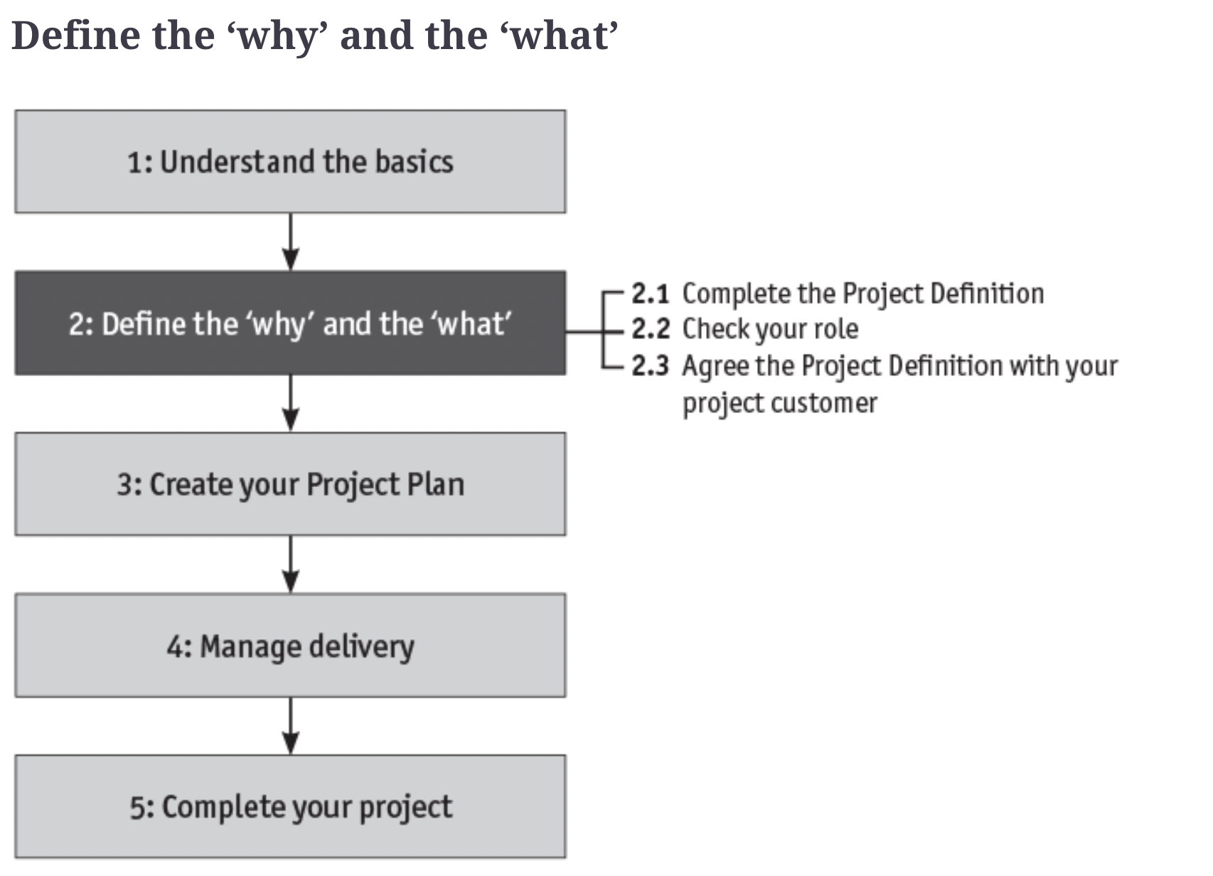

* Success in projects depends on understanding precisely, completely and unambiguously what you are trying to achieve.
* In established businesses the definition of why something is done often exists in a formal document known as a Business Case, or it may be called the Business Rationale or Business Benefit
* Once you know why you are doing your project, you need to understand what the outcome or deliverable from your project must be to enable you to achieve your ‘why’.

**The step-by-step guide STEP 2 – Defining ‘why’ and ‘what’**

* + Project Definition

*Why do you want to do this project?*

*What will you have at the end of this project that you don’t have now?*

*Will you (should you) deliver anything else?*

*Is anything explicitly excluded from the project?*

subsidiary questions to ask:

* *Are there any gaps or overlaps with other projects – or changes to the boundaries of your project?*
* *What assumptions (if any) are you making?(* The problem with assumptions is that *they can be wrong)*
* *Are there any significant problems you are aware of that you must overcome?*
* *Has the customer, or the situation, set any specific conditions or constraints on the way you do this project?*

Then:

* + Check your role – are you responsible for achieving the ‘why’ or making sure the ‘what’ happens?
  + Agree the Project Definition with your project customer

Summary

* Start by understanding *why* you are doing something, then define *what* it is. Not the other way around.
* Good projects start with the end result in mind.
* Don’t just think what your project is – write it down. Forcing yourself to write it down is a great way to ensure it makes sense.
* Success in developing a Project Definition requires that the information be specific, precise, complete, unambiguous and concise.
* Make sure you know if you are responsible for ‘what’ the project delivers or also for ensuring it achieves the ‘why’. It is easier just to be responsible for the ‘what’, and this is normally all a project manager is responsible for.
* If you are running a project for someone else, ensure they understand the Project Definition and the implications of its contents, and get them to sign it.