Exercise 1
Scenario 1:
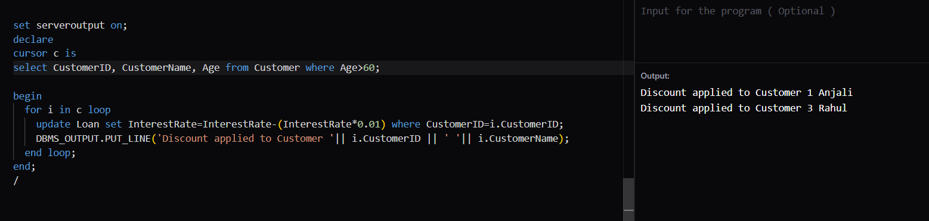

Scenario 2:
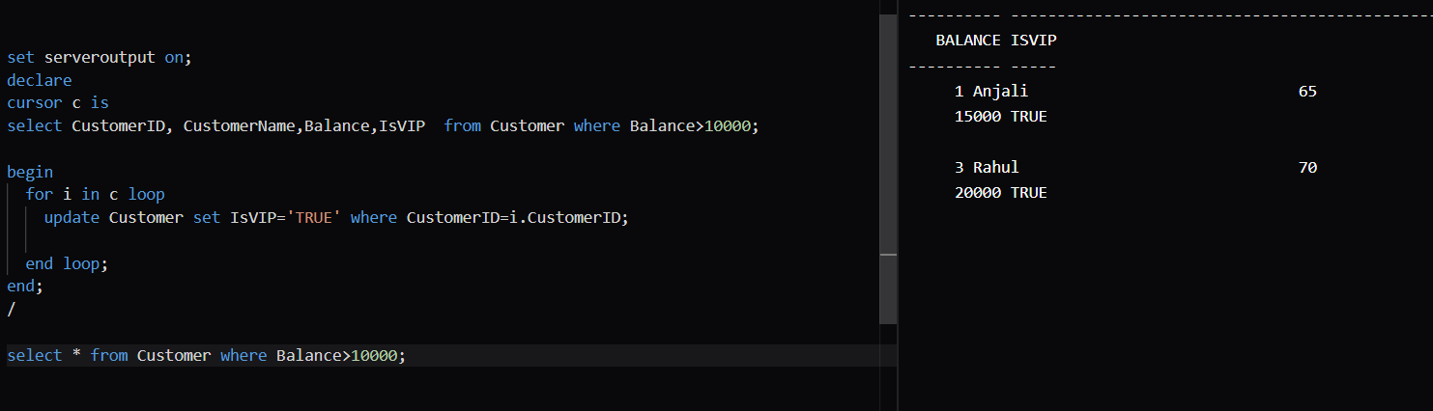
Scenario 3:
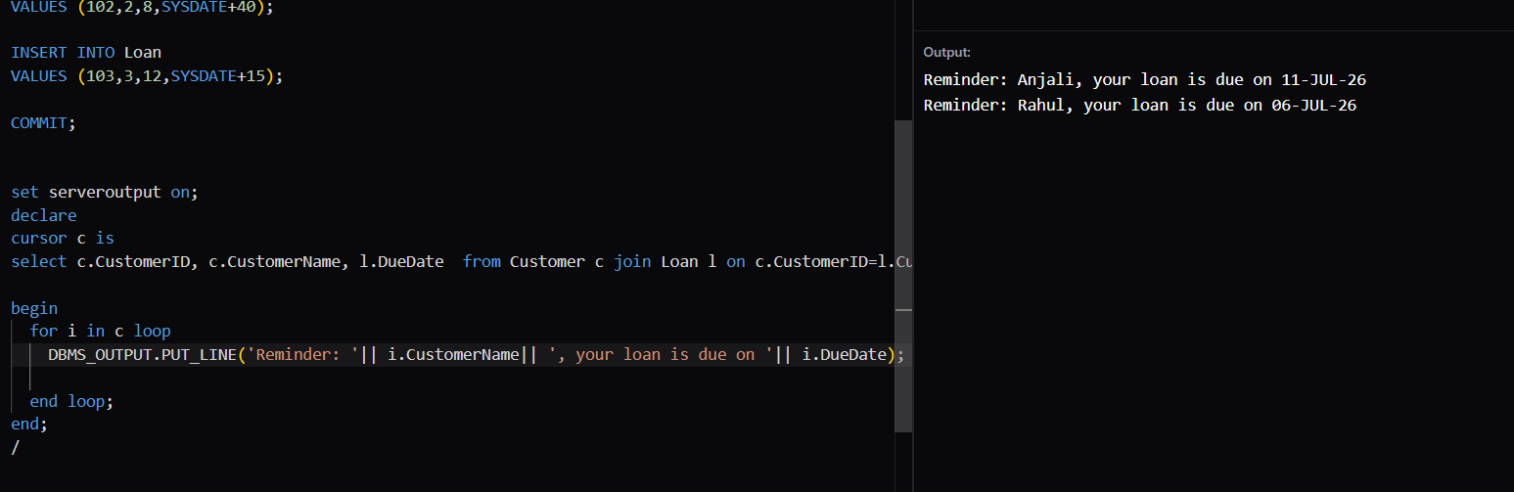

Exercise 3
Scenario 1:
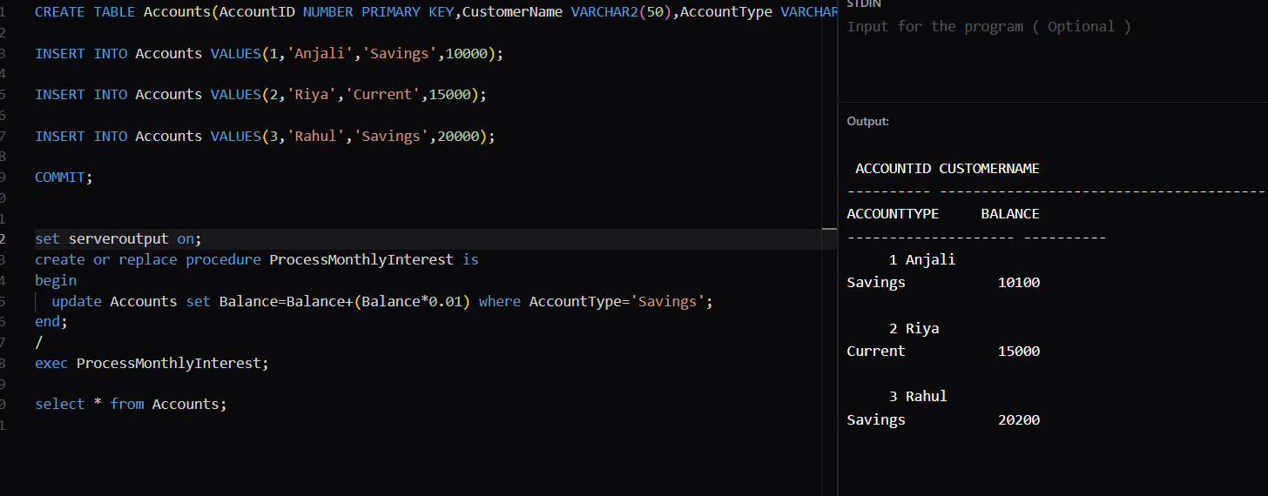
Scenario 2:
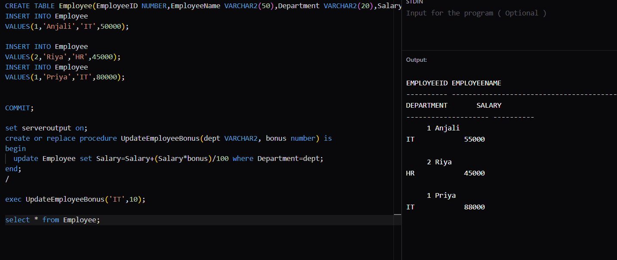

Scenario 3:
