EXPERIMENT NO: 8

**Name: Jesnamol Thomas**

**Roll No: 6 Batch: MCA B Date: 03-06-2022**

**AIM:**

**Perform CRUD Opertions**

**PROCEDURE:**

**1.CREATE**

use databasename : To create Database.

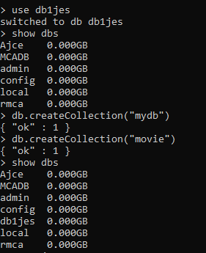

show dbs : Listing All Databases.



db.createCollection: Creating Collections(Tables).



show Collections :To show Collections.

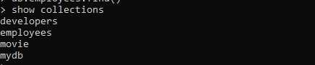

Insert(): Inserting Values to Collection

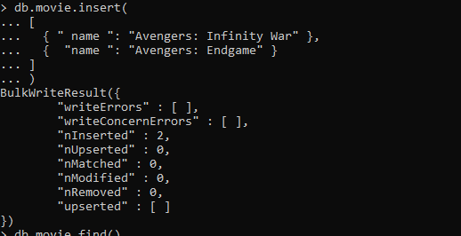

InsertMany():

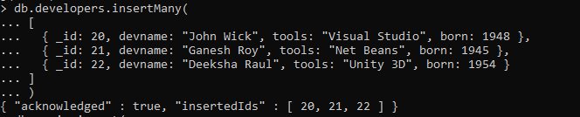

**2.READ**

Find():

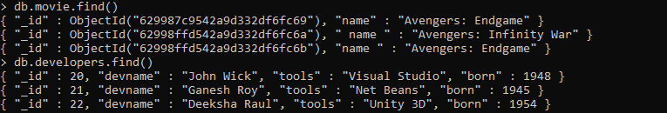

**3.UPDATE**

Update();

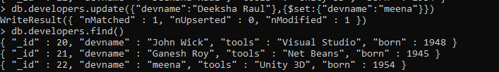

UpdateMany();

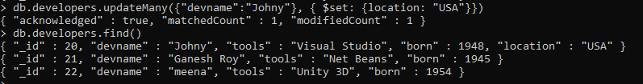

**4.DELETE**

DeleteOne():

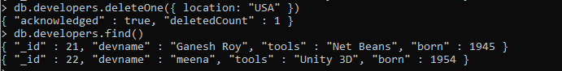

DeleteMany():

