**Name: Jesnamol Thomas**

**Roll No: 6**

**Batch: B**

**Date: 16/06/22**

**NETWORKING & SYSTEM ADMINISTRATION LAB**

**Experiment No.:**

**Aim**

KVM installation.

**Procedure**

1. **sudo gedit /usr/bin/script1.sh:** To create a shell script to run always until the system is running.

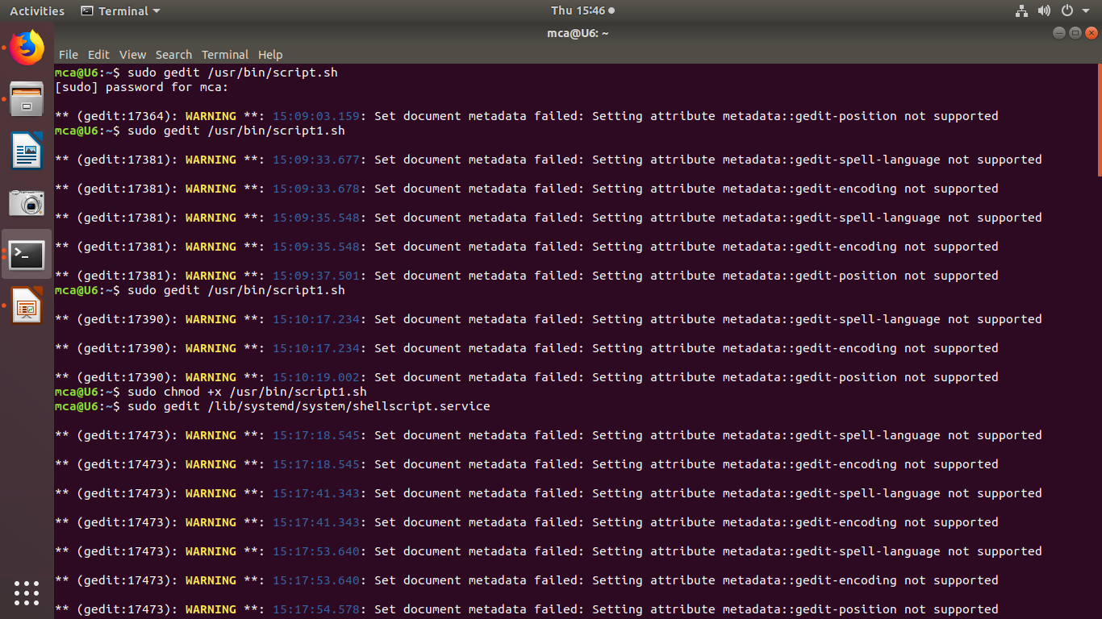

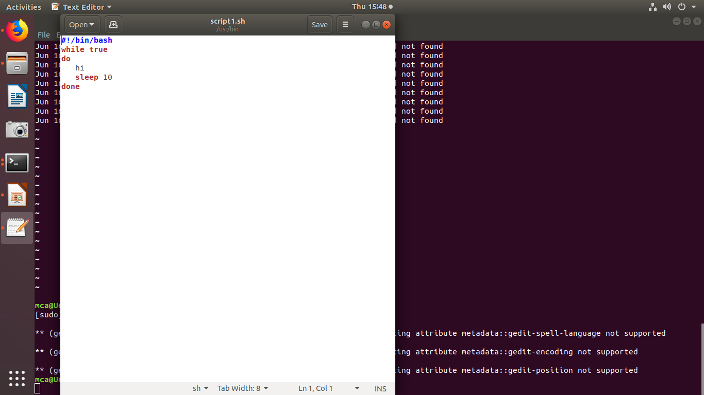

1. **sudo chmod +x /usr/bin/script1.sh** **:** To give permissions to the file.



1. **sudo gedit /lib/system/shellscript.service:** To create a SystemDfile.



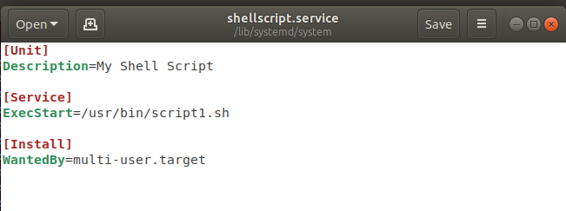

1. **sudo systemctl daemon-reload:**To reload the systemctl daemon to read new file.

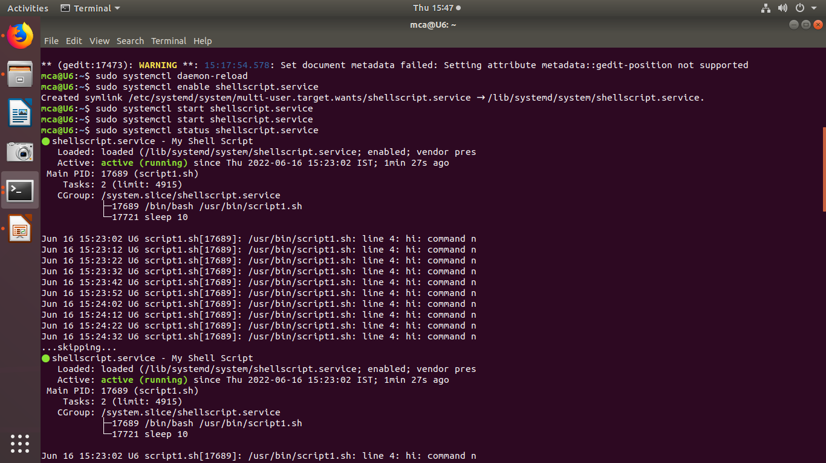

1. **sudo systemctl enable shellscript.service :** To enable the service.



1. **sudo systemctl start shellscript.service:** To start the service.



1. **sudo systemctl status shellscript.service:** To check the status .

