**Name: Jesnamol Thomas**

**Roll No: 6**

**Batch: B**

**Date: 07/05/22**

**NETWORKING & SYSTEM ADMINISTRATION LAB**

**Experiment No.: 7**

**Aim**

Familiarization of command line

**Procedure**

file.sh

#!/bin/bash

echo "hi" $1

echo $0

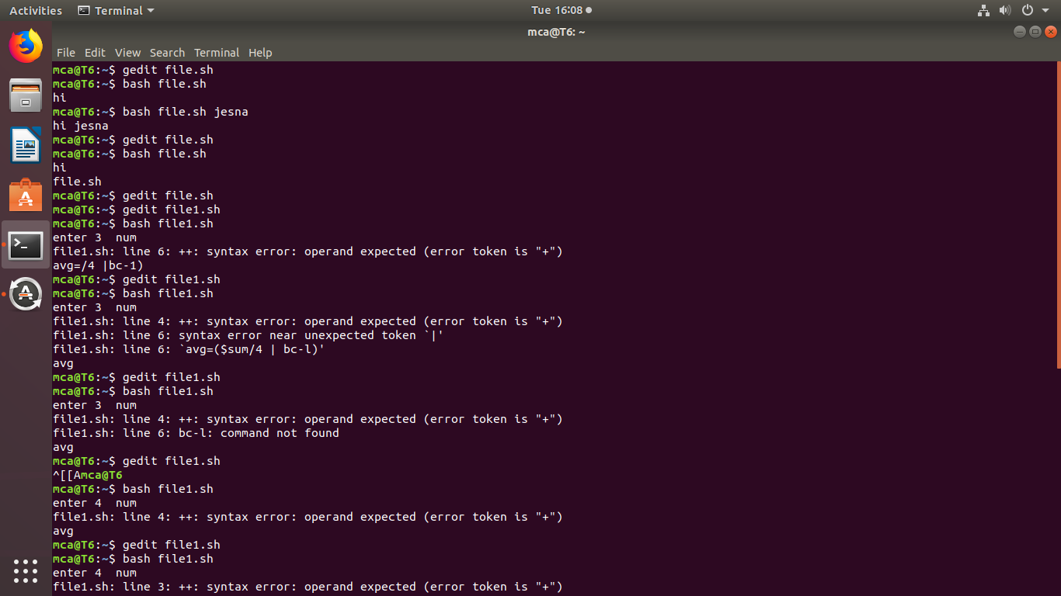

file1.sh

#!/bin/bash

sum=$(($1+$2+$3))

avg=$(echo $sum/3 | bc -l)

echo $avgS

